实验七

此实验使用了一个JSP、一个JavaBean和一个Servlet

JSP：calc.jsp

Servlet: control.java (URL=control.do)

JavaBean: calc.java

JSP

**Calc.jsp:**

<%@ page language=*"java"* import=*"java.util.*"* pageEncoding=*"UTF-8"*%>

<%

String path = request.getContextPath();

String basePath = request.getScheme()+"://"+request.getServerName()+":"+request.getServerPort()+path+"/";

%>

<!DOCTYPE HTML PUBLIC "-//W3C//DTD HTML 4.01 Transitional//EN">

<html>

<head>

<base href=*"*<%=basePath%>*"*>

<title>纳税所得额计算</title>

</head>

<div class=*"container"*>

<div class=*"starter-template"*>

<h1>Calculate The Revenue</h1>

<form action=*"control.do"* method=*"post"*>

<p class=*"lead"*>

<label for=*"money"*>请输入你的工资:</label>

<input id=*"money"* name=*"money"* type=*"text"*>

</p>

<input type=*"submit"* value=*"提交"*>

<div>应纳税所得额为:${ sessionScope.revenue}</div>

</form>

</div>

</div>

</html>

Servlet

**Control.java:**

**package** Bean;

**import** java.io.IOException;

**import** java.io.PrintWriter;

**import** javax.servlet.ServletException;

**import** javax.servlet.http.HttpServlet;

**import** javax.servlet.http.HttpServletRequest;

**import** javax.servlet.http.HttpServletResponse;

**import** javax.servlet.http.HttpSession;

**import** Bean.calc;

**public** **class** control **extends** HttpServlet {

**public** **void** doPost(HttpServletRequest request, HttpServletResponse response)

**throws** ServletException, IOException {

HttpSession session = request.getSession();

**double** money = Double.*valueOf*(request.getParameter("money"));

calc g = **new** calc(money);

session.setAttribute("revenue",g.calculate());

response.sendRedirect("calc.jsp");

}

}

JavaBean

calc.java:

**package** Bean;

**public** **class** calc {

**private** **double** income,dr;

**private** **double** revenue;

**public** calc(){}

**public** calc(**double** money){ income = money;}

**public** **void** setIncome(**double** income){**this**.income = income;}

**public** **double** getIncome(){**return** income;}

**public** **double** calculate(){

dr = income - 1600;

**if**(dr<=0){**return** 0.0;}

**if**(dr > 0 && dr <= 500){

revenue = dr * 0.05;

**return** revenue;

}**else** **if**(dr <= 3000){

revenue = dr * 0.10 - 25;

**return** revenue;

}**else** **if**(dr <=5000){

revenue = dr * 0.15 - 125;

**return** revenue;

}**else** **if**(dr <= 20000){

revenue = dr * 0.20 - 375;

**return** revenue;

}**else** **if**(dr <= 40000){

revenue = dr * 0.25 - 1375;

**return** revenue;

}**else** **if**(income <= 60000){

revenue = dr * 0.30 - 3375;

**return** revenue;

}**else** **if**(income <= 80000){

revenue = dr * 0.35 - 6375;

**return** revenue;

}**else** **if**(income <= 100000){

revenue = dr * 0.40 - 10375;

**return** revenue;

}**else**{

revenue = dr * 0.45 - 15375;

**return** revenue;

}

}

}

效果图

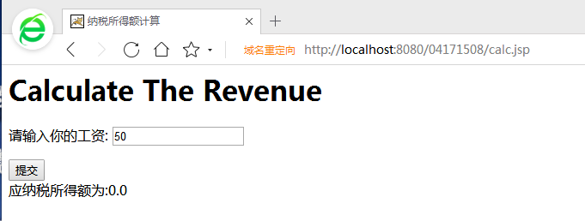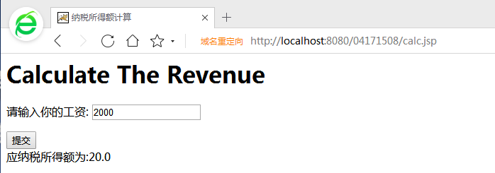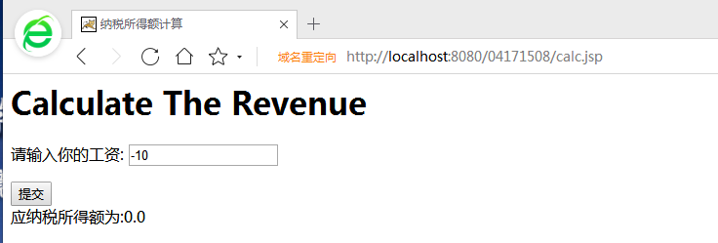

**总结：**

Javabean里面有进行对负数的判断，由于时间问题所以在页面上尚未添加提醒警告。未含有对字母的判断。

本想使<div>隐藏，待提交text文本框数据之后再进行显示。

