**Java Web开发**

**实验四**

**作业报告**

|  |  |
| --- | --- |
| 学 院 | 计算机 |
| 所在系 班 级 | 2017软件工程系7班 |
| 学 号 姓 名 | 王建平04171514 |
| 指 导 教 师 | 郭晓燕 |
| 完 成 时 间 | 2018年5月 |

1、页面输入收入，得到相应的缴纳税收

要求：Jsp提交收入，显示结果（可一个页面也可两个页面）。编写一个JavaBean计算税收，并在JSP页面输出结果

计算方法：全月应纳税所得额＝月收入－1600元

级数 全月应纳税所得额 税率% 速算扣除法(元) 1 dr <=500 5 0

2 500 <dr<=3000 10 25

3 3000 < dr <=5000 15 125

4 5000 < dr <=20000 20 375

5 20,000 < dr <=40000 25 1375

6 40,000 < dr <=60,000 30 3375

7 60,000 < dr <=80,000 35 6375 8 80,000 < dr <=100,000 40 10375 9 dr >100,000元 45 15375

如：月收入3000，则（3000-1600）*10%-25=115，因为3000-1600大于500小于2000，所以按10%计算后再扣除速算的部分

1.2代码

<%@ page contentType=*"text/html;charset=utf-8"* %>

<HTML><BODY><Font size=*8*>

<head>

<title></title>

</head>

<body>

<FORM action=*"control.view"* method=*post*>

<meta http-equiv=*"Content-Type"*

content=*"text/html;charset=UTF-8"*>

<table border=*"0"* width=*"100%"* cellspacing=*"0"* cellpadding=*"0"* height=*"307"*>

<tr align=*center*>

<td width=*"100%"* colspan=*"4"* height=*"20"* bgcolor=*"#3399ff"*>&nbsp;<font color=*"#ffffff"*>

个人所得税计算系统</font>

</td>

</tr>

<form name=*"form1"* method=*"post"* action=*"reg_ok.jsp"* onsubmit="**return** sub(this)">

<tr>

<td align=*"right"*><b>请输入您的月收入：</b></td>

<td>&nbsp;</td>

<td colspan=*"2"*>

<input type=*"text"* name=*"m"* >

</td>

</tr>

<tr>

<td align=*"center"*>&nbsp;</td>

<td align=*"left"* colspan=*"2"*>

<input type=*"submit"* value=*"填好了"* >

<input type=*"reset"* value=*"重填"*>

</td>

</tr>

</form>

</table>

</html>

package test7;

import java.io.IOException;

import java.io.PrintWriter;

import javax.servlet.ServletException;

import javax.servlet.annotation.WebServlet;

import javax.servlet.http.HttpServlet;

import javax.servlet.http.HttpServletRequest;

import javax.servlet.http.HttpServletResponse;

import javax.servlet.http.HttpSession;

import test7.calculate;

@WebServlet(name="control",urlPatterns={"/control.view"})

public class control extends HttpServlet {

public void doPost(HttpServletRequest request, HttpServletResponse response) throws ServletException, IOException

{

request.setCharacterEncoding("UTF-8");

response.setContentType("charset=utf-8");

PrintWriter out = response.getWriter();

HttpSession session = request.getSession();

String mo=request.getParameter("m");

if(mo==null)

out.println("输入数字不能为空kkkkkkk");

else

{

double money=Double.parseDouble(mo);

calculate ca=new calculate();

ca.setMoney(money);

session.setAttribute("c", ca);

response.sendRedirect("results.jsp");

}

}

}

package test7;

import java.io.IOException;

import java.io.PrintWriter;

import javax.servlet.ServletException;

import javax.servlet.annotation.WebServlet;

import javax.servlet.http.HttpServlet;

import javax.servlet.http.HttpServletRequest;

import javax.servlet.http.HttpServletResponse;

import javax.servlet.http.HttpSession;

import test7.calculate;

@WebServlet(name="control",urlPatterns={"/control.view"})

public class control extends HttpServlet {

public void doPost(HttpServletRequest request, HttpServletResponse response) throws ServletException, IOException

{

request.setCharacterEncoding("UTF-8");

response.setContentType("charset=utf-8");

PrintWriter out = response.getWriter();

HttpSession session = request.getSession();

String mo=request.getParameter("m");

if(mo==null)

out.println("输入数字不能为空kkkkkkk");

else

{

double money=Double.parseDouble(mo);

calculate ca=new calculate();

ca.setMoney(money);

session.setAttribute("c", ca);

response.sendRedirect("results.jsp");

}

}

}

<%@page language=*"java"* import=*"java.util.*"* pageEncoding=*"UTF-8"*%>

<jsp:useBean id=*"c"* class=*"test7.calculate"* scope=*"session"*/>

<!DOCTYPE HTML PUBLIC "-//W3C//DTD HTML 4.01 Transitional//EN">

<html>

<head>

</head>

<body>

您需要缴纳的税款：<%=c.gettax()%>

</body>

</html>

1.3截图

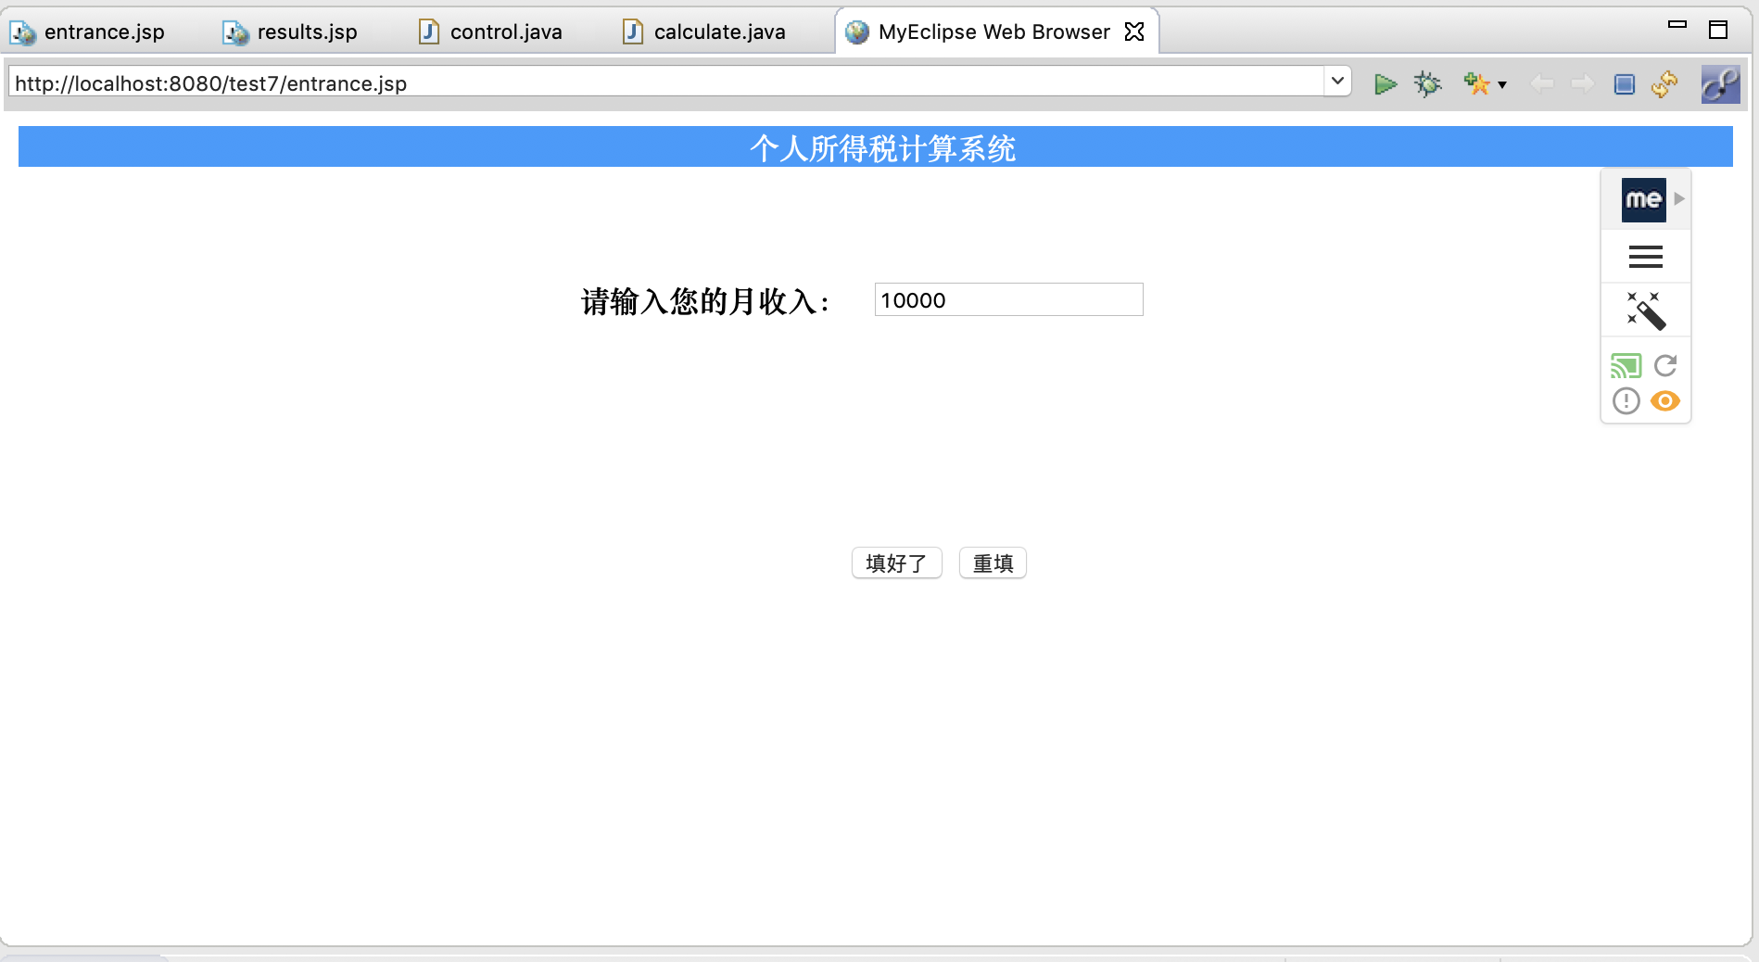

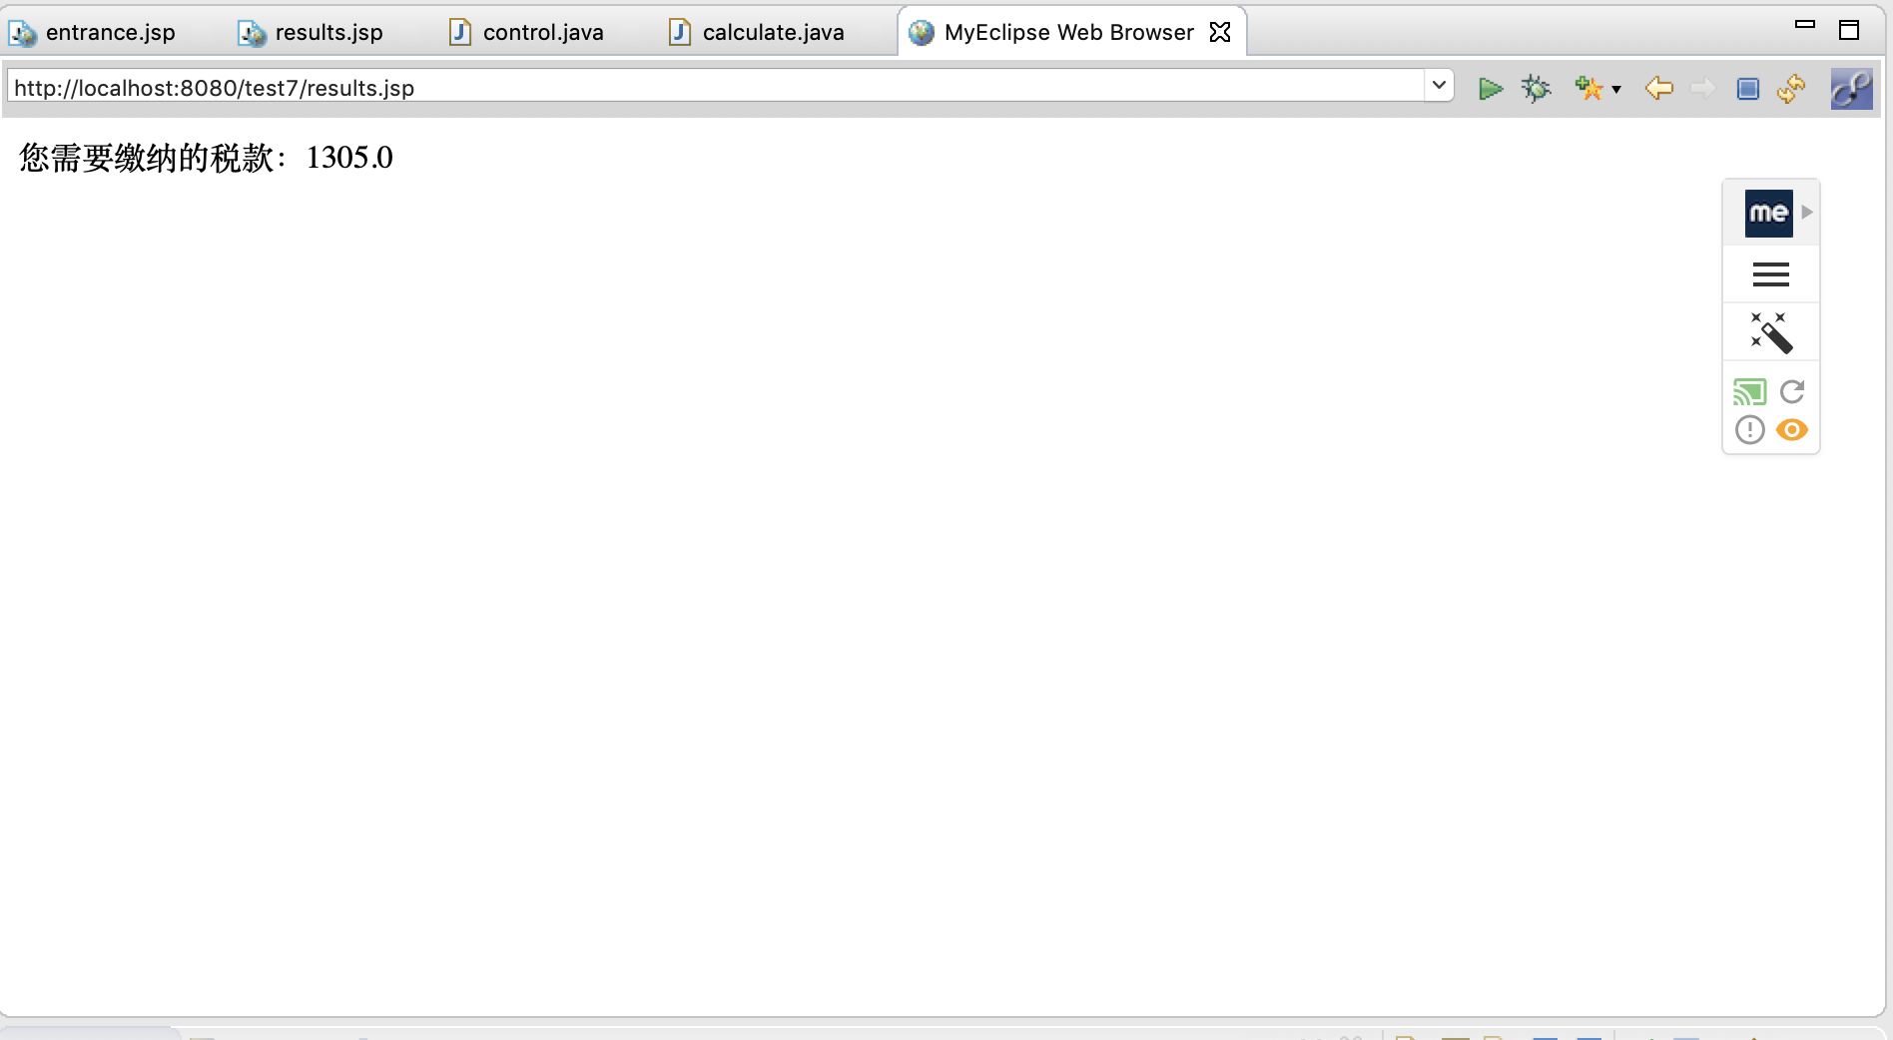

1.3感悟：通过简单的习题初步认识了MVC模式