**Java Web开发**

**实验七**

**作业报告**

|  |  |
| --- | --- |
| 学 院 | 计算机 |
| 所在系 班 级 | 2017软件工程系08班 |
| 学 号 姓 名 | 04171603鲍稚明 |
| 指 导 教 师 | 郭晓燕 |
| 完 成 时 间 | 2018年4月15日 |

# 实验题目

1、页面输入收入，得到相应的缴纳税收

要求：Jsp提交收入，显示结果（可一个页面也可两个页面）。编写一个JavaBean计算税收，并在JSP页面输出结果

计算方法：全月应纳税所得额＝月收入－1600元

级数 全月应纳税所得额 税率% 速算扣除法(元)   
1 dr <=500 5 0

2 500 <dr<=3000 10 25

3 3000 < dr <=5000 15 125

4 5000 < dr <=20000 20 375

5 20,000 < dr <=40000 25 1375

6 40,000 < dr <=60,000 30 3375

7 60,000 < dr <=80,000 35 6375   
8 80,000 < dr <=100,000 40 10375   
9 dr >100,000元 45 15375

如：月收入3000，则（3000-1600）*10%-25=115，因为3000-1600大于500小于2000，所以按10%计算后再扣除速算的部分。

# 分析与设计

此题较为容易，只需要在界面输入界面输出，计算部分放在javabean里思路极简。

# 关键源码（部分）

-----------------------------------------inputpage.jsp---------------------------------

<html lang=*"zh-CN"*><head><%@ page language=*"java"* contentType=*"text/html; charset=UTF-8"*

pageEncoding=*"UTF-8"*%>

<meta charset=*"utf-8"*>

<meta http-equiv=*"X-UA-Compatible"* content=*"IE=edge"*>

<meta name=*"viewport"* content=*"width=device-width, initial-scale=1"*>

<!-- 上述3个meta标签*必须*放在最前面，任何其他内容都*必须*跟随其后！ -->

<meta name=*"description"* content=*""*>

<meta name=*"author"* content=*""*>

<link rel=*"icon"* href=*"../../favicon.ico"*>

<title>Cover Template for Bootstrap</title>

<!-- Bootstrap core CSS -->

<link href=*"https://cdn.bootcss.com/bootstrap/3.3.7/css/bootstrap.min.css"* rel=*"stylesheet"*>

<!-- IE10 viewport hack for Surface/desktop Windows 8 bug -->

<link href=*"./CSS/inputCSS.css"* rel=*"stylesheet"*>

<!-- Custom styles for this template -->

<link href=*"cover.css"* rel=*"stylesheet"*>

<!-- Just for debugging purposes. Don't actually copy these 2 lines! -->

<!--[if lt IE 9]><script src="../../assets/js/ie8-responsive-file-warning.js"></script><![endif]-->

<script src=*"../../assets/js/ie-emulation-modes-warning.js"*></script>

<!-- HTML5 shim and Respond.js for IE8 support of HTML5 elements and media queries -->

<!--[if lt IE 9]>

<script src="https://cdn.bootcss.com/html5shiv/3.7.3/html5shiv.min.js"></script>

<script src="https://cdn.bootcss.com/respond.js/1.4.2/respond.min.js"></script>

<![endif]-->

</head>

<form name=*"form"* action=*"./servlet/revecon"*>

<body>

<br><br><br><br><br><br><br><br><br><br><br><br><br><br><br><br><br><br>

<p class=*"lead"*>请输入你的工资，将计算你应该所交的税</p>

<h2><input type=*"text"* name=*"money"* value=*""* style="color: Black; "></h2>

<button class=*"btn btn-lg btn-default"* type=*"sunmit"* >提交</button>

</form>

</body></html>

-------------------------------------------result.jsp---------------------------------------------

<html lang=*"zh-CN"*><head><%@ page language=*"java"* contentType=*"text/html; charset=UTF-8"*

pageEncoding=*"UTF-8"*%>

<meta charset=*"utf-8"*>

<meta http-equiv=*"X-UA-Compatible"* content=*"IE=edge"*>

<meta name=*"viewport"* content=*"width=device-width, initial-scale=1"*>

<!-- 上述3个meta标签*必须*放在最前面，任何其他内容都*必须*跟随其后！ -->

<meta name=*"description"* content=*""*>

<meta name=*"author"* content=*""*>

<link rel=*"icon"* href=*"../../favicon.ico"*>

<title>Cover Template for Bootstrap</title>

<!-- Bootstrap core CSS -->

<link href=*"https://cdn.bootcss.com/bootstrap/3.3.7/css/bootstrap.min.css"* rel=*"stylesheet"*>

<!-- IE10 viewport hack for Surface/desktop Windows 8 bug -->

<link href=*"./CSS/inputCSS.css"* rel=*"stylesheet"*>

<!-- Custom styles for this template -->

<link href=*"cover.css"* rel=*"stylesheet"*>

<!-- Just for debugging purposes. Don't actually copy these 2 lines! -->

<!--[if lt IE 9]><script src="../../assets/js/ie8-responsive-file-warning.js"></script><![endif]-->

<script src=*"../../assets/js/ie-emulation-modes-warning.js"*></script>

<!-- HTML5 shim and Respond.js for IE8 support of HTML5 elements and media queries -->

<!--[if lt IE 9]>

<script src="https://cdn.bootcss.com/html5shiv/3.7.3/html5shiv.min.js"></script>

<script src="https://cdn.bootcss.com/respond.js/1.4.2/respond.min.js"></script>

<![endif]-->

</head>

<body>

<br><br><br><br><br><br><br><br><br><br><br><br><br><br><br><br><br><br>

<h1 class=*"cover-heading"*>你需要交的税额是:</h1>

<p class=*"lead"* ><font size=*300*><%=session.getAttribute("res") %></font>元</p>

</body></html>

------------------------revecon.java----------------

**public** **void** doGet(HttpServletRequest request, HttpServletResponse response)

**throws** ServletException, IOException {

response . setContentType ("text/html; charset=UTF-8");

request.setCharacterEncoding("UTF-8");

PrintWriter out = response.getWriter();

**if**(!isNumeric(request.getParameter("money")))

{

out.println("<script language='javascript'>alert('输入了非数字！3秒跳转后，请重新输入！')</script>");

response.setHeader("refresh","3;../inputpage.jsp");

}

**int** money=Integer.*parseInt*(request.getParameter("money").toString())-1600;

**if**(money<-1600)

{

out.println("<script language='javascript'>alert('工资不能少于0！3秒跳转后，请重新输入！')</script>");

response.setHeader("refresh","3;../inputpage.jsp");

}

**if**(money<=0)

request.getSession().setAttribute("res", 0);

**else**

**if**(money<=500)

request.getSession().setAttribute("res", money*0.05);

**else**

**if**(money<=3000)

request.getSession().setAttribute("res", money*0.1-25);

**else**

**if**(money<=5000)

request.getSession().setAttribute("res", money*0.15-125);

**else**

**if**(money<=20000)

request.getSession().setAttribute("res", money*0.20-375);

**else**

**if**(money<=40000)

request.getSession().setAttribute("res", money*0.25-1375);

**else**

**if**(money<=60000)

request.getSession().setAttribute("res", money*0.30-3375);

**else**

**if**(money<=80000)

request.getSession().setAttribute("res", money*0.35-6375);

**else**

**if**(money<=100000)

request.getSession().setAttribute("res", money*0.40-10375);

**else**

request.getSession().setAttribute("res", money*0.45-15375);

response.sendRedirect("../result.jsp");

}

# 运行效果图

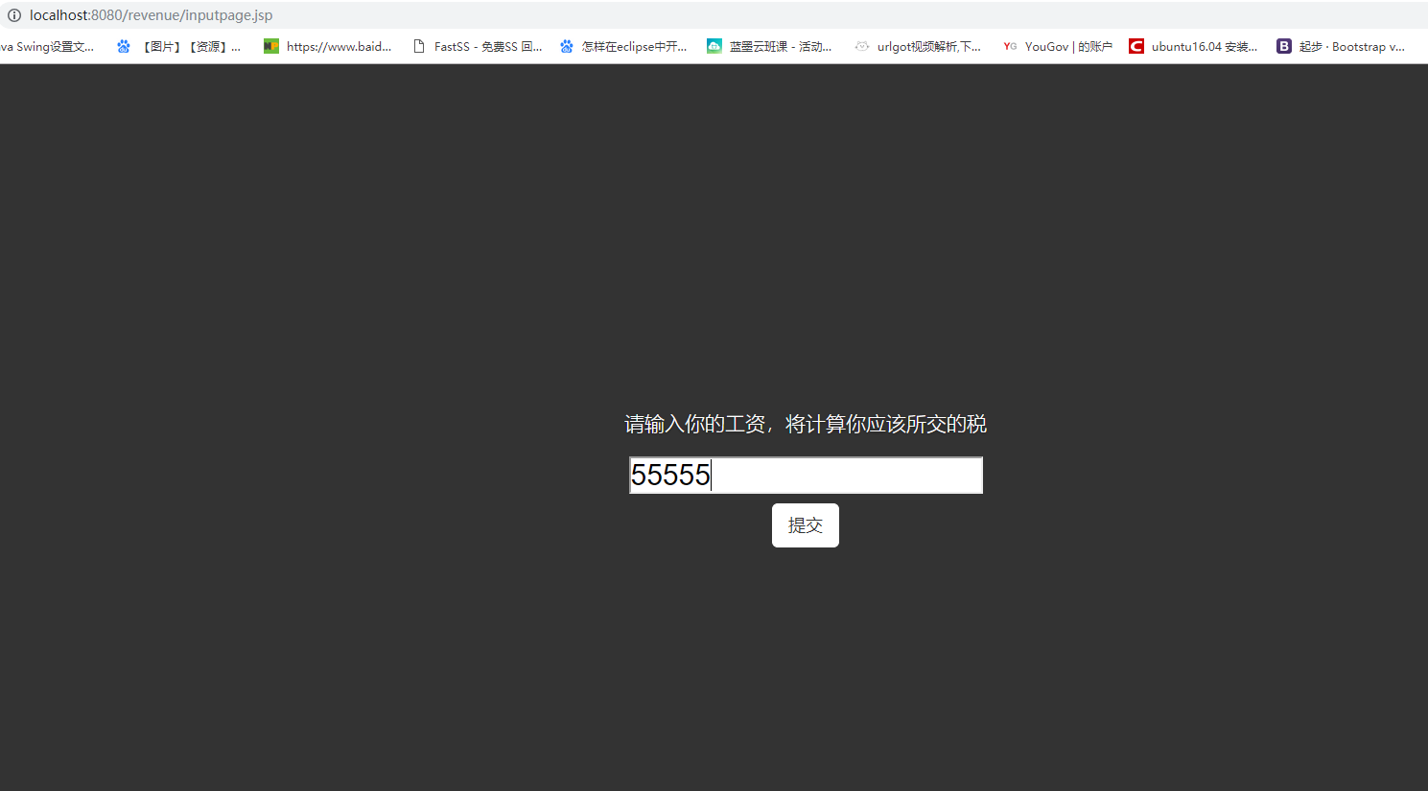

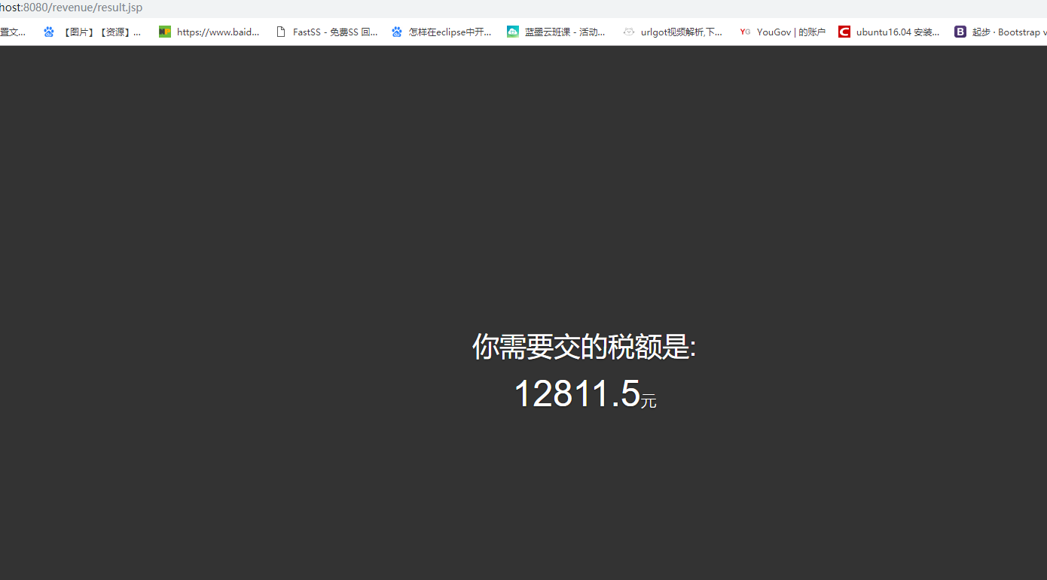

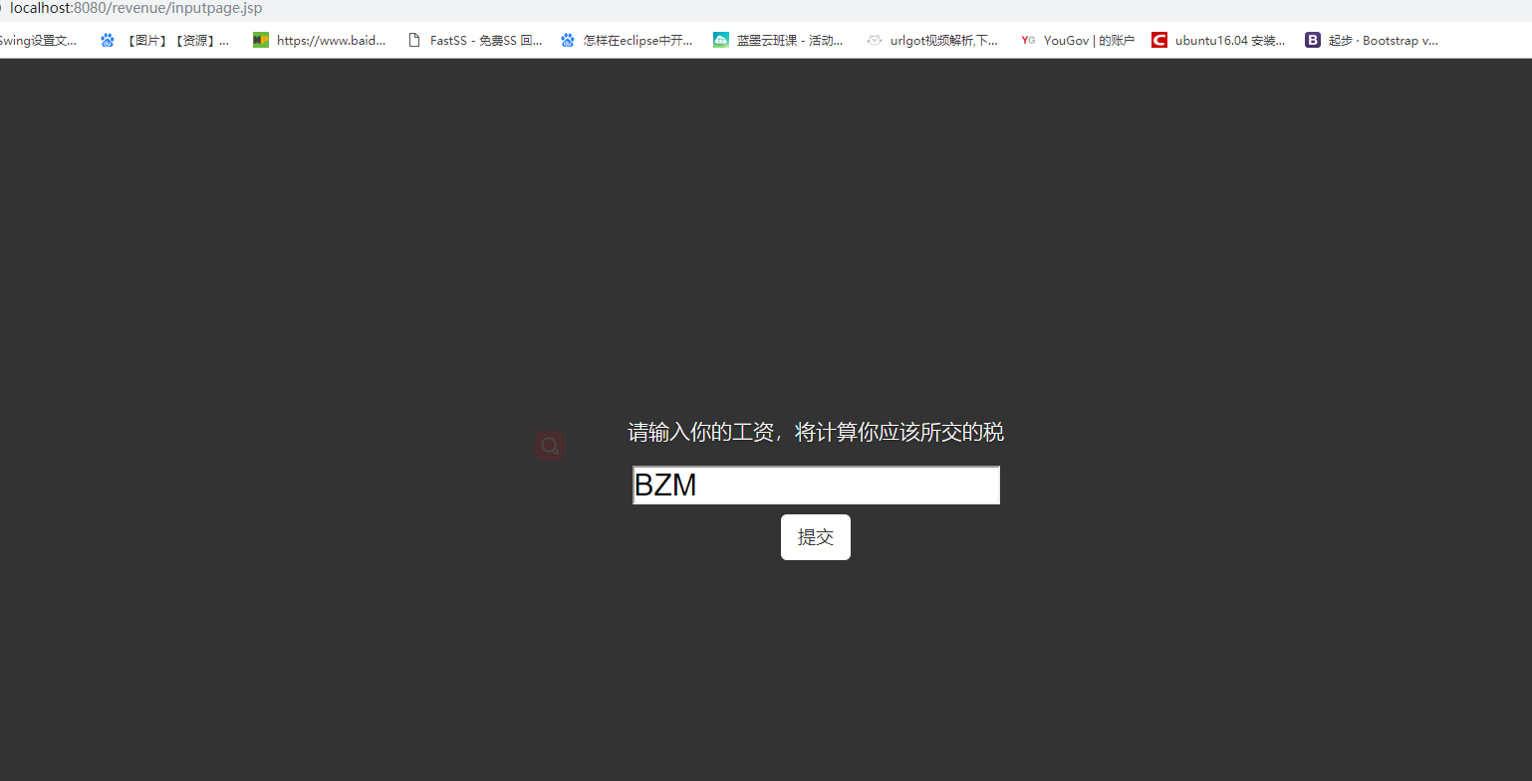

如上输入非数字给予提示



# 收获与问题

本次实验发现forward跳转到的页面css出现错误，问题尚未解决:

如果是通过转发到result页面，css模板不生效(似乎是本地模板未生效)。本次实验较为简单，收货是开心的心情。