**Java Web开发**

**实验七**

**作业报告**

|  |  |
| --- | --- |
| 学 院 | 计算机 |
| 所在系 班 级 | 2017软件工程系8班 |
| 学 号 姓 名 | 陈荣 |
| 指 导 教 师 | 郭晓燕 |
| 完 成 时 间 | 2019年4月20日 |

# 实验题目

1、页面输入收入，得到相应的缴纳税收

要求：Jsp提交收入，显示结果（可一个页面也可两个页面）。编写一个JavaBean计算税收，并在JSP页面输出结果

计算方法：全月应纳税所得额＝月收入－1600元

级数 全月应纳税所得额 税率% 速算扣除法(元)   
1 dr <=500 5 0

2 500 <dr<=3000 10 25

3 3000 < dr <=5000 15 125

4 5000 < dr <=20000 20 375

5 20,000 < dr <=40000 25 1375

6 40,000 < dr <=60,000 30 3375

7 60,000 < dr <=80,000 35 6375   
8 80,000 < dr <=100,000 40 10375   
9 dr >100,000元 45 15375

如：月收入3000，则（3000-1600）*10%-25=115，因为3000-1600大于500小于2000，所以按10%计算后再扣除速算的部分。

# 分析与设计

# 关键源码（部分）

*Input.jsp*

<%@ page language=*"java"* import=*"java.util.*"* pageEncoding=*"UTF-8"*%>

<%

String path = request.getContextPath();

String basePath = request.getScheme()+"://"+request.getServerName()+":"+request.getServerPort()+path+"/";

%>

<!DOCTYPE HTML PUBLIC "-//W3C//DTD HTML 4.01 Transitional//EN">

<html>

<head>

<title>月收入</title>

</head>

<body>

<div align=*"center"*>

<form action=*"JiaoShuiServlet"* method=*"post"*>

您的月收入是：<input name=*"mincome"* type=*"text"* value=*${requestScope.JiaoShui.mIncome*} >

</div>

<div align=*"center"*>

<button type=*"submit"* class=*"btn btn-primary"*>Submit</button>

</div>

</body>

</html>

**Show.jsp**

<%@ page language=*"java"* import=*"java.util.*"* pageEncoding=*"UTF-8"*%>

<%@ page import=*"cc.js.*"* %>

<%

String path = request.getContextPath();

String basePath = request.getScheme()+"://"+request.getServerName()+":"+request.getServerPort()+path+"/";

%>

<!DOCTYPE HTML PUBLIC "-//W3C//DTD HTML 4.01 Transitional//EN">

<html>

<head>

<title>缴税</title>

</head>

<body>

<div align=*"center"*>

您应缴纳的缴纳税收为：<input name=*"tincome"* type=*"text"* value=*${requestScope.JiaoShui.tIncome*} >

</div>

</body>

</html>

JiaoShui.java

**package** cc.js;

**public** **class** JiaoShui

{

**private** **double** mIncome;

**private** **double** tIncome;

**public** **void** setMIncome(**double** mIncome)

{

**this**.mIncome=mIncome;

}

**public** **double** getMIncome()

{

**return** mIncome;

}

**public** **void** setTIncome(**double** tIncome)

{

**this**.tIncome=tIncome;

}

**public** **double** getTIncome()

{

**return** tIncome;

}

**public** **double** getMoney(**double** mIncome,**double** tIncome)

{

**double** dr=mIncome-1600;

**if**(dr<=500)

{

tIncome=dr*0.05;

}

**else** **if**(dr<=3000)

{

tIncome=dr*0.10-25;

}

**else** **if**(dr<=5000)

{

tIncome=dr*0.15-125;

}

**else** **if**(dr<=20000)

{

tIncome=dr*0.20-375;

}

**else** **if**(dr<=40000)

{

tIncome=dr*0.25-1375;

}

**else** **if**(dr<=60000)

{

tIncome=dr*0.30-3375;

}

**else** **if**(dr<=80000)

{

tIncome=dr*0.35-6375;

}

**else** **if**(dr<=100000)

{

tIncome=dr*0.40-10375;

}

**else**

{

tIncome=dr*0.45-15375;

}

**return** tIncome;

}

}

JiaoShuiServlet.java

package cc.js;

import java.io.IOException;

import java.io.PrintWriter;

import javax.servlet.RequestDispatcher;

import javax.servlet.ServletException;

import javax.servlet.annotation.WebServlet;

import javax.servlet.http.HttpServlet;

import javax.servlet.http.HttpServletRequest;

import javax.servlet.http.HttpServletResponse;

import javax.servlet.http.HttpSession;

public class JiaoShuiServlet extends HttpServlet {

public void doPost(HttpServletRequest request, HttpServletResponse response)

throws ServletException, IOException {

response.setContentType("UTF-8");

HttpSession session=request.getSession();

if(request.getParameter("mincome")==null||request.getParameter("mincome")=="") {

session.setAttribute("key", "您没有输入数字");

response.sendRedirect("fail.jsp");

}

else {

double mincome=Double.parseDouble(request.getParameter("mincome"));

JiaoShui tr=new JiaoShui();

session.setAttribute("tr", tr);

response.sendRedirect("show.jsp");

}

}

}

# 运行效果图

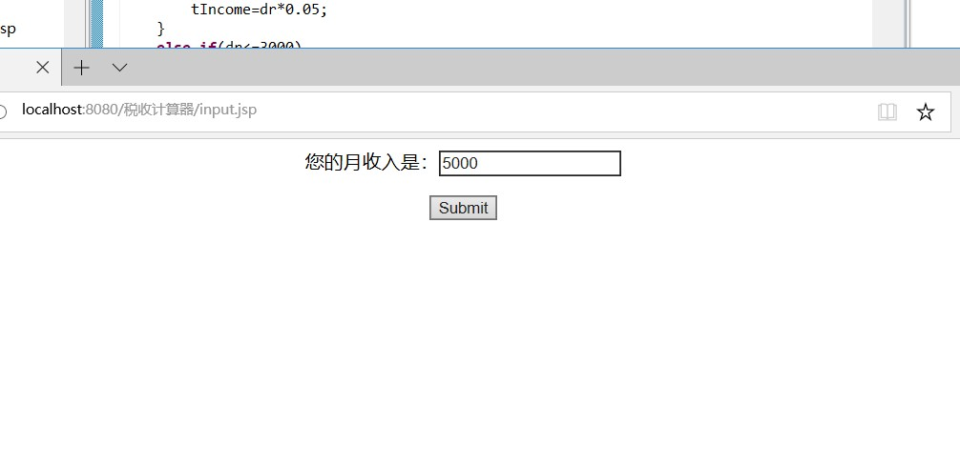

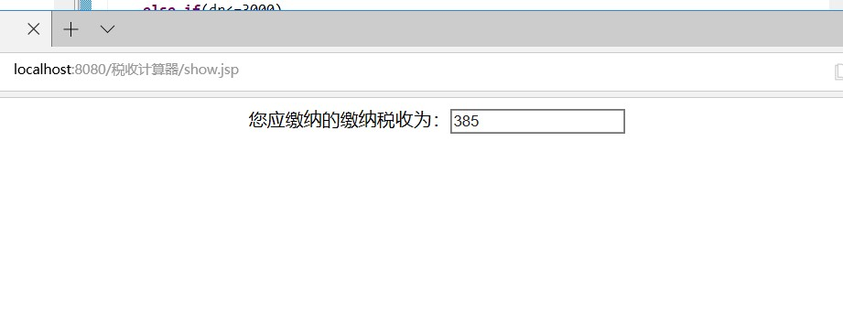

# 收获与问题