**Java Web开发**

**实验七**

**作业报告**

|  |  |
| --- | --- |
| 学 院 | 计算机 |
| 所在系 班 级 | 2017软件工程系8班 |
| 学 号 姓 名 | 钟静波 |
| 指 导 教 师 | 郭晓燕 |
| 完 成 时 间 | 2019年4月19日 |

# 实验题目

参页面输入收入，得到相应的缴纳税收

要求：Jsp提交收入，显示结果（可一个页面也可两个页面）。编写一个JavaBean计算税收，并在JSP页面输出结果

计算方法：全月应纳税所得额＝月收入－1600元

级数 全月应纳税所得额 税率% 速算扣除法(元) 1 dr <=500 5 0

2 500 <dr<=3000 10 25

3 3000 < dr <=5000 15 125

4 5000 < dr <=20000 20 375

5 20,000 < dr <=40000 25 1375

6 40,000 < dr <=60,000 30 3375

7 60,000 < dr <=80,000 35 6375 8 80,000 < dr <=100,000 40 10375 9 dr >100,000元 45 15375

如：月收入3000，则（3000-1600）*10%-25=115，因为3000-1600大于500小于2000，所以按10%计算后再扣除速算的部分

# 分析与设计

# 关键源码（部分）

index.jsp

*<%@ page language="java" import="java.util.*" pageEncoding="UTF-8"%>*

*<%*

*String path = request.getContextPath();*

*String basePath = request.getScheme()+"://"+request.getServerName()+":"+request.getServerPort()+path+"/";*

*%>*

*<!DOCTYPE HTML PUBLIC "-//W3C//DTD HTML 4.01 Transitional//EN">*

*<html>*

*<head>*

*<meta charset="utf-8">*

*<meta name="viewport" content="width=device-width, initial-scale=1">*

*<link rel="stylesheet" href="https://cdn.staticfile.org/twitter-bootstrap/4.1.0/css/bootstrap.min.css">*

*<script src="https://cdn.staticfile.org/jquery/3.2.1/jquery.min.js"></script>*

*<script src="https://cdn.staticfile.org/popper.js/1.12.5/umd/popper.min.js"></script>*

*<script src="https://cdn.staticfile.org/twitter-bootstrap/4.1.0/js/bootstrap.min.js"></script>*

*</head>*

*<body>*

*<table width="100%" height="80%" cellpadding="0" cellspacing="0">*

*<tr>*

*<td valign="middle" align="center">*

*<div class="container">*

*<form method=post name=form action="jump.do">*

*<div class="form-group" style="width:60%">*

*<label for="income">请输入您的收入：</label>*

*<br><input type="text" name="income" class="form-control">（请输入一个大于1600的数）*

*</div>*

*<button type="submit" class="btn btn-primary">Submit</button>*

*</form>*

*</div>*

*</td>*

*</tr>*

*</table>*

*</body>*

*</html>*

fail.jsp

*<%@ page language="java" import="java.util.*" pageEncoding="UTF-8"%>*

*<%*

*String path = request.getContextPath();*

*String basePath = request.getScheme()+"://"+request.getServerName()+":"+request.getServerPort()+path+"/";*

*%>*

*<!DOCTYPE HTML PUBLIC "-//W3C//DTD HTML 4.01 Transitional//EN">*

*<html>*

*<head>*

*<meta charset="utf-8">*

*<meta name="viewport" content="width=device-width, initial-scale=1">*

*<link rel="stylesheet" href="https://cdn.staticfile.org/twitter-bootstrap/4.1.0/css/bootstrap.min.css">*

*<script src="https://cdn.staticfile.org/jquery/3.2.1/jquery.min.js"></script>*

*<script src="https://cdn.staticfile.org/popper.js/1.12.5/umd/popper.min.js"></script>*

*<script src="https://cdn.staticfile.org/twitter-bootstrap/4.1.0/js/bootstrap.min.js"></script>*

*</head>*

*<body>*

*<table width="100%" height="100%" cellpadding="0" cellspacing="0">*

*<tr>*

*<td valign="middle" align="center">*

*<div class="alert alert-danger" style="width:60%">*

*<center><h1><%String key=(String)session.getAttribute("key"); %>*

*<%=key%></h1></center>*

*<a href="index.jsp">返回首页</a>*

*</div>*

*</td>*

*</tr>*

*</table>*

*</body>*

*</html>*

shoppingCar.jsp

*<%@ page language="java" import="java.util.*" pageEncoding="UTF-8"%>*

*<%@ page import="CLASS.*" %>*

*<%*

*String path = request.getContextPath();*

*String basePath = request.getScheme()+"://"+request.getServerName()+":"+request.getServerPort()+path+"/";*

*%>*

*<!DOCTYPE HTML PUBLIC "-//W3C//DTD HTML 4.01 Transitional//EN">*

*<html>*

*<body>*

*<br>*

*<%*

*Book[] BookList = new Book[4];*

*BookList=(Book[]) session.getAttribute("book");*

*int count=(Integer)session.getAttribute("count");*

*if(BookList[0].getBookNum()+BookList[1].getBookNum()+BookList[2].getBookNum()+BookList[3].getBookNum()==0)*

*{*

*out.println("<font size=8>请选择商品</font>");*

*out.println("<a href='index.jsp'>返回购物页面</a>");*

*}*

*else {*

*out.println("<font size=8>购物车</font><br><table border='1'><tr>");*

*for(int i=0;i<4;i++) {*

*if(BookList[i].getBookNum()>0)*

*out.println("<td><img src='img/"+BookList[i].getBookId()+".jpg'></td>");*

*}*

*out.println("</tr><tr>");*

*for(int i=0;i<4;i++) {*

*if(BookList[i].getBookNum()>0){*

*out.println("<td><a href='add.view?id="+BookList[i].getBookId()+"'><button>+</button></a>");*

*out.println("总共"+BookList[i].getBookNum()+"件");*

*out.println("<a href='minus.view?id="+BookList[i].getBookId()+"'><button>-</button></a>");*

*out.println("<br><a href='delete.view?id="+BookList[i].getBookId()+"'><button>删除此书</button></a></td>");*

*}*

*}*

*out.println("<p>总共"+count+"元</p>");*

*out.println("</tr><br><a href='index.jsp'><button>继续购物</button></a>");*

*}*

*%>*

*</body>*

*</html>*

output.jsp

*<%@ page language="java" import="java.util.*" pageEncoding="UTF-8"%>*

*<%@ page import="CLASS.*" %>*

*<%*

*String path = request.getContextPath();*

*String basePath = request.getScheme()+"://"+request.getServerName()+":"+request.getServerPort()+path+"/";*

*%>*

*<!DOCTYPE HTML PUBLIC "-//W3C//DTD HTML 4.01 Transitional//EN">*

*<html>*

*<head>*

*<meta charset="utf-8">*

*<meta name="viewport" content="width=device-width, initial-scale=1">*

*<link rel="stylesheet" href="https://cdn.staticfile.org/twitter-bootstrap/4.1.0/css/bootstrap.min.css">*

*<script src="https://cdn.staticfile.org/jquery/3.2.1/jquery.min.js"></script>*

*<script src="https://cdn.staticfile.org/popper.js/1.12.5/umd/popper.min.js"></script>*

*<script src="https://cdn.staticfile.org/twitter-bootstrap/4.1.0/js/bootstrap.min.js"></script>*

*</head>*

*<body>*

*<table width="100%" height="100%" cellpadding="0" cellspacing="0">*

*<tr>*

*<td valign="middle" align="center">*

*<div class="alert alert-success" style="width:60%">*

*<p>您应缴纳的缴纳税收为：</p>*

*<center><h1><%tax TAX=(tax)session.getAttribute("TAX"); %>*

*<%=TAX.getTaxpay() %>元</h1></center>*

*<a href="index.jsp">返回首页</a>*

*</div>*

*</td>*

*</tr></table>*

*</body>*

*</html>*

jump.java

*package SERVLET;*

*import java.io.IOException;*

*import java.io.PrintWriter;*

*import javax.servlet.ServletException;*

*import javax.servlet.http.HttpServlet;*

*import javax.servlet.http.HttpServletRequest;*

*import javax.servlet.http.HttpServletResponse;*

*import javax.servlet.http.HttpSession;*

*import CLASS.tax;*

*public class jump extends HttpServlet {*

*public void doPost(HttpServletRequest request, HttpServletResponse response) throws ServletException, IOException {*

*HttpSession session=request.getSession();*

*if(request.getParameter("income")==null||request.getParameter("income")=="") {*

*session.setAttribute("key", "您没有输入数字");*

*response.sendRedirect("fail.jsp");*

*}*

*else if(Double.parseDouble(request.getParameter("income"))<1600) {*

*session.setAttribute("key", "您输入了一个不符合规范的数字");*

*response.sendRedirect("fail.jsp");*

*}*

*else {*

*double income=Double.parseDouble(request.getParameter("income"));*

*tax TAX=new tax(income);*

*session.setAttribute("TAX", TAX);*

*response.sendRedirect("output.jsp");*

*}*

*}*

*}*

# 运行效果图

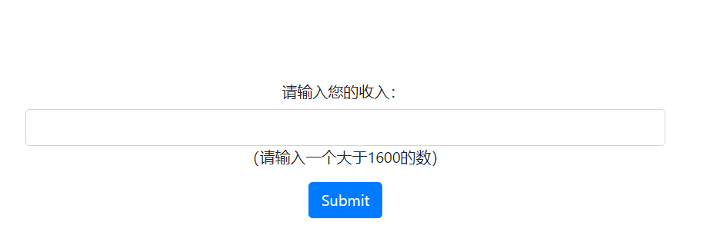



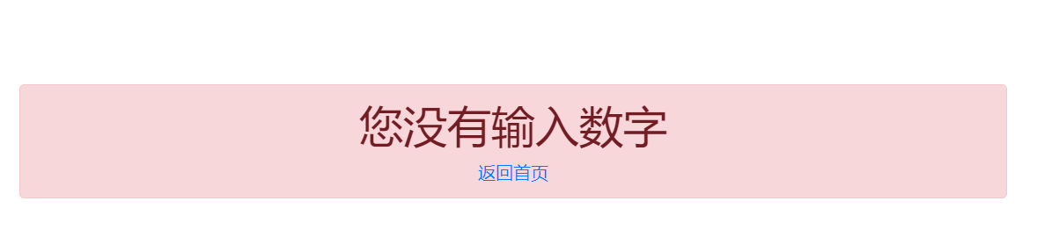

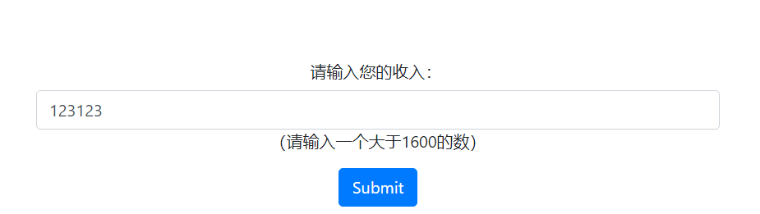



# 收获与问题