**Java Web开发**

**实验七**

**作业报告**

|  |  |
| --- | --- |
| 学 院 | 计算机 |
| 所在系 班 级 | 2017软件工程系八班 |
| 学 号 姓 名 | 04171622陈珂洁 |
| 指 导 教 师 | 郭晓燕 |
| 完 成 时 间 | 2018年4月30日 |

# 实验题目

1、页面输入收入，得到相应的缴纳税收

要求：Jsp提交收入，显示结果（可一个页面也可两个页面）。编写一个JavaBean计算税收，并在JSP页面输出结果

计算方法：全月应纳税所得额＝月收入－1600元

级数 全月应纳税所得额 税率% 速算扣除法(元)   
1 dr <=500 5 0

2 500 <dr<=3000 10 25

3 3000 < dr <=5000 15 125

4 5000 < dr <=20000 20 375

5 20,000 < dr <=40000 25 1375

6 40,000 < dr <=60,000 30 3375

7 60,000 < dr <=80,000 35 6375   
8 80,000 < dr <=100,000 40 10375   
9 dr >100,000元 45 15375

如：月收入3000，则（3000-1600）*10%-25=115，因为3000-1600大于500小于2000，所以按10%计算后再扣除速算的部分。

# 分析与设计

show.jsp显示工资输入文本框和应缴纳的税额，judge.java判断输入的文本内容是否为数字，将输入的工资进行计算，并把结果存储到session中，fail.jsp用来显示输入文本为非数字时进行提醒并给出跳转到show.jsp的超链接。calculate.jsp用来存储计算后的税额。

# 关键源码（部分）

show.jsp:

<%@ page language=*"java"* import=*"java.util.*"* pageEncoding=*"UTF-8"*%>

<%@ page import=*"test.vo.*"* %>

<html>

<%**if**(session.getAttribute("Tax")==**null**)

{

calculate tax=**new** calculate();

tax.setTax(0.00);

session.setAttribute("Tax", tax);

}

calculate tax1=(calculate)session.getAttribute("Tax");

%>

<body>

<form method=*"post"* action=*"judge.view"*>

工资：<input type=*"text"* name=*"money"*><br>

<input type=*"submit"* value=*"计算应缴纳的税额"*><br>

应缴纳税额：<%=tax1.getTax()%>

</form>

</body>

</html>

judge.java:

**package** test.controller;

**import** java.io.IOException;

**import** java.io.PrintWriter;

**import** test.vo.*;

**import** javax.servlet.ServletException;

**import** javax.servlet.http.HttpServlet;

**import** javax.servlet.http.HttpServletRequest;

**import** javax.servlet.http.HttpServletResponse;

**import** javax.servlet.http.HttpSession;

**public** **class** judge **extends** HttpServlet {

**public** **void** doGet(HttpServletRequest request, HttpServletResponse response)

**throws** ServletException, IOException {

doPost(request,response);

}

**public** **void** doPost(HttpServletRequest request, HttpServletResponse response)

**throws** ServletException, IOException {

response.setContentType("text/html");

PrintWriter out = response.getWriter();

HttpSession session=request.getSession();

calculate tax=(calculate)session.getAttribute("Tax");

String money1=request.getParameter("money");

**for**(**int** i=money1.length();--i>=0;)

{

**if**(!Character.*isDigit*(money1.charAt(i))){

response.sendRedirect("fail.jsp");

**return**;

}

}

**double** money=Double.*parseDouble*(request.getParameter("money"));

**double** dr=money-1600;

**if**(dr<0)

{

tax.setTax(0.00);

session.setAttribute("Tax", tax);

}

**if**(dr<=500)

{

tax.setTax(dr*0.05);

session.setAttribute("Tax", tax);

}

**if**(500<dr&&dr<=3000)

{

tax.setTax(dr*0.1-25);

session.setAttribute("Tax", tax);

}

**if**(3000<dr&&dr<=5000)

{

tax.setTax(dr*0.15-125);

session.setAttribute("Tax", tax);

}

**if**(5000<dr&&dr<=20000)

{

tax.setTax(dr*0.2-375);

session.setAttribute("Tax", tax);

}

**if**(20000<dr&&dr<=40000)

{

tax.setTax(dr*0.25-1375);

session.setAttribute("Tax", tax);

}

**if**(40000<dr&&dr<=60000)

{

tax.setTax(dr*0.3-3375);

session.setAttribute("Tax", tax);

}

**if**(60000<dr&&dr<=80000)

{

tax.setTax(dr*0.35-6375);

session.setAttribute("Tax", tax);

}

**if**(80000<dr&&dr<=100000)

{

tax.setTax(dr*0.4-10375);

session.setAttribute("Tax", tax);

}

**if**(dr>100000)

{

tax.setTax(dr*0.45-15375);

session.setAttribute("Tax", tax);

}

response.sendRedirect("show.jsp");

}

}

calculate.java:

**package** test.vo;

**import** javax.servlet.http.HttpSession;

**import** javax.servlet.http.HttpServletRequest;

**public** **class** calculate {

**private** **double** tax;

**public** calculate()

{

**this**.tax=tax;

}

**public** **double** getTax()

{

**return** tax;

}

**public** **void** setTax(**double** tax)

{

**this**.tax=tax;

}

}

fail.jsp:

<%@ page language=*"java"* import=*"java.util.*"* pageEncoding=*"UTF-8"*%>

<%

String path = request.getContextPath();

String basePath = request.getScheme()+"://"+request.getServerName()+":"+request.getServerPort()+path+"/";

%>

<!DOCTYPE HTML PUBLIC "-//W3C//DTD HTML 4.01 Transitional//EN">

<html>

<head>

</head>

<body>

输入格式不能为中文或字母<br>

<a href=*"show.jsp"*>回到首页</a>

</body>

</html>

# 运行效果图

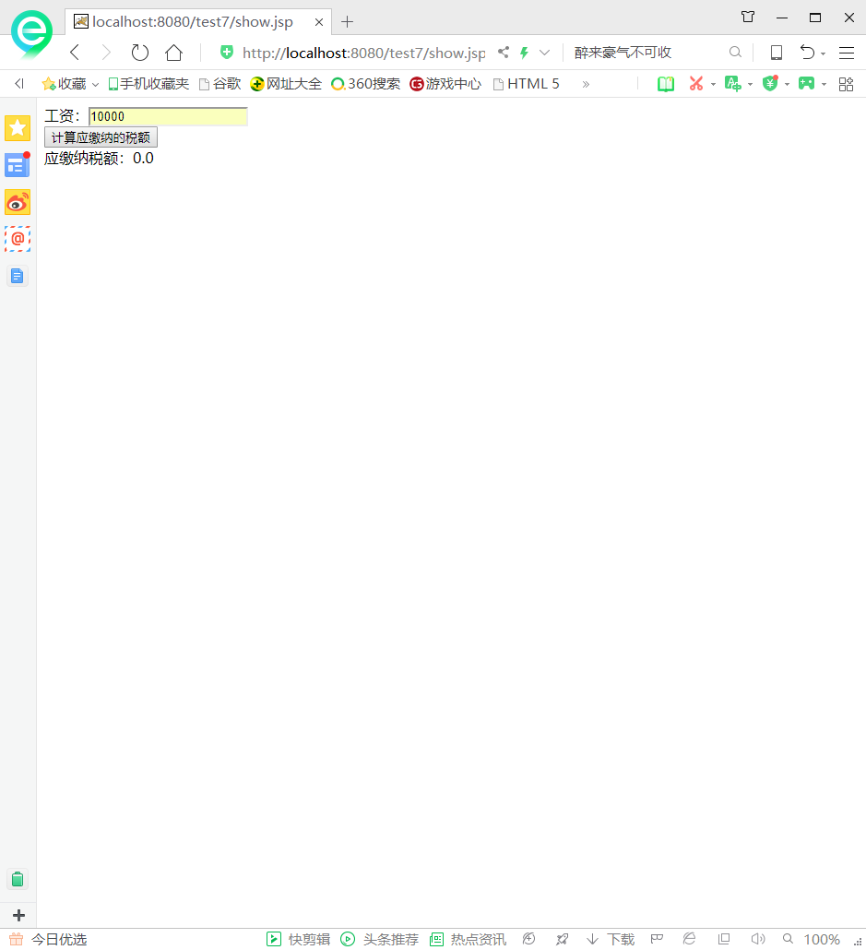

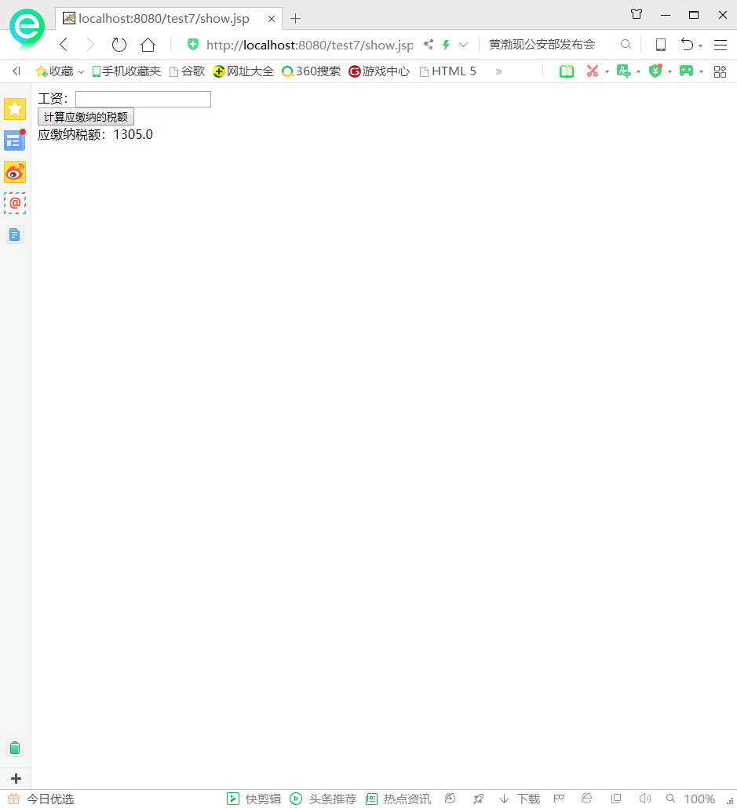

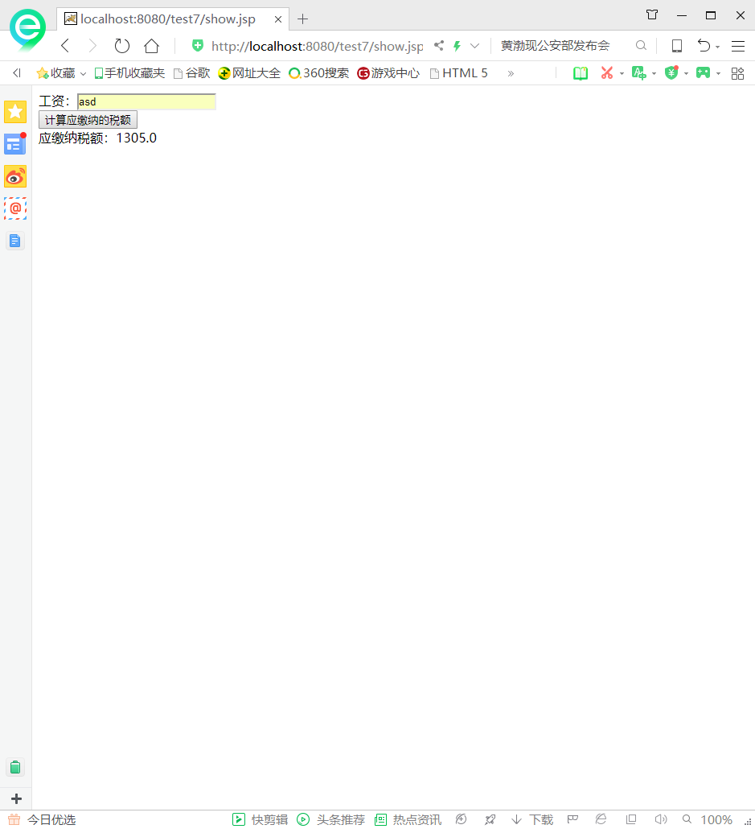

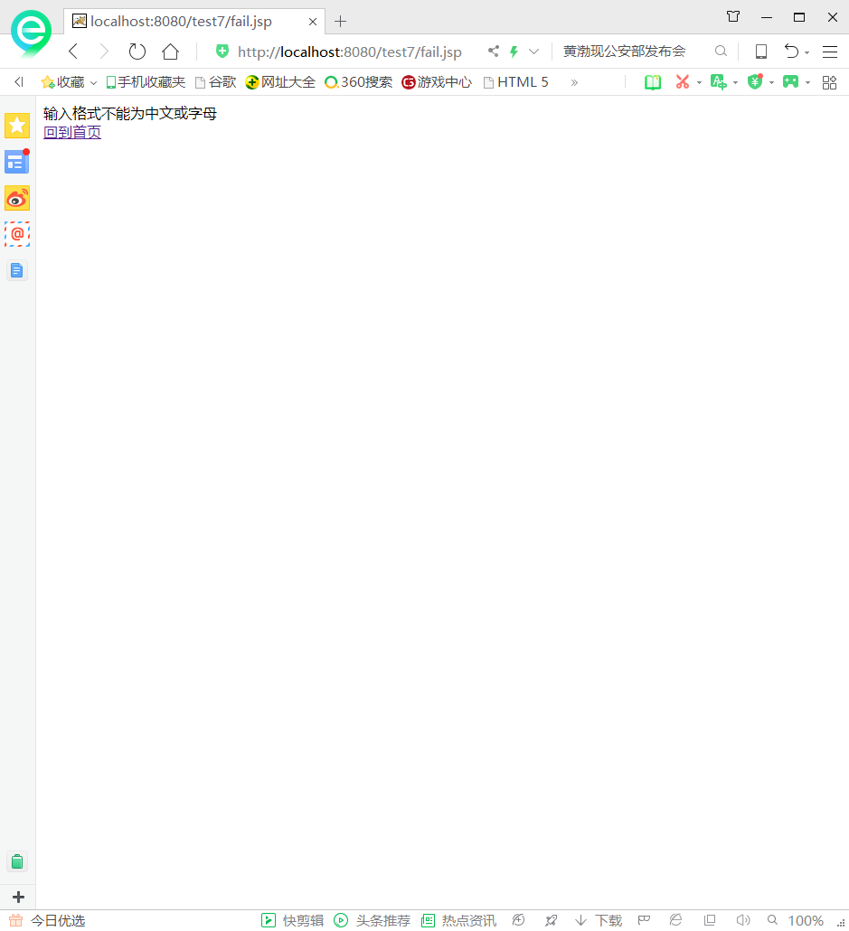

# 收获与问题