**Java Web开发**

**实验八**

**作业报告**

|  |  |
| --- | --- |
| 学 院 | 计算机 |
| 所在系 班 级 | 2017软件工程系5班 |
| 学 号 姓 名 | 04171305陈浩植 |
| 指 导 教 师 | 郭晓燕 |
| 完 成 时 间 | 2018年4月28号 |

1、（必做）请用模型2MVC模式完成1个功能，功能自选，例如：登录、注册、发帖、计算税收等；

# 分析与设计

用MVC模型2编写了税收功能。模型层，控制层，视图层写入相应代码。

# 关键源码（部分）

CartBean.java

**import** javax.servlet.http.HttpServlet;

**public** **class** CartBean **extends** HttpServlet {

**public** **double** Num;

**public** **double** sub;

**public** **double** result;

**public** **void** setNum(**double** Num){

**this**.Num=Num;

}

**public** **double** getNum() {

**return** Num;

}

**public** **double** getsub(){

sub=Num-1600.0;

**return** sub;

}

**public** **double** Result(**double** sub){

**if**(sub<0){

result=0;

}

**if**(sub>0&&sub<=500){

result=sub*0.05;

}

**if**(500<sub&&sub<=3000){

result=sub*0.1-25;

}

**if**(3000<sub&&sub<=5000){

result=sub*0.15-125;

}

**if**(5000<sub&&sub<=20000){

result=sub*0.2-375;

}

**if**(20000<sub&&sub<=40000){

result=sub*0.25-1375;

}

**if**(40000<sub&&sub<=60000){

result=sub*0.3-3375;

}

**if**(60000<sub&&sub<=80000){

result=sub*0.35-6375;

}

**if**(80000<sub&&sub<=10000){

result=sub*0.4-10375;

}

**if**(100000<sub){

result=sub*0.45-15375;

}

**return** result;

}

**public** **double** getnum(){

**return** Result(sub);

}

}

**Cart.java:public** **void** doGet(HttpServletRequest request, HttpServletResponse response)

**throws** ServletException, IOException {

response.setContentType("text/html;charset=utf-8");

PrintWriter out = response.getWriter();

CartBean cart=**new** CartBean();

cart.setNum(Integer.*parseInt*(request.getParameter("num")));//转为Int型

HttpSession session=request.getSession();

session.setAttribute("cart", cart);

request.getRequestDispatcher("result.jsp").forward(request,response);

}

import.jsp:

<body>

<form action=*"result.jsp"* method=*"get"*>

请输入你的收入：<input type=*"text"* name=*'num'*>

<input type=*'submit'* value=*'提交'*>

</form></body>

result.jsp:

<%@ page language=*"java"* import=*"java.util.*"* pageEncoding=*"utf-8"*%>

<%@page import=*"ww.CartBean"*%>

<%

String path = request.getContextPath();

String basePath = request.getScheme()+"://"+request.getServerName()+":"+request.getServerPort()+path+"/";

%>

<!DOCTYPE HTML PUBLIC "-//W3C//DTD HTML 4.01 Transitional//EN">

<html>

<head>

<base href=*"*<%=basePath%>*"*>

<title>My JSP 'result.jsp' starting page</title>

<meta http-equiv=*"pragma"* content=*"no-cache"*>

<meta http-equiv=*"cache-control"* content=*"no-cache"*>

<meta http-equiv=*"expires"* content=*"0"*>

<meta http-equiv=*"keywords"* content=*"keyword1,keyword2,keyword3"*>

<meta http-equiv=*"description"* content=*"This is my page"*>

<!--

<link rel="stylesheet" type="text/css" href="styles.css">

-->

</head>

<body>

<% CartBean cart=(CartBean)session.getAttribute("cart");

%>

<% cart.getsub();%>

您需缴纳的税收为:<%=cart.getnum() %><br>

<br><a href=*"import.jsp"*>返回查询</a>

</body>

</html>

# 运行效果图

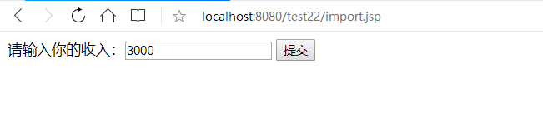

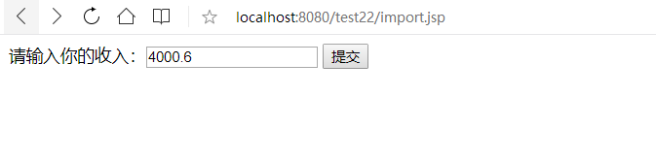

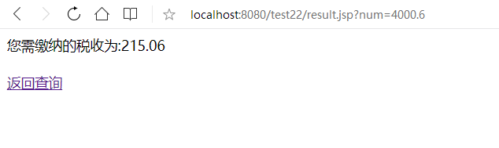

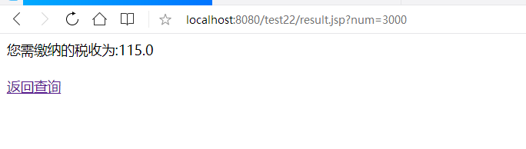

# 收获与问题

依然不太熟练于代码，需要继续努力。