**Java Web开发**

**实验八**

**作业报告**

|  |  |
| --- | --- |
| 学 院 | 计算机 |
| 所在系 班 级 | 2017软件工程系5班 |
| 学 号 姓 名 | 04171306叶铭浩 |
| 指 导 教 师 | 郭晓燕 |
| 完 成 时 间 | 2019年5月1日- |

# 实验题目

1、（必做）请用模型2MVC模式完成1个功能，功能自选，例如：登录、注册、发帖、计算税收等；

# 分析与设计

Jsp发送数据时，通过session的URL重定向交给Servlet处理，再将处理的数据发送给jsp，页面产生变化。

# 关键源码（部分）

1. login.jsp
2. <%@ **page import**="**java.lang.reflect.Parameter**" %>*<%--  
    Created by IntelliJ IDEA.  
    User: asus  
    Date: 2019/4/21  
    Time: 19:10  
    To change this template use File | Settings | File Templates.  
   --%>*<%@ **page contentType**="**text/html;charset=UTF-8**" **language**="**java**" %>  
   <**html**>  
   <**head**>  
    <**title**>登入</**title**>  
    <**meta charset="utf-8"**>  
    <**meta name="viewport" content="width=device-width, initial-scale=1"**>  
    <**link rel="stylesheet" href="https://cdn.staticfile.org/twitter-bootstrap/4.1.0/css/bootstrap.min.css"**>  
    <**script src="https://cdn.staticfile.org/jquery/3.2.1/jquery.min.js"**></**script**>  
    <**script src="https://cdn.staticfile.org/popper.js/1.12.5/umd/popper.min.js"**></**script**>  
    <**script src="https://cdn.staticfile.org/twitter-bootstrap/4.1.0/js/bootstrap.min.js"**></**script**>  
     
     
     
    <**style**>  
    .**row-center**{  
    **text-align**:**center**;  
    **margin-top**: 240**px**;  
    }  
     
    </**style**>  
     
     
   </**head**>  
   <**body**>  
    <**div class="container"**>  
    <**div class="row-center"** >  
    <**div class="col-md-4 offset-md-4"**>  
    <**form method="post" action="login.view"**>  
    <**h1 class="h3 mb-3 font-weight-normal"**>用户登入</**h1**>  
     
    <**label for="inputEmail" class="sr-only"**>邮箱</**label**>  
    <**input type="email" id="inputEmail" class="form-control" placeholder="Email address" required="" autofocus="" name='Email'**>  
     
    <**label for="inputPassword" class="sr-only"**>密码</**label**>  
    <**input type="password" id="inputPassword" class="form-control" placeholder="Password" required="" name='password'**>  
     
    **<% if**(request.getAttribute(**"loginError"**)!=**null**){ **%>** <**div class="alert alert-danger"**>  
    <**strong**>错误!</**strong**> **${**loginError**}** </**div**>  
    **<%** }  
    **%>** <**div class="checkbox mb-3"**>  
    <**label**>  
    <**input type="checkbox" value="remember-me"**> 记住我  
    </**label**>  
    </**div**>  
    <**button class="btn btn-lg btn-primary btn-block" type="submit"**>登入</**button**>  
    <**p class="mt-5 mb-3 text-muted"**>© 二狗子登入服务</**p**>  
    </**form**>  
    </**div**>  
    </**div**>  
    </**div**>  
     
   </**form**>  
   </**body**>  
   </**html**>

*2.loginServlet.java***package** com.exl_4;  
  
**import** javax.servlet.ServletException;  
**import** javax.servlet.annotation.WebServlet;  
**import** javax.servlet.http.HttpServlet;  
**import** javax.servlet.http.HttpServletRequest;  
**import** javax.servlet.http.HttpServletResponse;  
**import** java.io.IOException;  
  
*/**  
 \** ***@author*** *U12  
 \** ***@data*** *2019/4/21 - 22:07  
 */*@WebServlet(name = **"LoginServlet"**)  
**public class** LoginServlet **extends** HttpServlet {  
 **protected void** doPost(HttpServletRequest request, HttpServletResponse response) **throws** ServletException, IOException {  
 request.setCharacterEncoding(**"UTF-8"**);  
 response.setContentType(**"text/html;charset=UTF-8"**);  
  
 String email = request.getParameter(**"Email"**);  
 String pwd = request.getParameter(**"password"**);  
  
 String user = email;  
 String flag;  
 **if**(**"123456"**.equals(pwd)){  
 CardCar cardCar = **new** CardCar(user);  
 request.getSession().setAttribute(**"cardCar"**,cardCar);  
 request.getRequestDispatcher(**"shopping.jsp"**).forward(request,response);  
 } **else** {  
*// response.sendRedirect("login.jsp");* flag=**"密码错误"**;  
 request.setAttribute(**"loginError"**,flag);  
 request.getRequestDispatcher(**"login.jsp"**).forward(request,response);  
 }  
  
 }  
  
 **protected void** doGet(HttpServletRequest request, HttpServletResponse response) **throws** ServletException, IOException {  
  
 }  
}

6.web.xml

*<?***xml version="1.0" encoding="UTF-8"***?>*<**web-app xmlns="http://xmlns.jcp.org/xml/ns/javaee"  
 xmlns:xsi="http://www.w3.org/2001/XMLSchema-instance"  
 xsi:schemaLocation="http://xmlns.jcp.org/xml/ns/javaee http://xmlns.jcp.org/xml/ns/javaee/web-app_4_0.xsd"  
 version="4.0"**>  
 <**servlet**>  
 <**servlet-name**>shop</**servlet-name**>  
 <**servlet-class**>com.exl_4.ShoppingServlet</**servlet-class**>  
 <**load-on-startup**>1</**load-on-startup**>  
 </**servlet**>  
 <**servlet-mapping**>  
 <**servlet-name**>shop</**servlet-name**>  
 <**url-pattern**>/shopping.view</**url-pattern**>  
 </**servlet-mapping**>  
  
  
  
 <**servlet**>  
 <**servlet-name**>card</**servlet-name**>  
 <**servlet-class**>com.exl_4.CardServlet</**servlet-class**>  
 <**load-on-startup**>1</**load-on-startup**>  
 </**servlet**>  
 <**servlet-mapping**>  
 <**servlet-name**>card</**servlet-name**>  
 <**url-pattern**>/card.view</**url-pattern**>  
 </**servlet-mapping**>  
  
 <**servlet**>  
 <**servlet-name**>login</**servlet-name**>  
 <**servlet-class**>com.exl_4.LoginServlet</**servlet-class**>  
 <**load-on-startup**>1</**load-on-startup**>  
 </**servlet**>  
 <**servlet-mapping**>  
 <**servlet-name**>login</**servlet-name**>  
 <**url-pattern**>/login.view</**url-pattern**>  
 </**servlet-mapping**>  
</**web-app**>

# 运行效果图

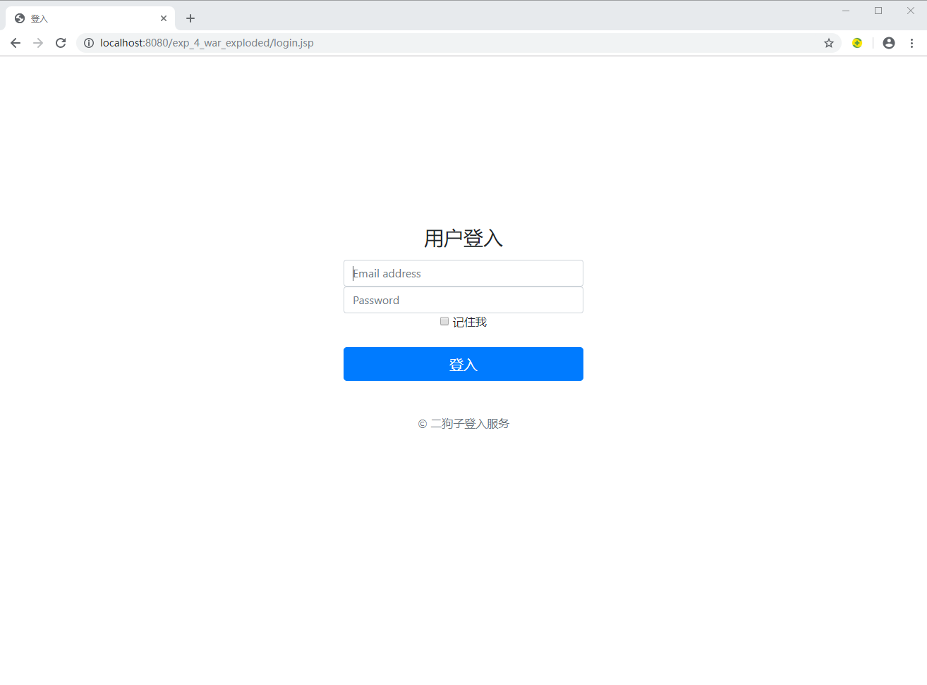

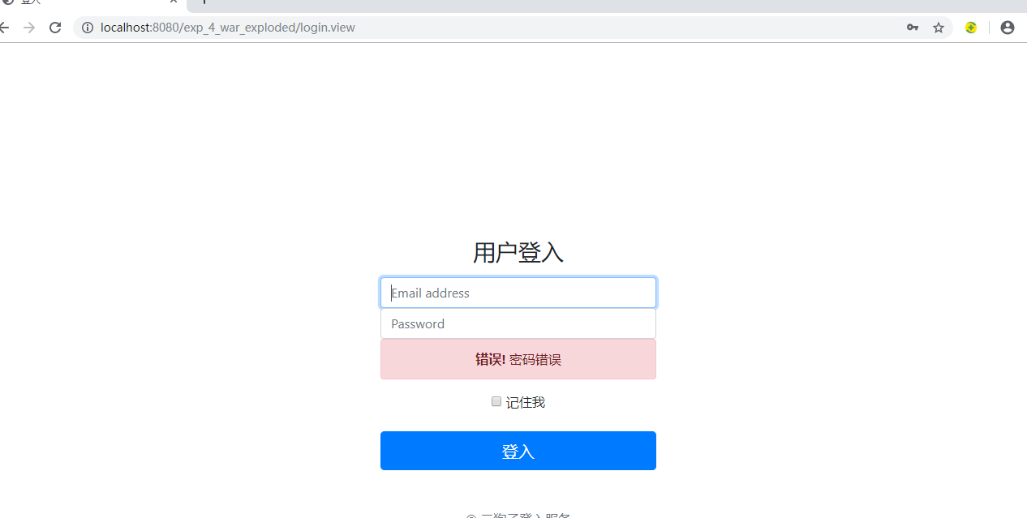

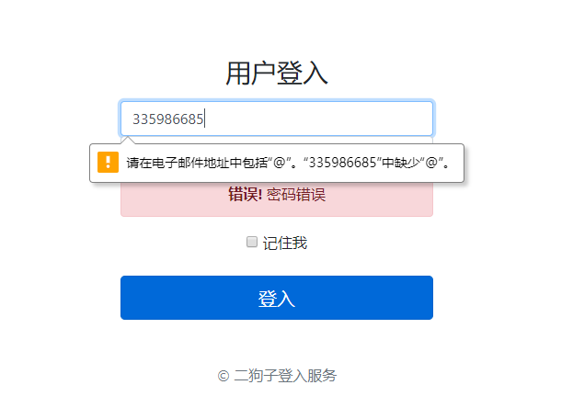

# 收获与问题

Mvc设计模式