**Java Web开发**

**实验八**

**作业报告**

|  |  |
| --- | --- |
| 学 院 | 计算机 |
| 所在系 班 级 | 2017软件工程系5班 |
| 学 号 姓 名 | 刘钊明 |
| 指 导 教 师 | 郭晓燕 |
| 完 成 时 间 | 2018年5月- |

# 实验题目

1、（必做）请用模型2MVC模式完成1个功能，功能自选，例如：登录、注册、发帖、计算税收等；

# 分析与设计

根据题目要求，计划设计几个文件来完成实验，每个文件的名字、作用。如果是类，要求写出类的变量和方法

# 关键源码（部分）

**package** shuishou;

**public** **class** car {

**private** **double** ys=0;

**private** **double** x;

**public** **double** cary(**double** x,**double** ys)

{

**if**(ys<0&&ys<1600)

{

x=0;

}

**if**(ys>=1600&&ys<=2100){

x = (ys-1600)*0.05;

}

**if**(ys>=2100&&ys<=4600){

x = (ys-1600)*0.10-25;

}

**if**(ys>=4600&&ys<=6600){

x = (ys-1600)*0.15-125;

}

**if**(ys>=6600&&ys<=41600){

x = (ys-1600)*0.20-3755;

}

**if**(ys>=41600&&ys<=61600){

x = (ys-1600)*0.25-1375;

}

**if**(ys>=61600&&ys<=81600){

x = (ys-1600)*0.30-3375;

}

**if**(ys>=81600&&ys<=101600){

x = (ys-1600)*0.35-6375;

}

**if**(ys>=101600){

x = (ys-1600)*0.45-15375;

}

**return** x;

}

**public** **double** la()

{

**return** cary(x,ys);

}

**public** **double** getYs() {

**return** ys;

}

**public** **void** setYs(**double** ys) {

**this**.ys = ys;

}

**public** **double** getX() {

**return** x;

}

**public** **void** setX(**double** x) {

**this**.x = x;

}

}

Shuishou：

package shuishou;

import java.io.IOException;

import java.io.PrintWriter;

import javax.servlet.ServletException;

import javax.servlet.annotation.WebServlet;

import javax.servlet.http.HttpServlet;

import javax.servlet.http.HttpServletRequest;

import javax.servlet.http.HttpServletResponse;

import javax.servlet.http.HttpSession;

@WebServlet(name="hello1",urlPatterns={"/hello1.view"})

public class shuishou extends HttpServlet {

/**

* The doGet method of the servlet. <br>

*

* This method is called when a form has its tag value method equals to get.

*

* @param request the request send by the client to the server

* @param response the response send by the server to the client

* @throws ServletException if an error occurred

* @throws IOException if an error occurred

*/

public void doGet(HttpServletRequest request, HttpServletResponse response)

throws ServletException, IOException {

response.setContentType("text/html");

PrintWriter out = response.getWriter();

out.println("<!DOCTYPE HTML PUBLIC \"-//W3C//DTD HTML 4.01 Transitional//EN\">");

out.println("<HTML>");

out.println(" <HEAD><TITLE>A Servlet</TITLE></HEAD>");

out.println(" <BODY>");

out.print(" This is ");

out.print(this.getClass());

out.println(", using the GET method");

out.println(" </BODY>");

out.println("</HTML>");

out.flush();

out.close();

}

/**

* The doPost method of the servlet. <br>

*

* This method is called when a form has its tag value method equals to post.

*

* @param request the request send by the client to the server

* @param response the response send by the server to the client

* @throws ServletException if an error occurred

* @throws IOException if an error occurred

*/

public void doPost(HttpServletRequest request, HttpServletResponse response)

throws ServletException, IOException {

HttpSession session=request.getSession();

request.setCharacterEncoding("utf-8");

response.setContentType("text/html;charset=utf-8");

PrintWriter out = response.getWriter();

double ys=Double.parseDouble(request.getParameter("ys"));

car c=new car();

c.setYs(ys);

request.setAttribute("c", c);

request.getRequestDispatcher("success.jsp").forward(request,response);

}

}

Shuishou。Jsp：

<%@ page language=*"java"* import=*"java.util.*"* pageEncoding=*"UTF-8"*%>

<%

String path = request.getContextPath();

String basePath = request.getScheme()+"://"+request.getServerName()+":"+request.getServerPort()+path+"/";

%>

<!DOCTYPE HTML PUBLIC "-//W3C//DTD HTML 4.01 Transitional//EN">

<html>

<head>

<base href=*"*<%=basePath%>*"*>

<title>My JSP 'Shuishou.jsp' starting page</title>

<meta http-equiv=*"pragma"* content=*"no-cache"*>

<meta http-equiv=*"cache-control"* content=*"no-cache"*>

<meta http-equiv=*"expires"* content=*"0"*>

<meta http-equiv=*"keywords"* content=*"keyword1,keyword2,keyword3"*>

<meta http-equiv=*"description"* content=*"This is my page"*>

<!--

<link rel="stylesheet" type="text/css" href="styles.css">

-->

</head>

<style type=*"text/css"*>

</style>

<body background=*"img/11.jpg"* >

<form action=*"hello1.view"* method=*'post'* action=*'hello1.view'*>

<h1 align=*"center"*>税收缴纳</h1>

<table align=*"center"*>

<tr align=*"center"*>

<td>请输入您的月收入:<input type=*'text'* name=*'ys'* size=*'25'* maxlength=*'16'*></td>

<td colspan=*"2"*><input type=*"submit"* value=*"提交"*/>

</td>

</tr>

</table>

</form>

</body>

</html>

Success。Jsp：

<%@ page language=*"java"* import=*"java.util.*"* pageEncoding=*"UTF-8"*%>

<%@ page import=*"shuishou.car"* %>

<%

String path = request.getContextPath();

String basePath = request.getScheme()+"://"+request.getServerName()+":"+request.getServerPort()+path+"/";

%>

<!DOCTYPE HTML PUBLIC "-//W3C//DTD HTML 4.01 Transitional//EN">

<html>

<head>

<title>My JSP 'success.jsp' starting page</title>

</head>

<%car c=(car)request.getAttribute("c"); %>

<style type=*"text/css"*>

</style>

<body background=*"img/11.jpg"* >

<a href=*"Shuishou.jsp"*>回到首页,继续计算</a>

<br>

由计算得您应纳税为:<%=c.la()%>

</html>

# 运行效果图

。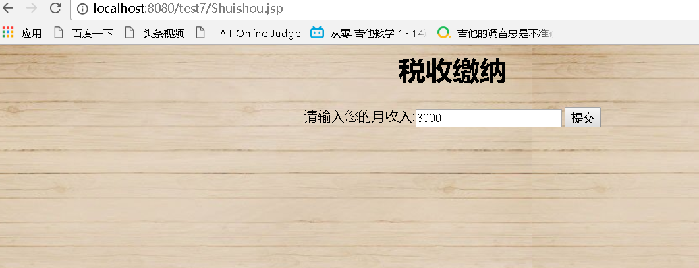

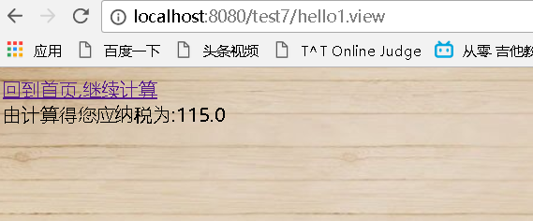

# 收获与问题

Mvc模式很好用，很方便。