**Java Web开发**

**实验八**

**作业报告**

|  |  |
| --- | --- |
| 学 院 | 计算机 |
| 所在系 班 级 | 2017软件工程系14班 |
| 学 号 姓 名 | 04171327 |
| 指 导 教 师 | 罗永生 |
| 完 成 时 间 | 2019年5月- |

# 实验题目

一）必做。

1、页面输入收入，得到相应的缴纳税收

要求：Jsp提交收入，显示结果（可一个页面也可两个页面）。编写一个JavaBean计算税收，并在JSP页面输出结果

计算方法：全月应纳税所得额＝月收入－1600元

级数 全月应纳税所得额 税率% 速算扣除法(元)   
1 dr <=500 5 0

2 500 <dr<=3000 10 25

3 3000 < dr <=5000 15 125

4 5000 < dr <=20000 20 375

5 20,000 < dr <=40000 25 1375

6 40,000 < dr <=60,000 30 3375

7 60,000 < dr <=80,000 35 6375   
8 80,000 < dr <=100,000 40 10375   
9 dr >100,000元 45 15375

如：月收入3000，则（3000-1600）*10%-25=115，因为3000-1600大于500小于2000，所以按10%计算后再扣除速算的部分。

# 关键源码（部分）

1

—————————————————————————————

**package** hdh;

**public** **class** Ffd {

**private** **float** S;

**private** **float** dr;

**private** **float** tax=0;

**public** **float** C(**float** S){

dr = S-1600;

/*

dr <=500 5 0

500 <dr<=3000 10 25

3000 < dr <=5000 15 125

5000 < dr <=20000 20 375

20,000 < dr <=40000 25 1375

40,000 < dr <=60,000 30 3375

60,000 < dr <=80,000 35 6375

80,000 < dr <=100,000 40 10375

dr >100,000元 45 15375

* **/

**if**(dr<=500){

tax = (**float**) (dr*0.05);

}**else** **if**(dr>500&&dr<=3000){

tax = (**float**) ((dr*0.1)-25);

}**else** **if**(dr>3000&&dr<=5000){

tax = (**float**) ((dr*0.15)-125);

}**else** **if**(dr>5000&&dr<=20000){

tax = (**float**) ((dr*0.2)-375);

}**else** **if**(dr>20000&&dr<=40000){

tax = (**float**) ((dr*0.25)-1375);

}**else** **if**(dr>40000&&dr<=60000){

tax = (**float**) ((dr*0.3)-3375);

}**else** **if**(dr>60000&&dr<=80000){

tax = (**float**) ((dr*0.35)-6375);

}**else** **if**(dr>80000&&dr<=100000){

tax = (**float**) ((dr*0.4)-10375);

}**else** **if**(dr>100000){

tax = (**float**) ((dr*0.45)-15375);

}

**return** tax;

}

}

2

<%@ page language=*"java"* import=*"java.util.*"* pageEncoding=*"UTF-8"* %>

<%

String path = request.getContextPath();

String basePath = request.getScheme()+"://"+request.getServerName()+":"+request.getServerPort()+path+"/";

%>

<!DOCTYPE HTML PUBLIC "-//W3C//DTD HTML 4.01 Transitional//EN">

<html>

<head>

<base href=*"*<%=basePath%>*"*>

<title>My JSP 'Enter.jsp' starting page</title>

<meta http-equiv=*"pragma"* content=*"no-cache"*>

<meta http-equiv=*"cache-control"* content=*"no-cache"*>

<meta http-equiv=*"expires"* content=*"0"*>

<meta http-equiv=*"keywords"* content=*"keyword1,keyword2,keyword3"*>

<meta http-equiv=*"description"* content=*"This is my page"*>

<!--

<link rel="stylesheet" type="text/css" href="styles.css">

-->

</head>

<body>

<form action=*"out.jsp"*>

<p>请输入你的月工资:<input type=*"text"* name=*"Salary"* > </p ><br>

<input type=*"submit"* value=*"提交"*>

</form>

</body>

</html>

3

<%@ page language=*"java"* import=*"java.util.*"* pageEncoding=*"UTF-8"* import=*"hdh.Ffd.*"*%>

<%@page import=*"hdh.Ffd"* %>

<%

String path = request.getContextPath();

String basePath = request.getScheme()+"://"+request.getServerName()+":"+request.getServerPort()+path+"/";

%>

<!DOCTYPE HTML PUBLIC "-//W3C//DTD HTML 4.01 Transitional//EN">

<html>

<head>

<base href=*"*<%=basePath%>*"*>

<title>My JSP 'out.jsp' starting page</title>

<meta http-equiv=*"pragma"* content=*"no-cache"*>

<meta http-equiv=*"cache-control"* content=*"no-cache"*>

<meta http-equiv=*"expires"* content=*"0"*>

<meta http-equiv=*"keywords"* content=*"keyword1,keyword2,keyword3"*>

<meta http-equiv=*"description"* content=*"This is my page"*>

<!--

<link rel="stylesheet" type="text/css" href="styles.css">

-->

</head>

<%

String salary = request.getParameter("Salary");

**float** s = Float.parseFloat(salary);

Ffd count = **new** Ffd();

**float** tax = count.C(s);

%>

<body>

<p>

你的月缴纳税额为：<%out.println(tax);%>

</p >

</body>

</html>

# 运行效果图

1

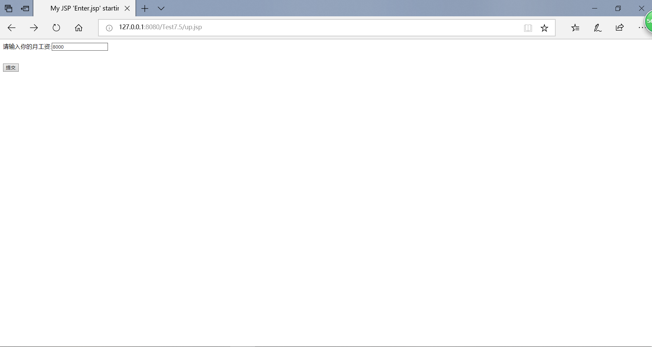

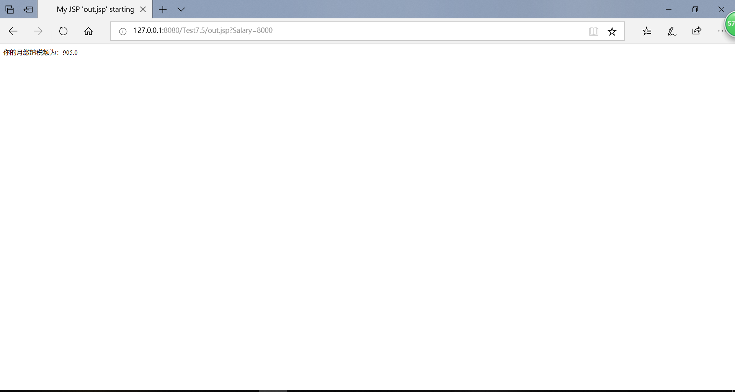

# 收获与问题

。