**Java Web开发**

**实验八**

**作业报告**

|  |  |
| --- | --- |
| 学 院 | 计算机 |
| 所在系 班 级 | 2017软件工程系06班 |
| 学 号 姓 名 | 04171417刘泽峰 |
| 指 导 教 师 | 罗永升 |
| 完 成 时 间 | 2018年5月5日 |

# 实验题目

1、（必做）请用模型2MVC模式完成1个功能，功能自选，例如：登录、注册、发帖、计算税收等；

# 分析与设计

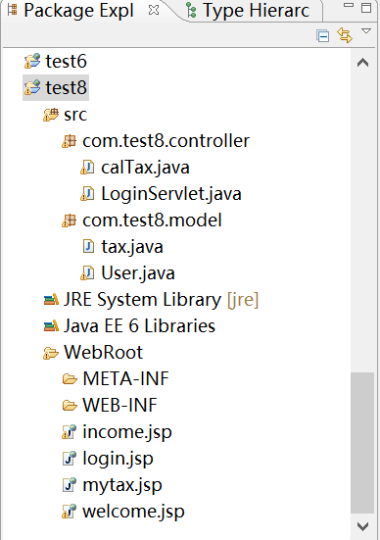

计算税收

model层：tax.java（JavaBean类）

view层：income.jsp：输入页面；mytax.jsp：输出页面

controller层：calTax.Java（servlet类，调用tax.java中的方法）

登录

model层：User.java

view层：login.jsp：登录页面；welcome.jsp：成功页面

controller层：LoginServlet.Java

# 关键源码（部分）

计算税收

tax.java

**package** com.test8.model;

**public** **class** tax {

**private** **double** income;

**private** **double** tax;

**public** tax(){

income=0;

tax=0;

}

**public** **double** getIncome() {

**return** income;

}

**public** **void** setIncome(**double** income) {

**this**.income = income;

}

**public** **double** getTax(**double** income) {

**return** cal_tax(income);

}

**public** **void** setTax(**double** tax) {

**this**.tax = tax;

}

**public** **double** cal_tax(**double** income){

**double** dr=income-1600;

**if**(dr<=500){

tax=(dr)*0.05;

}

**if**(dr>500 && dr<=3000){

tax=(dr*0.1)-25;

}

**if**(dr>3000 && dr<=5000){

tax=(dr*0.15)-125;

}

**if**(dr>5000 && dr<=20000){

tax=(dr*0.2)-375;

}

**if**(dr>20000 && dr<=40000){

tax=(dr*0.25)-1375;

}

**if**(dr>40000 && dr<=60000){

tax=(dr*0.3)-3375;

}

**if**(dr>60000 && dr<=80000){

tax=(dr*0.35)-6375;

}

**if**(dr>80000 && dr<=100000){

tax=(dr*0.40)-10375;

}

**if**(dr>100000){

tax=(dr*0.45)-15375;

}

**return** tax;

}

}

income.jsp

<%@ page language=*"java"* import=*"java.util.*"* pageEncoding=*"UTF-8"*%>

<%

String path = request.getContextPath();

String basePath = request.getScheme()+"://"+request.getServerName()+":"+request.getServerPort()+path+"/";

%>

<!DOCTYPE HTML PUBLIC "-//W3C//DTD HTML 4.01 Transitional//EN">

<html>

<head>

<title>收入</title>

</head>

<body>

<table>

<FORM action=*"tax.do"* method=*post* name=*form*>

<tr>

<td>收入:</td>

<td><INPUT type=*"text"* name=*"income"*>

</td>

<td><INPUT TYPE=*"submit"* value=*"确定"* name=*"submit"*>

</td>

</tr>

</table>

<br>

</body>

</html>

mytax.jsp

<%@ page language=*"java"* import=*"java.util.*"* pageEncoding=*"UTF-8"*%>

<%

String path = request.getContextPath();

String basePath = request.getScheme()+"://"+request.getServerName()+":"+request.getServerPort()+path+"/";

%>

<!DOCTYPE HTML PUBLIC "-//W3C//DTD HTML 4.01 Transitional//EN">

<html>

<head>

<title>税收</title>

</head>

<body>

<table>

<tr>

<td>收入：${sessionScope.myincome}</td>

</tr>

<tr>

<td>应缴税：${mytax}</td>

</tr>

</table>

</body>

</html>

calTax.java

**package com.test8.controller;**

**import java.io.IOException;**

**import java.io.PrintWriter;**

**import javax.servlet.ServletException;**

**import javax.servlet.annotation.WebServlet;**

**import javax.servlet.http.HttpServlet;**

**import javax.servlet.http.HttpServletRequest;**

**import javax.servlet.http.HttpServletResponse;**

**import javax.servlet.http.HttpSession;**

**import com.test8.model.tax;**

**@WebServlet("/tax.do")**

**public class calTax extends HttpServlet {**

**public void doGet(HttpServletRequest request, HttpServletResponse response)**

**throws ServletException, IOException {**

**doPost(request,response);**

**}**

**public void doPost(HttpServletRequest request, HttpServletResponse response)**

**throws ServletException, IOException {**

**request.setCharacterEncoding("utf-8");**

**HttpSession session=request.getSession();**

**double income=Double.parseDouble(request.getParameter("income"));**

**tax tt=new tax();**

**tt.setIncome(income);**

**session.setAttribute("myincome", income);**

**session.setAttribute("mytax", tt.getTax(income));**

**response.sendRedirect("mytax.jsp");**

**}**

**}**

**登录功能**

**User.java**

**package** com.test8.model;

**public** **class** User{

**private** String name;

**private** String pwd;

**public** User() {

**super**();

}

**public** User(String name, String pwd) {

**super**();

**this**.name = name;

**this**.pwd = pwd;

}

**public** String getName() {

**return** name;

}

**public** **void** setName(String name) {

**this**.name = name;

}

**public** String getPwd() {

**return** pwd;

}

**public** **void** setPwd(String pwd) {

**this**.pwd = pwd;

}

@Override

**public** String toString() {

**return** "User [name=" + name + ", pwd=" + pwd + "]";

}

**public** Boolean selectone(String uname,String upwd){

**if**(uname.equals("张三")&&upwd.equals("123456")){

**return** **true**;

}

**else** **return** **false**;

}

}

**Login.jsp**

<%@ page language=*"java"* import=*"java.util.*"* pageEncoding=*"utf-8"*%>

<%

String path = request.getContextPath();

String basePath = request.getScheme()+"://"+request.getServerName()+":"+request.getServerPort()+path+"/";

%>

<%@ taglib prefix=*"c"* uri=*"http://java.sun.com/jsp/jstl/core"*%>

<!DOCTYPE HTML PUBLIC "-//W3C//DTD HTML 4.01 Transitional//EN">

<html>

<base href=*"*<%=basePath%>*"*>

<head>

<title>登录</title>

</head>

<body>

<h2>用 户 登 录</h2>

<form action=*"login.do"* method=*"post"*>

<table>

<tr>

<td>用户名:</td>

<td><INPUT type=*"text"* name=*"uname"*></td>

</tr>

<tr>

<td>密码:</td>

<td><INPUT type=*"password"* name=*"pwd"*></td>

</tr>

<tr>

<td><INPUT TYPE=*"submit"* value=*"登录"* name=*"submit"*></td>

<td><INPUT TYPE=*"reset"* value=*"取消"* name=*"reset"*></td>

</tr>

</table>

</form>

<script type=*"text/javascript"* language=*"javascript"*>

<c:**if** test="${not empty error}">

alert("${error}");

</c:**if**>

</script>

</body>

</html>

**Welcome.jsp**

<%@ page language=*"java"* import=*"java.util.*"* pageEncoding=*"utf-8"*%>

<% request.setCharacterEncoding("utf-8");%>

<!DOCTYPE HTML PUBLIC "-//W3C//DTD HTML 4.01 Transitional//EN">

<html>

<head>

<title>登陆成功</title>

</head>

<body>

<P>登陆成功!</P>

<h5>欢迎您！</h5>

<p>用户名：${uname}</p>

</body>

</html>

**LoginServlet.java**

**package** com.test8.controller;

**import** java.io.IOException;

**import** javax.servlet.ServletException;

**import** javax.servlet.annotation.WebServlet;

**import** javax.servlet.http.HttpServlet;

**import** javax.servlet.http.HttpServletRequest;

**import** javax.servlet.http.HttpServletResponse;

**import** javax.servlet.http.HttpSession;

**import** com.test8.model.User;

@WebServlet("/login.do")

**public** **class** LoginServlet **extends** HttpServlet {

**public** **void** doGet(HttpServletRequest request, HttpServletResponse response)

**throws** ServletException, IOException {

doPost(request, response);

}

**public** **void** doPost(HttpServletRequest request, HttpServletResponse response)

**throws** ServletException, IOException {

//设置编码

request.setCharacterEncoding("utf-8");

response.setCharacterEncoding("utf-8");

response.setContentType("text/html;charset=utf-8");

//接收前台数据

String uname = request.getParameter("uname");

String pwd = request.getParameter("pwd");

HttpSession session=request.getSession();

//调用model层

User u=**new** User();

**if**(u.selectone(uname, pwd)==**true**){

session.setAttribute("uname", uname);

request.getRequestDispatcher("/welcome.jsp").forward(request, response);

}**else**{

request.setAttribute("error", "用户名或密码错误，请重新输入");

request.getRequestDispatcher("/login.jsp").forward(request, response);

}

}

}

# 运行效果图

**计算税收**

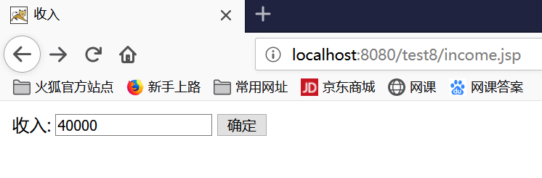

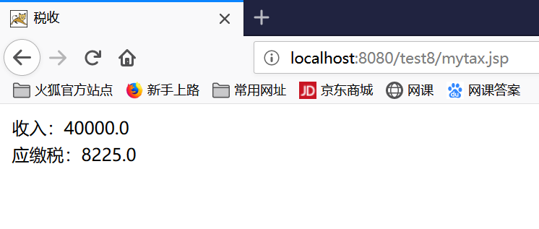

**登录**

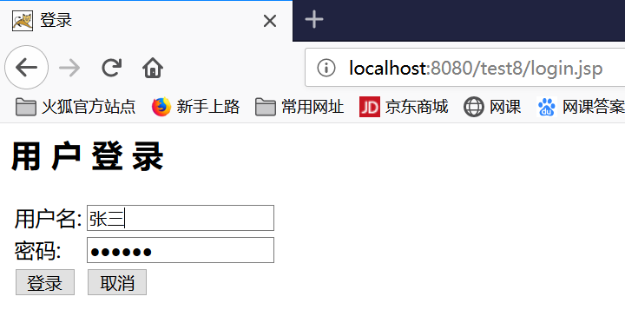

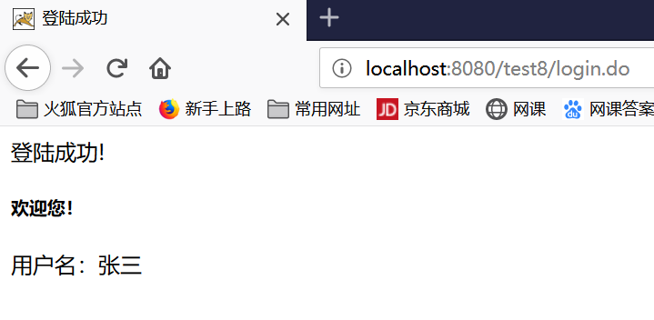

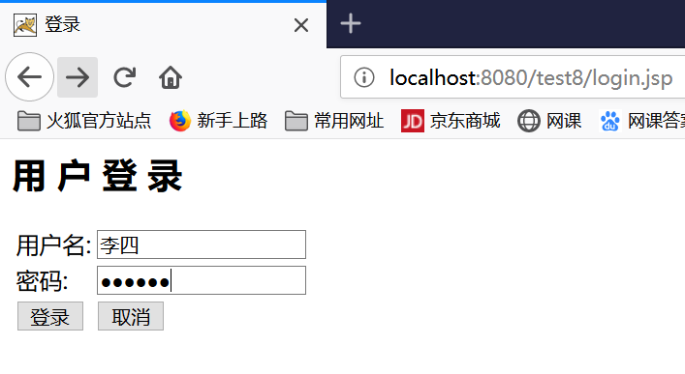

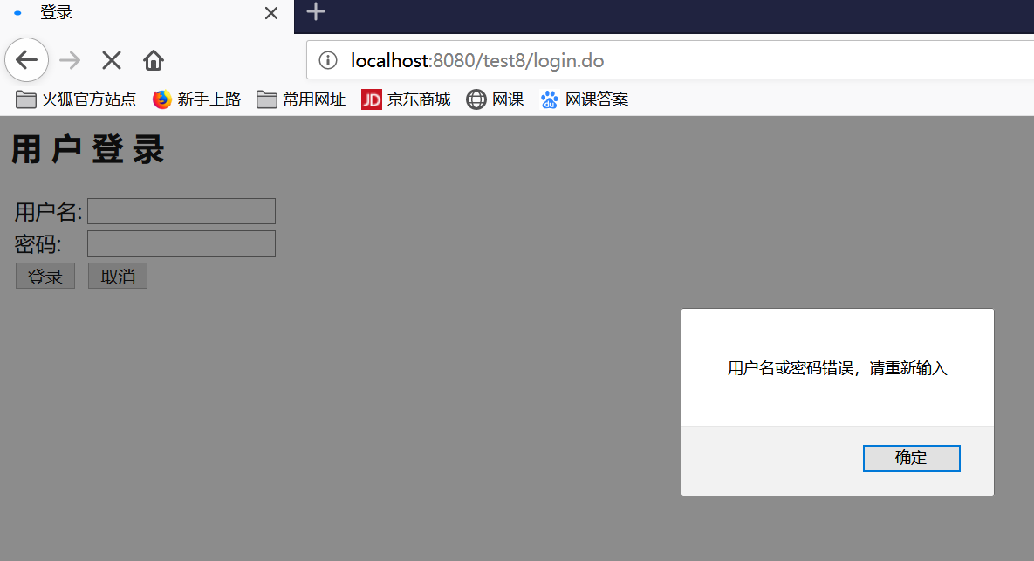

# 收获与问题

理解MVC模式的基本思想；

熟练掌握MVC模式的编程