**Java Web开发**

**实验八**

**作业报告**

|  |  |
| --- | --- |
| 学 院 | 计算机 |
| 所在系 班 级 | 2017软件工程系06班 |
| 学 号 姓 名 | 04171422 蔡文强 |
| 指 导 教 师 | 罗永升 |
| 完 成 时 间 | 2018年5月5日 |

# 实验题目

1、（必做）请用模型2MVC模式完成1个功能，功能自选，例如：登录、注册、发帖、计算税收等；

# 分析与设计

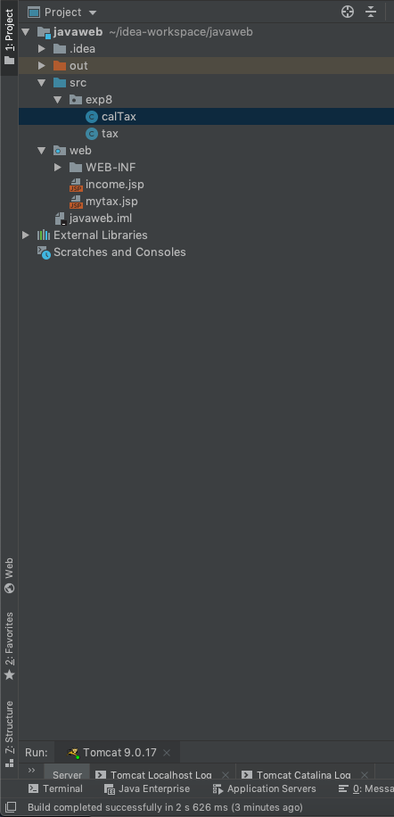

计算税收

model层：tax.java

view层：income.jsp：输入页面；mytax.jsp：输出页面

controller层：calTax.Java（servlet类，调用tax.java中的方法）

# 关键源码（部分）

计算税收

tax.java

package exp8;  
  
public class tax {  
  
 private double income=0;  
 private double tax=0;  
   
 public void setIncome(double income) {  
 this.income = income;  
 }  
 public double getTax(double income) {  
 return cal_tax(income);  
 }  
 public double cal_tax(double income){  
 double dr=income-1600;  
 if(dr<=500){  
 tax=(dr)*0.05;  
 }  
 if(dr>500 && dr<=3000){  
 tax=(dr*0.1)-25;  
 }  
 if(dr>3000 && dr<=5000){  
 tax=(dr*0.15)-125;  
 }  
 if(dr>5000 && dr<=20000){  
 tax=(dr*0.2)-375;  
 }  
 if(dr>20000 && dr<=40000){  
 tax=(dr*0.25)-1375;  
 }  
 if(dr>40000 && dr<=60000){  
 tax=(dr*0.3)-3375;  
 }  
 if(dr>60000 && dr<=80000){  
 tax=(dr*0.35)-6375;  
 }  
 if(dr>80000 && dr<=100000){  
 tax=(dr*0.40)-10375;  
 }  
 if(dr>100000){  
 tax=(dr*0.45)-15375;  
 }  
 return tax;  
 }  
}

income.jsp

<%@ **page** language="java" import="java.util.*" pageEncoding="UTF-8"%>  
  
<!DOCTYPE HTML PUBLIC "-//W3C//DTD HTML 4.01 Transitional//EN">  
<html>  
<head>  
 <title>收入</title>  
</head>  
  
<body>  
<table>  
 <FORM action="tax.do" method=post name=form>  
 <tr>  
 <td>收入:<INPUT type="text" name="income"></td>  
 <td><INPUT TYPE="submit" value="确定" name="submit"></td>  
 </tr>  
 </FORM>  
</table>  
</body>  
</html>

mytax.jsp

<%@ **page** language="java" import="java.util.*" pageEncoding="UTF-8"%>  
  
  
<!DOCTYPE HTML PUBLIC "-//W3C//DTD HTML 4.01 Transitional//EN">  
<html>  
<head>  
 <title>税收</title>  
</head>  
<body>  
<table>  
 <tr>  
 <td>收入：${sessionScope.myincome}</td>  
 </tr>  
 <tr>  
 <td>应缴税：${mytax}</td>  
 </tr>  
</table>  
</body>  
</html>

calTax.java

package exp8;  
  
  
import java.io.IOException;  
import javax.servlet.ServletException;  
import javax.servlet.annotation.WebServlet;  
import javax.servlet.http.HttpServlet;  
import javax.servlet.http.HttpServletRequest;  
import javax.servlet.http.HttpServletResponse;  
import javax.servlet.http.HttpSession;  
  
@WebServlet("/tax.do")  
public class calTax extends HttpServlet {  
  
 public void doGet(HttpServletRequest request, HttpServletResponse response)  
 throws ServletException, IOException {  
 doPost(request,response);  
 }  
  
 public void doPost(HttpServletRequest request, HttpServletResponse response)  
 throws ServletException, IOException {  
 request.setCharacterEncoding("utf-8");  
 HttpSession session=request.getSession();  
 double income=Double.*parseDouble*(request.getParameter("income"));  
 tax tt=new tax();  
 tt.setIncome(income);  
 session.setAttribute("myincome", income);  
 session.setAttribute("mytax", tt.getTax(income));  
 response.sendRedirect("mytax.jsp");  
 }  
  
}

# 运行效果图

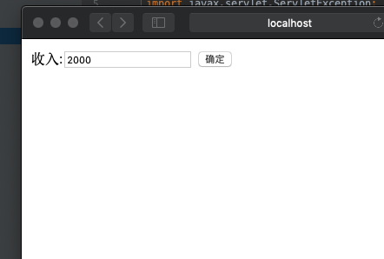

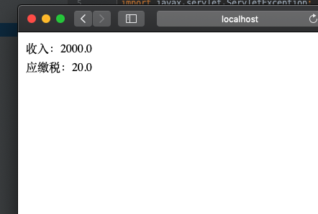

# 收获与问题

理解MVC模式的基本思想；

熟练掌握MVC模式的编程