**Java Web开发**

**实验八**

**作业报告**

|  |  |
| --- | --- |
| 学 院 | 计算机 |
| 所在系 班 级 | 2017软件工程系15班 |
| 学 号 姓 名 | 04171429赵美雯 |
| 指 导 教 师 | 郭晓燕 |
| 完 成 时 间 | 2019年5月13日 |

# 实验题目

请用模型2MVC模式完成1个功能，我选择的是计算税收。

1. **分析与设计**

有两个jsp文件，一个javabean文件,一个servlet文件，一个show.jsp、另一个是input.jsp。

MVC模式一个model层（revenue.java），两个view(input.jsp,show.jsp)，一个control(salary_servlet)

# 三、关键源码（部分）

**package project7;**

**import java.io.IOException;**

**import java.io.PrintWriter;**

**import javax.servlet.ServletException;**

**import javax.servlet.http.HttpServlet;**

**import javax.servlet.http.HttpServletRequest;**

**import javax.servlet.http.HttpServletResponse;**

**import javax.servlet.http.HttpSession;**

**public class salary_servlet extends HttpServlet {**

**/\*\***

**\* Constructor of the object.**

**\*/**

**public salary_servlet() {**

**super();**

**}**

**public void doGet(HttpServletRequest request, HttpServletResponse response)**

**throws ServletException, IOException {**

**response.setContentType("text/html");**

**doPost(request, response);**

**}**

**/\*\***

**\* The doPost method of the servlet. <br>**

**\***

**\* This method is called when a form has its tag value method equals to post.**

**\***

**\* @param request the request send by the client to the server**

**\* @param response the response send by the server to the client**

**\* @throws ServletException if an error occurred**

**\* @throws IOException if an error occurred**

**\*/**

**public void doPost(HttpServletRequest request, HttpServletResponse response)**

**throws ServletException, IOException {**

**response .setContentType("text/html;charset=utf-8");**

**HttpSession session =request .getSession() ;**

**request.setCharacterEncoding("utf-8") ;**

**double Salary=Double.valueOf(request.getParameter("income"));**

**PrintWriter out=response.getWriter();**

**revenue counts=new revenue();**

**if(Salary>0){**

**request.setAttribute("Salary",Salary);**

**double count=counts.count(Salary);**

**session.setAttribute("count",count);**

**request.getRequestDispatcher("input.jsp").forward(request, response);**

**}**

**else{**

**request.getRequestDispatcher("show.jsp").forward(request, response);**

**out.println("输入的值为空");**

**}**

**}**

}

**package** project7;

**public** **class** revenue {

**private** **double** income;//收入

**public** **double** getIncome() {

**return** income;

}

**public** **void** setIncome(**double** income) {

**this**.income = income;

}

**public** revenue(){

}

**public** **double** count(**double** salary){

**int** dr;//应纳税所得额

**double** tax_rate=0.0;//税率

dr=(**int**) (salary-1600);

**if**(0<dr&&dr<=500){

tax_rate=dr*0.05;

}

**if**(500<dr&&dr<=3000){

tax_rate=dr*0.1-25;

}

**if**(3000<dr&&dr<=5000){

tax_rate=dr*0.15-125;

}

**if**(5000<dr&&dr<=20000){

tax_rate=dr*0.2-375;

}

**if**(20000<dr&&dr<=40000){

tax_rate=dr*0.25-1375;

}

**if**(40000<dr&&dr<=60000){

tax_rate=dr*0.3-3375;

}

**if**(60000<dr&&dr<=80000){

tax_rate=dr*0.35-6375;

}

**if**(80000<dr&&dr<=100000){

tax_rate=dr*0.4-10375;

}

**if**(dr>100000)

{

tax_rate=dr*0.45-15375;

}

**return** tax_rate;

}

<%@ page language=*"java"* import=*"java.util.*"* pageEncoding=*"UTF-8"*%>

<%

String path = request.getContextPath();

String basePath = request.getScheme()+"://"+request.getServerName()+":"+request.getServerPort()+path+"/";

%>

<!DOCTYPE HTML PUBLIC "-//W3C//DTD HTML 4.01 Transitional//EN">

<html>

<head>

<base href=*"*<%=basePath%>*"*>

<title>收入</title>

</head>

<body>

<form action=*"show.jsp "* method=*"post"*>

您的收入:<input type=*"text"* name=*"income"*>

<input type=*"submit"* value=*"提交"*>

</form> <br>

</body>

</html>

<%@ page language=*"java"* import=*"java.util.*"* pageEncoding=*"UTF-8"*%>

<%

String path = request.getContextPath();

String basePath = request.getScheme()+"://"+request.getServerName()+":"+request.getServerPort()+path+"/";

%>

<!DOCTYPE HTML PUBLIC "-//W3C//DTD HTML 4.01 Transitional//EN">

<jsp:useBean id=*"person"* class=*"project7.revenue"* scope=*"session"*/>

<jsp:setProperty name=*"person"* property=*"income"* param=*"income"*/>

<%**int** income=(**int**)person.getIncome();%>

<html>

<head>

<base href=*"*<%=basePath%>*"*>

<title>缴税金额</title>

</head>

<body>

<h1>您的收入是:<%=person.getIncome()%></h1><br>

<h1>您需要交的税是:<%=person.count(income)%></h1>

</body>

</html>

# 运行效果图

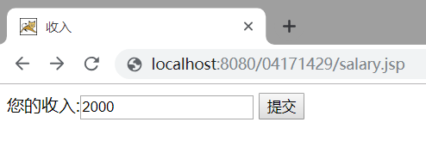

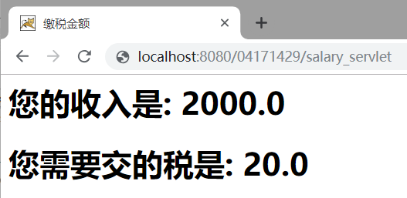

# 五、收获与问题

在control调用Javabean，在jsp中输出