**Java Web开发**

**实验八**

**作业报告**

|  |  |
| --- | --- |
| 学 院 | 计算机 |
| 所在系 班 级 | 2017软件工程系08班 |
| 学 号 姓 名 | 04171603鲍稚明 |
| 指 导 教 师 | 郭晓燕 |
| 完 成 时 间 | 2018年3月2日 |

# 实验题目

1、（必做）请用模型2MVC模式完成1个功能，功能自选，例如：登录、注册、发帖、计算税收等；

# 分析与设计

view接收用户输入，把命令传到controller  
controller处理命令，更新model  
model被更新后，controller会选一个view并forward到这个jsp，附带把model放到request参数  
这个view获得model然后显示

# 关键源码（部分）

**Model层：**

Bookinf.java书本信息

**public** **class** Bookinf {

**private** String name;

String id;

**int** numofb;

**int** value;

String inf;

**public** **Bookinf**(String n,String i,**int** val)

{

inf="此书没有简介";

name=n;

id=i;

numofb=0;

value=val;

}

**public** **void** **changeInf**(String str)

{

inf=str;

}

**public** String **getinf**()

{**return** inf;}

**public** **void** **add**()

{++numofb;}

**public** **void** **del**()

{--numofb;}

**public** String **getname**()

{**return** name;}

**public** String **getid**()

{**return** id;}

**public** **int** **getnum**()

{**return** numofb;}

**public** **int** **getvalue**()

{**return** value;}

}

**Control层：**

Login.java

**public** **class** login **extends** HttpServlet {

**public** **void** **doGet**(HttpServletRequest request, HttpServletResponse response)

**throws** ServletException, IOException {

doPost(request,response);

}

**public** **void** **doPost**(HttpServletRequest request, HttpServletResponse response)

**throws** ServletException, IOException {

response . setContentType ("text/html; charset=UTF-8");

request.setCharacterEncoding("UTF-8");

PrintWriter out = response.getWriter();

String getname= **new** String(request.getParameter("username").getBytes("iso-8859-1"),"UTF-8");

System.out.println(getname.isEmpty());

**int** length;

**if**(getname.isEmpty())

length=-1;

**else**

length=getname.length();

String vc=(String) request.getSession().getAttribute("vscode");

String sc=(String)request.getSession().getAttribute("scr");

System.out.println("$$$$$$$$"+getname+length+vc);

**if**(vc==**null**||

sc==**null**)

request.getRequestDispatcher("/faillogin.jsp").forward(request, response);

**else**

**if**(!request.getSession().getAttribute("vscode").equals(request.getParameter("vcod")))

{out.println("<script language='javascript'>alert('验证码输入错误！3秒跳转后，请重新输入！')</script>");

response.setHeader("refresh","3;/Shopping/login.jsp");

}

**else**

**if**(length==0

||length>10

||request.getParameter("key").length()!=6)

request.getRequestDispatcher("/failed.jsp").forward(request, response);

**else**

{

request.getSession().setAttribute("username",getname);

request.getRequestDispatcher("/Shopping.jsp").forward(request, response);

System.out.println(getname+"同学："+request.getParameter("key")+request.getSession().getAttribute("scr"));

}

}

}

Shoppingservelt.java

**public** **class** ShoppingServlet **extends** HttpServlet {

**public** **void** **doGet**(HttpServletRequest request, HttpServletResponse response)

**throws** ServletException, IOException {

System.out.println("wdnmd");

response.setContentType("text/html;charset=UTF-8");

PrintWriter out = response.getWriter();

HttpSession session = request.getSession();

Bookinf []books=(Bookinf[])session.getAttribute("booklist");

String mod=request.getParameter("mode");

**if**(mod.equals("add"))

**for**(**int** i=0;i<books.length;++i)

{

String id=request.getParameter("id");

**if**(books[i].getid().equals(id))

{

System.out.println("point1");

**int** sumnum=Integer.*parseInt*(session.getAttribute("sum").toString())+1;

**int** summoney=Integer.*parseInt*(session.getAttribute("moneysum").toString())+books[i].getvalue();

books[i].add();

session.setAttribute("booklist", books);

session.setAttribute("sum", sumnum);

session.setAttribute("moneysum", summoney);

request.getRequestDispatcher("/Shopping.jsp").forward(request, response);

**break**;

}

System.out.println("?"+books[i].getid()+id);

}

**if**(mod.equals("del"))

**for**(**int** i=0;i<books.length;++i)

{

String id=request.getParameter("id");

**if**(books[i].getid().equals(id))

{

System.out.println("point1");

**int** sumnum=Integer.*parseInt*(session.getAttribute("sum").toString())-1;

**if**(sumnum<0)

**break**;

**int** summoney=Integer.*parseInt*(session.getAttribute("moneysum").toString())-books[i].getvalue();

books[i].del();

session.setAttribute("booklist", books);

session.setAttribute("sum", sumnum);

session.setAttribute("moneysum", summoney);

request.getRequestDispatcher("/Shopping.jsp").forward(request, response);

**break**;

}

System.out.println("?"+books[i].getid()+id);

}

**if**(mod.equals("inf"))

**for**(**int** i=0;i<books.length;++i)

{

String id=request.getParameter("id");

**if**(books[i].getid().equals(id))

{

request.getRequestDispatcher("/bookinf.jsp?numof="+i).forward(request, response);

**break**;

}

}

**for**(**int** i=0;i<books.length;++i)

System.out.println(books[i].getnum()+books[i].getname());

}

**public** **void** **doPost**(HttpServletRequest request, HttpServletResponse response)

**throws** ServletException, IOException {

}

}

**View层：**

Login.jsp

<%@ page language="java" import="java.util.*" pageEncoding="UTF-8" %>

<html>

<head>

<meta charset="utf-8">

<meta http-equiv="X-UA-Compatible" content="IE=edge">

<meta name="viewport" content="width=device-width, initial-scale=1">

<!-- 上述3个meta标签*必须*放在最前面，任何其他内容都*必须*跟随其后！ -->

<meta name="description" content="">

<meta name="author" content="">

<link rel="icon" href="../../favicon.ico">

<title>登录</title>

<!-- Bootstrap core CSS -->

<link href="https://cdn.bootcss.com/bootstrap/3.3.7/css/bootstrap.min.css" rel="stylesheet">

<!-- IE10 viewport hack for Surface/desktop Windows 8 bug -->

<link href="./CSS/MYCS.css" rel="stylesheet">

<!-- Custom styles for this template -->

<link href="signin.css" rel="stylesheet">

<!-- Just for debugging purposes. Don't actually copy these 2 lines! -->

<!--[if lt IE 9]><script src="../../assets/js/ie8-responsive-file-warning.js"></script><![endif]-->

<script src="../../assets/js/ie-emulation-modes-warning.js"></script>

<!-- HTML5 shim and Respond.js for IE8 support of HTML5 elements and media queries -->

<!--[if lt IE 9]>

<script src="https://cdn.bootcss.com/html5shiv/3.7.3/html5shiv.min.js"></script>

<script src="https://cdn.bootcss.com/respond.js/1.4.2/respond.min.js"></script>

<![endif]-->

</head>

<body>

<div class="container">

<form name="log" action="\Shopping\servlet\login" class="form-signin" >

<h1 class="form-signin-heading">登录：</h1>

<h2>请输入用户名：</h2><input type=text name="username" class="form-control" value="">

<h2>请输入密码：</h2><input type=password name="key" class="form-control" value="">

<h2>验证码:</h2></font><input type="text" class="form-control" name="vcod">

<p><img src="/Shopping/servlet/Vcode">

<%session.setAttribute("scr", "1");%>

<p><button class="btn btn-lg btn-primary btn-block" type="submit">Sign in</button>

</form>

</body>

</html>

Filed.jsp

<body>

输入有误，请重新输入<br>

<a href="/Shopping/login.jsp">回到登录页面</a>

</body>

Shopping.jsp

<head>

<title>ShoppingPage</title>

<%

**if**(session.getAttribute("booklist")==**null**)

{

Bookinf[] book= **new** Bookinf[4];

book[0]=**new** Bookinf("java核心技术","10001",10);

book[1]=**new** Bookinf("java经典实例","10002",15);

book[2]=**new** Bookinf("java7","10003",30);

book[3]=**new** Bookinf("jsp&servlet","10004",40);

book[0].changeInf("《JAVA核心技术》（第8版）是2011年电子工业出版社出版的图书，作者是昊斯特曼、Gary Cornell。本书针对JavaSE6平台进行了全面更新，囊括了Java平台标准版(JavaSE/J2SE)的全部基础知识，提供了大量完整且具有实际意义的应用实例。");

book[1].changeInf("《Java经典实例（第2版）》收集了Java开发人员经常遇到的成百个问题的解决方案，涵盖了Java应用的方方面面，堪称讲述Java应用的百科全书。书中的实例从正确设置CLASSPATH和读取环境信息这样的简单任务，到应用XML，或者使用JDK 1.5所带的并发性工具实现多线程编程的完整程序，几乎无所不包。"+

"无论你是否直接使用书中的实例，作为灵感的源泉，作为学习Java的工具，或者用于其他用途，《Java经典实例（第2版）》都将成为你图书收藏中的珍品。还没有一《Java经典实例（第2版）》能够如此全面地讲述Java的诸多功能，并能够如此容易地运用到实践当中去。作为第二版，《Java经典实例（第2版）》更像是一部秘笈，指引你获取最新的第三方资源，以及提供实用的“招式”。《Java经典实例（第2版）》展现了JDK 1.5中许多新的编程语言与API特性，这些都包括在那些实例中。");

session.setAttribute("booklist", book);

session.setAttribute("sum", (**int**)0);

session.setAttribute("moneysum", (**int**)0);

}

%>

</head>

<form name="shopping" method=post action="/Shopping/result.jsp">

<body>

<h1><%String getname=(String)session.getAttribute("username");%><%=getname %>请选购:</h1>

<table border="1">

<%

Bookinf []book=(Bookinf[])session.getAttribute("booklist");

**for**(**int** i=0;i<book.length;++i)

{

out.print("<tr border = '0'>");

out.print("<td>"+book[i].getname()+"</td><td>价格:"+book[i].getvalue()+

"</td><td><a href='shopping.view?id="+book[i].getid()+"&mode=inf'>查看书籍详情</a></td>"+

"</td><td>\t您已购买:"+book[i].getnum()+"</td>"+

"<td><a href='shopping.view?id="+book[i].getid()+"&mode=add'>采购此书</a></td>");

out.print("<td><a href='shopping.view?id="+book[i].getid()+"&mode=del'>删除一本</a></td>");

System.out.println(book[i].getid());

}

%>

</table>

<p><input type="submit" value="提交" name="submit">

</body></form>

</html>

Result.jsp

<body>

<h1>您购买了

${sessionScope.sum}

本书</br>

总价为：${sessionScope.moneysum}

</h1>

<%

Bookinf[] books=(Bookinf[])session.getAttribute("booklist");

**for**(**int** i=0;i<books.length;++i)

out.print("<p>"+books[i].getname()+"您购买了"+books[i].getnum()+"本");

request.setAttribute("bookm",books);

%><br>

</body>

# 运行效果图

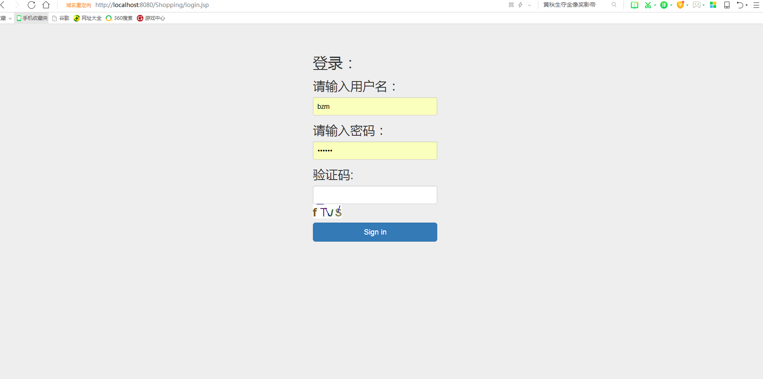

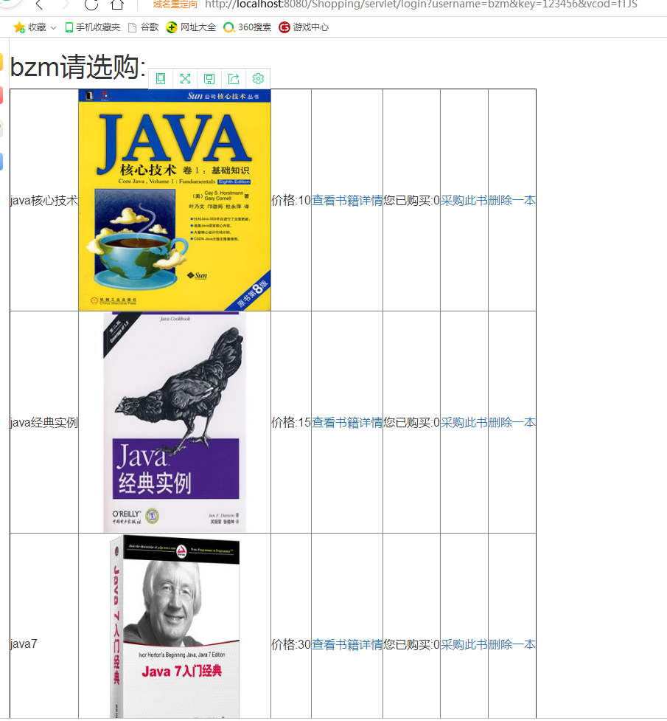

对书籍购买情况作出更改，通过点击“采购此书”和“删除一本”进行数量上的更改。

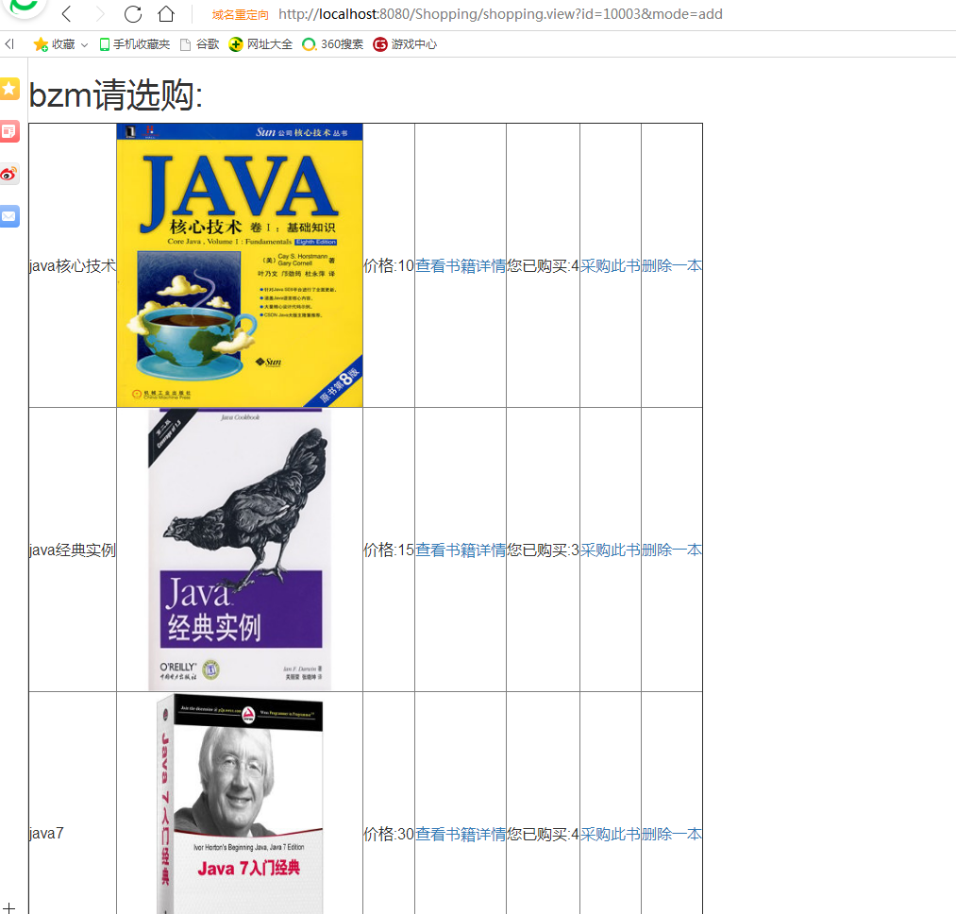

查看书籍信息

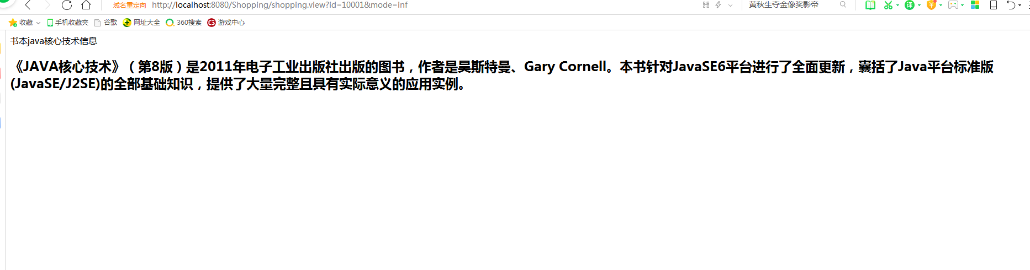

结算页面

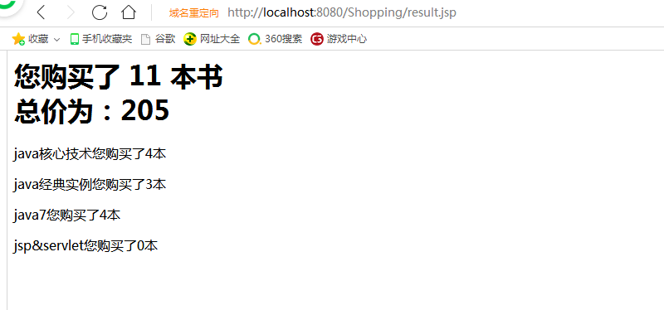

# 收获与问题

Mvc模式需要进一步掌握，在大作业中体现出来，这个结构体有着严密的逻辑结构，也符合操作系统的操作方式。