**Java Web开发**

**实验八**

**作业报告**

|  |  |
| --- | --- |
| 学 院 | 计算机 |
| 所在系 班 级 | 2017软件工程系8班 |
| 学 号 姓 名 | 陈荣 |
| 指 导 教 师 | 郭晓燕 |
| 完 成 时 间 | 2019年4月26日 |

# 实验题目

请用模型2MVC模式完成1个功能，功能自选，例如：登录、注册、发帖、计算税收等；

# 分析与设计

# 关键源码（部分）

Login.jsp

<%@ page language=*"java"* import=*"java.util.*"* pageEncoding=*"UTF-8"*%>

<%

String path = request.getContextPath();

String basePath = request.getScheme()+"://"+request.getServerName()+":"+request.getServerPort()+path+"/";

%>

<!DOCTYPE html>

<html lang=*"zh-CN"*>

<head>

<meta charset=*"utf-8"*>

<meta http-equiv=*"X-UA-Compatible"* content=*"IE=edge"*>

<meta name=*"viewport"* content=*"width=device-width, initial-scale=1"*>

<!-- 上述3个meta标签*必须*放在最前面，任何其他内容都*必须*跟随其后！ -->

<title>Bootstrap 101 Template</title>

<!-- Bootstrap -->

<link href=*"https://cdn.jsdelivr.net/npm/bootstrap@3.3.7/dist/css/bootstrap.min.css"* rel=*"stylesheet"*>

<!-- HTML5 shim 和 Respond.js 是为了让 IE8 支持 HTML5 元素和媒体查询（media queries）功能 -->

<!-- 警告：通过 file:// 协议（就是直接将 html 页面拖拽到浏览器中）访问页面时 Respond.js 不起作用 -->

<!--[if lt IE 9]>

<script src="https://cdn.jsdelivr.net/npm/html5shiv@3.7.3/dist/html5shiv.min.js"></script>

<script src="https://cdn.jsdelivr.net/npm/respond.js@1.4.2/dest/respond.min.js"></script>

<![endif]-->

<meta charset=*"UTF-8"*>

<title>login</title>

<script src=*"https://cdn.bootcss.com/jquery/2.2.4/jquery.min.js"*></script>

<link href=*"https://cdn.bootcss.com/bootstrap/3.3.7/css/bootstrap.min.css"* rel=*"stylesheet"*>

<link href=*"https://cdn.bootcss.com/font-awesome/4.7.0/css/font-awesome.min.css"* rel=*"stylesheet"*>

<script src=*"https://cdn.bootcss.com/bootstrap/3.3.7/js/bootstrap.min.js"*></script>

<link rel=*"stylesheet"* href=*"css/style.css"*>

<style type=*"text/css"*>

**body**{

background: *url("img/1.jpg")*;

animation-name:*myfirst*;

animation-duration:*12s*;

/*变换时间*/

animation-delay:*2s*;

/*动画开始时间*/

animation-iteration-count:*infinite*;

/*下一周期循环播放*/

animation-play-state:*running*;

/*动画开始运行*/

}

@**keyframes** **myfirst**

{

0% {background:*url("img/1.jpg")*;}

34% {**background***:url*("img/2*.jpg*");}

67% {**background***:url*("img/3*.jpg*");}

100% {**background***:url*("img/1*.jpg*");}

}

*.form*{background: *rgba(255,255,255,0.2)*;width:*400px*;margin:*120px auto*;}

/*阴影*/

*.fa*{display: *inline-block*;top: *27px*;left: *6px*;position: *relative*;color: *#ccc*;}

**input**[type="text"]**,input**[type="password"]{padding-left:*26px*;}

*.checkbox*{padding-left:*21px*;}

</style>

</head>

<body>

<form action=*"Contral.do"* method=*"post"* name=*form*>

<div class=*"container"*>

<div class=*"form row"*>

<div class=*"form-horizontal col-md-offset-3"* id=*"login_form"*>

<h3 class=*"form-title"*>LOGIN</h3>

<div class=*"col-md-9"*>

<div class=*"form-group"*>

<i class=*"fa fa-user fa-lg"*></i>

<input class=*"form-control required"* type=*"text"* placeholder=*"Username"* id=*"username"* name=*"username"* autofocus=*"autofocus"* maxlength=*"20"*/>

</div>

<div class=*"form-group"*>

<i class=*"fa fa-lock fa-lg"*></i>

<input class=*"form-control required"* type=*"password"* placeholder=*"Password"* id=*"password"* name=*"password"* maxlength=*"8"*/>

</div>

<div class=*"form-group"*>

<label class=*"checkbox"*>

<input type=*"checkbox"* name=*"remember"* value=*"1"*/>记住账号密码

</label>

</div>

<div class=*"form-group col-md-offset-9"*>

<button type=*"submit"* class=*"btn btn-success pull-right"* name=*"submit"*>登录</button>

</div>

</div>

</div>

</div>

</div>

<!-- jQuery (Bootstrap 的所有 JavaScript 插件都依赖 jQuery，所以必须放在前边) -->

<script src=*"https://cdn.jsdelivr.net/npm/jquery@1.12.4/dist/jquery.min.js"*></script>

<!-- 加载 Bootstrap 的所有 JavaScript 插件。你也可以根据需要只加载单个插件。 -->

<script src=*"https://cdn.jsdelivr.net/npm/bootstrap@3.3.7/dist/js/bootstrap.min.js"*></script>

</body>

</html>

Model.java

**package** cc.gg.com;

**public** **class** Model

{

**private** String username;

**private** String password;

**public** **void** setUsername(String username)

{

**this**.username=username;

}

**public** **void** setPassward(String password)

{

**this**.password=password;

}

**public** String getUsername()

{

**return** username;

}

**public** String getPassword()

{

**return** password;

}

}

Contral.java

**public** **void** doPost(HttpServletRequest request, HttpServletResponse response)

**throws** ServletException, IOException {

request.setCharacterEncoding("UTF-8");

response.setContentType("text/html;charset=uft-8");

String username = request.getParameter("username");

String password = request.getParameter("password");

System.*out*.println(username);

**if** (username.equals("")||password.equals("")||username.length()<6||username.length()>8||password.length()<6)

{

request.getRequestDispatcher("fail.jsp").

forward(request,response);

}

**else**

{

response.sendRedirect("success.jsp");

}

}

}

Fail.jsp

<%@ page language=*"java"* import=*"java.util.*"* pageEncoding=*"UTF-8"*%>

<%

String path = request.getContextPath();

String basePath = request.getScheme()+"://"+request.getServerName()+":"+request.getServerPort()+path+"/";

%>

<!DOCTYPE HTML PUBLIC "-//W3C//DTD HTML 4.01 Transitional//EN">

<html>

<head>

<style type=*"text/css"*>

**body**

{

background: *url("img/1.jpg")*;

width:*100%*;

height:*100%*;

}

</style>

<base href=*"*<%=basePath%>*"*>

<title>My JSP 'fail.jsp' starting page</title>

<meta http-equiv=*"pragma"* content=*"no-cache"*>

<meta http-equiv=*"cache-control"* content=*"no-cache"*>

<meta http-equiv=*"expires"* content=*"0"*>

<meta http-equiv=*"keywords"* content=*"keyword1,keyword2,keyword3"*>

<meta http-equiv=*"description"* content=*"This is my page"*>

<!--

<link rel="stylesheet" type="text/css" href="styles.css">

-->

</head>

<body>

<font size=*3*>

<a href=*"Login.jsp"*>用户名或密码错误，很遗憾你登陆失败,请重新再来</a>

</font>

</body>

</html>

Success.jsp

<%@ page language=*"java"* import=*"java.util.*"* pageEncoding=*"UTF-8"*%>

<%

String path = request.getContextPath();

String basePath = request.getScheme()+"://"+request.getServerName()+":"+request.getServerPort()+path+"/";

%>

<!DOCTYPE HTML PUBLIC "-//W3C//DTD HTML 4.01 Transitional//EN">

<html>

<head>

<style type=*"text/css"*>

**body**{

background: *url("img/1.jpg")*;

}

</style>

<base href=*"*<%=basePath%>*"*>

<title>My JSP 'success.jsp' starting page</title>

<meta http-equiv=*"pragma"* content=*"no-cache"*>

<meta http-equiv=*"cache-control"* content=*"no-cache"*>

<meta http-equiv=*"expires"* content=*"0"*>

<meta http-equiv=*"keywords"* content=*"keyword1,keyword2,keyword3"*>

<meta http-equiv=*"description"* content=*"This is my page"*>

<!--

<link rel="stylesheet" type="text/css" href="styles.css">

-->

</head>

<body>

<font size=*8*>

欢迎来到吉珠购物

</font>

</body>

</html>

# 运行效果图

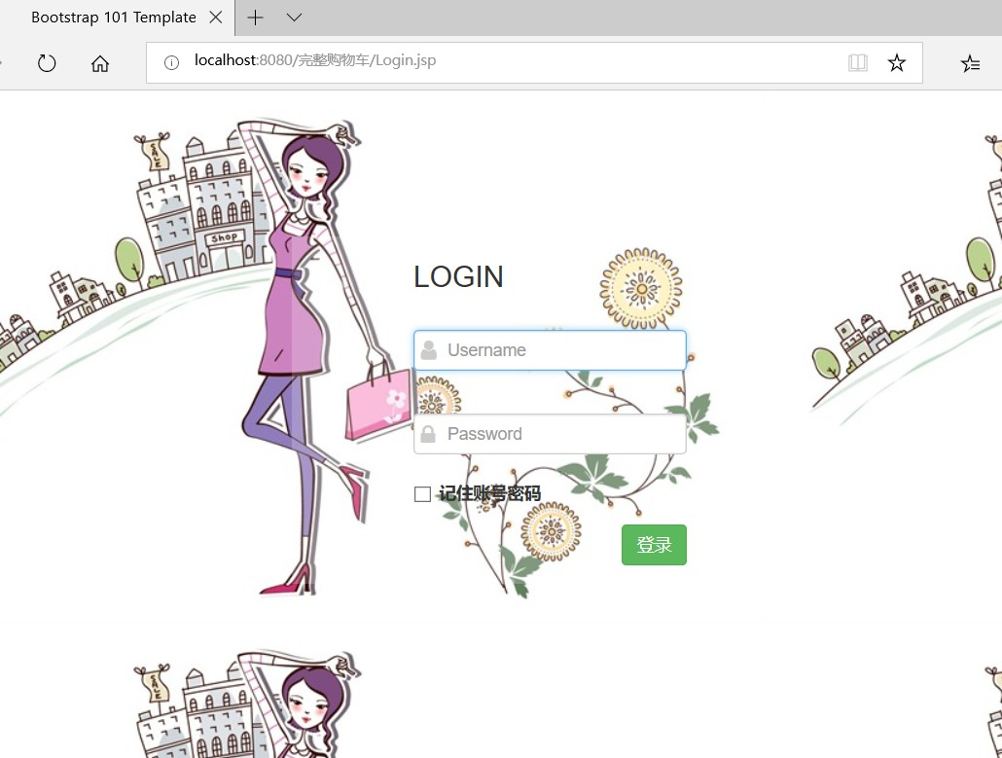

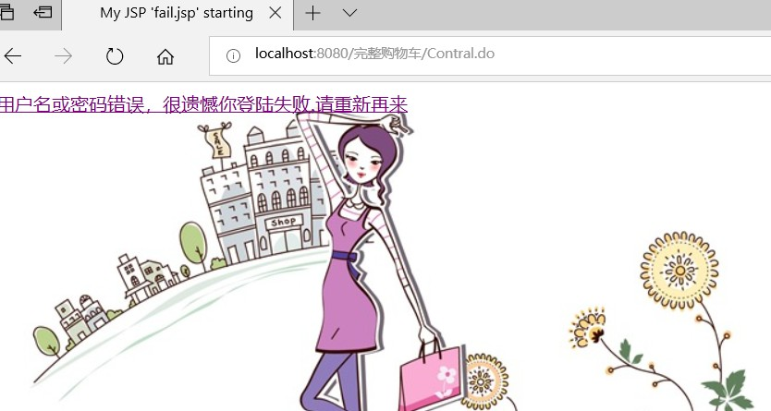

# 收获与问题