**Java Web开发**

**实验八**

**作业报告**

|  |  |
| --- | --- |
| 学 院 | 计算机 |
| 所在系 班 级 | 2017软件工程系8班 |
| 学 号 姓 名 | 04171615 梁峰源 |
| 指 导 教 师 | 郭晓燕 |
| 完 成 时 间 |  |

# 实验题目

1、（必做）请用模型2MVC模式完成1个功能，功能自选，例如：登录、注册、发帖、计算税收等；

# 关键源码（部分）

Login.jsp

<html>

<body>

<html>

<body>

<form action=*"LoginServlet"* method=*"post"* name =*"form"*>

用户名：<input type=*"text"* name=*"username"*> </br>

密码：<input type=*"password"* name=*"password"*></br>

<input type=*"submit"* value=*"提交"*><br>

</form>

</body>

</html>

</body>

</html>

Success.jsp

<html>

<body>

<% request.setCharacterEncoding("UTF-8");

response.setContentType("text/html;charset=UTF-8");

out.println("<p>恭喜你注册成功："+request.getAttribute("username")+"</p>");

%>

</body>

</html>

Failere.jsp

<html>

<body>

<% request.setCharacterEncoding("UTF-8");

response.setContentType("text/html;charset=UTF-8");

out.println("注册失败");

%>

</body>

</html>

LoginDo.java

**package** test8;

**public** **class** LoginDo {

**private** String username;

**private** String password;

**public** LoginDo(String username,String password){

**this**.username=username;

**this**.password=password;

}

**public** String getUsername() {

**return** username;

}

**public** **void** setUsername(String username) {

**this**.username = username;

}

**public** String getPassword() {

**return** password;

}

**public** **void** setPassword(String password) {

**this**.password = password;

}

**public** **boolean** judge(String username,String password){

**int** len=username.length();

**int** len2 = username.length();

**if**(len>=6&&len<=11&&len2>=6&&len2<=11){

**return** **true**;

}**else**{

**return** **false**;

}

}

}

LoginServlet.java

package test8;

import java.io.IOException;

import javax.servlet.ServletException;

import javax.servlet.annotation.WebServlet;

import javax.servlet.http.HttpServlet;

import javax.servlet.http.HttpServletRequest;

import javax.servlet.http.HttpServletResponse;

import javax.servlet.http.HttpSession;

@WebServlet("/LoginServlet")

public class LoginServlet extends HttpServlet {

private static final long serialVersionUID = 1L;

public LoginServlet() {

super();

// TODO Auto-generated constructor stub

}

protected void doPost(HttpServletRequest request, HttpServletResponse response) throws ServletException, IOException {

String username = request.getParameter("username");

String password = request.getParameter("password");

HttpSession session=request.getSession();

LoginDo a = new LoginDo(username,password);

boolean b = a.judge(username,password);

if(b){

session.setAttribute("username",username);

request.getRequestDispatcher("success.jsp")

.forward(request,response);

}else{

request.getRequestDispatcher("failure.jsp")

.forward(request,response);

}

}

}

# 运行效果图

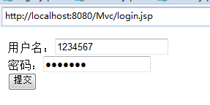

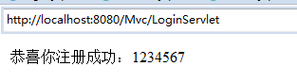

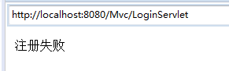

# 收获与问题

谈一谈你在本实验中所收获的内容及问题。