**Java Web开发**

**实验九**

**作业报告**

|  |  |
| --- | --- |
| 学 院 | 计算机 |
| 所在系 班 级 | 2017软件工程系6班 |
| 学 号 姓 名 | 04171424柯海扬 |
| 指 导 教 师 | 罗永升 |
| 完 成 时 间 | 2019年5月13日 |

# 实验题目

在程序中加入jstl;

# 分析与设计

# 关键源码（部分）

#login.jsp

<%@ page language=*"java"* contentType=*"text/html; charset=UTF-8"*

pageEncoding=*"UTF-8"*%>

<%@ taglib prefix=*"c"* uri=*"http://java.sun.com/jsp/jstl/core"*%>

<!doctype html>

<html class=*"no-js"* lang=*"zxx"*>

<head>

<meta charset=*"utf-8"*>

<meta http-equiv=*"x-ua-compatible"* content=*"ie=edge"*>

<title>登陆与注册</title>

<meta name=*"description"* content=*""*>

<meta name=*"viewport"* content=*"width=device-width, initial-scale=1"*>

<!-- Favicon -->

<link rel=*"shortcut icon"* type=*"image/x-icon"* href=*"assets/img/favicon.png"*>

<!-- CSS

============================================ -->

<!-- Bootstrap CSS -->

<link rel=*"stylesheet"* href=*"assets/css/bootstrap.min.css"*>

<!-- Icon Font CSS -->

<link rel=*"stylesheet"* href=*"assets/css/icons.min.css"*>

<!-- Plugins CSS -->

<link rel=*"stylesheet"* href=*"assets/css/plugins.css"*>

<!-- Main Style CSS -->

<link rel=*"stylesheet"* href=*"assets/css/style.css"*>

<!-- Modernizer JS -->

<script src=*"assets/js/vendor/modernizr-2.8.3.min.js"*></script>

<script>

**function** validateForm0(){

**var** x=document.forms["myform1"]["user"].value;

**var** y=document.forms["myform1"]["password"].value;

**if** (x==**null** || x==""){

alert("用户名必须填写");

**return** **false**;

}

**if** (y==**null** || y==""){

alert("密码必须填写");

**return** **false**;

}

}

</script>

<script>

**function** validateForm1(){

**var** x=document.forms["myform"]["usr"].value;

**var** y=document.forms["myform"]["password"].value;

**var** z=document.forms["myform"]["name"].value;

**var** k=document.forms["myform"]["phone"].value;

**var** e=document.forms["myform"]["email"].value;

**var** q=document.forms["myform"]["qq"].value;

**var** y1=document.forms["myform"]["password1"].value;

**var** atpos=e.indexOf("@");

**var** dotpos=e.lastIndexOf(".");

**var** phone = /^[0-9]{11,11}$/;

**var** qq = /^[0-9]{6,15}$/;

**if** (x==**null** || x==""){

alert("用户名必须填写");

**return** **false**;

}

**if** (z==**null** || z==""){

alert("名字必须填写");

**return** **false**;

}

**if** (k==**null** || k==""||k.length<11){

alert("手机号码填写错误");

**return** **false**;

}

**if**(!phone.test(k)) {

alert("手机号码填写错误");

**return** **false**;

}

**if** (atpos<1 || dotpos<atpos+2 || dotpos+2>=e.length){

alert("不是一个有效的 e-mail 地址");

**return** **false**;

}

**if** (q==**null** || q==""){

alert("qq填写错误");

**return** **false**;

}

**if**(!qq.test(q)) {

alert("qq填写错误");

**return** **false**;

}

**if** (y==**null** || y==""){

alert("密码必须填写");

**return** **false**;

}

**if** (y1==**null** || y1==""){

alert("确认密码必须填写");

**return** **false**;

}

**if**(y!=y1)

{

alert("密码不一致");

**return** **false**;

}

}

</script>

</head>

<body>

<div class=*"wrapper"*>

<header class=*"header-area sticky-bar"*>

<div class=*"main-header-wrap"*>

<div class=*"container"*>

<div class=*"row"*>

<div class=*"col-xl-2 col-lg-2"*>

<div class=*"logo pt-40"*>

<h3>

<a href=*"index1.jsp"*>

旅行

</a>

</h3>

</div>

</div>

<div class=*"col-xl-7 col-lg-7 "*>

<div class=*"main-menu"*>

<nav>

<ul>

<li class=*"angle-shape"*><a href=*"index1.jsp"*>主页</a>

</li>

<li class=*"angle-shape"*><a href=*"shop.html"*>购物<span>new</span> </a>

<ul class=*"submenu"*>

<li><a href=*"index.html"*>旅游商品 </a></li>

<li><a href=*"index-2.html"*>旅游线路 </a></li>

</ul>

</li>

<li class=*"angle-shape"*><a href=*"login.jsp"*>登陆/注册</a>

</li>

<li class=*"angle-shape"*><a href=*"#"*>个人中心</a>

</li>

</ul>

</nav>

</div>

</div>

<div class=*"col-xl-3 col-lg-3"*>

<div class=*"header-right-wrap pt-40"*>

<div class=*"header-search"*>

<a class=*"search-active"* href=*"#"*><i class=*"sli sli-magnifier"*></i></a>

</div>

<div class=*"cart-wrap"*>

<button class=*"icon-cart-active"*>

<span class=*"icon-cart"*>

<i class=*"sli sli-bag"*></i>

<span class=*"count-style"*>02</span>

</span>

<span class=*"cart-price"*>

$320.00

</span>

</button>

<div class=*"shopping-cart-content"*>

<div class=*"shopping-cart-top"*>

<h4>Shoping Cart</h4>

<a class=*"cart-close"* href=*"#"*><i class=*"sli sli-close"*></i></a>

</div>

<ul>

<li class=*"single-shopping-cart"*>

<div class=*"shopping-cart-img"*>

<a href=*"#"*><img alt=*""* src=*"assets/img/cart/cart-1.jpg"*></a>

<div class=*"item-close"*>

<a href=*"#"*><i class=*"sli sli-close"*></i></a>

</div>

</div>

<div class=*"shopping-cart-title"*>

<h4><a href=*"#"*>Product Name </a></h4>

<span>1 x 90.00</span>

</div>

</li>

<li class=*"single-shopping-cart"*>

<div class=*"shopping-cart-img"*>

<a href=*"#"*><img alt=*""* src=*"assets/img/cart/cart-2.jpg"*></a>

<div class=*"item-close"*>

<a href=*"#"*><i class=*"sli sli-close"*></i></a>

</div>

</div>

<div class=*"shopping-cart-title"*>

<h4><a href=*"#"*>Product Name</a></h4>

<span>1 x 90.00</span>

</div>

</li>

</ul>

<div class=*"shopping-cart-bottom"*>

<div class=*"shopping-cart-total"*>

<h4>Total : <span class=*"shop-total"*>$260.00</span></h4>

</div>

<div class=*"shopping-cart-btn btn-hover text-center"*>

<a class=*"default-btn"* href=*"checkout.html"*>checkout</a>

<a class=*"default-btn"* href=*"cart-page.html"*>view cart</a>

</div>

</div>

</div>

</div>

</div>

</div>

</div>

</div>

<!-- main-search start -->

<div class=*"main-search-active"*>

<div class=*"sidebar-search-icon"*>

<button class=*"search-close"*><span class=*"sli sli-close"*></span></button>

</div>

<div class=*"sidebar-search-input"*>

<form>

<div class=*"form-search"*>

<input id=*"search"* class=*"input-text"* value=*""* placeholder=*"Search Now"* type=*"search"*>

<button>

<i class=*"sli sli-magnifier"*></i>

</button>

</div>

</form>

</div>

</div>

</div>

</header>

<div class=*"breadcrumb-area pt-35 pb-35 bg-gray"*>

<div class=*"container"*>

<div class=*"breadcrumb-content text-center"*>

<ul>

<li>

<a href=*"index1.jsp"*>主页</a>

</li>

<li class=*"active"*>登陆 / 注册</li>

</ul>

</div>

</div>

</div>

<div class=*"login-register-area pt-100 pb-100"*>

<div class=*"container"*>

<div class=*"row"*>

<div class=*"col-lg-7 col-md-12 ml-auto mr-auto"*>

<div class=*"login-register-wrapper"*>

<div class=*"login-register-tab-list nav"*>

<a class=*"active"* data-toggle=*"tab"* href=*"#lg1"*>

<h4> 登陆 </h4>

</a>

<a data-toggle=*"tab"* href=*"#lg2"*>

<h4> 注册 </h4>

</a>

</div>

<div class=*"tab-content"*>

<div id=*"lg1"* class=*"tab-pane active"*>

<div class=*"login-form-container"*>

<div class=*"login-register-form"*>

<form action=*"../login1.do"* method=*post* name=*"myform1"* onsubmit="return validateForm0()">

<input type=*"text"* placeholder=*"账号"* id=*"user"* name=*"user"* autofocus=*"autofocus"* maxlength=*"20"*/>

<input type=*"password"* placeholder=*"密码"* id=*"password"* name=*"password"* maxlength=*"8"* />

<c:if test=*"*${message!=null }*"*>

<font size=*"3"* color=*"red"*>${message}</font>

<%session.setAttribute("message", **null**); %>

</c:if>

<div class=*"button-box"*>

<div class=*"login-toggle-btn"*>

<input type=*"checkbox"*>

<label>记住我</label>

</div>

<button type=*"submit"*>登陆</button>

</div>

</form>

</div>

</div>

</div>

<div id=*"lg2"* class=*"tab-pane"*>

<div class=*"login-form-container"*>

<div class=*"login-register-form"*>

<form role=*"form"* action=*"../register.do"* method=*post* name=*"myform"* onsubmit="return validateForm1()">

<input type=*"text"* id=*"usr"* name=*"usr"* placeholder=*"请输入用户名"* maxlength=*"20"*>

<input type=*"text"* id=*"name"* name=*"name"* placeholder=*"请输入你的名字"* maxlength=*"16"*>

<input type=*"text"* id=*"phone"* name=*"phone"* placeholder=*"请输入你的手机号"* maxlength=*"11"*>

<input type=*"text"* id=*"email"* name=*"email"* placeholder=*"请输入你的邮箱地址"* maxlength=*"30"*>

<input type=*"text"* id=*"qq"* name=*"qq"* placeholder=*"请输入你的qq"* maxlength=*"20"*>

<input type=*"text"* id=*"pp"* name=*"pp"* placeholder=*"请输入你的个性签名"* maxlength=*"40"*>

<input type=*"password"* maxlength=*"8"* name=*"password"* id=*"password"* placeholder=*"请输入密码"* >

<input type=*"password"* maxlength=*"8"* name=*"password1"* id=*"password1"* placeholder=*"请输入确认密码"*><br/>

<c:if test=*"*${message!=null }*"*>

<font size=*"3"* color=*"red"*>${message}</font>

<%session.setAttribute("message", **null**); %>

</c:if>

<div class=*"button-box"*>

<button type=*"submit"*>注册</button>

</div>

</form>

</div>

</div>

</div>

</div>

</div>

</div>

</div>

</div>

</div>

<footer class=*"footer-area bg-paleturquoise"*>

<div class=*"container"*>

<div class=*"footer-top text-center pt-80 pb-80"*>

<nav>

<ul>

<li><a href=*"index1.jsp"*>主页</a></li>

<li><a href=*"shop.html"*>商品 </a></li>

<li><a href=*"login.jsp"*>登陆/注册 </a></li>

<li><a href=*"contact-us.html"*>个人中心</a></li>

</ul>

</nav>

</div>

</div>

</footer>

</div>

<!-- All JS is here

============================================ -->

<!-- jQuery JS -->

<script src=*"assets/js/vendor/jquery-1.12.4.min.js"*></script>

<!-- Popper JS -->

<script src=*"assets/js/popper.min.js"*></script>

<!-- Bootstrap JS -->

<script src=*"assets/js/bootstrap.min.js"*></script>

<!-- Plugins JS -->

<script src=*"assets/js/plugins.js"*></script>

<!-- Ajax Mail -->

<script src=*"assets/js/ajax-mail.js"*></script>

<!-- Main JS -->

<script src=*"assets/js/main.js"*></script>

</body>

</html>

#login.java

<%@ page language=*"java"* contentType=*"text/html; charset=UTF-8"*

pageEncoding=*"UTF-8"*%>

<%@ taglib prefix=*"c"* uri=*"http://java.sun.com/jsp/jstl/core"*%>

<!doctype html>

<html class=*"no-js"* lang=*"zxx"*>

<head>

<meta charset=*"utf-8"*>

<meta http-equiv=*"x-ua-compatible"* content=*"ie=edge"*>

<title>登陆与注册</title>

<meta name=*"description"* content=*""*>

<meta name=*"viewport"* content=*"width=device-width, initial-scale=1"*>

<!-- Favicon -->

<link rel=*"shortcut icon"* type=*"image/x-icon"* href=*"assets/img/favicon.png"*>

<!-- CSS

============================================ -->

<!-- Bootstrap CSS -->

<link rel=*"stylesheet"* href=*"assets/css/bootstrap.min.css"*>

<!-- Icon Font CSS -->

<link rel=*"stylesheet"* href=*"assets/css/icons.min.css"*>

<!-- Plugins CSS -->

<link rel=*"stylesheet"* href=*"assets/css/plugins.css"*>

<!-- Main Style CSS -->

<link rel=*"stylesheet"* href=*"assets/css/style.css"*>

<!-- Modernizer JS -->

<script src=*"assets/js/vendor/modernizr-2.8.3.min.js"*></script>

<script>

**function** validateForm0(){

**var** x=document.forms["myform1"]["user"].value;

**var** y=document.forms["myform1"]["password"].value;

**if** (x==**null** || x==""){

alert("用户名必须填写");

**return** **false**;

}

**if** (y==**null** || y==""){

alert("密码必须填写");

**return** **false**;

}

}

</script>

<script>

**function** validateForm1(){

**var** x=document.forms["myform"]["usr"].value;

**var** y=document.forms["myform"]["password"].value;

**var** z=document.forms["myform"]["name"].value;

**var** k=document.forms["myform"]["phone"].value;

**var** e=document.forms["myform"]["email"].value;

**var** q=document.forms["myform"]["qq"].value;

**var** y1=document.forms["myform"]["password1"].value;

**var** atpos=e.indexOf("@");

**var** dotpos=e.lastIndexOf(".");

**var** phone = /^[0-9]{11,11}$/;

**var** qq = /^[0-9]{6,15}$/;

**if** (x==**null** || x==""){

alert("用户名必须填写");

**return** **false**;

}

**if** (z==**null** || z==""){

alert("名字必须填写");

**return** **false**;

}

**if** (k==**null** || k==""||k.length<11){

alert("手机号码填写错误");

**return** **false**;

}

**if**(!phone.test(k)) {

alert("手机号码填写错误");

**return** **false**;

}

**if** (atpos<1 || dotpos<atpos+2 || dotpos+2>=e.length){

alert("不是一个有效的 e-mail 地址");

**return** **false**;

}

**if** (q==**null** || q==""){

alert("qq填写错误");

**return** **false**;

}

**if**(!qq.test(q)) {

alert("qq填写错误");

**return** **false**;

}

**if** (y==**null** || y==""){

alert("密码必须填写");

**return** **false**;

}

**if** (y1==**null** || y1==""){

alert("确认密码必须填写");

**return** **false**;

}

**if**(y!=y1)

{

alert("密码不一致");

**return** **false**;

}

}

</script>

</head>

<body>

<div class=*"wrapper"*>

<header class=*"header-area sticky-bar"*>

<div class=*"main-header-wrap"*>

<div class=*"container"*>

<div class=*"row"*>

<div class=*"col-xl-2 col-lg-2"*>

<div class=*"logo pt-40"*>

<h3>

<a href=*"index1.jsp"*>

旅行

</a>

</h3>

</div>

</div>

<div class=*"col-xl-7 col-lg-7 "*>

<div class=*"main-menu"*>

<nav>

<ul>

<li class=*"angle-shape"*><a href=*"index1.jsp"*>主页</a>

</li>

<li class=*"angle-shape"*><a href=*"shop.html"*>购物<span>new</span> </a>

<ul class=*"submenu"*>

<li><a href=*"index.html"*>旅游商品 </a></li>

<li><a href=*"index-2.html"*>旅游线路 </a></li>

</ul>

</li>

<li class=*"angle-shape"*><a href=*"login.jsp"*>登陆/注册</a>

</li>

<li class=*"angle-shape"*><a href=*"#"*>个人中心</a>

</li>

</ul>

</nav>

</div>

</div>

<div class=*"col-xl-3 col-lg-3"*>

<div class=*"header-right-wrap pt-40"*>

<div class=*"header-search"*>

<a class=*"search-active"* href=*"#"*><i class=*"sli sli-magnifier"*></i></a>

</div>

<div class=*"cart-wrap"*>

<button class=*"icon-cart-active"*>

<span class=*"icon-cart"*>

<i class=*"sli sli-bag"*></i>

<span class=*"count-style"*>02</span>

</span>

<span class=*"cart-price"*>

$320.00

</span>

</button>

<div class=*"shopping-cart-content"*>

<div class=*"shopping-cart-top"*>

<h4>Shoping Cart</h4>

<a class=*"cart-close"* href=*"#"*><i class=*"sli sli-close"*></i></a>

</div>

<ul>

<li class=*"single-shopping-cart"*>

<div class=*"shopping-cart-img"*>

<a href=*"#"*><img alt=*""* src=*"assets/img/cart/cart-1.jpg"*></a>

<div class=*"item-close"*>

<a href=*"#"*><i class=*"sli sli-close"*></i></a>

</div>

</div>

<div class=*"shopping-cart-title"*>

<h4><a href=*"#"*>Product Name </a></h4>

<span>1 x 90.00</span>

</div>

</li>

<li class=*"single-shopping-cart"*>

<div class=*"shopping-cart-img"*>

<a href=*"#"*><img alt=*""* src=*"assets/img/cart/cart-2.jpg"*></a>

<div class=*"item-close"*>

<a href=*"#"*><i class=*"sli sli-close"*></i></a>

</div>

</div>

<div class=*"shopping-cart-title"*>

<h4><a href=*"#"*>Product Name</a></h4>

<span>1 x 90.00</span>

</div>

</li>

</ul>

<div class=*"shopping-cart-bottom"*>

<div class=*"shopping-cart-total"*>

<h4>Total : <span class=*"shop-total"*>$260.00</span></h4>

</div>

<div class=*"shopping-cart-btn btn-hover text-center"*>

<a class=*"default-btn"* href=*"checkout.html"*>checkout</a>

<a class=*"default-btn"* href=*"cart-page.html"*>view cart</a>

</div>

</div>

</div>

</div>

</div>

</div>

</div>

</div>

<!-- main-search start -->

<div class=*"main-search-active"*>

<div class=*"sidebar-search-icon"*>

<button class=*"search-close"*><span class=*"sli sli-close"*></span></button>

</div>

<div class=*"sidebar-search-input"*>

<form>

<div class=*"form-search"*>

<input id=*"search"* class=*"input-text"* value=*""* placeholder=*"Search Now"* type=*"search"*>

<button>

<i class=*"sli sli-magnifier"*></i>

</button>

</div>

</form>

</div>

</div>

</div>

</header>

<div class=*"breadcrumb-area pt-35 pb-35 bg-gray"*>

<div class=*"container"*>

<div class=*"breadcrumb-content text-center"*>

<ul>

<li>

<a href=*"index1.jsp"*>主页</a>

</li>

<li class=*"active"*>登陆 / 注册</li>

</ul>

</div>

</div>

</div>

<div class=*"login-register-area pt-100 pb-100"*>

<div class=*"container"*>

<div class=*"row"*>

<div class=*"col-lg-7 col-md-12 ml-auto mr-auto"*>

<div class=*"login-register-wrapper"*>

<div class=*"login-register-tab-list nav"*>

<a class=*"active"* data-toggle=*"tab"* href=*"#lg1"*>

<h4> 登陆 </h4>

</a>

<a data-toggle=*"tab"* href=*"#lg2"*>

<h4> 注册 </h4>

</a>

</div>

<div class=*"tab-content"*>

<div id=*"lg1"* class=*"tab-pane active"*>

<div class=*"login-form-container"*>

<div class=*"login-register-form"*>

<form action=*"../login1.do"* method=*post* name=*"myform1"* onsubmit="return validateForm0()">

<input type=*"text"* placeholder=*"账号"* id=*"user"* name=*"user"* autofocus=*"autofocus"* maxlength=*"20"*/>

<input type=*"password"* placeholder=*"密码"* id=*"password"* name=*"password"* maxlength=*"8"* />

<c:if test=*"*${message!=null }*"*>

<font size=*"3"* color=*"red"*>${message}</font>

<%session.setAttribute("message", **null**); %>

</c:if>

<div class=*"button-box"*>

<div class=*"login-toggle-btn"*>

<input type=*"checkbox"*>

<label>记住我</label>

</div>

<button type=*"submit"*>登陆</button>

</div>

</form>

</div>

</div>

</div>

<div id=*"lg2"* class=*"tab-pane"*>

<div class=*"login-form-container"*>

<div class=*"login-register-form"*>

<form role=*"form"* action=*"../register.do"* method=*post* name=*"myform"* onsubmit="return validateForm1()">

<input type=*"text"* id=*"usr"* name=*"usr"* placeholder=*"请输入用户名"* maxlength=*"20"*>

<input type=*"text"* id=*"name"* name=*"name"* placeholder=*"请输入你的名字"* maxlength=*"16"*>

<input type=*"text"* id=*"phone"* name=*"phone"* placeholder=*"请输入你的手机号"* maxlength=*"11"*>

<input type=*"text"* id=*"email"* name=*"email"* placeholder=*"请输入你的邮箱地址"* maxlength=*"30"*>

<input type=*"text"* id=*"qq"* name=*"qq"* placeholder=*"请输入你的qq"* maxlength=*"20"*>

<input type=*"text"* id=*"pp"* name=*"pp"* placeholder=*"请输入你的个性签名"* maxlength=*"40"*>

<input type=*"password"* maxlength=*"8"* name=*"password"* id=*"password"* placeholder=*"请输入密码"* >

<input type=*"password"* maxlength=*"8"* name=*"password1"* id=*"password1"* placeholder=*"请输入确认密码"*><br/>

<c:if test=*"*${message!=null }*"*>

<font size=*"3"* color=*"red"*>${message}</font>

<%session.setAttribute("message", **null**); %>

</c:if>

<div class=*"button-box"*>

<button type=*"submit"*>注册</button>

</div>

</form>

</div>

</div>

</div>

</div>

</div>

</div>

</div>

</div>

</div>

<footer class=*"footer-area bg-paleturquoise"*>

<div class=*"container"*>

<div class=*"footer-top text-center pt-80 pb-80"*>

<nav>

<ul>

<li><a href=*"index1.jsp"*>主页</a></li>

<li><a href=*"shop.html"*>商品 </a></li>

<li><a href=*"login.jsp"*>登陆/注册 </a></li>

<li><a href=*"contact-us.html"*>个人中心</a></li>

</ul>

</nav>

</div>

</div>

</footer>

</div>

<!-- All JS is here

============================================ -->

<!-- jQuery JS -->

<script src=*"assets/js/vendor/jquery-1.12.4.min.js"*></script>

<!-- Popper JS -->

<script src=*"assets/js/popper.min.js"*></script>

<!-- Bootstrap JS -->

<script src=*"assets/js/bootstrap.min.js"*></script>

<!-- Plugins JS -->

<script src=*"assets/js/plugins.js"*></script>

<!-- Ajax Mail -->

<script src=*"assets/js/ajax-mail.js"*></script>

<!-- Main JS -->

<script src=*"assets/js/main.js"*></script>

</body>

</html>

# 运行效果图

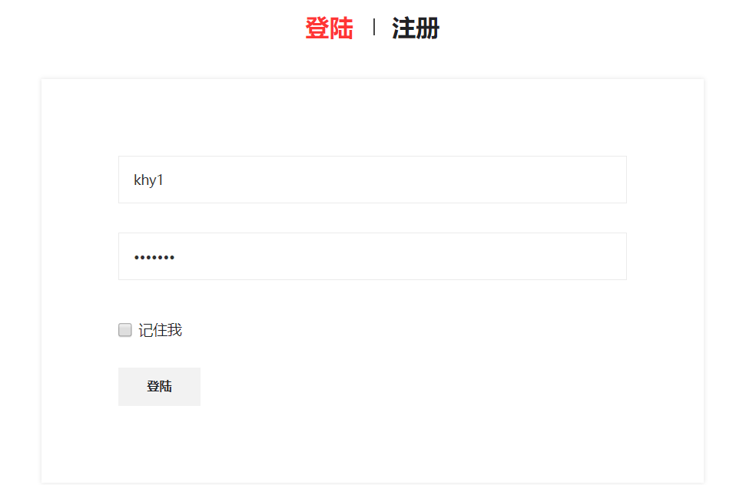

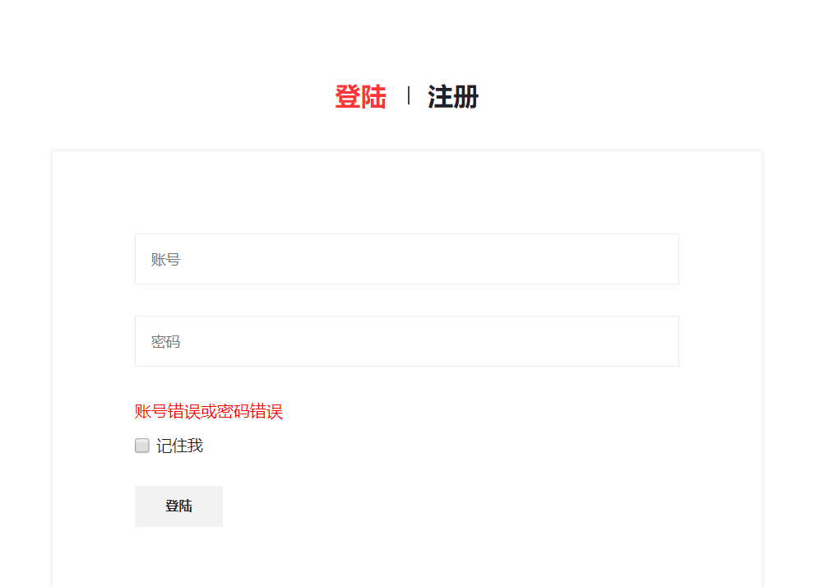

# 收获与问题