**Java Web开发**

**实验九**

**作业报告**

|  |  |
| --- | --- |
| 学 院 | 计算机 |
| 所在系 班 级 | 2017软件工程系6班 |
| 学 号 姓 名 | 04171427 |
| 指 导 教 师 | 罗永升 |
| 完 成 时 间 | 2019年5月- |

# 实验题目

对自己做的任何程序的JSP页面进行JSTL的改写，练习JSTL及EL标签的使用

# 分析与设计

根据题目要求，计划设计几个文件来完成实验，每个文件的名字、作用。如果是类，要求写出类的变量和方法

# 关键源码（部分）

Login.jsp:

<%@ page language=*"java"* import=*"java.util.*"* pageEncoding=*"utf-8"*%>

<!DOCTYPE HTML PUBLIC "-//W3C//DTD HTML 4.01 Transitional//EN">

<html>

<head>

<title>登陆(MVC模式)</title>

</head>

<body>

<form method=*"post"* action=*"login.do"*>

<fieldset>

<legend>登陆</legend>

请输入账户：<input type=*"text"* name=*"username"* ><br><br>

请输入密码：<input type=*"password"* name=*"password"*><br><br>

<input type=*"submit"* value=*"登陆"* name=*"submit"*>

</fieldset>

</form>

</body>

</html>

Success.jsp:

<%@ page language=*"java"* import=*"java.util.*"* pageEncoding=*"utf-8"*%>

<!DOCTYPE HTML PUBLIC "-//W3C//DTD HTML 4.01 Transitional//EN">

<html>

<head>

<title>登陆成功</title>

</head>

<body>

<h1>

${param.username}

<%-- <jsp:getProperty property="username" name="user"/> --%>登陆成功！</h1>

</body>

</html>

Fail.jsp：  
<%@ page language=*"java"* import=*"java.util.*"* pageEncoding=*"utf-8"*%>

<!DOCTYPE HTML PUBLIC "-//W3C//DTD HTML 4.01 Transitional//EN">

<html>

<head>

<title> 登陆失败</title>

</head>

<body>

<h2>登陆失败</h2><br><br>

<a href=*"login.jsp"*>点击返回登陆</a>

</body>

</html>

user.java：

**package** cc.openhome;

**import** java.io.Serializable;

**public** **class** User **implements** Serializable{

**private** String username;

**private** String password;

**public** String getUsername() {

**return** username;

}

**public** **void** setUsername(String username) {

**this**.username = username;

}

**public** String getPassword() {

**return** password;

}

**public** **void** setPassword(String password) {

**this**.password = password;

}

**public** **boolean** isValid(){

**return** "sunny".equals(username) && "000000".equals(password);

}

}

Loginservlet.java:

**package** cc.openhome;

**import** java.io.IOException;

**import** javax.servlet.ServletException;

**import** javax.servlet.annotation.WebServlet;

**import** javax.servlet.http.HttpServlet;

**import** javax.servlet.http.HttpServletRequest;

**import** javax.servlet.http.HttpServletResponse;

**import** javax.servlet.http.HttpSession;

/**

* Servlet implementation class LoginServlet

*/

@WebServlet("/login.do")

**public** **class** LoginServlet **extends** HttpServlet {

**private** **void** processRequest(HttpServletRequest request, HttpServletResponse response)

**throws** ServletException, IOException {

response.setContentType("text/html");

request.setCharacterEncoding("UTF-8");

HttpSession session=request.getSession();

User user=(User)session.getAttribute("user");

**if**(user == **null**){

user = **new** User();

request.setAttribute("user", user);

}

user.setUsername(request.getParameter("username"));

user.setPassword(request.getParameter("userpassword"));

session.setAttribute("user",user);

**if**(user.isValid()==**true**){

response.sendRedirect("success.jsp");

}**else**{

response.sendRedirect("fail.jsp" );//重定向

}

}

**protected** **void** doGet(HttpServletRequest request, HttpServletResponse response) **throws** ServletException, IOException {

processRequest(request,response);

}

/**

* **@see** HttpServlet#doPost(HttpServletRequest request, HttpServletResponse response)

*/

**protected** **void** doPost(HttpServletRequest request, HttpServletResponse response) **throws** ServletException, IOException {

processRequest(request,response);

}

}

# 运行效果图

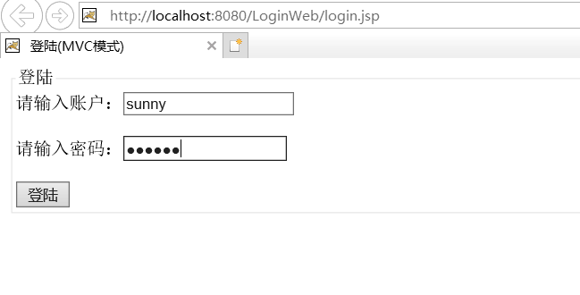

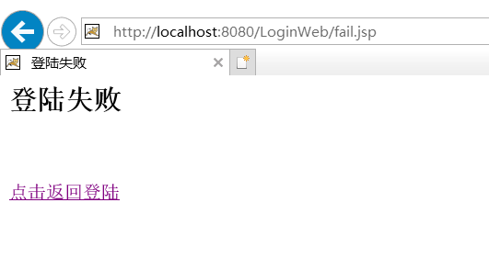

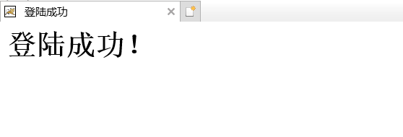

# 收获与问题

谈一谈你在本实验中所收获的内容及问题。