**Java Web开发**

**实验九**

**作业报告**

|  |  |
| --- | --- |
| 学 院 | 计算机 |
| 所在系 班 级 | 2017软件工程系8班 |
| 学 号 姓 名 | 符家成 |
| 指 导 教 师 | 郭晓燕 |
| 完 成 时 间 |  |

# 实验题目

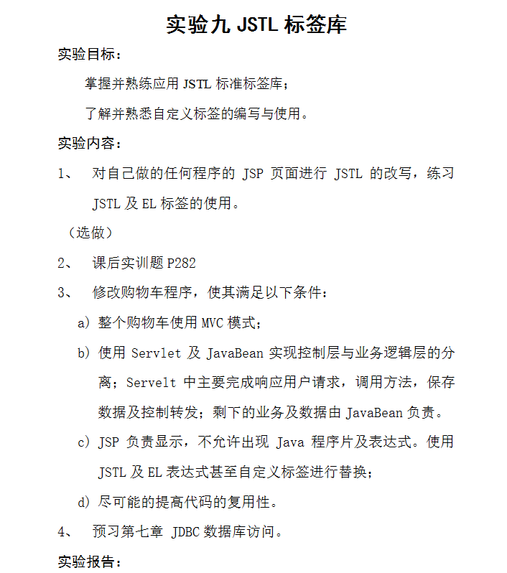

# 分析与设计

分析：用jstl改写之前的jsp代码即可

本次实验包含选做第三题

# 关键源码（部分）

Book.java

**package** shop;

**public** **class** Book {

**int** bookID;

String bookName;

String bookImg;

**int** shopNum=0;

Book[] BookList=**new** Book[3];

**public** Book(**int** id,String name,String img,**int** num){

**this**.bookID=id;

**this**.bookName=name;

**this**.bookImg=img;

**this**.shopNum=num;

}

**public** Book() {

BookList[0]=**new** Book(1,"扎瓦","img\\0001.jpg",0);

BookList[1]=**new** Book(2,"吸加加","img\\0002.jpg",0);

BookList[2]=**new** Book(3,"资诶哎死劈教学","img\\0003.jpg",0);

}

**public** **int** getBookID(){

**return** bookID;

}

**public** **void** setBookID(**int** bookID){

**this**.bookID=bookID;

}

**public** String getBookName(){

**return** bookName;

}

**public** **void** setBookName(String bookName){

**this**.bookName=bookName;

}

**public** **int** getShopNum(){

**return** shopNum;

}

**public** **void** setShopNum(**int** shopNum){

**this**.shopNum=shopNum;

}

**public** String getBookImg(){

**return** bookImg;

}

**public** **void** setBookImg(String bookImg){

**this**.bookImg=bookImg;

}

**public** **void** delete(){

**this**.shopNum=0;

}

**public** **void** count(){

**this**.shopNum+=1;

}

**public** Book[] getBookList() {

**return** BookList;

}

}

IntroduceServlet.java

package shop;

import java.io.IOException;

import java.io.PrintWriter;

import javax.servlet.ServletException;

import javax.servlet.annotation.WebServlet;

import javax.servlet.http.HttpServlet;

import javax.servlet.http.HttpServletRequest;

import javax.servlet.http.HttpServletResponse;

import javax.servlet.http.HttpSession;

@WebServlet("/introduce.view")

public class introduceServlet extends HttpServlet {

public void doGet(HttpServletRequest request, HttpServletResponse response)throws ServletException, IOException {

doPost(request, response);

}

public void doPost(HttpServletRequest request, HttpServletResponse response)throws ServletException, IOException {

HttpSession session=request.getSession();

Book[]book=(Book[])session.getAttribute("bookList");

int ID=Integer.parseInt(request.getParameter("id"))-1;

String bookName=book[ID].getBookName();

session.setAttribute("bookName", bookName);

request.getRequestDispatcher("Shopping.jsp").forward(request, response);

}

}

LoginServlet.java

**package** shop;

**import** java.io.IOException;

**import** javax.servlet.ServletException;

**import** javax.servlet.annotation.WebServlet;

**import** javax.servlet.http.HttpServlet;

**import** javax.servlet.http.HttpServletRequest;

**import** javax.servlet.http.HttpServletResponse;

**import** javax.servlet.http.HttpSession;

**import** com.sun.faces.renderkit.html_basic.HtmlBasicRenderer.Param;

**import** shop.*;

@WebServlet("/login.do")

**public** **class** LoginServlet **extends** HttpServlet {

**protected** **void** doGet(HttpServletRequest request, HttpServletResponse response) **throws** ServletException, IOException {

doPost(request, response);

}

**protected** **void** doPost(HttpServletRequest request, HttpServletResponse response) **throws** ServletException, IOException {

HttpSession session=request.getSession();

String name=request.getParameter("name");

**if**(name==**null**&&name.length()<1){

name="";

response.sendRedirect("Login.jsp");

}**else**{

Book a=**new** Book();

Book[]bookList=a.getBookList();

String bookName = "--------------------------------";

session.setAttribute("bookList", bookList);

session.setAttribute("sum", 0);

session.setAttribute("bookName", bookName);

response.sendRedirect("Shopping.jsp");

}

}

}

Delete.java

package shop;

import java.io.IOException;

import java.io.PrintWriter;

import javax.servlet.ServletException;

import javax.servlet.annotation.WebServlet;

import javax.servlet.http.HttpServlet;

import javax.servlet.http.HttpServletRequest;

import javax.servlet.http.HttpServletResponse;

import javax.servlet.http.HttpSession;

@WebServlet("/delete.view")

public class delete extends HttpServlet {

public void doGet(HttpServletRequest request, HttpServletResponse response)throws ServletException, IOException {

doPost(request, response);

}

public void doPost(HttpServletRequest request, HttpServletResponse response)throws ServletException, IOException {

HttpSession session=request.getSession();

Book[]book=(Book[])session.getAttribute("bookList");

int ID=Integer.parseInt(request.getParameter("id"))-1;

book[ID].delete();

int sum=book[0].getShopNum()+book[1].getShopNum()+book[2].getShopNum();

session.setAttribute("sum", sum);

request.getRequestDispatcher("Shopping.jsp").forward(request, response);

}

}

ShoppingServlet.java

package shop;

import java.io.IOException;

import javax.servlet.ServletException;

import javax.servlet.annotation.WebServlet;

import javax.servlet.http.HttpServlet;

import javax.servlet.http.HttpServletRequest;

import javax.servlet.http.HttpServletResponse;

import javax.servlet.http.HttpSession;

@WebServlet("/Shopping.view")

public class ShoppingServlet extends HttpServlet {protected void doGet(HttpServletRequest request, HttpServletResponse response) throws ServletException, IOException {

doPost(request, response);

}

protected void doPost(HttpServletRequest request, HttpServletResponse response) throws ServletException, IOException {

HttpSession session=request.getSession();

Book[] book=(Book[])session.getAttribute("bookList");

int ID=Integer.parseInt(request.getParameter("id"))-1;

book[ID].count();

int sum=book[0].getShopNum()+book[1].getShopNum()+book[2].getShopNum();

session.setAttribute("sum", sum);

request.getRequestDispatcher("Shopping.jsp").forward(request, response);

}

}

Shopping.jsp

<%@ page language=*"java"* import=*"java.util.*"* pageEncoding=*"UTF-8"*%>

<%@ page import=*"shop.*"* %>

<%@ taglib prefix=*"c"* uri=*"http://java.sun.com/jsp/jstl/core"* %>

<!DOCTYPE HTML PUBLIC "-//W3C//DTD HTML 4.01 Transitional//EN">

<jsp:useBean id=*"book"* class=*"shop.Book"*/>

<html>

<body>

<img src=*"img/0000.jpg"* height=*"100px"* width=*"100px"*>

<a href=*"account.jsp"*>已采购<%=session.getAttribute("sum") %>本书籍，点击结算</a>

<br><br><br>

<%=session.getAttribute("bookName") %><br><br><br>

<table border=*"13"*>

<%

Book[] bookList=(Book[])session.getAttribute("bookList");

%>

<c:forEach var=*"book"* items="${bookList}">

<tr>

<td><img height=*'250px'* width=*'200px'* src=*'*${book.bookImg}*'*><a href=*"introduce.view?id=*${book.bookID}*"*>点此查看信息</a></td>

<td><a href=*"Shopping.view?id=*${book.bookID}*"*>采购此书</a></td>

<td><a href=*"delete.view?id=*${book.bookID}*"*>删除购买</a></td>

</tr>

</c:forEach>

</table>

</body>

</html>

Account.jsp

<%@ page language=*"java"* import=*"java.util.*"* pageEncoding=*"UTF-8"*%>

<%@ page import=*"shop.*"* %>

<%@ taglib prefix=*"c"* uri=*"http://java.sun.com/jsp/jstl/core"* %>

<!DOCTYPE HTML PUBLIC "-//W3C//DTD HTML 4.01 Transitional//EN">

<html>

<head>

</head>

<body>

<% Book[]book=(Book[])session.getAttribute("bookList");

**int** sum=book[0].getShopNum()+book[1].getShopNum()+book[2].getShopNum();

**int** account=sum*10;

%>

已采购本<%=session.getAttribute("sum") %>书籍<br>

每本10元共<%=account%>元<br>

<a href=*'Shopping.jsp'*>返回修改购物</a>

<table border=*"13"*>

<c:forEach var=*"book"* items="${bookList}">

<tr>

<td><img height=*'250px'* width=*'200px'* src=*'*${book.bookImg}*'*><a>${book.bookName}共${book.shopNum}本</a></td>

</tr>

</c:forEach>

</table>

</body>

</html>

# 运行效果图

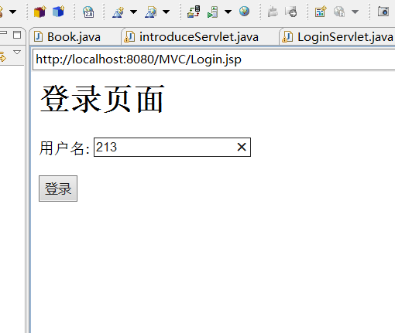

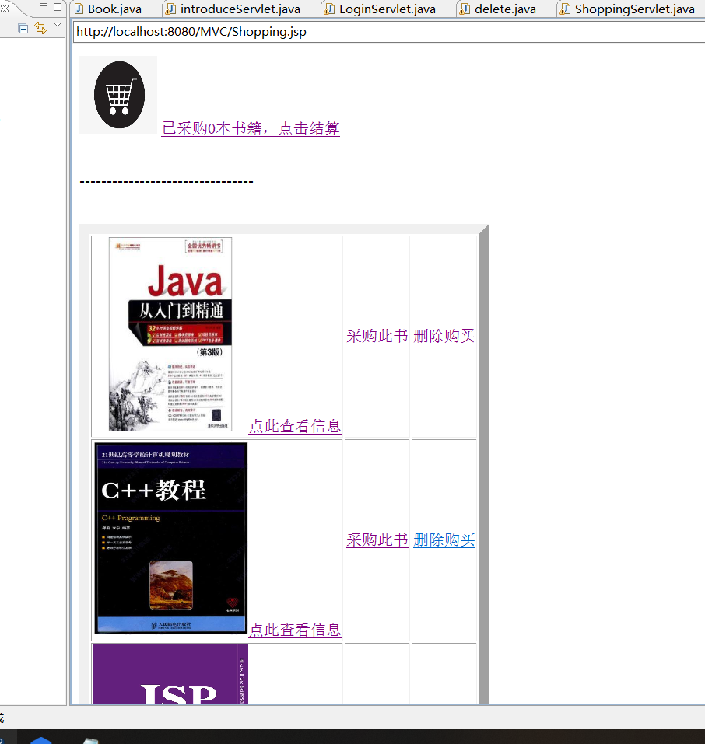

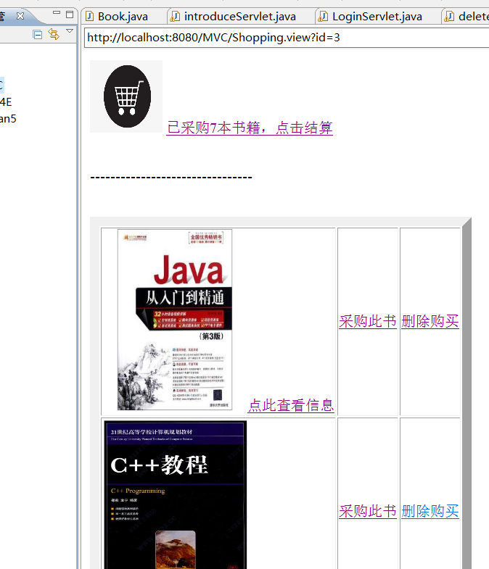

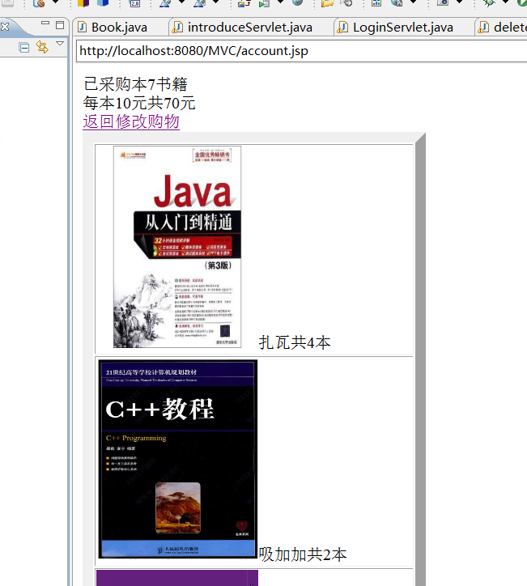

# 收获与问题

对jstl和el有了初步了解