Github

Home

Profile

Your repositories

Add New

Clone to local repository (same as done for class repository)

Go to gitbash and clone (done to desktop in this example

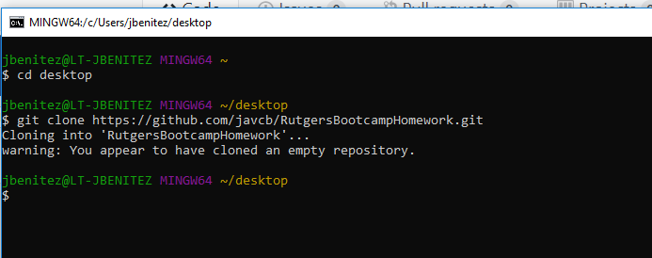

When you add files to RutgersBootcampHomework and you want to upload stuff:

Point to directory . commena🡪 git add * (*means add all files)

To commit🡪git commit -m”added activity 5” (-m message used as a reminder of what you’re committing here) the **-m”entertext”** is REQUIRED otherwise you’ll run into issues

Add is to add file

Commit is to say you’re done editing—and you want to commit all changes

Command to push file to online repository 🡪 git push

**Udemy github course notes:**

Create git folder:

1. go to destination folder via git bash
2. enter ‘git init foldername’