**DEVELOPMENT PROGRESS REPORT**

**October 10, 2025**

|  |  |
| --- | --- |
| **WEBSITE’S PAGES:** | |
| ***Client Side*** | ***Auth Side*** |
| ✅ **Home**  ✅ **About Us**  ✅ **Community**  ✅ **Terms and Condition**  ✅ **Login**  ✅ **Register** | ✅ **Items**  ✅ **Post an Item**  ✅ **Specific Item**  ✅ **Community2**  ✅ **Discussions**  ✅ **Specific Discussion**  ✅ **Post a Discussion**  ✅ **Post a Photo**  ✅ **Specific Resource**  ✅ **Dashboard**  ✅ **Message**  ✅ **Profile** |

**Demo Site:** [**https://website-079a545a.fee.xnf.temporary.site/**](https://website-079a545a.fee.xnf.temporary.site/) **Source Code Repository:** [**https://github.com/javecilla/crisannesweredprayerofjohnrover.com**](https://github.com/javecilla/crisannesweredprayerofjohnrover.com)

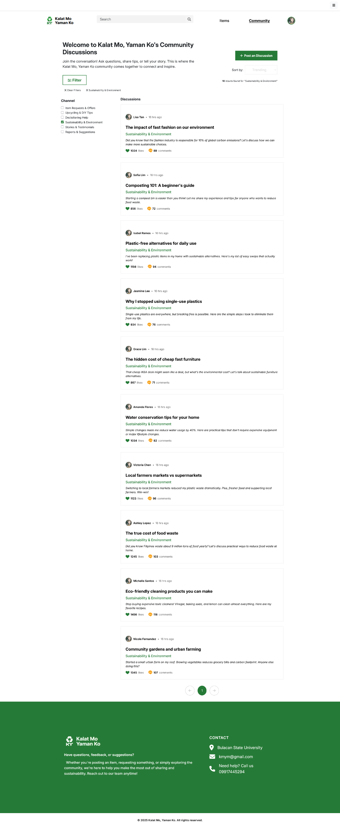**DISCUSSIONS PAGE**

**SPECIFIC DISCUSSION PAGE**

