**DEVELOPMENT PROGRESS REPORT**

**October 2, 2025**

|  |  |
| --- | --- |
| **WEBSITE’S PAGES:** | |
| ***Client Side*** | ***Auth Side*** |
| ✅ **Home**  ✅ **About Us**  ✅ **Community**  ✅ **Terms and Condition**  ✅ **Login**  ✅ **Register** | ❌ **Items**  ❌ **Post an Item**  ❌ **Specific Item**  ❌ **Discussions**  ❌ **Specific Discussion**  ❌ **Post a Discussion**  ❌ **Post a Photo**  ❌ **Specific Resource**  ❌ **Dashboard**  ❌ **Message**  ❌ **Profile** |

**Demo Site:** [**https://website-079a545a.fee.xnf.temporary.site/**](https://website-079a545a.fee.xnf.temporary.site/) **Source Code Repository:** [**https://github.com/javecilla/crisannesweredprayerofjohnrover.com**](https://github.com/javecilla/crisannesweredprayerofjohnrover.com)

**HOME PAGE**

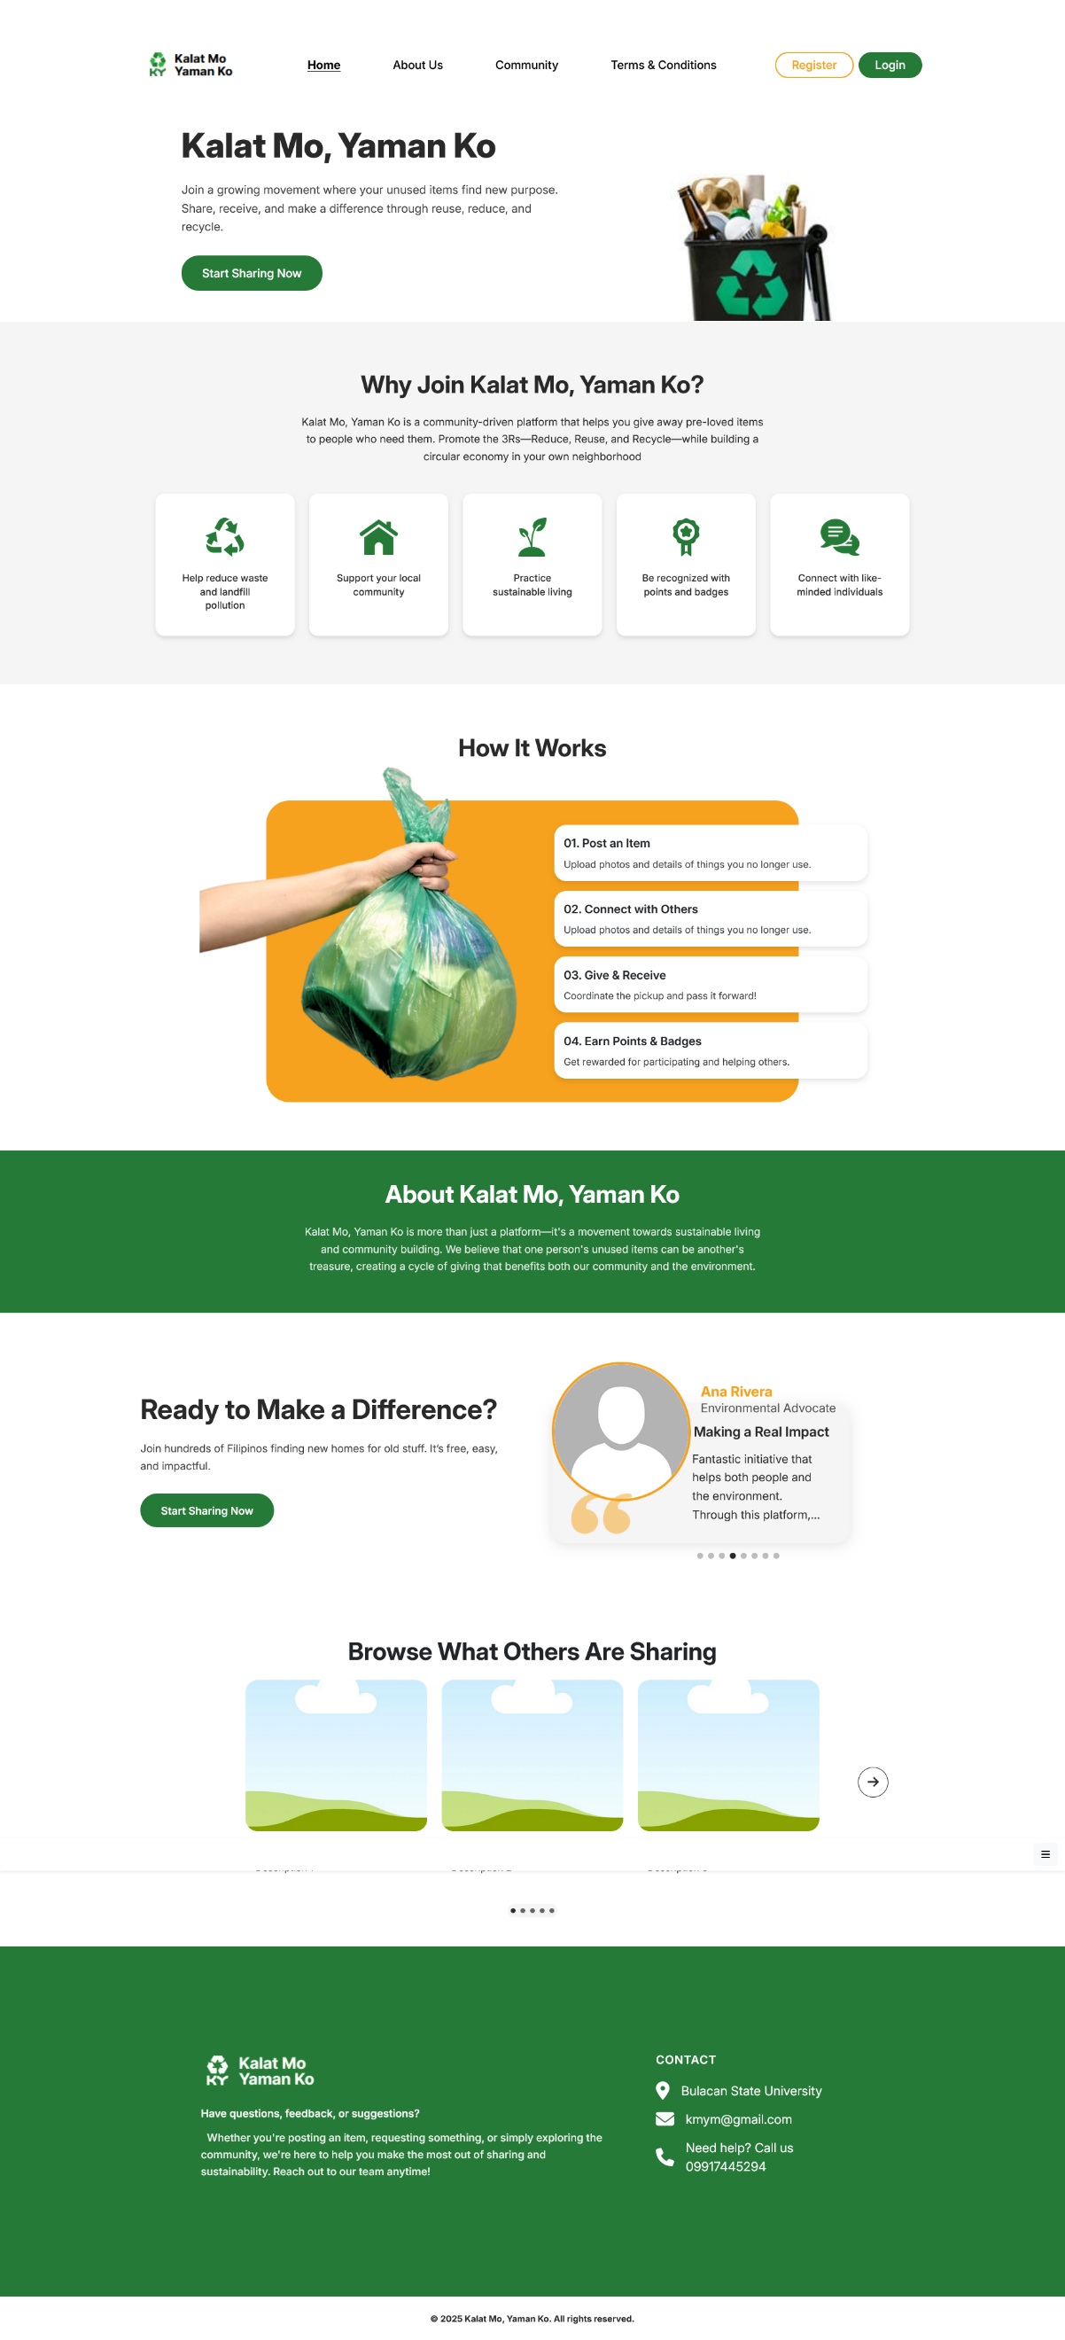

**ABOUT US PAGE**

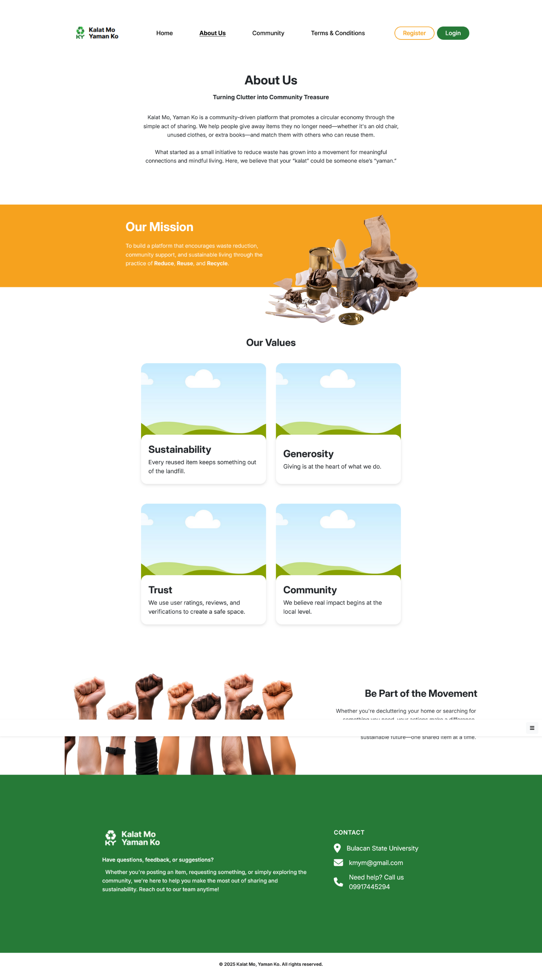

**COMMUNITY PAGE**

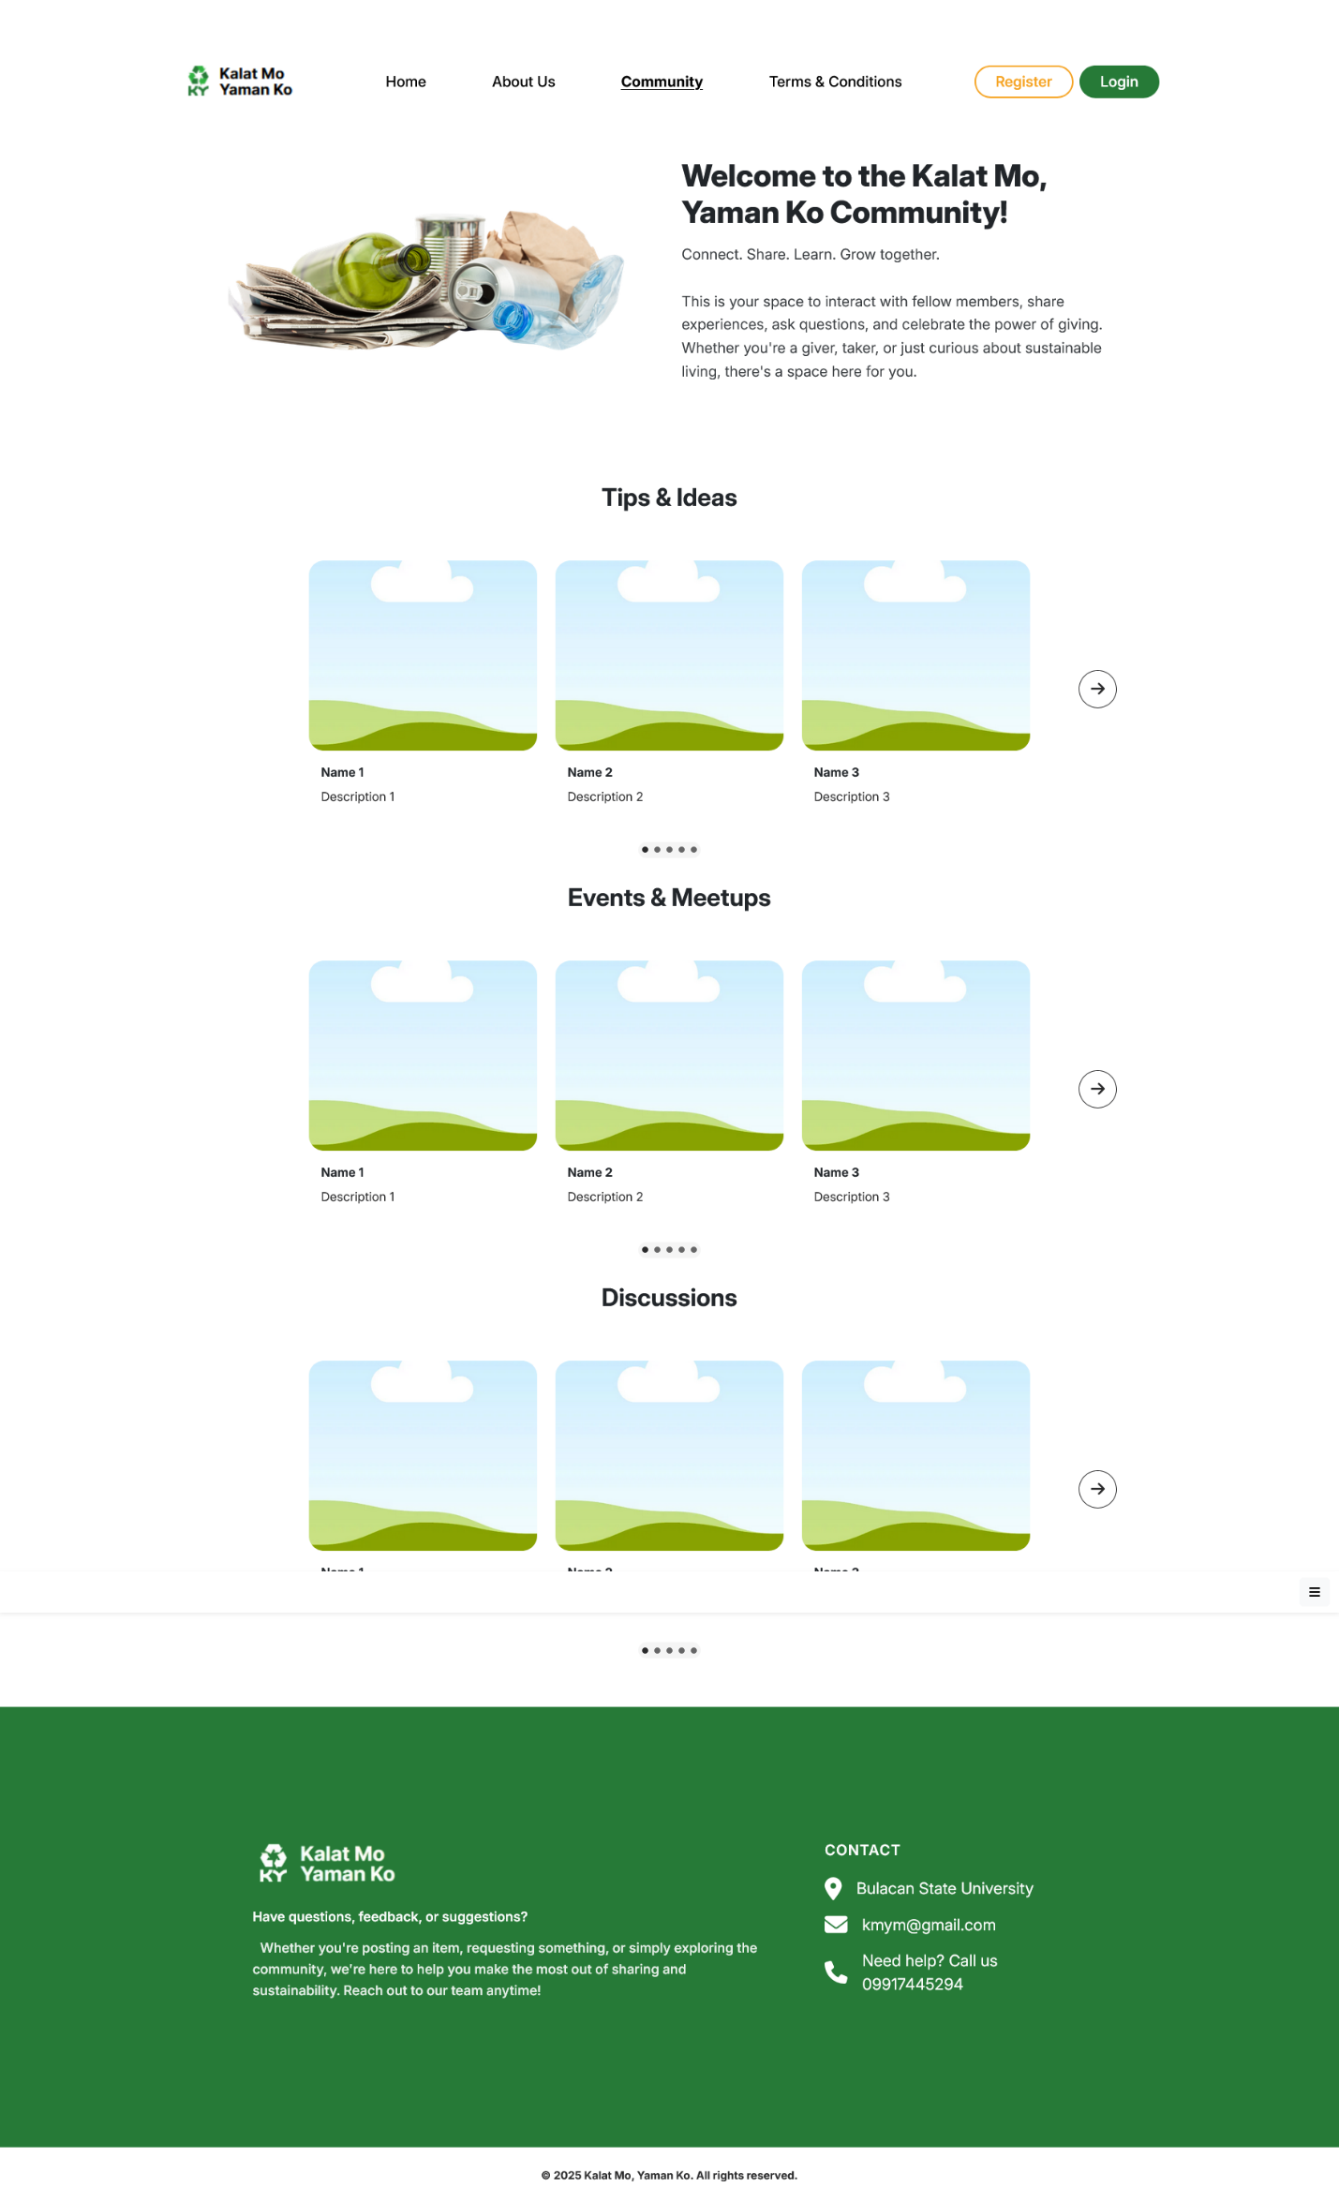

**TERMS AND CONDITIONS PAGE**

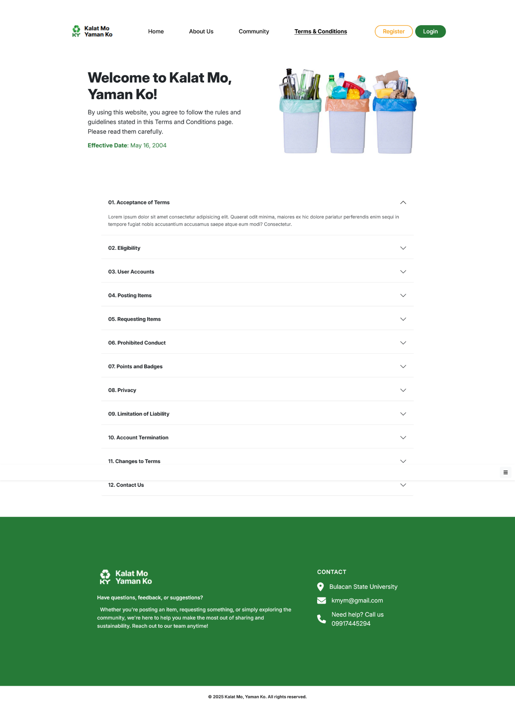

**REGISTRATION PAGE**



**LOGIN PAGE**

