Javed Akhtar  Senior Director of Customer Service · AI-First CX & Operations Leader  Bengaluru, Karnataka | +91-8217541640 | javed.siddique765@gmail.com  javed-akhtar-siddique.github.io | linkedin.com/in/javed-akhtar-53264a16 | 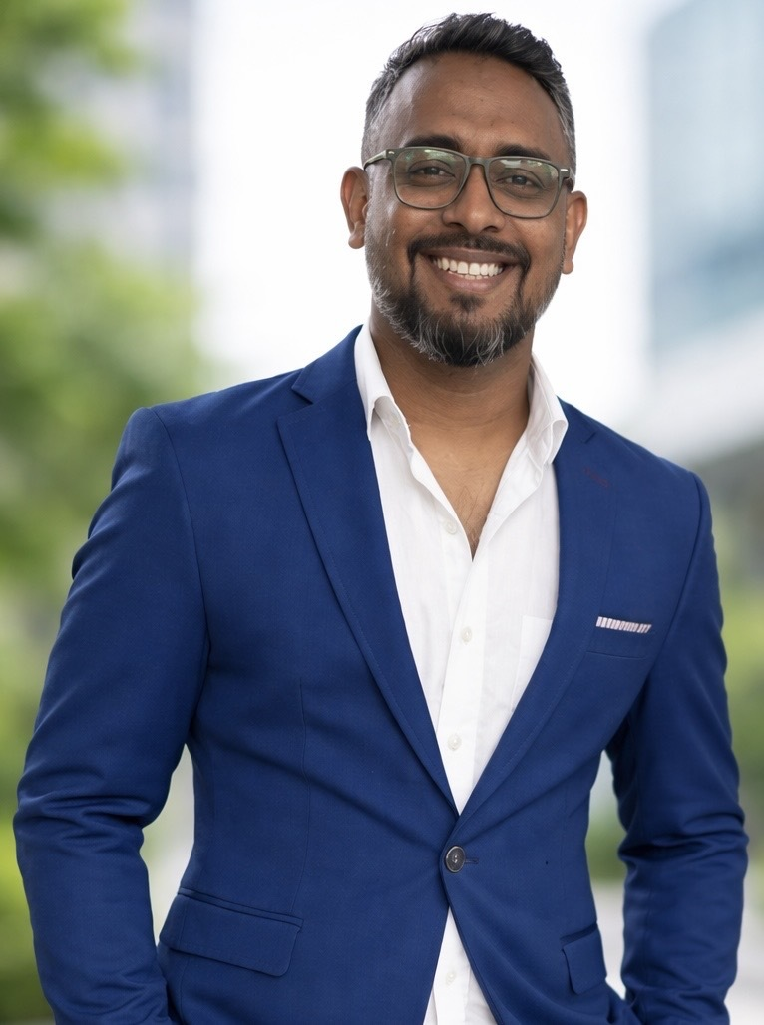
SUMMARY
AI-first Customer Experience and Operations leader with 13+ years building scalable, data-driven customer operations across EdTech, SaaS and PropTech. I believe exceptional customer experience sits where AI, intelligent process design and human insight meet. I lead a 25+ person team and have moved support from reactive to a proactive, AI-powered retention engine, using automation, SQL and API integrations to turn customer data into decisions. I run teams against quality, productivity and service-level targets and plan their capacity, shifts and work allocation. I have worked with globally distributed teams for 5+ years and am open to night-shift, in-office work in Bengaluru.
CORE SKILLS
Team leadership: Coaching, performance reviews, hiring, onboarding, training, escalation management
Operations: Workforce planning, capacity management, shift scheduling, SLA/quality/productivity management, SOPs
Data & systems: SQL, Redash, Postgres, Python, API integrations, ETL, dashboards, AI agents and AI briefs (Claude)
Tools: Atlas, Intercom, Freshdesk, Zendesk, Slack, Airtable, Monday.com, Livechat
EXPERIENCE
Senior Director of Customer Service Oct 2024 – Present
Codingal (EdTech, YC W21) · Bengaluru
- Lead a 25+ person support, retention and success team handling 1,200 WhatsApp chats, 500 website chat messages and 300 emails a day. Plan capacity, scheduling and work allocation to meet service levels.
- Hold 90%+ CSAT on chat and above 85% on email, with first response under 2 min on chat and 60 min on email, and average resolution under 48 hours.
- Cut monthly churn from 16% to 9%. Raised trial-to-completion from 44% to 56% and course completion from 15% to 25%.
- Revamped the customer onboarding process, started an after-class feedback loop and redesigned ticket routing. The parent-teacher meeting (PTM) rate rose to 90%.
- Built a support data platform: a Python and Cloudflare pipeline syncs every ticket into a Postgres warehouse that feeds all dashboards, agents and reports. Write the SQL and Redash queries the team runs on.
- Deployed live AI agents (trial enquiries, paid-course Q&A, teacher payouts) with automatic hand-off to a human. Built a daily AI quality-audit and AI briefs that score ticket handling before each shift.
- Integrated Atlas, Slack, Airtable, Redash and Google Sheets through their APIs to automate reporting, lead feedback and the monthly incentive payout.
- Wrote company-wide SOPs, escalation frameworks and a knowledge base. Work with product and engineering to turn ticket trends into roadmap changes.
Director of Customer Service Oct 2023 – Oct 2024
Codingal · Bengaluru
- Built the support function from scratch: team structure, CRM and ticketing setup, SLA frameworks and the first CSAT measurement across all channels.
- Designed churn-signal playbooks and retention workflows. Aligned support with sales, product and teacher operations.
Customer Success Manager Sep 2018 – Oct 2023
CasaOne (PropTech, Furniture-as-a-Service) · Bengaluru
- First Customer Success hire at an 8-person company. Built the team, processes, KPIs and tool stack, including hiring criteria, onboarding and performance coaching.
- Worked with globally distributed teams across time zones for 5+ years.
- Tracked NPS, CSAT, first-contact resolution, missed-call rate, call wait time and ticket and chat resolution time. Ran NPS programmes, customer interviews and churn reduction.
- Cut failed installations and re-delivery runs by profiling lift, doorway and room dimensions before delivery.
- Administered and trained teams on Zendesk, Slack, Monday.com, DocuSign, Livechat, Textline and DispatchTrack.
Customer Experience Manager Feb 2018 – Sep 2018
Bicycle AI · Bengaluru
- Automated and streamlined support processes, cutting customer complaints by 30% and avoiding extra headcount. Hired and led the team.
Customer Experience Manager Sep 2016 – Feb 2018
Furlenco (FurnitureTech) · Bengaluru
- Lifted customer retention by 20% and upsell revenue by 10% through loyalty programmes and better interactions.
- Wrote policies and SOPs for delayed deliveries and damaged-furniture pickups.
Technical Support Engineer Jan 2016 – Jul 2016
Convergys · Greater Delhi
- Resolved customer issues within SLA and trained new joiners.
EDUCATION
B.Tech, Hardware & Networking · Gandhi Engineering College
LANGUAGES
English, Hindi, Oriya

