***Javed Shaukat***

**Lab 12A – Postgresql | Tuesday, April 29, 2025 – (Introduction)**

Class Example:

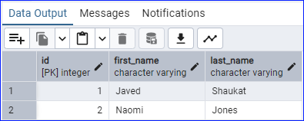

**Lab Exercise 1 | Tuesday, April 29, 2025 – (Exercise)**

Manually create a database, table, and columns.

* Database name: demoDB
* Tables: courses, tuition

Courses table will have four columns: id (primary key), course_code (2 characters), semester (character varying), schedule (text).

* Create two courses’ data entries.

Tuition table will have three columns: id (primary key), pt_credit_price (numerical), ft_price(numerical).

* Create one data entry for local students.
* Create one data entry for international students.

Courses Table and data entry:

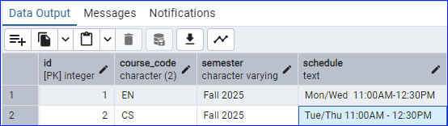

Tuition Table and data entry:

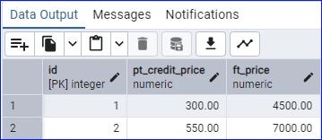

**Thursday, May 01, 2025 (CRUD)**

Class Example:

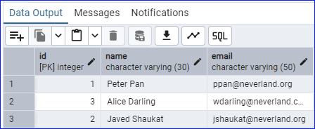

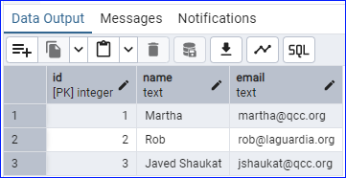

**12B Lab Exercise:**

-- 1. CREATE THE TABLE:

CREATE TABLE books (

id SERIAL PRIMARY KEY,

title VARCHAR(100) NOT NULL,

author VARCHAR(100) NOT NULL,

year_published INT

);

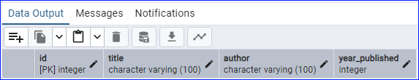

-- 2. INSERT RECORDS:

INSERT INTO books (title, author, year_published) VALUES

('The Great Gatsby', 'F. Scott Fitzgerald', 1925),

('Animal Farm', 'George Orwell', 1945),

('To Kill a Mockingbird', 'Harper Lee', 1960),

('Brave New World', 'Aldous Huxley', 1932);

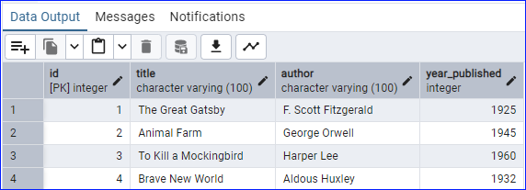

-- 3. READ DATA

SELECT * FROM books;

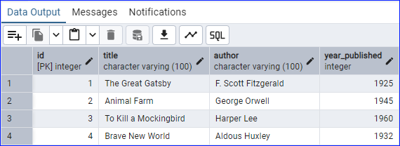

-- 3B SELECT BOOKS BY GEORGE ORWELL

SELECT * FROM books WHERE author = 'George Orwell';

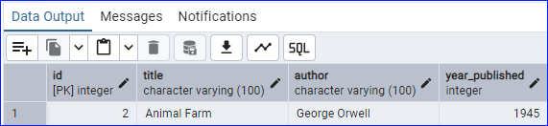

-- 4. UPDATE DATA, UPDATE THE PUBLICATION YEAR OF BRAVE NEW WORLD:

UPDATE books

SET year_published = 1931

WHERE title = 'Brave New World';

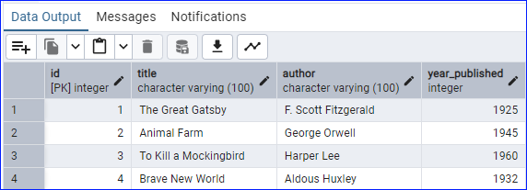

-- 5. DELETE DATA, DELETE TO KILL A MOCKING BIRD:

DELETE FROM books

WHERE title = 'To Kill a Mockingbird';

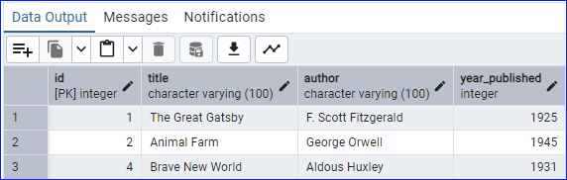

-- 6. VIEW FINAL TABLE:

SELECT * FROM books;

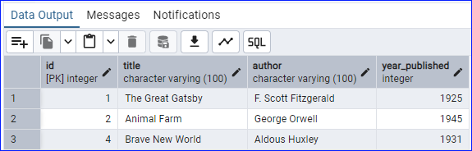

-- BONUS CHALLENG, ADD A NEW COLUMN 'GENRE' TO THE BOOKS TABLE:

ALTER TABLE books

ADD COLUMN genre VARCHAR(50);

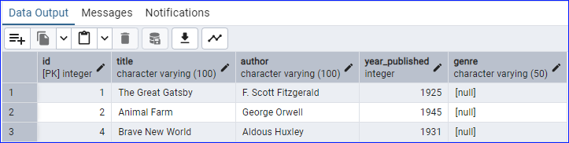

-- UPDATE THE GENRE FOR EACH BOOK:

UPDATE books SET genre = 'Classic' WHERE title = 'The Great Gatsby';

UPDATE books SET genre = 'Dystopian' WHERE title = 'Animal Farm';

UPDATE books SET genre = 'Dystopian' WHERE title = 'Brave New World';

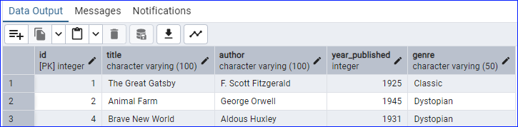

-- SELECT ALL BOOKS GROUPED BY GENERE:

SELECT genre, COUNT(*) as book_count, STRING_AGG(title, ', ') as titles

FROM books

GROUP BY genre;

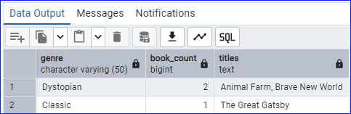

**Friday, May 02, 2025**

Class Example:

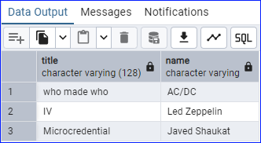

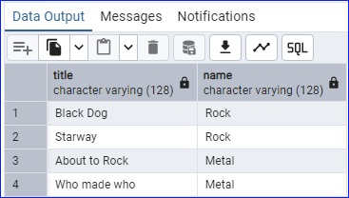

**LAB 12C – LAB EXERCISE**

Relational database

Activity description: Create a database for a university to manage students, courses, and

enrollments, and practice performing some SQL queries.

Assignment:

• Create three tables:

o ‘students’ table with columns:

▪ id, serial and primary key

▪ name, variant character maximum of 100 characters

▪ major, variant character maximum of 100 characters

o ‘courses’ table with columns:

▪ id, serial and primary key

▪ title, variant character maximum of 100 characters.

▪ department, variant character maximum of 100 characters.

o ‘enrollments’ table with columns:

▪ id, serial and primary key

▪ grade, 2 characters

▪ Foreign key named ‘student_id’ to student’s id

▪ foreign key named ‘courses_id' to courses’ id

Create a database:

Right-click on "Databases" and select "Create" > "Database"

Name it "university" and click "Save"

-- Students table

CREATE TABLE students (

id SERIAL PRIMARY KEY,

name VARCHAR(100) NOT NULL,

major VARCHAR(100) NOT NULL

);

-- Courses table

CREATE TABLE courses (

id SERIAL PRIMARY KEY,

title VARCHAR(100) NOT NULL,

department VARCHAR(100) NOT NULL

);

-- Enrollments table

CREATE TABLE enrollments (

id SERIAL PRIMARY KEY,

grade CHAR(2),

student_id INT REFERENCES students(id),

course_id INT REFERENCES courses(id)

);

SELECT * FROM students;

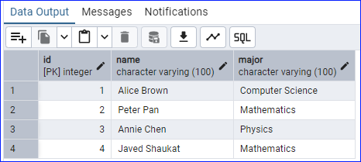

SELECT * FROM courses;

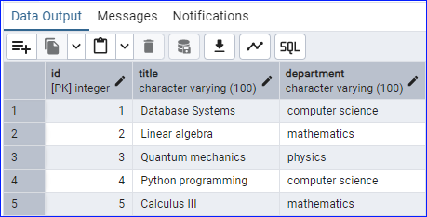

SELECT * FROM enrollments;

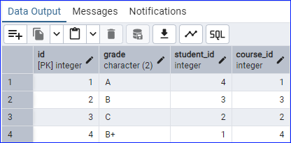

-- Insert students

INSERT INTO students (name, major) VALUES

('Alice Brown', 'Computer Science'),

('Peter Pan', 'Mathematics'),

('Annie Chen', 'Physics'),

('Javed Shaukat', 'Mathematics');

-- Insert courses

INSERT INTO courses (title, department) VALUES

('Database Systems', 'computer science'),

('Linear algebra', 'mathematics'),

('Quantum mechanics', 'physics'),

('Python programming', 'computer science'),

('Calculus III', 'mathematics');

-- Insert enrollments

-- Note: You'll need to use the actual IDs from your tables

-- This assumes the IDs were created in order as inserted

INSERT INTO enrollments (grade, student_id, course_id) VALUES

('A', 4, 1), -- Javed in Database Systems

('B', 3, 3), -- Annie in Quantum mechanics

('C', 2, 2), -- Peter in Linear algebra

('B+', 1, 4); -- Alice in Python programming

-- Read all students and their majors

SELECT name, major FROM students;

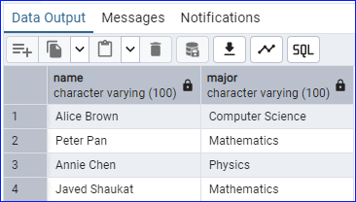

-- Read the title of courses each student is enrolled in

SELECT s.name, c.title

FROM students s

JOIN enrollments e ON s.id = e.student_id

JOIN courses c ON c.id = e.course_id;

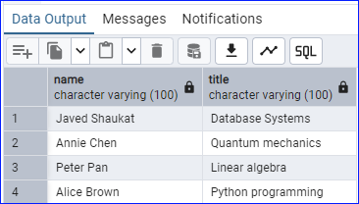

-- Read all students with grades and courses

SELECT s.name, c.title, e.grade

FROM students s

JOIN enrollments e ON s.id = e.student_id

JOIN courses c ON c.id = e.course_id;

