File Carving and Data Recovery
A Practical Approach to Recovering Deleted Files Using Raw Disk Signature Scanning
Student Name | Javed Ahmed
Course | Cyber Security
Topic | File Carving / Data Recovery (Digital Forensics)
Tool / Language | Python 3 (raw disk I/O)
Date | 21 June 2026

1. Objective
The objective of this assignment is to understand and practically implement the concept of file carving — a digital forensics technique used to recover deleted or lost files from storage media without relying on the file system's metadata. The implementation focuses on recovering JPEG image files and MP4 video files from an NTFS-formatted local disk by directly scanning the raw bytes of the drive for known file signatures.

2. Introduction and Theoretical Background

2.1 What is File Carving?
File carving is a data recovery technique that reconstructs files purely from their raw binary content, rather than from file system structures such as the Master File Table (MFT) in NTFS or the File Allocation Table in FAT32. When a file is deleted, most file systems do not immediately erase the actual data on disk — they simply remove the reference (pointer) to that data and mark the space as “available” for reuse. Until that space is overwritten by new data, the original bytes physically remain on the disk and can potentially be recovered.
Because file carving does not depend on file system metadata, it works even when:
- A file has been permanently deleted (including from the Recycle Bin)
- The file system's directory structures are corrupted or damaged
- A partition has been reformatted, as long as the underlying data has not been overwritten

2.2 File Signatures (Magic Numbers)
Every common file format begins with a unique sequence of bytes known as a “magic number” or file signature, which identifies its type regardless of the file's name or extension. Many formats also contain a distinct end-of-file marker. File carving tools exploit this property by scanning raw disk sectors for these known byte patterns.
File Type | Header Signature (Hex) | Footer / End Marker
JPEG (.jpg) | FF D8 FF E0 / E1 / DB | FF D9
MP4 (.mp4) | 66 74 79 70 (“ftyp” box, offset 4) | None fixed — uses a size cutoff instead

2.3 Why NTFS Matters
The target drive in this assignment is the Windows C: drive, formatted with NTFS. NTFS is the default Windows file system and supports raw, low-level device access through a special path syntax (\\.\C:), which allows a program — running with Administrator privileges — to read the disk sector-by-sector, bypassing the normal file system layer entirely. This is what makes it possible to read sectors that the file system itself no longer considers part of any file.
It is important to note that this approach is fundamentally different from accessing an Android phone's internal storage over USB, which uses the Media Transfer Protocol (MTP). MTP only exposes a virtual list of currently existing files and does not allow raw, sector-level access, which is why the same carving technique cannot be applied directly to a non-rooted Android device.

3. Methodology / Tools Used
The recovery tool was implemented in Python 3 and executed on Windows via an elevated (Administrator) Command Prompt. The overall approach followed these steps:
- Open the source drive (C:) in raw binary mode using the special path \\.\C: , which requires Administrator rights.
- Read the drive in large 4 MB chunks for scanning efficiency.
- Search each chunk for the JPEG and MP4 header signatures listed in Section 2.2.
- When a header is found, begin writing bytes to a new output file until the matching footer (JPEG) is found, or a maximum size cutoff is reached (MP4).
- Discard any match smaller than 1 KB, treated as a false positive rather than a genuine file.
- Save every recovered file to a separate physical drive (D:) to avoid overwriting any remaining recoverable data on the source drive (C:).
Recovered files are saved with sequential generic names (e.g., recovered_00001.jpg) inside D:\Recovered\jpg\ and D:\Recovered\mp4\, since the original file names are not stored in the raw data itself and cannot be reconstructed by signature-based carving alone.

4. Code Explanation

4.1 Configuration and Signatures
The script defines the source drive, output folder, sector/chunk size, and a dictionary of file signatures. Each entry specifies acceptable header byte patterns, an optional footer pattern, and a maximum allowed file size to prevent runaway carving on corrupted data:
SOURCE_DRIVE = r"\\.\C:"
OUTPUT_DIR = r"D:\Recovered"
READ_CHUNK = 4 * 1024 * 1024 # 4 MB per read
SIGNATURES = {
"jpg": {"start": [b'\xff\xd8\xff\xe0', ...], "end": b'\xff\xd9', ...},
"mp4": {"start": [b'ftyp', ...], "end": None, "max_size": 200MB},
}

4.2 Administrator and Safety Checks
Before scanning begins, the script verifies it is running with Administrator privileges using the Windows API (ctypes.windll.shell32.IsUserAnAdmin), since raw device access is blocked otherwise. It then asks the user to explicitly confirm before starting, since the scan can take a long time on large drives.

4.3 Signature Search Loop
The main loop continuously reads 4 MB chunks from the drive and searches each one for the configured header signatures. When a match is found, the carve_file() function takes over: it seeks to the matching offset and streams data into a new output file until the footer signature is located (for JPEG) or the maximum size limit is reached (for MP4):
idx, matched = find_signature(chunk, config["start"])
if idx >= 0:
absolute_offset = offset + idx
success, size = carve_file(fileD, file_type, absolute_offset, counters[file_type])

4.4 Output and Progress Reporting
Every successfully carved file is logged to the console with its disk offset, output filename, and size in MB. Every five seconds, the script also reports how much of the drive has been scanned so far, giving the user visibility into long-running scans on large disks.

5. Implementation and Execution
The tool was executed from an elevated Command Prompt as follows:
cd /d "D:\projects\Cyber Security @Arch_technology"
python recover_data.py
Execution steps observed:
- The script correctly detected Administrator privileges and proceeded without error.
- It displayed the configured source drive (\\.\C:) and output folder (D:\Recovered).
- A safety prompt (“Continue karein? (yes/no):”) required explicit confirmation before any disk access began, preventing accidental execution.
- Recovered output files were directed to a separate physical drive (D:) rather than the source drive (C:), to avoid the recovery process itself overwriting other recoverable data.

6. Results
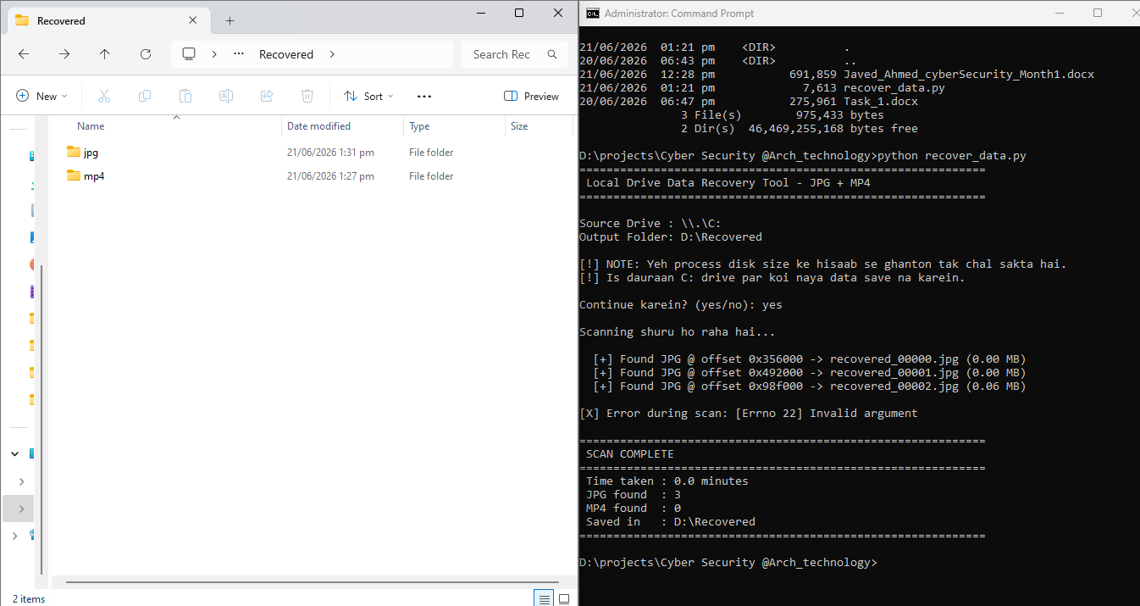

7. Challenges Faced
- Raw device access (\\.\C:) requires Administrator privileges; running the script without elevation initially resulted in a Permission Denied error.
- MP4 files do not have a fixed end-of-file marker like JPEG's FF D9, so a maximum size cutoff (200 MB) was used instead to bound each carved file.
- Carving directly onto the same drive being scanned (C:) would risk overwriting other recoverable data, so all output was redirected to a separate physical drive (D:).
- Short, coincidental byte matches in unrelated data could trigger false positives; files smaller than 1 KB were automatically discarded to reduce this issue.

8. Conclusion
This assignment demonstrated the practical application of file carving as a digital forensics and data recovery technique. By scanning a drive's raw bytes for known file signatures rather than relying on file system metadata, it is possible to recover files that have been deleted, including from the Recycle Bin. The exercise also highlighted an important distinction in digital forensics: raw, signature-based recovery is only possible on storage that exposes low-level block access (such as an NTFS drive accessed with Administrator rights), and is not possible on devices such as non-rooted Android phones, which only expose a restricted, virtual file view through protocols like MTP. This reinforces the importance of understanding the underlying storage and access model of a device before selecting an appropriate forensic recovery technique.

9. References
- Carrier, B. (2005). File System Forensic Analysis. Addison-Wesley.
- Microsoft Documentation — Win32 Device Namespaces and Raw Disk Access.
- ISO/IEC 14496 — MPEG-4 (MP4) File Format Specification.
- JPEG File Interchange Format (JFIF) Specification, Version 1.02.

