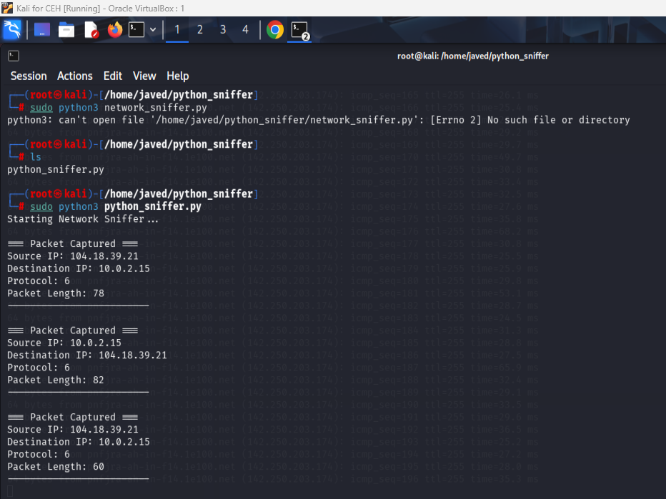
Task 1 : Network Sniffer:

