Blog for CA674 Cloud Architecture project

Team Members:

* Javedali Shaikh
* Sanjay Singh
* Kevin Shortall

Please note that this github blog was created on 15th November 2017. Up until this date, progress was tracked in a Google Sheet location in Google Drive, at the link shown below. The first entries shown in this blog come from that Google Sheet.

**Google Sheet location:**

<https://docs.google.com/spreadsheets/d/1fGVU8-_ZSk_-E7G1xKPsJQ1M4j3zhTc23c0DhKyYrhk/edit#gid=0>

**Original Google Sheet entries:**

|  |  |  |  |
| --- | --- | --- | --- |
| **Date** | **Student(s)** | **Topic** | **Detail** |
| 27/9/2017 | All | Group formation | Initial group formed of three students. |
| 29/9/2017 | Kevin | Project Topic | Initial project topic regarding the storage of photos on various cloud servers sent to the group via email. |
| 1/10/2017 | Sanjay | Project Topic | Additional project topic suggestions regarding various versions of SQL accessing docker locations on different cloud platforms. |
| 6/10/2017 | Kevin | Project Group | Project group of 3 students (Sanjay, Javed, Kevin) confirmed to lecturer. |
| 9/10/2017 | All | Meeting | Group meeting in Business School of DCU to brainstorm project ideas. Discussed possibilities of using DockerHub for code storage locations and accessing it from AWS and Azure. Also examining different storage types, such as table, file, blob, etc. |
| 11/10/2017 | All | Project Topic | Email sent by Kevin to lecturer, after discussion with the whole group, regarding some initial potential project topics, as well as seeking clarification on the scope required. Response received on the same day which ruled out some of the smaller-scoped project ideas. |
| 17/10/2017 | Javed | Project Topic | Suggestion to use face recognition application, fetching images from storage on the cloud and using machine learning services. Other suggestions of IoT Hub (connect and monitor IoT devices) and Develop Micro-services and orchestrate containers. |
| 18/10/2017 | Sanjay | Project | Whatsapp group created for the project. |
| 18/10/2017 | All | Skype Call | Discussed various project options. Decided upon running face recognition app on a hosted website using three different sources - Azure, AWS and OpenShift. |
| 19/10/2017 | Kevin | Project Topic | Confirmation that AWS is more suitable than Google due to Google has a face detection API, but not a face recognition API. |
| 20/10/2017 | Kevin | Project Proposal | Proposal file uploaded to Loop for review by the lecturer. |
| 28/10/2017 | Sanjay | Project Report | Draft report suggestion circulated to the group containing suggested headings and content. |
| 29/10/2017 | Javed | Website format | Request that ability of hosting asp.net websites is required of all three cloud services. Confirmed by all students. |
| 30/10/2017 | All | Skype Call | Confirmation that all three infrastructures can support asp.net websites. |
| 30/10/2017 | Javed | Skype Call | Website code sourced. Code to be refined and submitted to github as the central repository. |
| 08/11/2017 | Kevin | Blog | Google Spreadsheet created and shared to be used as a Blog location for the team. |
| 12/11/2017 | Javed | Web code | Initial website code for face recognition api shared with the group via Github. |
| 13/11/2017 | All | Project Meeting | Demonstration of web code developed so far and it's interaction with Microsoft Azure. Clarification of the next steps to incorporate that code into AWS and Open Shift cloud platforms. Layout of the remainder of the project approximately as follows: 1. Hosting  2. Configuring  3. Storage  4. Scaling |
| 13/11/2017 | Kevin | Visual Studio | Visual Studio 2017 Community Edition installed. When trying to open the FaceAPI_MVC.sln file, the following feature was required to be installed in Visual Studio: ..\FaceAPI_MVC.Web\FaceAPI_MVC.Web.csproj |
| 15/11/2017 | Kevin/Sanjay | Meeting | Meeting in Business School in DCU. Review of recent progress with regards to hosting website on AWS and OpenShift. Demonstration of VM Machine used by Sanjay to access Cloud areas. |
| 15/11/2017 | Sanjay | Minishift | MiniShift setup on Windows -  Installed Virtual Box 5.1.3  minishift-1.6.0-windows-amd64  Just tried how to start and stop Virtual Box using cmd command and setup to access Openshift using local IP - <https://192.168.99.100:8443/console/> |

**12 November 2017 - Javed**

Face API, an ASP.NET based website created and commited to GITHUB. This was our first github commit. Microsoft Azure face API service is used in the backend (Software as a Service)

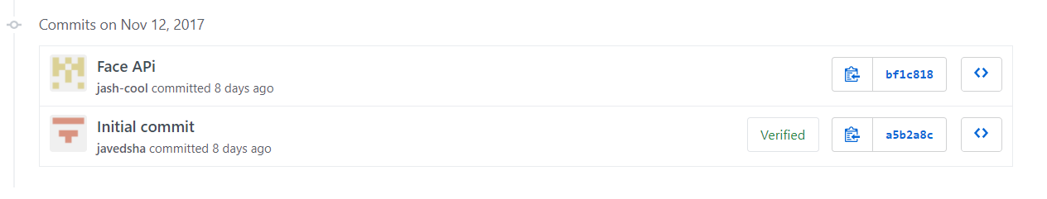

The website has one major functionality added at this moment – detecting faces from an image uploaded through user’s local hard drive. The website code was taken from [here](https://code.msdn.microsoft.com/Face-API-Using-ASPNet-MVC-40259a76) and modified to suite our requirements.

**13 November 2017 - Javed**

Created new Face API account in Microsoft azure to get our free trial Face API endpoint.

Updated the Face API website with the new face API endpoint and also updated the code to point to right location of Face API endpoint (<https://westcentralus.api.cognitive.microsoft.com/face/v1.0>)

Lastly, code was updated to refer latest nuget packages (binaries) for Face API.

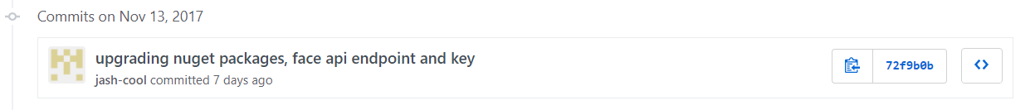

**16/11/2017 - Kevin**

Web app successfully deployed to AWS via the AWS Toolkit in Visual Studio 2017. The URL successfully brings the user to a browser window which shows the web application interface.

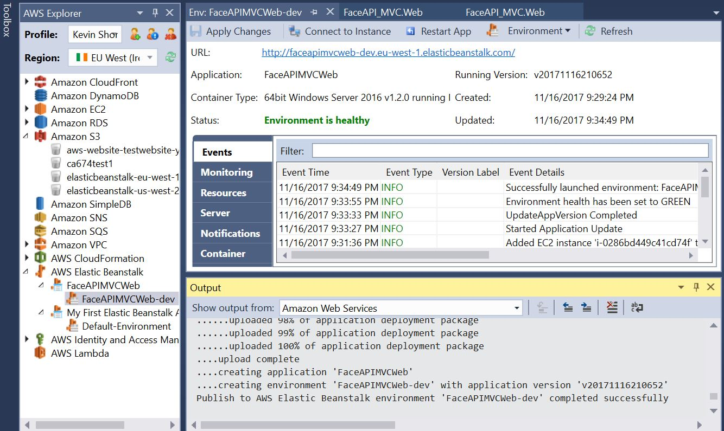

**17/11/2017 – Kevin**

Difficulty found when trying to upload an image from a local source to the Face API webpage. I have accessed the url from different devices, so the page is live, but there is a disconnect with retrieving the images. I am still working on a solution to this.

**18 November 2017 – Javed**

Created new Microsoft Azure Subscription (Free trial). It is valid for 1 year and has $200 credit.

Deployed the Face API website to Microsoft Azure (Web Apps). It is hosted as a website in Azure using S3 (standard tier). Machine configurations are: 1 Core, 1.75 GB RAM and 50GB internal storage. Cost of the machine is $40/month (roughly depend on the numbers of hours). So balance money is $160.

Below are the main screen shot for the process of deploying the website to Azure. Tools used are Visual Studio 2015 and Cloud Explorer.

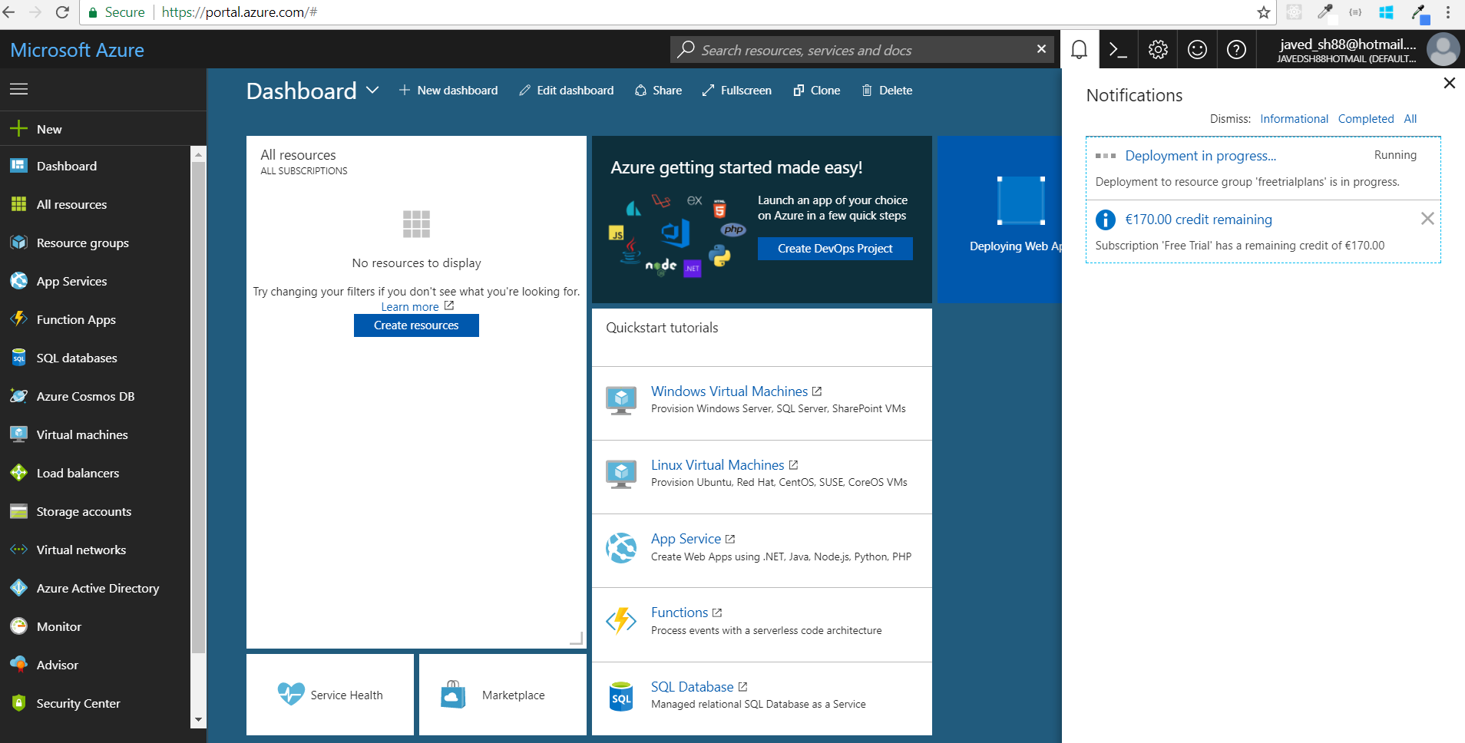

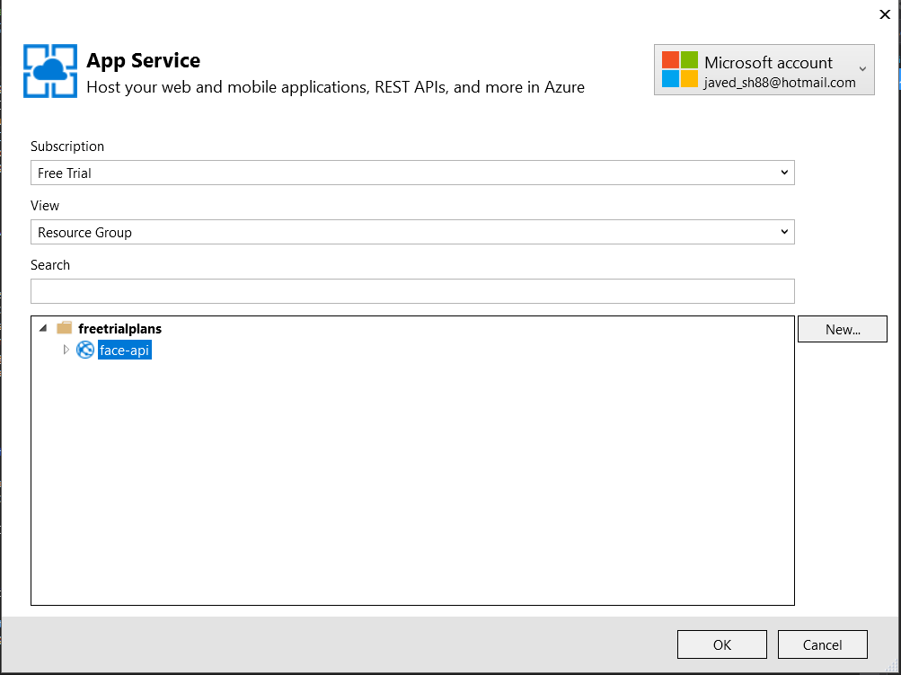

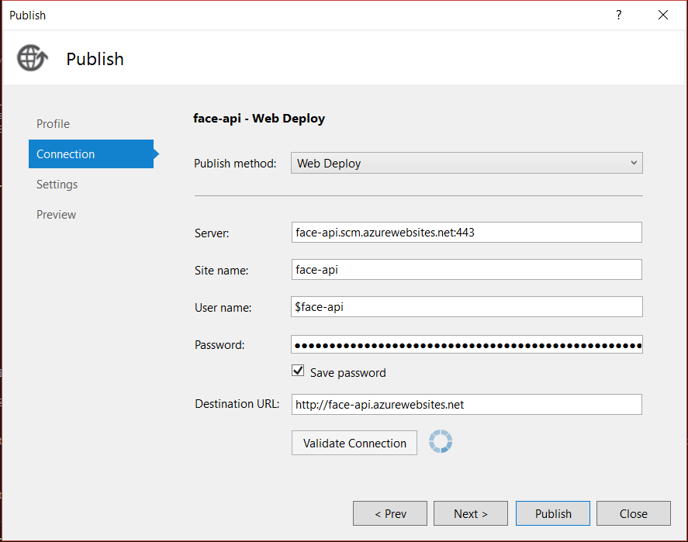

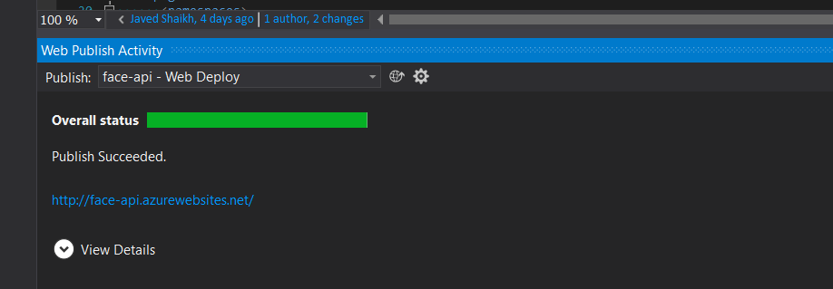

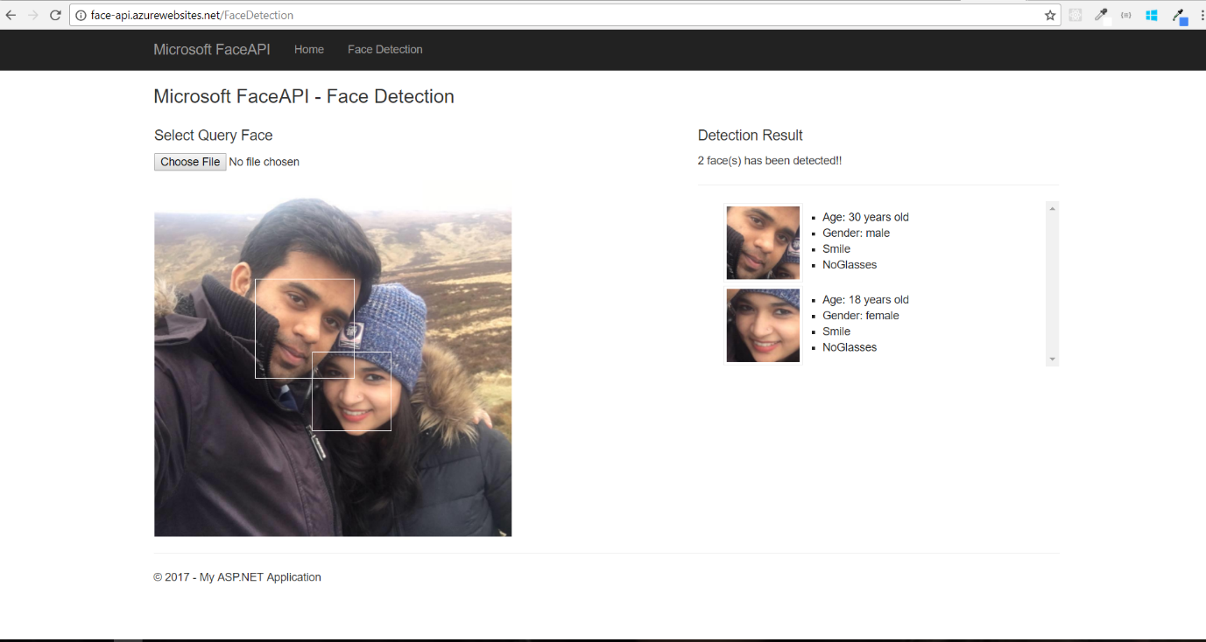

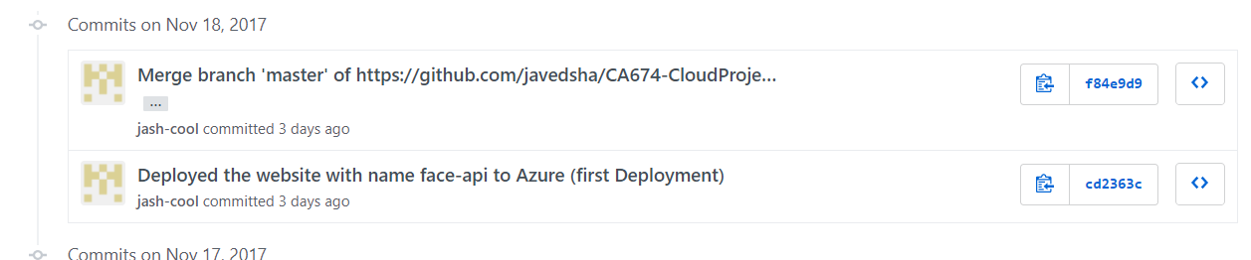

**19 November 2017 – Javed**

Created plan on ‘How to use Storage aspects of Cloud’. Discussed with Sanjay and Kevin and.

There are two options, which we discussed:

1. Creating a storage contract (IStorage.cs) and implementing three different solutions for Azure, AWS and Open Shift.
2. Investigate if all three cloud storages has REST API to access the storage (READ/WRITE). If yes, then we can develop one single component which can interact with any storage layer as long as it follows REST protocols which is quite standard. We are planning to store the different REST endpoints in web.config so that we can change it in each cloud provider.

Looks like option #2 is the best approach. Everyone will investigate and after that we will make a decision.

**20 November 2017 – All**

Had our sync after the lecture. Start Time: 6:00 PM. End Time: 7:40PM.

Main points for discussion:

1. Normal Status update
2. Looking at the issues we are facing in hosting the Face API website in AWS. In AWS, when we are trying to upload an image from local hard drive, we are getting error. After debugging we found that, the code is failing to create a folder in website directory. Though this works fine in Azure. Possible solution discussed are to give permission to ‘wwwroot’ folder in AWS server machine or updating the code to store uploaded images in a different folder.
3. Looking at the issues faces in Open Shift. Open shift has different mechanism to host ASP.NET 4.5 and ASP.NET Core based websites. Turns out that former is more complex. We were trying to set up proper tools on Sanjay’s machine – Visual Studio 2015 Community version and Click2Cloud extension for VS 2015. Sanjay originally installed VS 2017, but the Click2Cloud extension is not supported. So, he uninstalled 2017 version and then re-installed VS 2015. During this process, looks like something has went wrong with Visual Studio and .NET Framework. He is trying to do a clean install again.