# **Analysis of PaaS & SaaS Interoperability through Azure, OpenShift and AWS**

### Javedali Shaikh (16212373) | Sanjay Singh (16211668) | Kevin Shortall (16213216)

### Team 10

### 06/12/2017

## Introduction

The advent of the cloud industry has changed the way the world interacts with computing. Compared to traditional computing, cloud computing offers benefits such as increased cost efficiency, vastly increased storage potential, and backup and recovery. These advantages have seen most medium- and large-scale companies shift their businesses to the cloud. The resulting growth in the cloud computing industry has seen providers branch into an increasing number of areas, with many cloud providers now offering services such as data gathering and data analytics.

In this paper we will compare PaaS solutions on the two market leaders in commercial cloud (Amazon’s AWS and Microsoft’s Azure) and one open-source cloud platform (OpenShift). We will deploy to the platforms an application written in asp.net programming language, designed for face detection in images. We will examine various aspects of the platforms in relation to this interaction, such as storage, auto-scaling, interoperability and backup/recovery.

## Goal of the Project

The goal of this project is to build and deploy an application across three difference cloud platforms and compare those cloud platforms on a number of features. The application will make use of storage locations within those platforms to retrieve image files, which it will analyse for face detection. The three cloud platforms chosen are Microsoft Azure, Amazon Web Service (AWS) and an open source platform called OpenShift.

## Method

Due to the expertise within the team, it was decided that Microsoft Azure would be the anchor platform, with AWS and OpenShift working in comparison to Azure. The code for the application was built using asp.net language. The method consisted of firstly deploying a simple Face Detection app on all platforms that allowed one image to be uploaded at a time. Once successful, the code was updated to retrieve multiple images from storage locations within the relevant cloud platforms. The code was also adapted to apply an artificial loading to the CPU to confirm that auto-scaling is working as planned.

## Description of chosen Cloud Platforms/ Conceptual view (Literature-based)

## Microsoft Azure

## OpenShift

## AWS

## Amazon’s AWS Cloud Platform is the longest established major cloud platform in the market and has continuously dominated the market share, with reports [1] in November 2017 of a 44% public cloud market share. AWS continues to offer customers the largest range of cloud projects, with recent branching into data analytics and machine learning, and reported future ventures into healthcare and education.

## More Required here!

## [1] <https://www.business2community.com/cloud-computing/cloud-service-provider-comparison-will-next-big-provider-part-one-alibaba-01965914#vLEEF3SQY1hyfF2d.97>

## Architecture of chosen Cloud platforms

## Microsoft Azure

## OpenShift

## AWS

## High-Level view of Results and Challenges

The application was successfully deployed on Azure and AWS but challenges occurred in OpenShift due to differing asp.net framework versions.

## Summary Comparison Table

|  |  |  |  |
| --- | --- | --- | --- |
|  | **Azure** | **OpenShift** | **AWS** |
| Creating an Account / Installation |  |  |  |
| Documentation & Community |  |  |  |
| Management Portal & Account Administration |  |  |  |
| Public/Private/Enterprise Options |  |  |  |
| Data Storage |  |  |  |
| Querying Data |  |  |  |
| Deploying Applications |  |  |  |
| Interoperability |  |  |  |
| Costs & Free Plans |  |  |  |
| Configuration changes |  |  |  |
| Backup resources and options |  |  |  |
| Ease of Use/User-Friendliness |  |  |  |
| Monitoring |  |  |  |
| Security |  |  |  |
| **Total Score** |  |  |  |

## Comparison points:

### Creating an Account / Installation

* Microsoft Azure
* OpenShift
* AWS

The creation of an AWS account is quite straightforward and intuitive. There is a free usage allowance given to each new user, though credit card details must be supplied in case of exceeding those thresholds. There is no local installation required to work with AWS but the installation of Visual Studio 2017 (Community Version) was of assistance throughout this project.

### Documentation & Community

* Microsoft Azure
* OpenShift
* AWS

AWS has a plethora of information, support and documentation, throughout the internet and within the AWS environment. This information ranges from personal blogs to forums to online ‘how-to’ videos. While this is obviously an advantage in most scenarios, as a beginner with AWS and cloud in general, the breadth of information can make it difficult to find solutions to particular problems. Also, due to AWS’s comparative longevity in the cloud market, quite a sizeable amount of that information is now already outdated, such is the speed of evolution in the Cloud market. Indeed, one noticeable flaw in AWS’s documentation was how many of the ‘support’ pages were referencing old versions of the AWS GUI, which sometimes made it difficult to find certain aspects that were referred to. 3.5/5

### Management Portal & Account Administration

* Microsoft Azure
* OpenShift
* AWS

### Public/Private/Enterprise options

* Microsoft Azure
* OpenShift
* AWS

### Data Storage

* Microsoft Azure
* OpenShift
* AWS

### Querying Data

* Microsoft Azure
* OpenShift
* AWS

### Deploying Applications

* Microsoft Azure
* OpenShift
* AWS

### Interoperability

* Microsoft Azure
* OpenShift
* AWS

As market leader, AWS does not have to worry about the interoperability problems that many other providers suffer. Applications, services and platforms will all aim to be AWS-friendly in order to secure as many potential customers as possible. The addition of the AWS Toolkit add-on to Visual Studio is an example of this, and one of great help and convenience in this project. There were no interoperability issues of note experienced in this project. 5/5

### Costs & Free Plans

* Microsoft Azure
* OpenShift
* AWS

AWS requires credit card details at sign-up in case the ‘Free Tier’ usage thresholds are exceeded. Some tools within AWS, such as the CloudWatch monitoring service, are given as completely free usage (“Non-expiring offers”). These also include some of the newer offerings such as Amazon Mobile Analytics and AWS X-Ray.

Others are offered as free for a 12-month introductory period once certain usage thresholds are not exceeded. These include some of the more familiar AWS tools such as Elastic Compute Cloud (EC2) which allows 750 hours per month, and Amazon Simple Storage Service (S3) which allows 5GB of standard storage.

The ‘Billing Dashboard’ is always easily available in the console banner and gives a breakdown of current expenditure balance per tool. Further in-depth analysis can be done at various granularity levels. Billing alerts can also be set up to send an email after certain usage thresholds. These alerts are not offered as default upon setup so it is important for all users, but particularly beginners, to be aware of their usage as costs can easily occur without noticing when tools such as EC2 are running. 4.5/5.

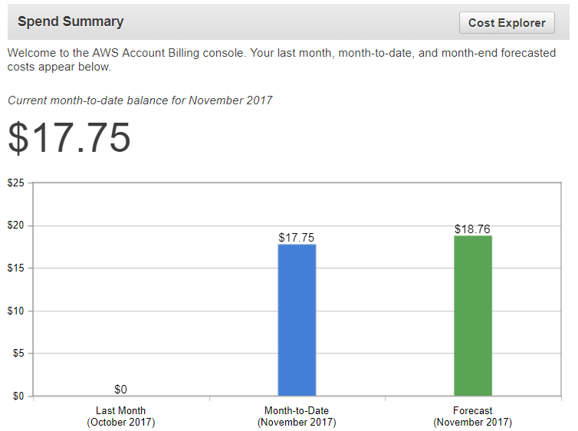

### Configuration changes (e.g. Platform & Software config changes)

* Microsoft Azure
* OpenShift
* AWS

### Backup resources and options

* Microsoft Azure
* OpenShift
* AWS

### Ease of Use/User-Friendliness

* Microsoft Azure
* OpenShift
* AWS

### Monitoring

* Microsoft Azure
* OpenShift
* AWS

### Security

* Microsoft Azure
* OpenShift
* AWS

## Conclusion