CA683: Data Analytics and Data Mining

Name | Javedali Shaikh - 16212373  Ken Brennock - 16213319  Sanjay Kumar Singh – 16211668  Kevin Shortall - 16213216
Student Number
Programme | MCM
Module Code | CA683
Assignment Title | Unsupervised Text Categorisation
Submission date | 17/04/2018
Module coordinator

I declare that this material, which I now submit for assessment, is entirely my own work and has not been taken from the work of others, save and to the extent that such work has been cited and acknowledged within the text of my work. I understand that plagiarism, collusion, and copying are grave and serious offences in the university and accept the penalties that would be imposed should I engage in plagiarism, collusion or copying. I have read and understood the Assignment Regulations set out in the module documentation. I have identified and included the source of all facts, ideas, opinions, and viewpoints of others in the assignment references. Direct quotations from books, journal articles, internet sources, module text, or any other source whatsoever are acknowledged and the source cited are identified in the assignment references. This assignment, or any part of it, has not been previously submitted by me or any other person for assessment on this or any other course of study.

I have read and understood the referencing guidelines found recommended in the assignment guidelines.

Name:____________________________________________ Date: ________________

Introduction
Question: Can Unsupervised Machine Learning be used to categorize a corpus of text?
Doing text classification with supervised machine learning is not difficult and have state-of-the-art results in literature. But in real world we don’t always have ‘target labels’. In fact, being working in software industry related to content, we can definitely say that we never have ‘target labels’ for massive data sets. So, we are left with the problem – unsupervised machine learning. Topic modelling, an unsupervised approach, is often used to perform clustering, but there are lot of challenges when we want to do text classification. In our project, we did research and experimentation on this exact problem.
For the experimentation we have used ‘20 News Groups’ [1] dataset, in which all documents are pre-assigned among 20 topics. Two different topic models (LDA and NMF) were implemented on the data, and the predicted topics received were compared with the original topics. For evaluation, confusion matrix was examined, and a novel approach (Dec 2017) known as ‘Stability’ was implemented.

Proposed method
The CRISP-DM process model, which is a cross-industry standard process for data mining, was followed for this project. The following sections detail the steps taken through that process.
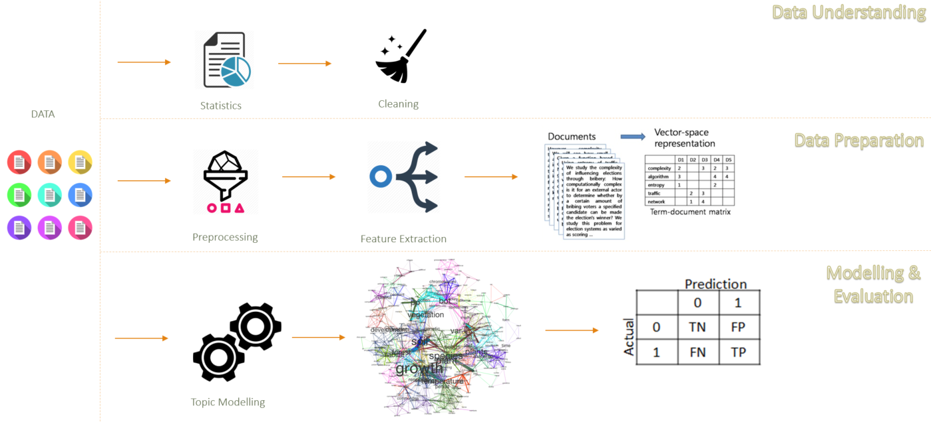
Fig 1: CRISP-DM process flow, tailored for our project

2.1 Data Understanding
The initial Data exploration gave some important insights into the dataset. There are approximately 18K documents in the 20 Newsgroup dataset of varying size, from 1 KB to approximately 44 KB. 20 Categories are already defined in the data. Each category had between 700 and 1200 documents. The wide range of document lengths we spotted initially, hinted that we might pose a problem later during the modelling.
The original dataset contains about 500K unique tokens (i.e. ‘words’).
It was clear from the topic names in the original dataset, that there are topics which are very closely related to each other. E.g. 3 topics related to ‘Religion’: soc.religion.Christian; talk.religion.misc; alt.atheism. 2 topics related to hardware: ‘Mac.Hardware’ and ‘IBM.hardware’. We were already got the feeling that this would cause problem during modelling phase.
Note: When doing topic modelling, we don’t split the datasets into ‘Train’ and ‘Test’, like conventional machine learning approaches. Instead, we provide the entire datasets to the topic models (this is the standard procedure).

2.2 Data Preparation
Many data cleaning and data preparation steps were taken to ensure the original data was correctly prepared for modelling. These included:
- Removing ‘stop-words’ – this was done using the library ‘NLTK’ written in python. These are words that occur so commonly in written English, that they are not useful in assigning topics to documents. Examples include: ‘the’, ‘it’, ‘has’.
During the testing and investigation, it was found that, quite common words should also be removed which are not present in the ‘stop-words’. For example, the word ‘subject’ was in nearly all the documents, therefore it does not add any information as to the topic of the document. Hence, a ‘user defined’ stop-words routine was also developed. Other examples for user defined words included, ‘.org’, ‘.edu’, ‘.com’ etc.
- All punctuation was also removed.
- All numbers were also removed. This was done with the reasoning that, we didn’t have any topic related to topics, and having numbers would impact the model performances. We tried a version with numbers, and we were seeing numbers present in the topics top K terms.
- Some non-English words were found when reading the documents. All non-English words were removed.
- Stemming was performed using Wordnet. This reduces the words to their root form. For example, the words ‘fish’, ‘fished’, ‘fisher’ would all be reduced to the word ‘fish’.
- There were some recommendations on some sites that removing all unique words also helps with the modelling. As LDA is a probabilistic methodology intuitively this would make sense. Unique words do not add value when assigning a topic. Removing unique words (this was done for the LDA-model only). As for NFM we used TF-IDF, which does the weighting like what we did with LDA. (Note: We don’t use TF-IDF for LDA, as it has its own weighting scheme)
All this data cleaning activity reduced the number of unique words (‘tokens’) to 25,174, the total corpus remained at about 300,000 words.
Also, we noticed that, without this cleaning, we were getting bad words from LDA/NMF. So, it was sure that all this cleaning process is improving the final performance of the models.

2.3 Modelling
The two models used in this project were Latent Dirichlet Allocation (LDA) [2] and Non-negative Matrix Factorization (NMF) [3]. Both models were implemented in Python. For LDA we used the library ‘gensim’ [4] and for NMF we used another library ‘scikit-learn’ [5].

LDA (Latent Dirichlet Allocation)
The algorithm [13], [14] for LDA is relatively infinitive and is described below.
- Tell the algorithm how many topics, in this case as there was already 20 topics the number of topics was set to 20.
- Assign a temporary topic to every word, this is not completely random, it is done using a Dirichlet distribution (Anon., n.d.) (Sklar, 2017). This allocation of topics to word was not investigated in detail during the assignment.
- Algorithm will check and update topics assignments based on the probabilities below. Looping through each word in every document and for each word its topics assignment is modified based on the two probabilities described below;
  - Probability (prevalent) of the word across a topic – p(topic t | document d) = the proportion of words in document d that are currently assigned to topic t. This is the allocation of topics to this word across all documents.
  - Probability (prevalent) of the topic is in the document - p(word w | topic t) = the proportion of assignments to topic t over all documents, that come from word w

- Reassign the word with a new topic, where we pick the topic with the probability of;
p(topic t | document d) * p(word w | topic t)
The diagram below represents this iterative cycle.
All the data is allocated to the model at the very start and the documents are given a probability of belonging to a topic. It should be remembered that the topics are just a construct. In this case there were topics 0 to 19. The theory is that all the documents of the same topic will end up being in the same topic. It is then up to the human to give the topics names. In this assignment it was attempted to allocate the topics to the original news groups by reading the documents.

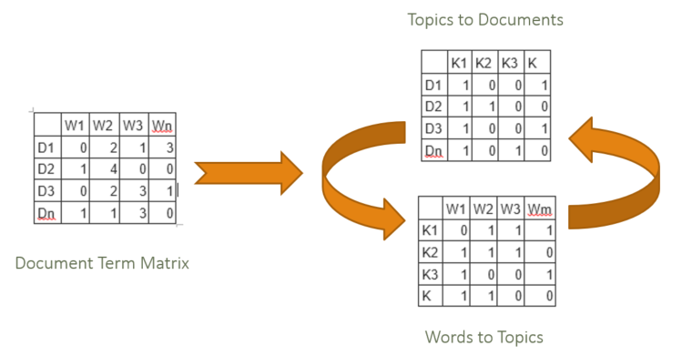
Fig: LDA Matrix operations

Below screen shot shows the input, pre-processing output and LDA output.
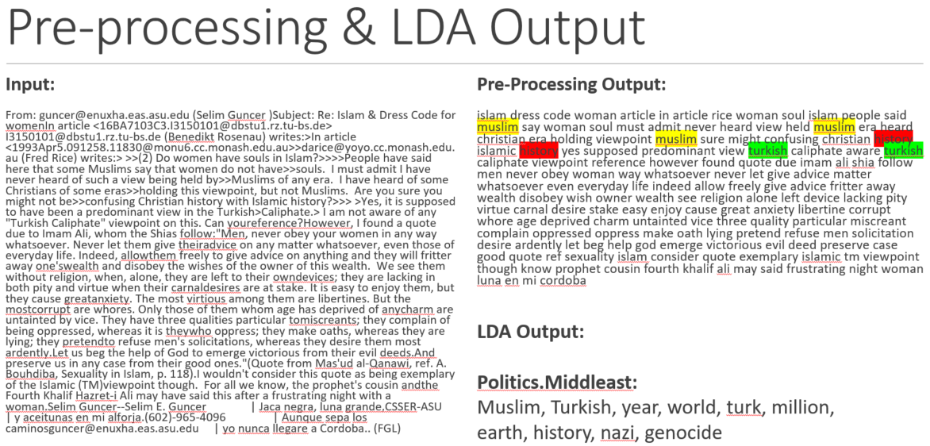
Fig: LDA example output showing original (left) and cleaned/categorised (right) text in a document

Visualization
The LDA model can be visualised using the LDAvis package in R [6], which produces an interactive d3.js web interface, as shown in Fig below.
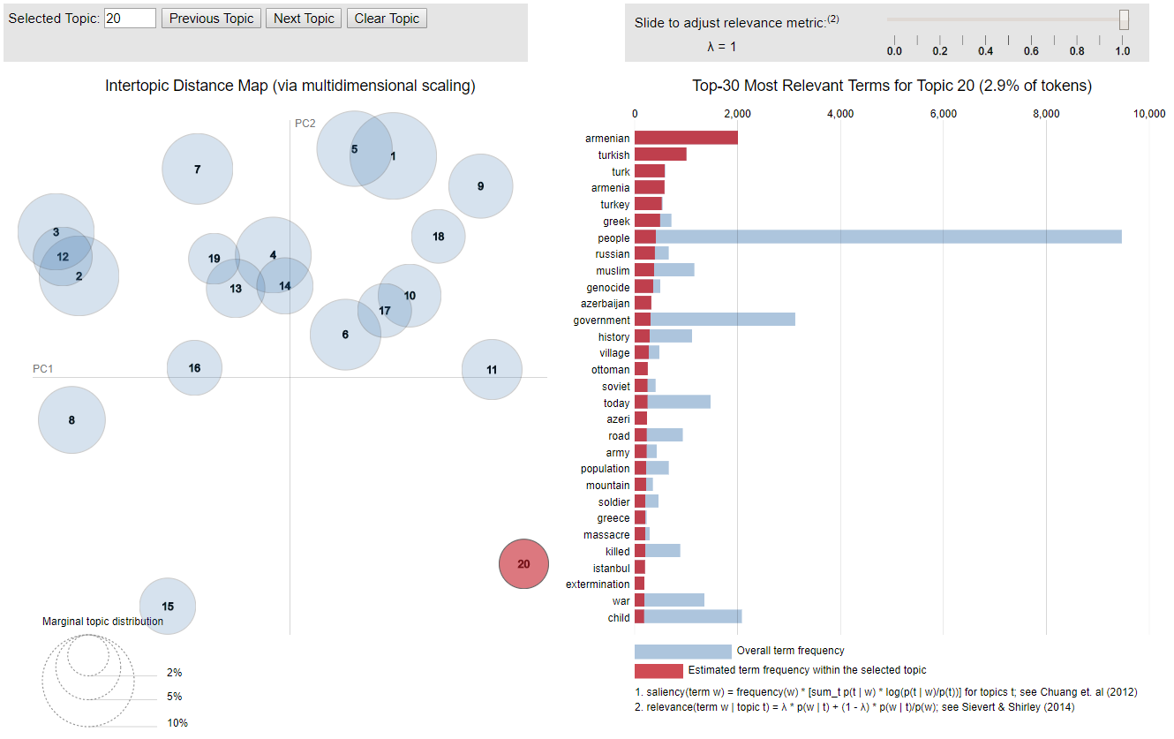
Fig: Interactive browser output from the LDAvis package in R

The interface helps to give clarity to LDA outputs by answering three main questions:
- How prevalent is each topic? This is shown on the left side of the screen. Each topic is represented by a circle. The larger the circle, the more prevalent that topic across the corpus of documents.
- How do the topics relate to each other? Again, this is shown on the left side of the screen. The distance between the circles is an approximation of the semantic relationship between the topics. The package uses Jensen-Shannon divergence to compute the inter-topic distances, and scaling is done through Principal Component Analysis.
- What is the meaning of each topic? This is shown on the right by the 30 most relevant words of any topic which has been selected on the left. Each relevant word is represented by a horizontal bar chart, which can be made up of two colours. The first colour (red) shows how often that word occurs in just the selected topic, while the second colour (blue) shows how often that word occurs overall in the corpus. Thus, those words with a high proportion of blue bar chart are less effective at identifying this particular topic and are less relevant, as they occur very frequently elsewhere in the corpus. The lambda value can be adjusted to change the relevance of the displayed words: the lower the lambda value, the more relevant the displayed words are to just that particular topic.

2.3.3 NMF (Non-negative Matrix Factorisation)
NMF [7] is a linear algebraic algorithm two factorize a matrix ‘A’ into two smaller matrix ‘W’ and ‘H’, with the property that all three metrices have no negative elements. This non-negativity makes the resulting metrices easier to inspect. This algorithm is widely used in dimensionality reduction techniques, clustering and topic modelling.
Before, we can use this algorithm we first have to convert our words into a vector representation (pre-processing and cleaning is already done). We used two approaches here:
- Bag of Words: [8] Count the number of times words appears in a document and create a vector for each document. So, each document will be of the size of corpus vocabulary. So, in our corpus after cleaning we had ~25K unique tokens, so the size of each document vector will be 25K dimensions. Now, most of the entries in the vector will be 0 i.e. it will be a highly sparse matrix. Here, libraries use sparse matrices to reduce the memory consumption.
- TF-IDF: [9] Bag of words is a good start, but it doesn’t gives any weights to the words. Words like ‘high’ doesn’t represent any topic in the data set, and could appear in all documents. Hence, such words should get less weightage as compared to unique words like ‘ball’ which highly indicates a sport topic. TF-IDF does the same thing, it gives less weightage to common words across corpus, and more weightage to in-frequent words across corpus.
Below screen shot represents the output of bag-of-words and TF-IDF.

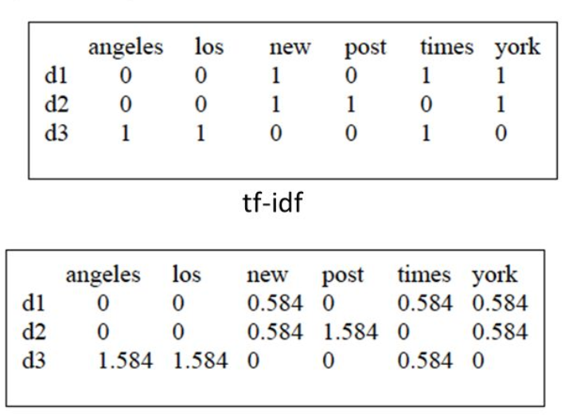
Fig: TF-IDF example

Once we have our weighted vectors, we can feed them to NMF model.
Intuitively, NMW will factorize the input matrix ‘A’ (i.e. the TF-IDF matrix shown in above figure) and decompose this matrix into two matrices ‘W’ and ‘H’.
Matrix ‘W’ represents the document-topic relationship and matrix ‘H’ represents the word-topic relationship. As shown in below image, in matrix W, we can see that document 1 belongs to Topic 2, and document 2 belongs to topic 3. Similarly, in matrix H, we can see that, the word ‘bank’ belongs to topic 3 and the word ‘hospital’ belongs to topic 2.
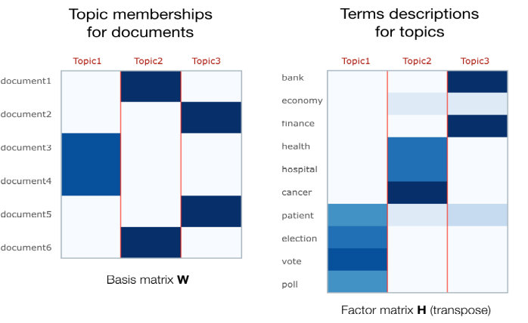
Fig: NMF explanatory charts

Below screen shot shows the input document and NMF output. It successfully classified the document as ‘cryptography’ topic.

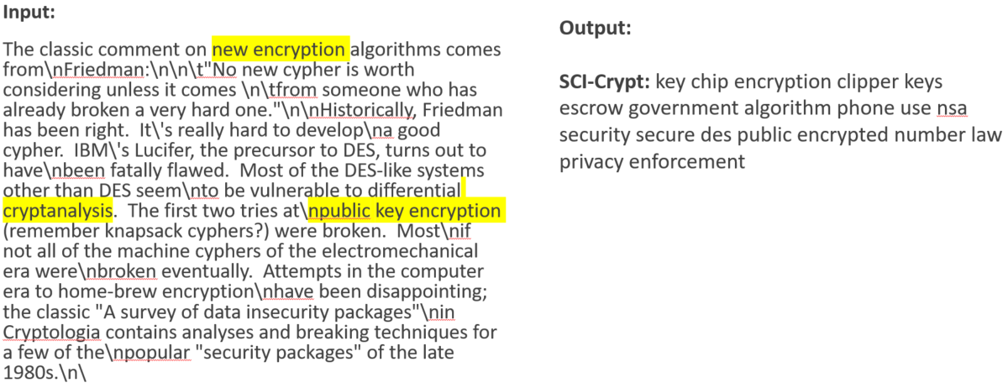
Fig: NMF example output showing original (left) and document topic ‘sci-crypt’ (right).

2.4 Evaluation
Two measures of evaluation were used in this project: Confusion Matrix and Stability.

2.4.1 Confusion Matrix:
We first manually labelled all topics from LDA and NMF, as they are abstract (Topic 0, 1, 2, etc.) This is a difficult, labour-intensive activity that does not scale well to larger topics. But we can do for small number of topics.

LDA/NMF will give 20 topics for each document, with topic probability for each document. We took the topic which had maximum probability.

The overall precision for all topics was very less for both models. But when we drilled down to each individual topic, we found good precision for some topics, some topics were having average precision (algorithm was confused as they were closely related), and some topics were missed (not enough data provided).

 | NMF | LDA
Overall | 30% | 32%
Good Labels | - Crypt: 80% | - Windows.X: 89%
 | - Politics Middle-East: 68% | - Hockey: 86%
 |  | - Politics.middle-east: 80%
Confused Labels (due to close relation) | - MAC.Hardware: 26% | - Graphics (18%)
Confused Labels (due to close relation) | - IBM.Hardware: 42% | - MAC.Hardware: (17%)
Missed Labels | - Religion Atheism | - Religion Atheism
 | - Medical | - Medical

Table 1: Confusion Matrix outcomes

Below is example of some mis-classified documents:

Document | Actual Topic | Predicted Topic
1 | Mac.Hardware | IBM.Hardware
2 | Comp.Windows | Comp.Windows.Misc
3 | Autos | Motorcyles

The reason for most of the mis-classification was, assigning a document to topic which are closely related. E.g. as shown above, document 1 was misclassified as IBM.Hardware, whereas its actual topic is ‘Mac.Hardware’. This is because both topics are very closely related to each other i.e both topics share many common words.

Why were the documents allocated to the ‘wrong’ topic?
There are a variety of reasons that could be found: 1) the document just contained some of these words but with multiple instances, hence, pushing up the probability of the document belonging to this topic. 2) the documents were very small so even one word had a big impact on the topic allocation.

When investigating the results the team found a couple of points that were felt impeded a more positive outcome;
- The documents are divided in news groups, however, even when reading some of these documents it is difficult to see how they were put into a specific news group. Some of the news groups are similar in the types of topic, as mentioned earlier there are three topics on religion.
- Before cleaning there was an enormous range in the size (number of words) of the documents. When pre-processed as described above some of the documents were left empty. Hence, they would be dropped from the model. However, there was still a large variation on the size of documents.
- The documents are allocated to a topic based on the highest score they received. However, in some cases the scores could be close and all below 50%.

2.4.2 Stability
This concept is take from recent paper (Dec 2017) [10] written by Mark Belford from UCD, Insights Center. Before this paper, there weren’t any good evaluation metrics available for Topic Modelling. And the big reason for that was, it is an unsupervised algorithm i.e. no target labels.

We met Mark in NLP meet up in Zolando, and he happily shared the draft paper and the Git Hub code. Note: We spent a good amount of time in understanding the original code from authors [11], changing it for our needs (different format and logical flow).

Average Term Stability (ATS) – compares the similarity between two topic models based on a pairwise matching process at a topic level.

Uses the Jaccard Index:
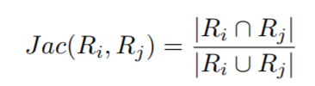

To carry out the experiment, we performed below steps:
- K = top 10 terms
- Ran 10 ‘runs’ of LDA (L1, L2, …, L10)
- output top k terms for 20 topics
- Calculate ATS for each combination of (L1, L2, …., L10)
- Take the mean ATS
- Repeat steps 1-5 for k = 20, 30, 40 and 50
- Repeat steps 1-6 for NMF

NMF: Stability increased as we increased the number of top terms per topics.
LDA: Stability was constant – 1. This is very strange and should not happen. But the reason for this behaviour could be small set of dataset (after intensive cleaning).

Below is the graph representing the same:

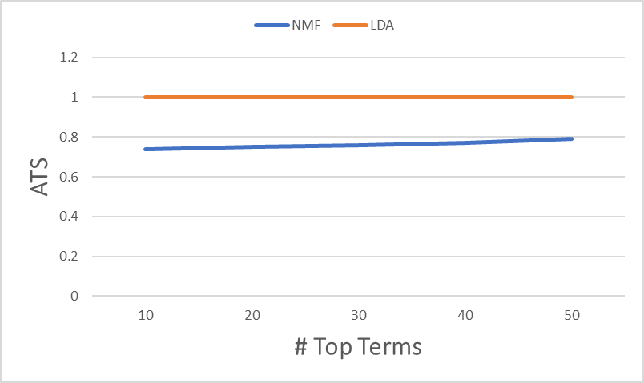
Fig: Term stability graph

3. Conclusion
- Both models faced difficulties in identifying topics which are closely related (autos-bikes).
The solution to this as per our research is: have more data specially for topics which are similar. Also, to use advanced algorithms like ‘Guided LDA’ [12]. We did try to implement this algorithm for our project but due to time limits, we were not able to complete. The main gist of this algorithm is, you can provide seed topics/words with higher probability distribution (rather than uniform as in the case of original LDA). And then the algorithm successfully separates the closely related topics, even without the need of having extra data.
- Varying sizes of documents impact the performance.
After our cleaning process, we found that there was a large mis-proportion in # of words. Some documents had more words, but most had less words. This has impacted the output of LDA & NMF.
- More data would be required to improve the performance of models.
The general rule of thumb for Topic modelling algorithms is, more the data better it is. As it can cover wider vocabulary range. But, there is a relation between # of topics we want and the data available. For e.g. In our case we wanted 20 topics and the size of unique tokens after cleaning was only 25K. This straight away looks less. On top of the that we have other problems mentioned in point 1 and 2. To proof this reasoning, when we run the algorithms with less number of topics (like 7-10) and with same data, we were getting higher precision for these 7-10 topics.
- NMF runs much faster than LDA!
NMF is a linear algebraic process. And that says everything. It takes around 1 minute to run NMF, whereas LDA takes 20 minutes with same settings.
- Quality of words were better in LDA.
Upon manual evaluation, we found that LDA was outputting topics with better (more related to topic) terms.
- Doing text classification is hardest with unsupervised algorithms!
Our final conclusion is: you can do text classification using unsupervised algorithms, but it has to be on smaller scale. On bigger scale it becomes really hard to manually assign topics from algorithms a human name. For 20 topics, it took us ~2 hours. In real world, we could end up with 200-500 topics.
Our proposal for real word project:
Create a sample data set which represents your larger data-set. This data set should contain categories/topics which are “high level” like – sports, news, finance, entertainment, autos, weather, lifestyle etc. Also, this data set should have target labels. For this, you can use domain experts (crowd sourcing) or internal resources, to label each document with one or more topic. This will give you your supervised data set (i.e. containing target labels).
Now you can run the entire experiment which is describe in report i.e. run unsupervised algorithms like LDA/NMF on sample data and let them create topics for you. Next, manually go through all the topics (not many) and give them human name. After this, for each document in the sample data set, obtain ‘single/multiple’ topic using trained LDA/NMF. Once all your documents are assigned topic(s), you can compute the confusion matrix (precision/recall) and stability. Now two things can happen:
- Numbers are satisfactory: You can now use this version of LDA/NMF (parameters, hyperparameters) and train it on larger dataset.
- Numbers are not satisfactory: Repeat the experiment with varying the parameters/hyperparameters, updates in model, doing ensemble, or updating your sample dataset, until you are happy with the results.

4. References
[1] - Ken Lang, http://qwone.com/~jason/20Newsgroups/
[2] – David M. Blei, Andrew NG and Michael I. Jordan, https://ai.stanford.edu/~ang/papers/nips01-lda.pdf
[3] – Daniel D. Lee and H.Sebastian Seung, https://papers.nips.cc/paper/1861-algorithms-for-non-negative-matrix-factorization.pdf
[4] - https://radimrehurek.com/gensim/
[5] - http://scikit-learn.org/
[6] - https://github.com/cpsievert/LDAvis
[7] - https://en.wikipedia.org/wiki/Non-negative_matrix_factorization
[8] - https://en.wikipedia.org/wiki/Bag-of-words_model
[9] - https://en.wikipedia.org/wiki/Tf%E2%80%93idf
[10] - Mark Belford, Brian Mac Namee, Derek Greene, Stability of Topic Modelling via Matrix Factorization, https://arxiv.org/abs/1702.07186
[11] - https://github.com/derekgreene/topic-stability
[12] - https://github.com/vi3k6i5/GuidedLDA
[13] - https://en.wikipedia.org/wiki/Latent_Dirichlet_allocation
[14] - https://www.quora.com/What-is-a-good-explanation-of-Latent-Dirichlet-Allocation

