Discussion Forum- [beamdog](https://forums.beamdog.com/discussion/25272/baldurs-gate-meme-thread-ii-enhanced-edition-careful-everyone-spoilers)

**Id**: 1

**Name:** SCARY_WIZARD

**Comment**: Going to star this'n out with a few favey-rights from the last thread...

= = = = = = = = =

Kitties aside, it's time for rules. Let me see, here...Keep It Clean-ish: Let's keep this thread PG-13. -I'm not saying "Let's make jokes that are appropriate for Leave It To Beaver!", just avoid the profanity and sexual content. Don't Spoil The Fun!: As far as spoilers go, well, it'd be mighty fine if you could put spoiler tags ( [ spoiler ] [ /spoiler ] , without the spaces) around such things, so people new to this game in need of a quick giggle don't get spoiled like I did on Wikipedia in 2006. :(Now I regard spoilers twice as much. Play Nice: Like Alora says, "Careful, everyone, play nice!". This is a "space" for us to have fun. Let's play nice, and not bait or antagonize (troll) others. Something Is Wrong, Here...: SCARY_WIZARD thinks you should contact some moderators if a rule appears to have been broken. We have, to my knowledge, @Dee (formerly Aosaw, if you've been absent for a while; the sentientest wombat I ever read things from!), @mInevese, @Nathan, @Coriander, @LadyRhian, @Cuv, @CamDawg (THEY MAKE COOL THINGS), @Jalily, @Metalloman, or any of the other Staff members (whose text happens to be on a blue or grey background). PLEASE, let us not discuss what caused the other thread to be locked, lest this one get locked, as well, and future meme threads be prohibited! Here's the officialest rules we can get, from @Dee: http://forum.baldursgate.com/discussion/10852/site-rules-mind-the-gap = = = = = = = = = Here's the last thread, in all its high-larious glory: http://forum.baldursgate.com/discussion/3079/baldur-s-gate-meme-thread-spoilers-all-over-the-place/ . A hoot and a half, especially when there was a whole page of CATS! I love cats. = = = = = = = = = Here's how to post an image, if you're like me and know HTML and vB Code/UBB Code, but are derpy. Copy this: image, and paste it, replacing "LINKGOESHERE" with the URL of the image you want to post. Attaching is cool, too, but you might be like me and want to just link. Here's some stuff on formatting your posts: forum.baldursgate.com/discussion/161/how-to-format-your-posts/p1 I don't do that, but I'm not exactly the best example, am I. = = = = = = = = = EDIT: Rules ironed out, as suggested by @Metalloman.

**Time**: November 2013

**Id**: 1.1

**Name:** Akihiko

**Comment**: Hm? Did the other one go poof? I got curious since you made this, and I can't find it now.

**Time**: November 2013

**Id:** 1.2

**Name:** CrevsDaak

**Comment**: @SCARY_WIZARD just set some rules, please :D. Now I feel like Vhailor :3

**Time**: November 2013

**Id:** 1.3

**Name:** LordRumfish

**Comment:** Akihiko said:Hm? Did the other one go poof? I got curious since you made this, and I can't find it now. And lo, lords and ladies, thus closed here lately A titan of templates, troublesome troubadour: The Baldur's Gate Meme Thread was threatened and thrashed By fault of the fickle folk frequenting the forum. Those sumptuous spoilers now languish in Archives Where once one could witness them on the first page. In General Discussion; our cynics sighed sadly. While restless trolls roiled and raved in their dens. No more shall those pages of persnickety petulance. Be propped up by bumps or besmirched by Boo. An end to a saga I now sing for you sadly. Unless this latest attempt prove more fruitful with laughs. The old thread had been closed, The admins' eyes like steel. It might have been no rose; Let's keep this one, fo' real.

**Time**: November 2013

**Id:** 1.4

**Name:** CrevsDaak

**Comment**: We should have used it even before the disturbance could have started, Yoda could have helped to find the disturbance (in the Force) and @Dee could have vanquished before it grown.

**Time**: November 2013

**Id:** 1.5

**Name:** Voltron

**Comment**: CrevsDaak said: We should have used it even before the disturbance could have started, Yoda could have helped to find the disturbance (in the Force) and @Dee could have vanquished before it grown. :'D! Can I put that in the Original Post? Seeing's how my name's got "Wizard" in it, and wizards cast spells (and priests, too). I laid down some rules for the thread. Dropped some moderator's names, in case there's ugliness.

**Time**: November 2013

**Id:** 1.6

**Name**: XerxesV

**Comment:** Too bad the mods couldn't reload an earlier save on that thread. That's what I do in BG after a bad troll attack.

**Time**: November 2013

**Id:** 1.7

**Name**: meagloth

**Comment**: So who's going to copy and past the first 90 pages of the original thread? Those where all fine. Here are a few of the old ones I happen to have saved. I'll come up with some of my own, eventually. Now I'll just try I get the ball Rolling. Rolling.

**Time**: November 2013

**Id**: 1.8

**Name**: SCARY_WIZARD

**Comment**: meagloth said: So who's going to copy and past the first 90 pages of the original thread? Those where all fine. I ate all the paste I had. :( It tasted good, though!

**Time**: November 2013

**Id**: 1.9

**Name**: JuliusBorisov

**Comment**: Let us celebrate 50 years of Doctor Who;)

**Time**: November 2013

**Id**: 1.10

**Name**: Night_Watch

**Comment**: one of my favourite that I made XD. one of my favourite I saw on the web XD. one of my favourite I saw from the old meme thread XD. I really hope anyone who does a meme about BG2:EE uses a spoiler tag for all the new content =)

**Time**: November 2013

**Id**: 1.11

**Name**: Metalloman

**Comment**: @meagloth: there's a link to the first MEME thread in OP. ;)

**Time**: November 2013

**Id**: 1.12

**Name**: Kaltzor

**Comment**: Just a few I made over the course of that old thread to keep them around...

**Time**: November 2013

**Id**: 1.13

**Name**: GemHound

**Comment**: Just thought I would bring this one over to here since it might have been buried due to all the nonsense in the old thread.

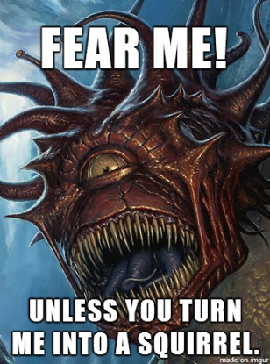

**Time**: November 2013

**Id**: 1.14

**Name**: Montresor_SP

**Comment**: A few classics from the old thread: By @Tr_ond By @Rerel By @Majoca

**Time**: November 2013

**Id**: 1.15

**Name:** booinyoureyes

**Comment**:

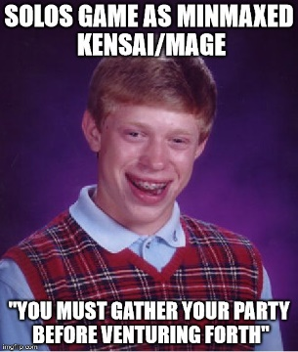

**Time**: November 2013

**Id**: 1.16

**Name**: SethDavis

**Comment**: Nooooooo! Now i have to see the same memes all over again!

**Time**: November 2013

**Id**: 1.17

**Name**: Metalloman

**Comment** SethDavis said: Nooooooo! Now i have to see the same memes all over again!

**Time**: November 2013

**Id**: 1.18

**Name**: Quartz

**Comment**: Yeah I should totally dig up some of my classics from the old meme thread to farm likes. EYEROLL EYEROLL EYEROLL EYEROLL xD All in good fun, but seriously it's kinda lame

**Time**: November 2013

**Id**: 1.19

**Name**: booinyoureyes

**Comment**: for the last thread, i just imagined k again " Are you some kind of a moron, what do ya think you was doing?"

**Time**: November 2013

**Id**: 1.20

**Name**: CrevsDaak

**Comment**: @SCARY_WIZARD yes, you can use that picture in the thread's opening. And, if you want, you can get some more images from here: http://forum.baldursgate.com/discussion/25090

**Time**: November 2013

**Id**: 1.21

**Name**: CrevsDaak

**Comment**: And I had a better one, but I forgot it :S

**Time**: November 2013

**Id**: 1.22

**Name**: meagloth

**Comment**: NO. ITS NOT "DOCTOR WHO" ITS "THE DOCTOR". DOCTOR WHO IS THE NAME OF THE SHOW. THE DOCTOR'S NAME IS THE DOCTOR.

**Time**: November 2013

**Id**: 1.23

**Name**: Foggy

**Comment**:

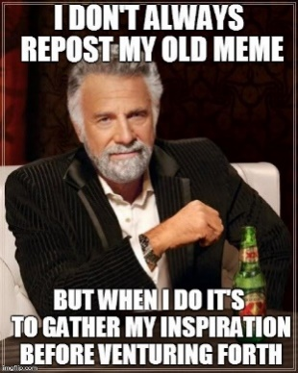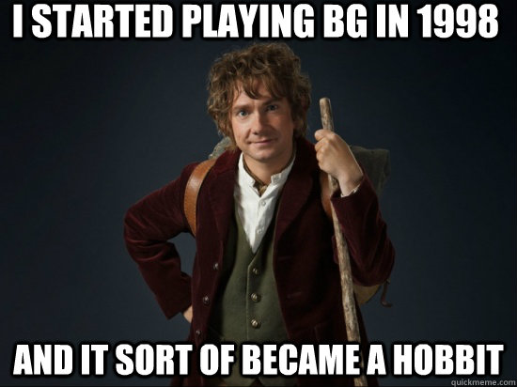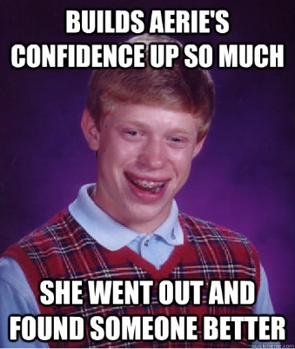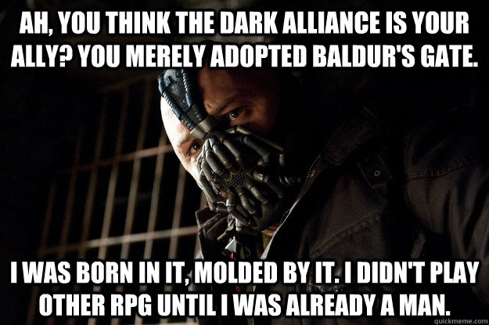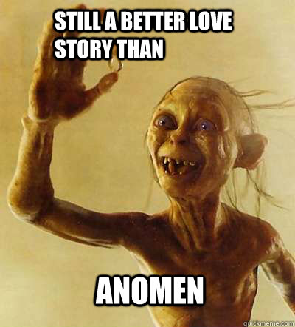

**Time**: November 2013

**Id**: 1.24

**Name**: Foggy

**Comment**: let's venture forth with @Dee blessing

**Time**: November 2013

**Id**: 1.25

**Name**: sarevok57

**Comment**: @Foggy my respect for you has increased infinite fold for the pulp fiction meme - gives a small bow

**Time**: November 2013

**Id**: 1.26

**Name**: booinyoureyes

**Comment**: Foggy said: let's venture forth with @Dee blessing. This is the best meme yet!

**Time**: November 2013

**Id**: 1.27

**Name**: Jalily

**Comment**: Foggy said: Last one should be Dorn. ;)

**Time**: November 2013

**Id**: 1.28

**Name**: Eudaemonium

**Comment**: Clearly the others just ran off with Hexxat.

**Time**: November 2013

**Id**: 1.29

**Name**: Kaltzor

**Comment**: 2 of the ones I posted again were like 30+ pages before the thread started breaking down, some people might've not gone through the whole thread and haven't seen them...

**Time**: November 2013

**Id**: 1.30

**Name**: Quartz

**Comment**: OK @Kaltzor cool story bro. You might want to get rid of the word "apparently" in your meme. I guess I'll rage elsewhere.

**Time**: November 2013