Discussion Forum-[cigarforums](https://www.cigarforums.net/forums/vb/general-discussion/277400-memes-21.html)

**Id**: 1

**Name:** TexaSmoke

**Comment**: Sent from my LG-M210 using Tapatalk

**Time**: ‎ ‎08-07-2018, 08:03 PM

**Like: 3**

**Id**: 2

**Name:** BOSSTANK

**Comment**:

**Time**: ‎ ‎Old 08-07-2018, 09:31 PM

**Like: 1**

**Id**: 3

**Name:** PTAaron

**Comment:**

**Time**: ‎ ‎Old 08-10-2018, 12:11 AM

**Like**: 3

**Id**: 4

**Name:** PTAaron

**Comment:**

**Time**: ‎ ‎Old 08-10-2018, 01:16 PM

**Like: 2**

**Id**: 5

**Name:** Dran

**Comment:**

**Time**: ‎ 08-13-2018, 07:19 AM

**Like: 2**

**Id**: 6

**Name:** PTAaron

**Comment**: Memes

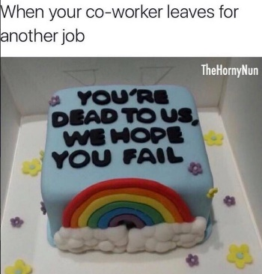

**Time**: ‎ ‎Old 08-13-2018, 10:33 PM

**Like: 3**

**Id**: 7

**Name:** TexaSmoke

**Comment**: Sent from my LG-M210 using Tapatalk

**Time**: Old 08-15-2018, 10:03 AM

**Id**: 8

**Name:** TonyBrooklyn

**Comment**: Attached Images

**Time**: ‎ Old 08-15-2018, 01:14 PM

**Like: 3**

**Id**: 8

**Name:** TonyBrooklyn

**Comment**: For some reason the meme won't post. I guess its one per customer

**Time**: ‎ ‎ Old 08-15-2018, 01:17 PM