Advertising Dataset – Sales Prediction Analysis
Multiple Linear Regression | Business Analysis Report

Business Scenario
This analysis looks at a simple business question: if a company changes how much it spends on TV, Radio, and Newspaper advertising, what happens to product sales? Instead of looking at each channel separately, we use all three channels together in one model. This gives the company a practical way to understand the historical relationship between advertising spend and sales and to estimate sales for a planned budget.

1. Dataset Overview
The dataset contains 200 advertising records and four columns: TV, Radio, Newspaper, and Sales. TV, Radio, and Newspaper represent advertising expenditure, while Sales is the outcome we want to predict. There are no additional identifier columns required for this analysis.
Column | Meaning | Role
TV | TV advertising spend | Input feature
Radio | Radio advertising spend | Input feature
Newspaper | Newspaper advertising spend | Input feature
Sales | Product sales | Target variable
The dataset has 200 rows and 4 columns. The first five records from the supplied dataset were used to confirm the structure before modelling.

2. Approach Used
I used Multiple Linear Regression because the target, Sales, is a continuous numerical value and there are three numerical input variables. The model learns how Sales changes when the advertising budgets change, while considering the three channels together.
The data was divided into 80% training data and 20% test data. The model learned from the training data and was then tested on records it had not seen before. A fixed random state of 42 was used so that the split and results can be reproduced.

3. Model Results
Metric | Result
Mean Absolute Error (MAE) | 1.2748
Mean Squared Error (MSE) | 2.9078
Root Mean Squared Error (RMSE) | 1.7052
R² Score | 0.9059
On the unseen test data, the model has an MAE of 1.27 sales units. In simple terms, the predictions are off by about 1.27 units on average. The RMSE is 1.71, which gives more weight to larger mistakes. The R² score is 0.906, meaning the model explains about 90.6% of the variation in sales in this test split. Overall, this is a reasonably good baseline model for this small dataset.

4. Prediction for the Planned Advertising Budget
Advertising Channel | Planned Spend
TV | 150
Radio | 20
Newspaper | 30
For the planned budget of TV = 150, Radio = 20, and Newspaper = 30, the model predicts sales of approximately 15.04 units.
Predicted Sales: 15.04 units

5. Coefficient Interpretation
Feature | Coefficient | Interpretation
TV | 0.054509 | Positive relationship
Radio | 0.100945 | Strongest
Newspaper | 0.004337 | Least
The fitted equation is approximately: Sales = 4.7141 + 0.0545(TV) + 0.1009(Radio) + 0.0043(Newspaper). Radio has the largest coefficient (0.1009), so it has the strongest positive relationship with sales in this model when the other channels are held constant. Newspaper has the smallest coefficient (0.0043), so it has the least impact according to this model. These coefficients describe association in the historical data; they should not automatically be interpreted as proof that increasing one channel will always cause sales to rise by the exact amount.

6. Actual Sales vs Predicted Sales
The chart below compares the sales values that actually occurred with the values predicted by the model. Points closer to the diagonal line indicate more accurate predictions.
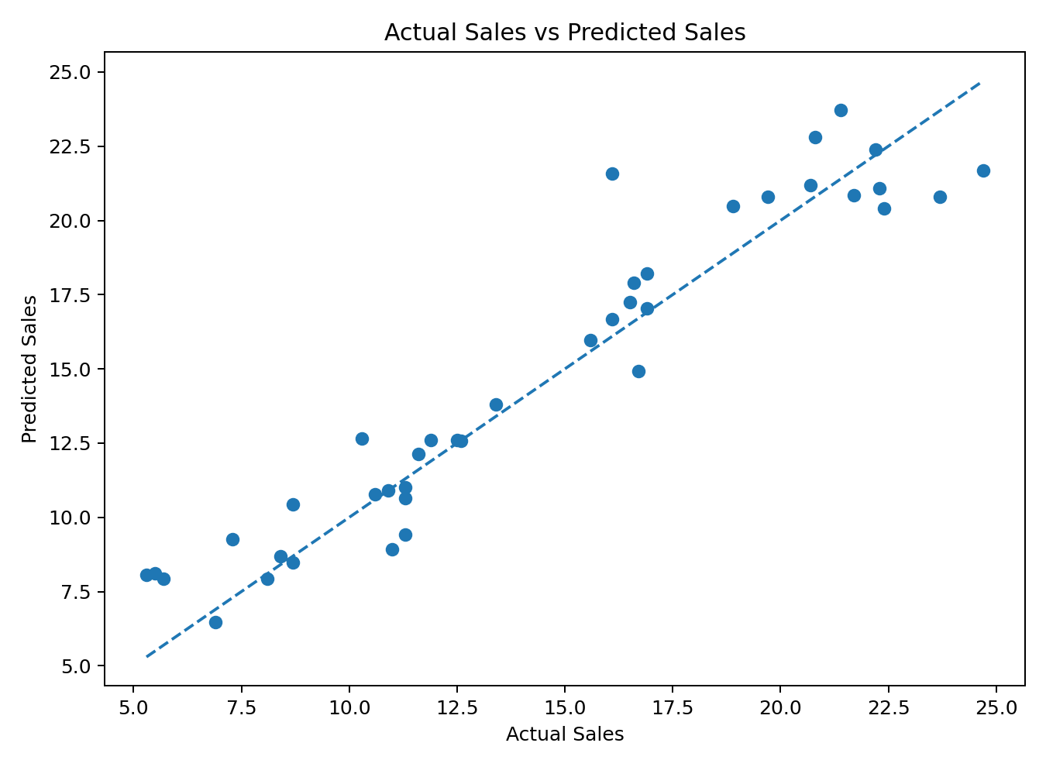

7. Business Recommendation
The company should consider putting more emphasis on Radio advertising, because Radio shows the strongest positive coefficient in the model. A sensible business approach would be to test a gradual shift of some budget toward Radio while continuing to use TV, rather than moving the entire budget to one channel. The company should then compare actual sales results before making a larger budget change.

8. Technical Improvement
A useful next step would be to use cross-validation and compare this linear model with non-linear models such as Random Forest or Gradient Boosting. The company could also add useful variables such as product price, promotions, seasonality, competitor activity, and campaign timing. More relevant historical data would make the prediction more reliable.

9. Final Conclusion
The analysis shows that advertising expenditure is strongly related to sales in this dataset. The Multiple Linear Regression model achieved an R² of 0.906 on the test set. Radio had the strongest coefficient, while Newspaper had the weakest. For the planned budget of 150 for TV, 20 for Radio, and 30 for Newspaper, the estimated sales are 15.04 units. The model is useful as a baseline, but the company should validate budget changes with real campaign results and improve the model with more business variables and stronger validation.

Appendix: Python Code Used
import pandas as pd
import numpy as np
from sklearn.model_selection import train_test_split
from sklearn.linear_model import LinearRegression
from sklearn.metrics import mean_absolute_error, mean_squared_error, r2_score

df = pd.read_csv("advertising.csv")

X = df[["TV", "Radio", "Newspaper"]]
y = df["Sales"]

X_train, X_test, y_train, y_test = train_test_split(
X, y, test_size=0.20, random_state=42
)

model = LinearRegression()
model.fit(X_train, y_train)

y_pred = model.predict(X_test)

mae = mean_absolute_error(y_test, y_pred)
mse = mean_squared_error(y_test, y_pred)
rmse = np.sqrt(mse)
r2 = r2_score(y_test, y_pred)

new_budget = pd.DataFrame({
"TV": [150],
"Radio": [20],
"Newspaper": [30]
})

prediction = model.predict(new_budget)

print("MAE:", mae)
print("MSE:", mse)
print("RMSE:", rmse)
print("R2:", r2)
print("Predicted Sales:", prediction[0])
print("Coefficients:", model.coef_)

Output:

