Reducing Power Dissipation in Digital Circuits Using Memristors: Designing a 3-bit Encoder

**Javeed Syed1, Rohith M.N.2, Subbaiah M.V.3**

1,2,3,Department of Electronics and Communications, Final Year Student, Narayana Engineering College - Nellore, India

**Abstract**

**The main purpose of this paper is to explore the use of memristors in digital circuit design as an alternative to current integrated circuit design. The idea is to reduce power dissipation in digital circuits by incorporating memristors into the design of digital logic gates. This approach offers a promising development in computing architecture, with the added benefit of straightforward manufacturing processes for memristor-based gates.By designing memristors on top of the polysilicon gate of NMOS transistors, we can increase transistor density on a chip. The increased transistor density can lead to faster processing speeds and improved performance of digital circuits. However, increasing the transistor density on a chip often leads to increased power consumption. To achieve even lower power consumption, the memristor's Ron, Roff, and Rint values are adjusted in this project.The memristor-based design can be utilized to model various combinational logic circuits, and our primary objective is to analyze and design a 3-bit encoder with different logics using LTspice. An encoder is a digital circuit that converts a set of inputs into a coded output. The 3-bit encoder is a specific type of encoder that encodes three binary inputs into a coded output. We will use different logics to design the encoder and analyze the results using LTspice, a widely-used software tool for simulating and analyzing digital circuits.**

**Keywords: Digital design, Encoder, Logic circuits, Memristor.**

# **Introduction**

Moore's law states that the number of transistors per area of semiconductors has been doubling every two years, but there are limits to how small transistors can become. To keep up with the demand for smaller, more efficient semiconductors, researchers are looking for alternatives to the standard transistor. One promising option is the memristor, a passive device that was first proposed in 1971 and was realized in 2008 by HP Labs. Memristors have been proposed for use in many devices, including amplifiers and memory devices. They have also been used as building blocks for logic gates. The shrinking size of transistors creates problems like increased leakage currents and higher error rates, but memristors can help solve these problems. Memristors have been proposed for use in a variety of applications, such as memory, neuromorphic systems, and analog circuits. When used in digital settings, a high memristance is considered logic 0, and a low memristance is considered logic 1.One common digital circuit is an encoder, which encodes signals to make them easier to select in digital logic circuits. There are many ways to design logic circuits using memristors, and this paper focuses on using memristor ratioed logic to implement an encoder design. The goal is to compare the power efficiency of the memristor-based encoder with existing CMOS and Pseudo NMOS circuit logics.

# **Working Of Memristor**

A memristor is a passive, non-volatile element with two terminals. As the link between magnetic flux and charge, it is regarded as the fourth basic element. The equation M = dφ/dq gives the relation between charge and ﬂux where memristance M(ohm), charge q(coulomb), magnetic ﬂux *φ* (Volt-second). It has two platinum metal layers with pure titanium dioxide (TiO2) acting as a dielectric between them. A doped titanium dioxide layer acts as a semiconductor on top of the dielectric. The current flowing through the memristor causes the resistance of the device to vary. When the width of the doped region is wider than the n doped region width of TiO2, the device has a low resistance called Ron.

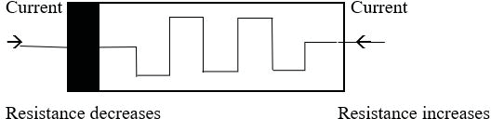

Fig. 1. Memristor model..

Conversely, when the width of the undoped region is wider than the doped region, the device has a high resistance called Roff. The polarity of the memristor is indicated by a black thick line, and when current flows towards the black line, the resistance decreases, and the minimum resistance offered by the memristor is called the ON resistance (Ron). If the current flows away from the black line, the resistance increases.

1. **Memristor Ratioed Logic**

Memristor ratioed logic (MRL) is a hybrid design that combines the use of memristors and transistors. In MRL, the memristors are used as variable resistors, while the transistors act as switches to control the flow of current through the circuit. The use of memristors in MRL offers advantages such as low power consumption and high density, making it a promising technology for future integrated circuits. The design of MRL relies on the ratio of the memristor resistance to the transistor resistance, which allows for the implementation of different logic gates with a small number of components. MRL has the potential to overcome the limitations of traditional logic designs and to provide a more efficient and flexible approach to circuit design. It is easy to fabricate Memristor on the top of the CMOS polysilicon layer, then it reduces the area of the design. It also reduces the number of transistors . In the Fig. 2, connecting two Memristors M1 and M2 in parallel, and output of that is given to the CMOS inverter it gives NAND gate logic. Similarly, It can be observed that the NOR gate logic may be obtained by simply inverting the polarity terminals of the Memristors in previous architecture. This logic has a very low signal attenuation when compared to MAGIC and IMPLY logic.

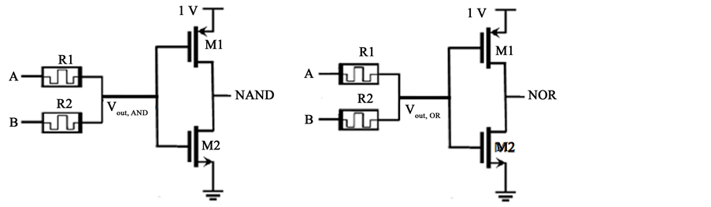

Fig. 2. NAND & NOR gate using Memristor

# **Memristor Models**

Window functions in memristors refer to the range of applied voltage values that induce a change in resistance. Different types of memristors have distinct window functions that depend on their specific design and materials used. The window function is an important characteristic of a memristor as it determines its operation range and can affect its reliability and performance. The Joglekar Resistance Switch memristor model is a type of memristor that has been proposed for use in electronic circuits. The JRS model is a mathematical representation of the memristor that takes into account its window function and switching behavior. The model is based on the assumption that the memristor has two stable resistance states, high and low, and can be switched between them by applying an appropriate voltage. The JRS model has been shown to accurately predict the behavior of memristors under different operating conditions and can be used to design and optimize electronic circuits that use memristors. The model has also been used to study the effects of noise and variability in memristors and to investigate the potential use of memristors in neuromorphic computing and other applications. Overall, the JRS model is a valuable tool for understanding and designing memristor-based circuits. The Joglekar window function is a sigmoidal function that describes the dependence of the memristor's resistance on the applied voltage. The function is given by:

f(v) = 1 / [1 + exp(-(v - v0) / w)]

where v is the applied voltage, v0 is the voltage at which the function's midpoint occurs, and w is the width of the window function. The Joglekar window function has a value of 0.5 when v = v0, which corresponds to the point at which the memristor's resistance is halfway between its high and low states. The width of the window function, w, determines the slope of the sigmoidal curve and thus affects the sensitivity of the memristor to changes in voltage.

# **Encoder Design And Operation**

Information in digital logic circuits with speciﬁc meaning is encoded into corresponding binary bits. Encoder is a circuit which does this encoding function. The encoder’s function is to encode when one of the input bits is of effective level, and the encoder’s output changes in accordance with its input bits. The circuit has ‘N’ outputs and ‘M’ inputs and they are related by M = 2N . Fig. 4 and Table I show the encoder logic and its truth table respectively. From the Encoder truth table, the outputs and inputs are related by

Y0 = X1 + X3 + X5 + X7

Y1 = X2 + X3 + X6 + X7

Y2 = X4 + X5 + X6 + X7

TABLE I Encoder Truth Table

| **X0** | **X1** | **X2** | **X3** | **X4** | **X5** | **X6** | **X7** | **Y2** | **Y1** | **Y0** |
| --- | --- | --- | --- | --- | --- | --- | --- | --- | --- | --- |
| 1 | 0 | 0 | 0 | 0 | 0 | 0 | 0 | 0 | 0 | 0 |
| 0 | 1 | 0 | 0 | 0 | 0 | 0 | 0 | 0 | 0 | 1 |
| 0 | 0 | 1 | 0 | 0 | 0 | 0 | 0 | 0 | 1 | 0 |
| 0 | 0 | 0 | 1 | 0 | 0 | 0 | 0 | 0 | 1 | 1 |
| 0 | 0 | 0 | 0 | 1 | 0 | 0 | 0 | 1 | 0 | 0 |
| 0 | 0 | 0 | 0 | 0 | 1 | 0 | 0 | 1 | 0 | 1 |
| 0 | 0 | 0 | 0 | 0 | 0 | 1 | 0 | 1 | 1 | 0 |
| 0 | 0 | 0 | 0 | 0 | 0 | 0 | 1 | 1 | 1 | 1 |

Encoder circuits, X1- X7 are input bits and Y2, Y1, Y0 are output bits.

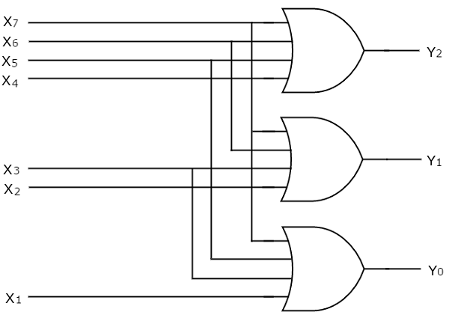

Fig. 3. Encoder logic

# **Results And Discussion**

The 3-bit encoder output has been achieved with less number of transistors and power has been reduced to lower power Memristor with Ron = 1Ω and Roff = 25MΩ with initial resistance Rinit = 20MΩ.The memristor circuit element has been modeled using Verilog-AMS, transition analysis done with time period of .100ms, tweaking Roff, Ron & Rinit values can help in achieving lower power consumption in digital circuits like encoders. A comparison has been done between CMOS and MRL logics by taking the pulse inputs with a delay of 12ms.

Tweaking the value of memristor has been shown to help in achieving lower power dissipation in digital circuits. Memristors are a promising technology that can be used to replace traditional transistors in logic gates, memory devices, and other digital circuits. By adjusting the resistance of memristors, it is possible to optimize the power consumption of digital circuits, leading to improved energy efficiency. The window function used is Joglekar window.

The 3-bit encoder output has been verified on CMOS and MRL logic respectively using LTspice software . The power dissipated in the conventional CMOS logic and the average power during the analysis is found to be 890.27 nW. The Power dissipated in MRL design, the average power during the analysis was found to be 486.7 nW which is lower than power dissipated in conventional CMOS based design. It can be depicted that there is a 45.33% decrease of power dissipated when compared to CMOS logic circuit design. The power dissipated is very low for the MRL when compared to CMOS logic circuit design. As it is known that the area occupied by a Memristor based design is lesser than CMOS it can be depicted that this design is efficient with respect to the area consumed. However, to achieve significant power savings using MRL, the ON resistance (RON) of the transistors used in the circuit must be increased. Higher RON values reduce the current flowing through the transistors, which in turn reduces the power dissipation. The tradeoff is that higher RON values typically come at a higher cost due to the need for more advanced fabrication techniques and specialized materials. Therefore, when designing a circuit, it is important to carefully balance the cost of the components with the potential power savings to achieve an optimal solution.

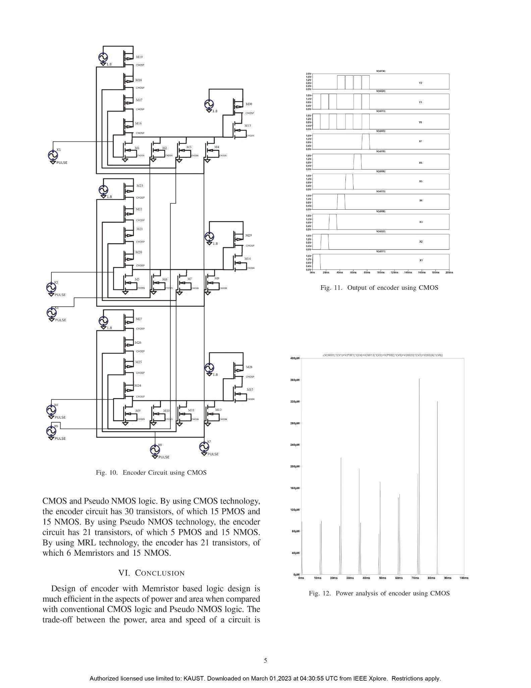

Fig. 4. Encoder CMOS logic[1]

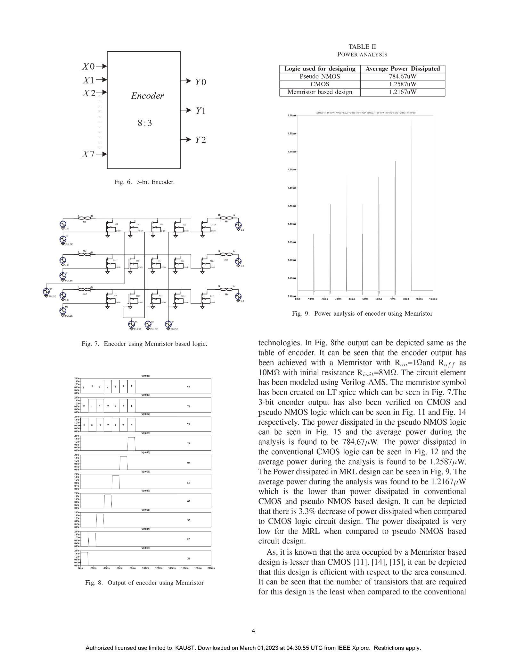

Fig. 5. Encoder MRL logic[1]

TABLE II Comparison

| **Logic used for designing** | **Number of transistors used** | **Average Power Dissipated** |
| --- | --- | --- |
| CMOS | 30 Transistors  (15 NMOS + 15 PMOS) | 890.27 nW |
| MRL | 15 Transistors  (15 NMOS + 0 PMOS) | 486.7 nW |

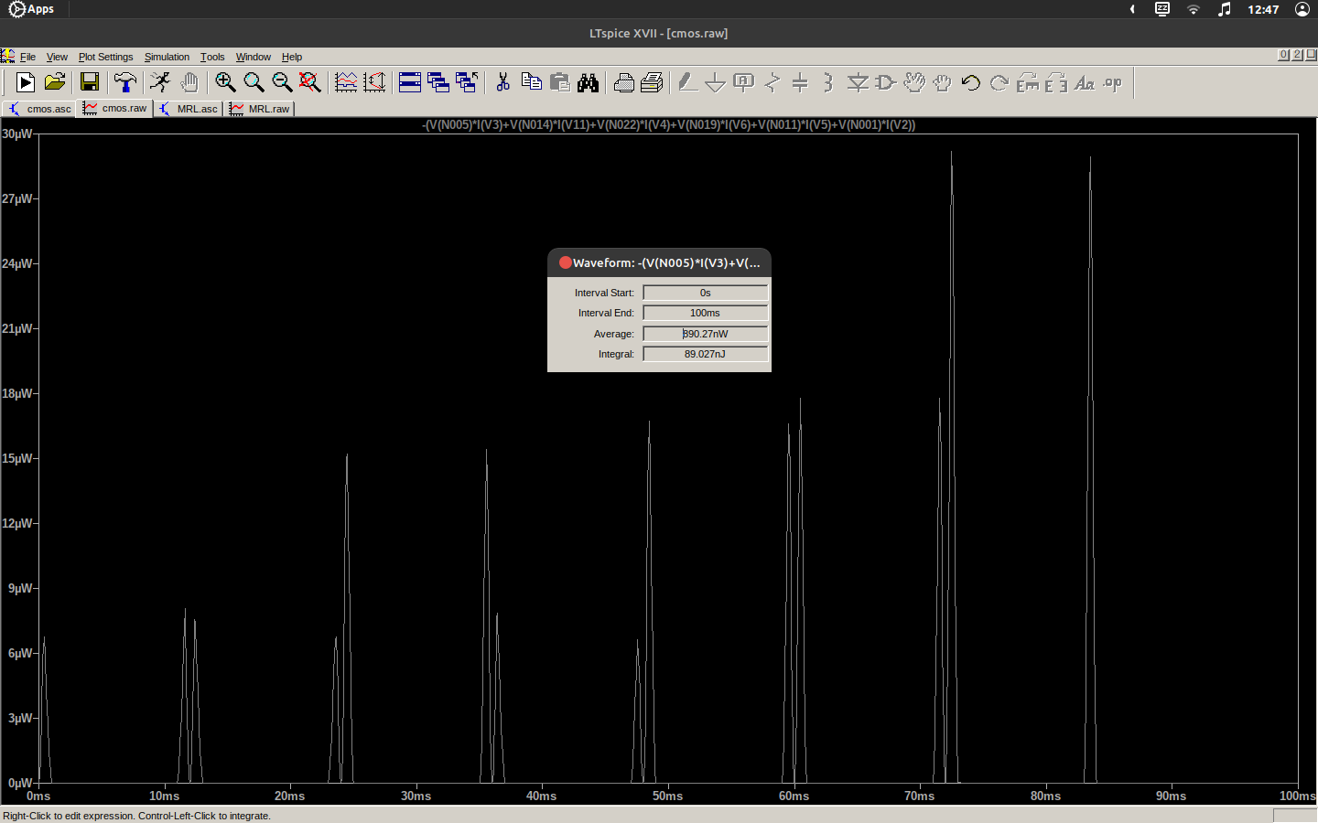

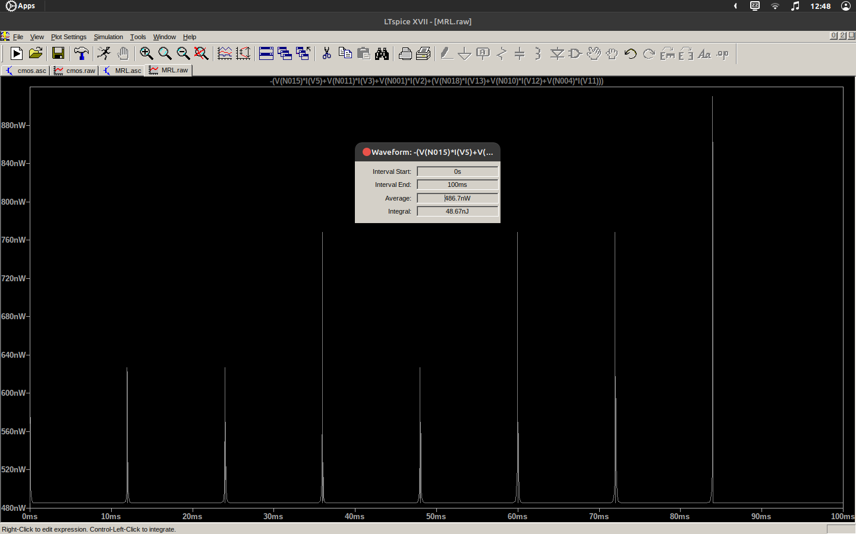

# Fig. 6. Power dissipation in CMOS & MRL logics using LTspice

# **Conclusions**

The utilization of memristor-based logic design in encoder design has been found to be more effective in terms of power and area compared to traditional CMOS logic and Pseudo NMOS logic. Despite the persistent trade-off between power, area, and speed in circuit design, the memristor-based logic design technique has been observed to require fewer transistors, making it a more efficient approach to digital circuit design.

**Acknowledgment**

I would like to thank my teachers for providing invaluable guidance and support throughout the research process. Their knowledge and expertise were instrumental in shaping the direction of this study. I would also like to extend my appreciation to the reference base papers that served as a foundation for this research. Without their thorough analysis and insights, this study would not have been possible. In addition, I would like to thank my colleagues and friends who provided valuable feedback and support throughout the writing process. Their critiques and encouragement were invaluable.Thank you all for your support and encouragement throughout this project.

**References**

1. Suri Shanmukh, Sompalli RohitKumar, Paluru Hemaprasad, and R.Sakthivel, “Low Power 3-Bit Encoder Design using Memristor,” 2022 2nd International Conference on Intelligent Technologies (CONIT) Karnataka, India. June 24-26, 2022
2. K. Mbarek, F. O. Rziga, S. Ghedira, and K. Besbes, “Design and properties of logic circuits based on memristor devices,” in 2020 IEEE International Conference on Design & Test of Integrated Micro & Nano-Systems (DTS). IEEE, 2020, pp. 1–5.
3. A. Singh, “Memristor based xnor for high speed area efficient 1-bit full adder,” in 2017 International Conference on Computing, Communication and Automation (ICCCA). IEEE, 2017, pp. 1549–1553.
4. A. Sasi, M. Ahmadi, and A. Ahmadi, “Low power memristor-based shift register design,” in 2020 27th IEEE International Conference on Electronics, Circuits and Systems (ICECS). IEEE, 2020, pp. 1–4.
5. D. B. Strukov, D. R. Stewart, J. Borghetti, X. Li, M. Pickett, G. M. Ribeiro, W. Robinett, G. Snider, J. P. Strachan, W. Wu et al., “Hybrid cmos/memristor circuits,” in 2010 IEEE International Symposium on Circuits and Systems (ISCAS). IEEE, 2010, pp. 1967–1970.
6. S. Kvatinsky, N. Wald, G. Satat, A. Kolodny, U. C. Weiser, and E. G. Friedman, “Mrl—memristor ratioed logic,” in 2012 13th International Workshop on Cellular Nanoscale Networks and their Applications. IEEE, 2012, pp. 1–6.
7. V. A. Slipko and Y. V. Pershin, “Importance of the window function choice for the predictive modelling of memristors,” IEEE Transactions on Circuits and Systems II: Express Briefs, vol. 68, no. 6, pp. 2167–2171, 2019.
8. L. Chua, “Memristor-the missing circuit element,” IEEE Transactions on circuit theory, vol. 18, no. 5, pp. 507–519, 1971.
9. G. Liu, S. Shen, P. Jin, G. Wang, and Y. Liang, “Design of memristor-based combinational logic circuits,” Circuits, Systems, and Signal Processing, vol. 40, no. 12, pp. 5825–5846, 2021.