A SRP Project Report on
NOISE REMOVAL TECHNIQUE FOR MEDICAL IMAGES
is submitted in partial fulfillment of the requirement for the award of the Degree of Bachelor of Technology
to

JAWAHARLAL NEHRU TECHNOLOGICAL UNIVERSITY ANANTAPUR, ANANTHAPURAMU
by
SD. JAVEED (LEADER)
(19711A04A9.)
SK. MASTHAN SHARIF S. PRAVEEN KUMAR
(19711A04A2.) (19711A0494.)
P. YASHWANTH KUMAR SK. MASTHAN
(19711A0489.) (19711A04A1.)
Under the Guidance of
Dr.K.MURALI, _{M.Tech., Ph.D}.
Professor & HOD

Department of Electronics and Communication Engineering

July 2022

Department of Electronics and Communication Engineering

CERTIFICATE

This is to certify that the project report entitled “Noise removal technique for medical images” being submitted by SD. JAVEED (19711A04A9.), SK.MASTHAN SHARIF (19711A04A2.), S. PRAVEEN KUMAR (19711A0494.), P. YASHWANTH KUMAR (19711A0489), SK. MASTHAN (19711A04A1.) in partial fulfillment for the award of the Degree of Bachelor of Technology in Electronics & Communication Engineering Department to the Jawaharlal Nehru Technological University Anantapur, Ananthapuramu is a record of bonafied work carried out by them under my guidance and supervision.
The results embodied in this project report have not been submitted to any other University or Institute for the award of any Degree or Diploma.

Dr.K.MURALI, _{M.Tech., Ph.D.} Dr.K.MURALI, _{M.Tech., Ph.D.}
Professor & HOD Professor & HOD
Project Supervisor Department of ECE

ACKNOWLEDGEMENT

We are extremely grateful to Dr.P. NARAYANA, Ph.D.Founder, Narayana Educational Institutions, Andhra Pradesh for the kind blessings. We are extremely thankful to Mr R Sambasiva Rao B.Tech, Registrar Narayana Engineering College, Nellore.
We are much obliged to Dr. A.V.S Prasad, Ph.D. Director, Narayana Engineering & Pharmacy Colleges, for the continuous encouragement and support. We owe indebtedness to our Principal Dr.G. Srinivasulu Reddy,M.Tech., Ph.D., Narayana Engineering College, Nellore for providing us the required facilities.
We express our deep sense of gratitude and sincere thanks to Dr. K. Murali,M.Tech, Ph.D , Professor & HOD, Department of Electronics and Communication Engineering, Narayana Engineering College, Nellore for providing the necessary facilities and encouragement towards the SRP project work.
We thank our Faculty Incharge – SRP, Dr. K.Selvakumarasamy, Ph.D, Professor, Department of Electronics and Communication Engineering, Narayana Engineering College, Nellore for his guidance, valuable suggestions and support in the completion of the project.
We thank our project guide, Dr. K. Murali,M.Tech, Ph.D , Professor & HOD, Department of Electronics and Communication Engineering for his guidance, valuable suggestions and support in the completion of the project.
We gratefully acknowledge and express our thanks to teaching and non-teaching staff of E.C.E Department..

Project Associates
SD. JAVEED 19711A04A9
SK. MASTHAN SHARIF 19711A04A2
S. PRAVEEN KUMAR 19711A0494
P. YASHWANTH KUMAR 19711A0489
SK. MASTHAN 19711A04A1

ABSTRACT

In the recent years image processing techniques are used as a tool to improve detection and diagnostic capabilities in the medical applications. Medical applications have been so much affected by these techniques which some of them are embedded in medical instruments such as MRI, CT and other medical devices. Among these techniques, medical image enhancement algorithms play an essential role in removal of the noise which can be produced by medical instruments and during image transfer. It has been proved that impulse noise is a major type of noise, which is produced during medical operations, such as MRI, CT, and angiography, by their image capturing devices. An embeddable hardware module which is able to denoise medical images before and during surgical operations could be very helpful. we propose an accurate algorithm for real-time removal of impulse noise in medical images. All image blocks are divided into three categories of edge, smooth, and disordered areas. A different reconstruction method is applied to each category of blocks for the purpose of noise removal. The proposed method can be tested in all medical images. in future, the project can be extended for other type of noise also.

CONTENTS
Abstract iv
Contents v
List of Figures and Tables vi
CHAPTER 1 INTRODUCTION
1.1 Background Information 7
1.2 Scope of project 9

CHAPTER 2 LITERATURE REVIEW
2.1 Methodology 10
2.2 Objective 14
CHAPTER 4 PROBLEM
3. 1 Problem Statement 15
3.2 Problem Solution 16
CHAPTER 4 APPENDIX 18
CHAPTER 5 RESULTS AND DISCUSSIONS 21
CHAPTER 6 CONCLUSIONS 24
REFERENCES 25

LIST OF FIGURES AND TABLES

Figure 1.1 represent de-noising model 8
Figure 2.1 Sorting in median filter. 13
Figure 3.1 Algorithm used for adaptive median filter 17
Figure 5.1 Result 23
Figure 5.2 Result in GUI (Graphical user interface) 23
CHAPTER 1

INTRODUCTION
  - Background Information
Preprocessing is one of the simplest and important methods of image processing and try to make the diagnostic details clearer. It is an important and diverse set of image preparation for the next process of image processing. Preprocessing techniques play an important role in the accuracy and performance of the post processing application.
Preprocessing include removing noise and eliminating unnecessary and invisible information. Other preprocessing steps might include gray level or spatial quantization (reducing the number of bits per pixel or the image size).

Noise:

Noise is any distortion that occurs in the digital image and may damage the contents of the image. So removing the noise is necessary until the image becomes closer to the scene of the real goals of the photographer. The noise in the images is a serious problem, or it is happening by any introduced into the data via any electrical system used for storage, transmission, and processing.

Different types of noise exist in the image and there are a variety of noise reduction techniques to remove noise. The selection of noise removal algorithm depends on the application. In this research (Salt and pepper noise, Gaussian noise, Shot noise and Speckle noise) are types of noises that are present in an image. The principle approach of remove noise in image is filtering. Available filters to remove noise from the image are (Median filter, Gaussian filter, Wiener filter and Fuzzy logic).

Noise removal is an important step in digital image processing. it is consider important step to be taken before analyzing image data. It is necessary to apply an effective technique to compensate for data damage.

The main properties of a good model are eliminates noise while maintaining edges. The goal of eliminating noise is to reduce noise through two phases namely: noise detection and noise removal. (Figure 1) represent the de-noising model. The noise detection is a process in which screening the image pixel is noise. After noise removal, the damaged pixels of the input image are replaced by the appropriate values calculated from the specified methods

+
Noise Removal Filter
image De-noise image

Figure 1.1 represent de-noising model

  - Scope of Project

As the instruments ages and have errors, It has been proved that impulse noise is a major type of noise, which is produced during medical operations, such as MRI, CT, and angiography, by their image capturing devices. To remove such noises using Matlab. Preprocessing is one of the simplest and important methods of image processing and try to make the diagnostic details clearer. It is an important and diverse set of image preparation for the next process of image processing. Preprocessing techniques play an important role in the accuracy and performance of the post processing application. This include removing noise and eliminating unnecessary and invisible information.

CHAPTER 2
LITARATURE REVIEW

2.1 METHODOLOGY
In the field of image processing image gets corrupted during image transmission or acquisition stage due to various influencing parameters such as faulty device etc. Such type of corruption gives rise to noise in the image which affects the information present in the image. The various type of noise that arises in the image is impulse noise also know as salt and pepper noise, Gaussian noise, and speckle noise to name a few . In order to retrieve the original information from the image and eliminate noise from the image we need to apply certain de-noising techniques. These denoising techniques make use of kernel which is made to convolve over the image and the result obtain through this convolution is a noise free image. The size of kernel (window) used for the same varies and intended output with same also varies. One such commonly used technique is median filtering. Median filtering works fine when the noise intensity is less but it starts to fail when the noise intensity in the image is high . In order to overcome this problem we can make of spatial filtering technique. One such Filtering algorithm used is adaptive median filter. Adaptive median filtering is better than median as it is a two step filtering technique. The main advantage of adaptive median filter is that the behavior of the adaptive filter changes depending on the characteristics of the image under filter. Other main feature of adaptive filter is that it works well not only for impulse noise but also for speckle noise and Gaussian noise .

Types of noise existing in the images used in the research are following:

- Salt-and-pepper noise
The image with salt and pepper noise will contain dark pixels in bright areas and bright pixels in dark areas ^{[9]}. This type of noise is an impulse, which is also called to as intensity spikes, This is due to data transmission errors ^{[10,} ^{11]}.

Shot noise (Poisson noise)
This type of noise occurs in the lighter parts of the image due to statistical fluctuations. Noise occurs in different pixels and is independent of each other. Shot noise is also called Poisson noise, and does not differ significantly from the Gaussian noise ^{[4,} ^{12]}.

Speckle noise
This type of noise is double noise because the random interference between obstacles is coherent. It's usually occurs in imaging systems. Its follows the gamma distribution ^{[12]}.

Gaussian noise (Amplifier noise)
Gaussian noise is a kind of statistical noise. It is a essential part of reading image sensor noise. The probability density function for Gaussian noise is equal to the normal distribution function, also known as the Gaussian distribution. which has a bell shaped probability distribution function ^{[6,} ^{13]}.

METHODS:

There are many methods to remove noise from medical image, In this research three best types of filter (median filter, wiener filter, Gaussian filter) and fuzzy logic are used.

Median filter
This technique is one of the most important techniques used to remove noise and is a necessary step for the pre-analysis of the subsequent processing ^{[14]}. The important property in this type is to remove the effect of large quantities of noise. It can also eliminate various types of noise and is a non-linear digital filtering technology ^{[15]}.

Wiener Filter
This filter is one of the filters used to reduce the amount of signal in the image signal compared to the estimate of the signal without noise. It is not an adaptive candidate because the theory assumes that input is constant ^{[16,} ^{17]}.

Gaussian filter
The Gaussian filter set filters the input signal. This type of filters is designed to reduce the rise and fall time. It is modifies input signal by embedding with a Gaussian function ^{[16]}.

Fuzzy logic
Fuzzy logic techniques is used extensively to eliminate noise in digital image processing ^{[18]}. The main objective is to find the average pixel processing based on adjacent pixel values. The characteristics of the image should not be affected. The center pixel is denoted as Pij. The neighboring pixels are present: (i-1,j-1), (i-1,j), (i-1,j+1), (i,j-1), (i,j+1), (i+1,j-1), (i+1,j) and (i+1,j+1) respectively ^{[19]}.

MEDIAN FILTER
Median filter is the most commonly used filter. It is a non linear method of filtering. The size of the kernel can be of nxn size which is made to convolve or slide over a mxm corrupted image. While performing this operation the median value of nxn kernel on the image is obtained and then the value of a particular pixel is replaced with the median value of the nxn kernel.

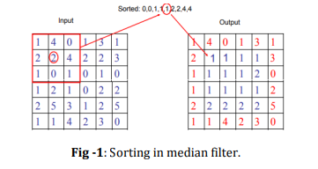
Figure 2.1 Sorting in median filter.

Drawbacks of median filter:
Effective only when the noise is impulse
• Noise (salt and pepper). Its output quality deteriorates when the
• Noise is more than 20%. It does not work efficiently when the
• Spatial density of noise is high. For large kernel size, there is no proper
• Smoothening of the image instead valuable information from the image gets blur.

2.2 OBJECTIVE

Peak signal to noise ratio (PSNR):
PSNR is the ratio between the potential strength of the signal and the force of the noise affecting its representation. It is often measured to see the quality between the original image and the image after noise removal ^{[20]}. The higher PSNR value, the better the image quality will be after the noise is removed. PSNR depends on MSE and is calculated by the following equation:
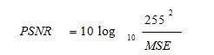
Where MSE is the mean square error between the original image (input image) and the resolution image after noise removal (output image). MSE is defined as followed:
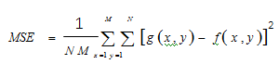
Where: M= Number of rows in the image, N: Number of columns in the image, g: Input image (Damaged image), f: Output image (Filtered image). The Less value than MSN is the best result in image

CHAPTER 3
PROBLEM
3.1 PROBLEM STATEMENT
Image noise removal plays a vital role in image processing as a processing stage. In image processing noise appear from different sources like variation in the detector sensitivity, environmental variation, transmission, and casualization. High levels of noise are always undesirable. Hence noise removal has to be employed before the image could be used for further analysis The available literature shows many methods based on mean and median filters employed for removal of salt and Pepper noise. Some of them are discussed below. In recent years, many improved algorithms are proposed to overcome the signal pixel and noise pixel. At present, there are many different types of median filtering, such as weighted median filter, switching median filter, adaptive median filter, and adaptive weighted mean filter and so on. According to the distribution of local pixels, Sue J. (2010) proposed a noise detection algorithm based on Improved Standard Median Filtering (ISMF). In the authors have used weighted median filter to remove salt and pepper noise without damaging image quality. In, median filtering is introduced as boundary discriminate noise detection filter. Here, they achieve a better PSNR value over a wide range of noise density variations between 10% and 70%. In the authors describe different filters, such as MF, AMF, decision based median filtering, and decision based asymmetric pruning median filters, for removing salt and pepper noise. Adaptive median filtering works well under low noise density. But at higher noise-densities, it leads to large window size which may blur the image. This algorithm has a good effect on noise suppression, but it often fails when the pixels are destroyed in the window. We propose a selective adaptive median filter to remove salt and pepper noise, which is different from the adaptive median filter. We find that although we can clearly identify the shape of the image, the pixels value varies little in a small range. If we can make full use of the local distribution information to infer the maximum likelihood value of the target pixels, we can improve the PSNR of the restored image .

3.2 PROBLEM SOLUTION

In this research, noise in medical images was removed by used the best three types of filters (Median filter, Wiener filter, Gaussian filter) and fuzzy logic to remove (Salt and Pepper noise, Shot noise, Speckle noise and Gaussian noise).To determine the quality of the noise reduction in medical images is measured by the statistical quantity measures: Mean Square Error (MSE) and Peak Signal to Noise Ratio are used.

The adaptive median filter is designed to eliminate the drawbacks faced by the standard median. The main advantage of adaptive median filter is the size of the kernel surrounding the corrupted image is variable due to which better output result is obtained. The other main advantage of adaptive filter is that unlike median filter it does not replace all the pixel values with the median value. The working of adaptive filter is a two step process; in the first step its finds the median value for the kernel and in the second step it checks whether the current pixel value is a impulse (salt and pepper noise) or not. If pixel value is corrupted then it changes it value with median or else it retains the value of the gray scale pixel. By doing this, one can ensure that only the pixels with impulse noise is changed while all other pixel values are retained as they are. 3.1. Implementation of adaptive median filter
Zmin = Minimum gray level value in Sxy.
Zmax = Maximum gray level value in Sxy
Zmed = Median of gray levels in Sxy
Zxy = gray level at coordinates (x, y)
Smax = Maximum allowed size of Sxy
The adaptive median filter works in two levels denoted Level A and Level B as follows: Level A: A1= Zmed - Zmin
A2= Zmed - Zmax
If A1 > 0 AND A2 < 0, Go to level B
Else increase the window size
If window size <=Smax repeat level A
Else output Zxy
Level B: B1 = Zxy – Zmin
B2 = Zxy – Zmin
If B1 > 0 And B2 < 0 output Zxy
Else output Zmed

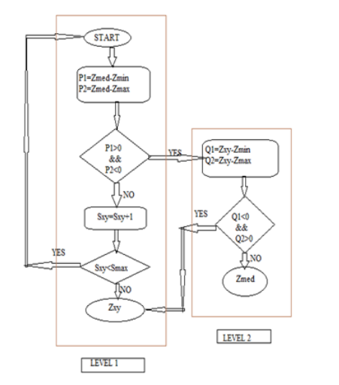
Figure 3.1: Algorithm used for adaptive median filter

CHAPTER 4
APPENDIX
MATLAB PROGRAM

%Median filter
clear all;
pic = imread('n1.png');
subplot(2,2,1)
imshow(pic);
title('MRI Scan with salt & pepper noise')
pause;

size(pic);
picd=double(pic);
pic2=picd(:,:,1);
pic3=mat2gray(pic2);
pic4=pic3;
size(pic2);
filteredpic = medfilt2(pic4,[3,3]);
subplot(2,2,2)
imshow(filteredpic);
title('MRI Scan after processing through median filter')
pause;

pic = imread('n2.png');
size(pic);
picd=double(pic);
pic2=picd(:,:,1);
pic3=mat2gray(pic2);
pic4=pic3;
size(pic4);
subplot(2,2,3);
imshow(pic4);
title('MRI Scan with salt & pepper noise');
pause;

%adaptive median filtered pic
smax = 7;
g = pic4;
[m n] = size(g);

%initial setup
f=g;
f(:) = 0;

%begin filtering
for k=3:2:smax
zmin = ordfilt2(g,1,ones(k,k),'symmetric');
zmax = ordfilt2(g,k*k,ones(k,k),'symmetric');
zmed = medfilt2(g,[k,k],'symmetric');

processusinglevelb = (zmed>zmin) & (zmax>zmed);

zb = (g>zmin) & (zmax>g);
outputzxy = processusinglevelb & zb;
outputzmed = processusinglevelb & ~zb;
f(outputzxy) = g(outputzxy);
f(outputzmed) = zmed(outputzmed);
end

subplot(2,2,4);
filteredpic = f;
imshow(filteredpic);
title('MRI Scan after processing through adaptive median filter')

CHAPTER 5
RESULTS AND DISCUSSIONS

The standard median filter and adaptive median is been implemented using MATLAB Software. The PSNR (peak signal to noise ratio) is been calculated to understand the efficiency of both the filters. Basically when more is the PSNR value better is noise reduction by the filter. From the calculated values we can observe that the adaptive median filter has better noise filtering capacity than the standard median filter.
PSNR We have tested our proposed algorithm for different levels of noise ranging from as low as to as high as 90%. The experimental results have been gauged using the mean square error (MSE) [19] and peak signal-to-noise ratio (PSNR) measures that have been given below [20].
Where A and R are the original and the restored images having are resolution of mxn
Where max is the maximum possible pixel value of the image and its value is255in the case of a gray scale image.

A simple median filter [11] uses the median of the window to replace the central pixels considered by the window. If the center pixels are (Pepper) or (salt), it will be replaced by the middle value of the window, which will not be or. The major drawback of standard median filter is that even if the pixels under consideration is uncorrected (other than 0 or 255), it is replaced by the median of the window. This will damage the overall visual quality of the image. In addition, a simple median filter cannot maintain edges. It works as follows: The window sorted in ascending. Median is the middle value after the sort. Therefore, the undamaged pixels are replaced by the median value of the window.
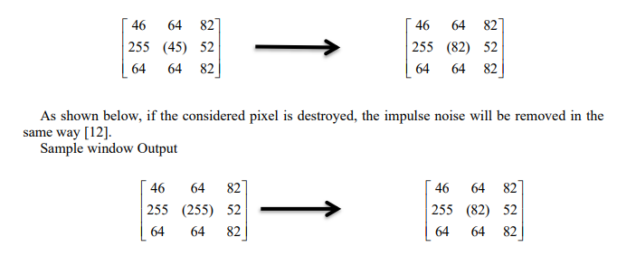

Improved Self-adaptive Median Filter Based on the classical adaptive median filtering algorithm, an improved adaptive median filter (IMF) based on dynamic window size is proposed. It is executed as follows.
- The noise pixel g(x,y) are detected by comparing the simple thresholds and averages around the target pixels.
- Select the (3x3) windowed centered at the noise pixels g(x,y) If there exist informative pixels g(x,y); g(x,y) is replaced by the median value of informative pixels in the window.
- If there not enough pixels g(x,y), the window will be expanded to (5x5) and repeat the above steps.

Because noisy pixels are replaced by the median values got from informative pixels, the IMF algorithm avoids the spread of noisy signals in the adjacent efficiently during filtering. However, the original pixel distribution is not considered in the recovery process. There is always a significant correlation between adjacent pixel values in natural images. There are often significant correlations between adjacent pixel values in a nature image. Therefore, noise pixels replaced by adjacent values outside the median value are sometimes more accurate.

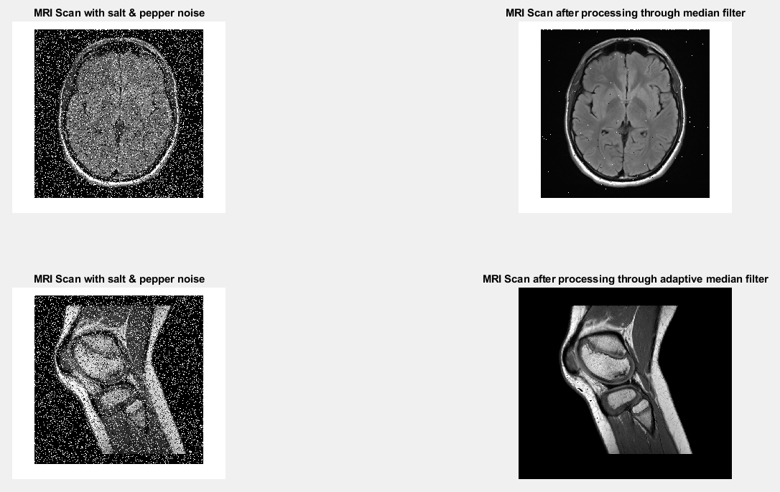
Figure 5.1 Result
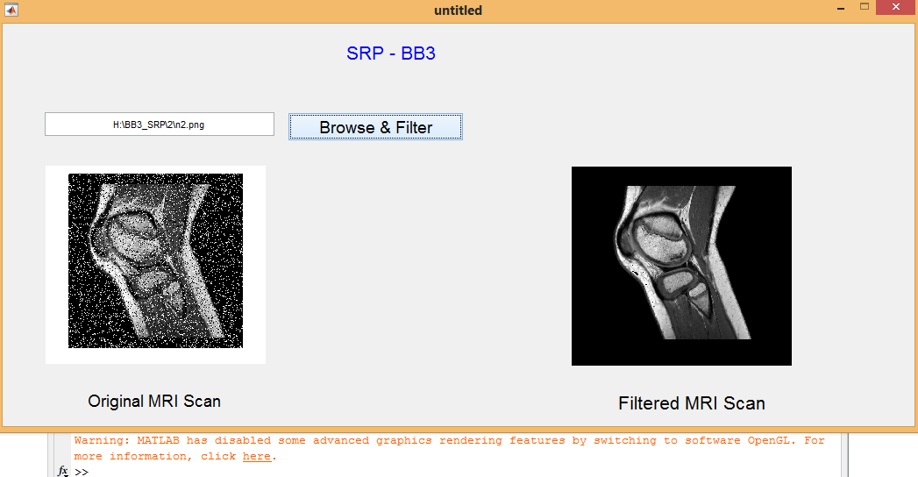
Figure 5.2 Result in GUI (Graphical user interface)

CHAPTER 6
CONCLUSIONS

CONCLUSION:

After implementing both standard and adaptive median filter, we can observe that the adaptive median filter works accurately for the impulse noise that is salt and pepper noise. For Gaussian noise the adaptive median filter gives much better output than the standard median but we can also observe that the output results are not so satisfactory and accurate ,so there needs to be some more modification to be done in the proposed model to obtained better results for Gaussian noise.

Noise removal is an important step in medical image processing. and there are many methods to eliminate noise, the best methods is to remove noise while retaining image detail. A self-adaptive median filter based on local pixel distribution information to remove pepper and salt noise is presented in this paper. The proposed method can not only achieve better image quality, but also have shorter computation time. And our method is simple and easy to be understood. Simulation results reveal that the proposed method provides better performance than the existing method presented for the corrupted by highly noise density in terms of noise suppression and detail preservation. The proposed method gives an efficient filter frame-work, and is suitable for real-time implementation. Experimental results show that the performance of the proposed method is much superior to that of classical median filter. It performs better than that of the traditional filtering techniques and we hope that our effort will help to improve the future experiments over image processing and performance analysis. In future we will try to explore the effect of other filtering techniques over noisy image and upgrade them according to achieve the better performance.

REFERENCES
- Advances in Intelligent Systems Research, volume 161 International Conference on Transportation & Logistics, Information & Communication, Smart City (TLICSC 2018)
- International Research Journal of Engineering and Technology (IRJET) Volume: 07 Issue: 05 | May 2018
- International Research Journal of Engineering and Technology (IRJET) Volume: 06 Issue: 10 | Oct 2019
- Rafael C. Gonzalez and Richard E. Woods Digital Image Processing, 2001, pp.220-225.
- R. Boyle and R. Thomas Computer Vision: A First Course, Blackwell Scientific Publications, 1988, pp. 32 – 34
- Suman Shrestha, Image denoising using new adaptive based median filter ,Signal & Image Processing : An International Journal (SIPIJ) Vol.5, No.4, August 2014
- Afrose, Zinat. (2012). Relaxed Median Filter: A Better Noise Removal Filter for Compound Images. International Journal on Computer Science and Engineering (IJCSE).
- Ammayappan, Sathesh. (2018). A Nonlinear Adaptive Median Filtering Based Noise Removal Algorithm.

