**Introduction to Graph Data Structure**

**Graph Data Structure**is a [non-linear data structure](https://www.geeksforgeeks.org/introduction-to-hierarchical-data-structure) consisting of vertices and edges. It is useful in fields such as social network analysis, recommendation systems, and computer networks. In the field of sports data science, graph data structure can be used to analyze and understand the dynamics of team performance and player interactions on the field.

**What is Graph Data Structure?**

**Graph** is a [non-linear data structure](https://www.geeksforgeeks.org/introduction-to-hierarchical-data-structure) consisting of vertices and edges. The vertices are sometimes also referred to as nodes and the edges are lines or arcs that connect any two nodes in the graph. More formally a Graph is composed of a set of vertices( **V**) and a set of edges( **E**). The graph is denoted by **G(V, E).**

Imagine a game of football as a web of connections, where players are the nodes and their interactions on the field are the edges. This web of connections is exactly what a graph data structure represents, and it’s the key to unlocking insights into team performance and player dynamics in sports.

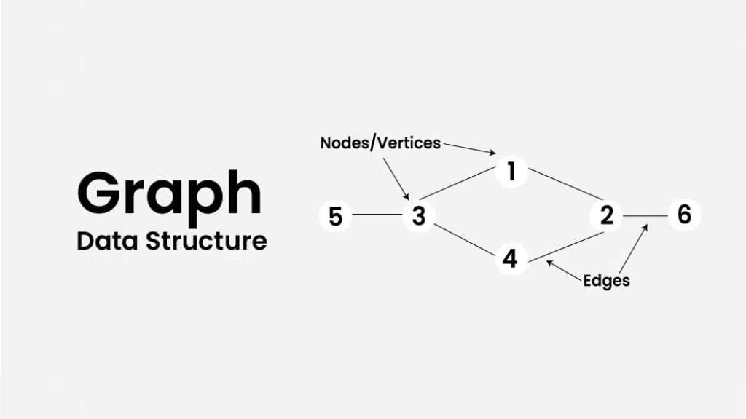

**Components of Graph Data Structure**

* **Vertices:** Vertices are the fundamental units of the graph. Sometimes, vertices are also known as vertex or nodes. Every node/vertex can be labeled or unlabelled.
* **Edges:** Edges are drawn or used to connect two nodes of the graph. It can be ordered pair of nodes in a directed graph. Edges can connect any two nodes in any possible way. There are no rules. Sometimes, edges are also known as arcs. Every edge can be labelled/unlabelled.