# Spring Boot Actuator

Developing and Managing an application are the two most important aspects of the application’s life cycle. It is very crucial to know what’s going on beneath the application. Also when we push the application into production, managing it gradually becomes critically important. Therefore, it is always recommended to monitor the application both while at the development phase and at the production phase.

For the same use case, Spring Boot provides an actuator dependency that can be used to monitor and manage your Spring Boot application, By /actuator and /actuator/health endpoints you can achieve the purpose of monitoring.

* With the help of Spring Boot, we can achieve the above objectives.
* Spring Boot’s ‘Actuator’ dependency is used to monitor and manage the Spring web application.
* We can use it to monitor and manage the application with the help of HTTP endpoints or with the JMX.

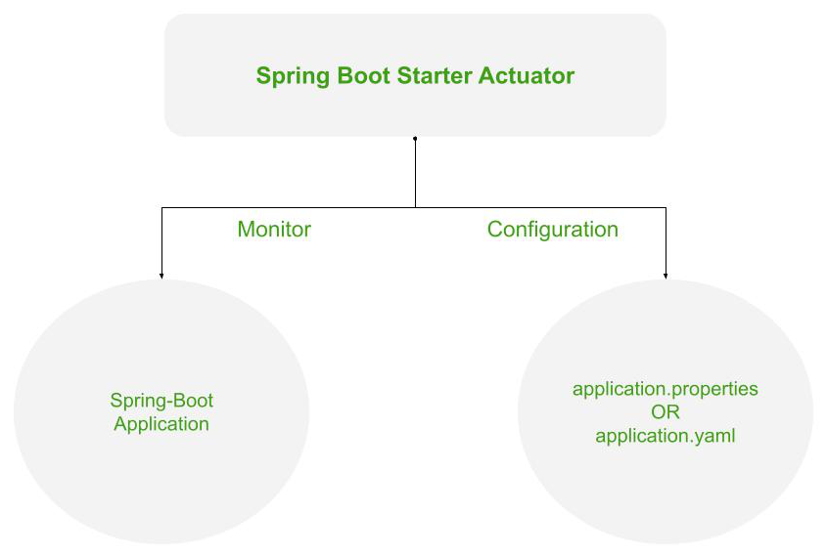

*Working of the Spring’s Actuator*

**Advantages of Actuator the Application**

1. It increases customer satisfaction.
2. It reduces downtime.
3. It boosts productivity.
4. It improves Cybersecurity Management.
5. It increases the conversion rate.

**1. Configuration for Actuator**

In order to use hibernate validators, these configurations are necessary in your Spring Boot project.

**1.1 Dependency for Actuator**

To use the ‘Actuator’ add the following dependency in your application’s project settings file.

Dependency configuration for both Maven and Gradle build system.

***Maven* -> pom.xml**  
  
<dependencies>  
 <dependency>  
 <groupId>org.springframework.boot</groupId>  
 <artifactId>spring-boot-starter-actuator</artifactId>  
 </dependency>  
</dependencies>

***Gradle***

**-> build.gradle**  
  
dependencies {  
 implementation 'org.springframework.boot:spring-boot-starter-actuator'  
}

**1.2 Application Properties configuration for Actuator**

There more configurations available for Actuator, few of them are listed:

* You can also change the default endpoint by adding the following in the application.properties file.

management.endpoints.web.base-path=/details

* Including IDs/Endpoints

By default, all IDs are set to false except for ‘health’. To include an ID, use the following property in the application.properties file.

management.endpoint.<id>.enabled  
  
**Example ->** management.endpoint.metrics.enabled=true

* List down all IDs that you want to include which are separated by a comma.

management.endpoints.web.exposure.include=metrics,info

* Include only metrics and info IDs and will exclude all others (‘health’ too).

To add/include all ID information about your application, you can do it in the application.properties file by simply adding the following –

management.endpoints.web.exposure.include=*

* Excluding IDs/Endpoints

To exclude an ID or endpoint, use the following property and list out the respective IDs separated by a comma in the application.properties file.

management.endpoints.web.exposure.exclude  
  
**Example ->** management.endpoints.web.exposure.exclude=info