Database project
Topic: Hotel Reservation System
Final Technical Report

Javeria Javaid
Bcsf24a041

TOPIC:COMPLEX SQL QUERIES

1-Hotel Revenue:
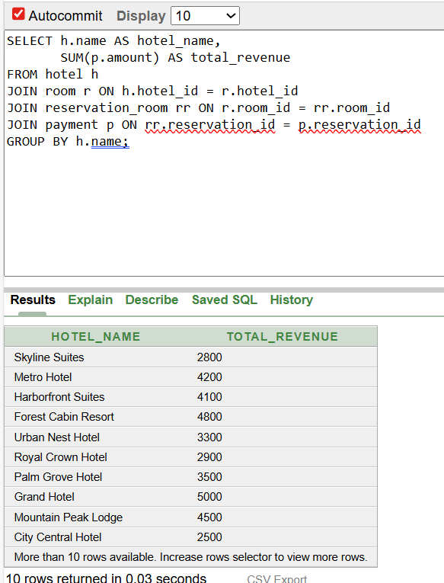

2-Guests staying more than 3 days:
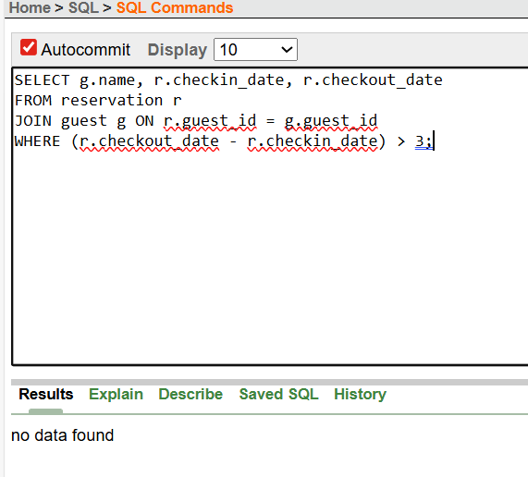

3-Hotels with no reservations:
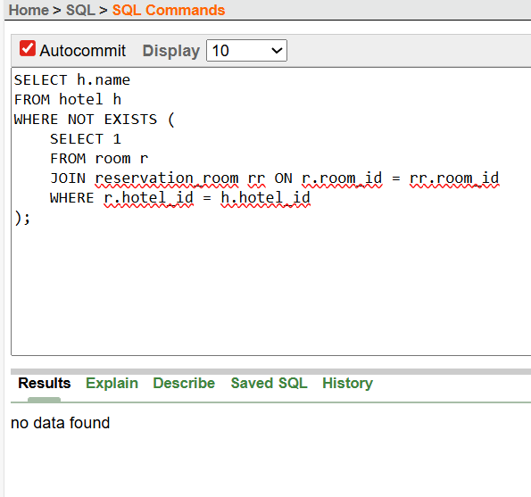

4-Top 5 highest-paying guests:
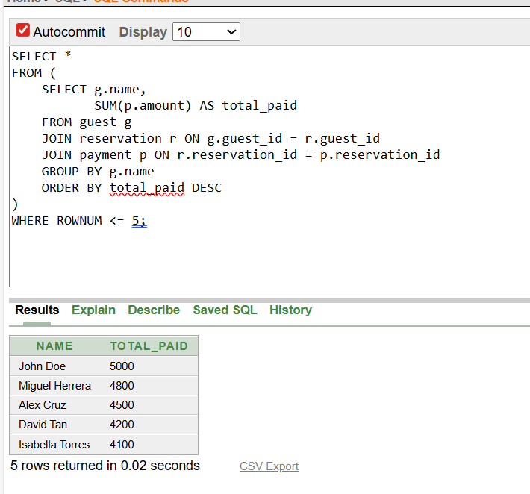

5-Total services per staff member:
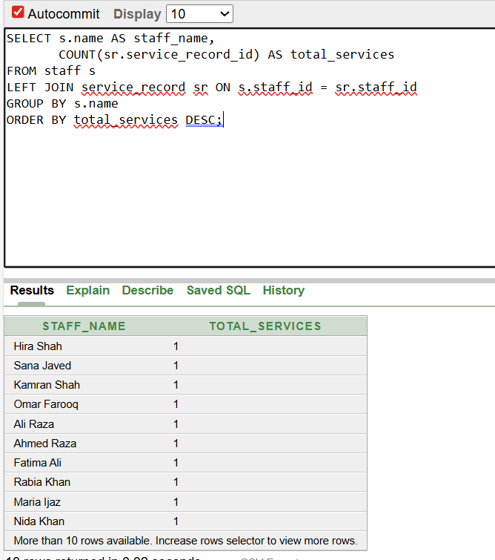

6-Rooms never reserved:
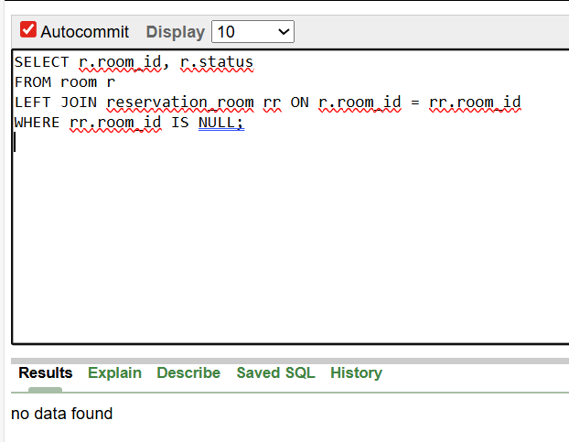

7-Total revenue per service:
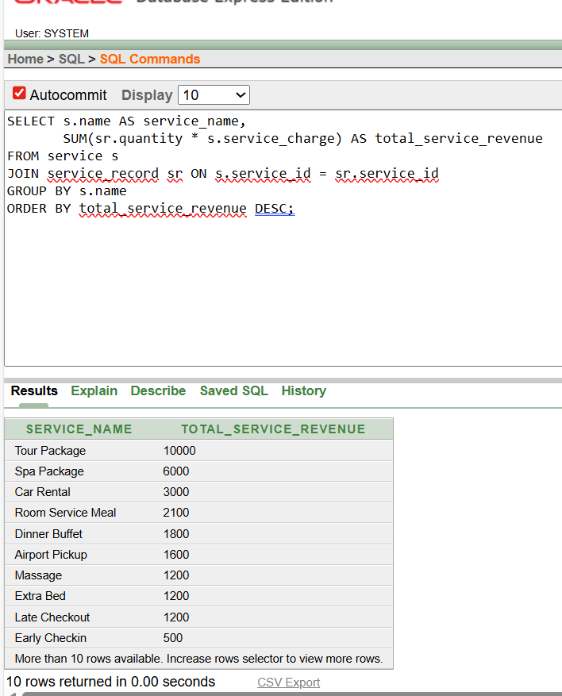

8-Guests with no payments:
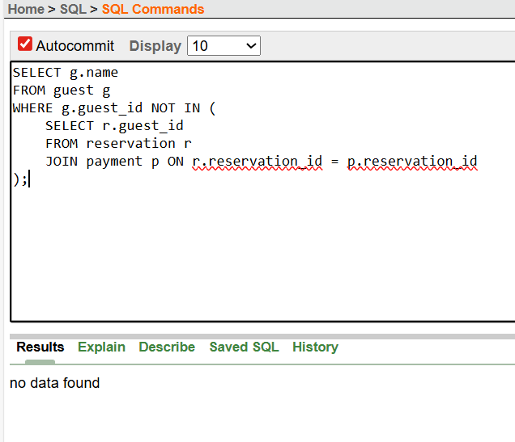

9-Most expensive room type per hotel:
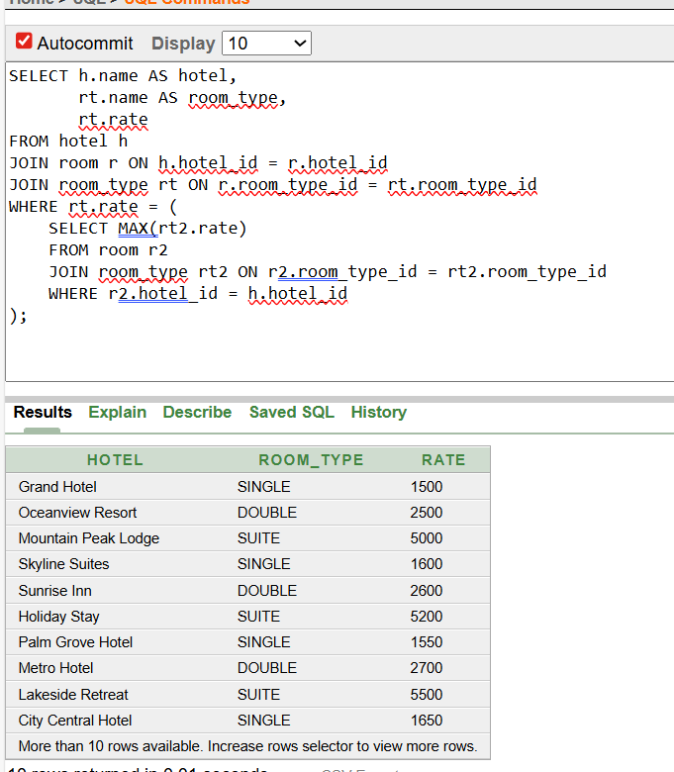

10-Reservations per room type:
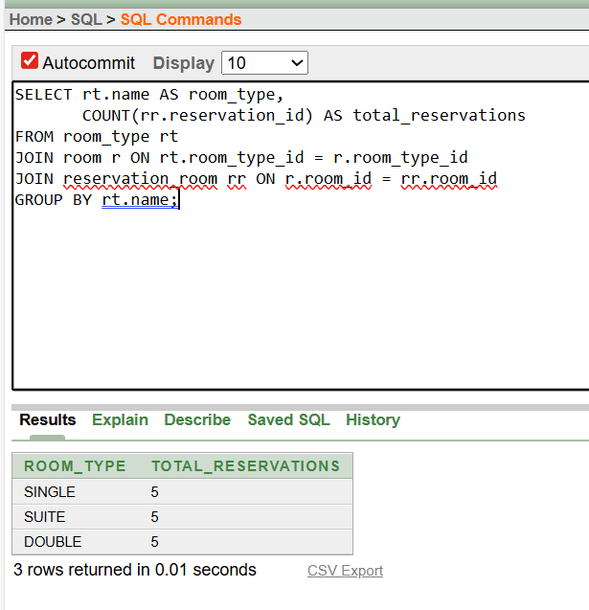

11-Payments above average:
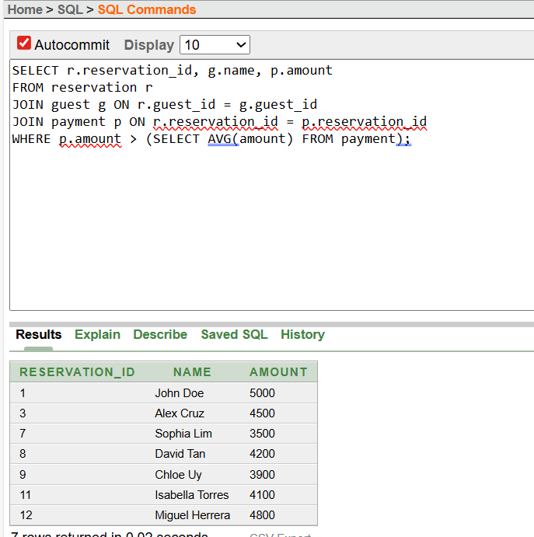

12-Staff with > 2 service records:
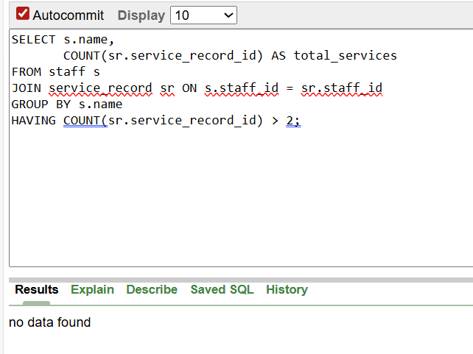

13-Most frequently used service:
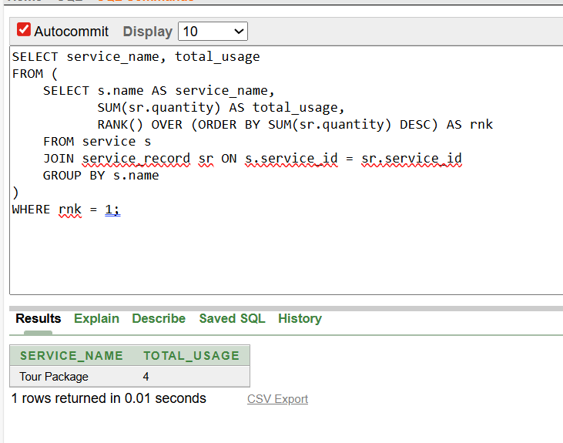

14-Guests who booked in more than one hotel:
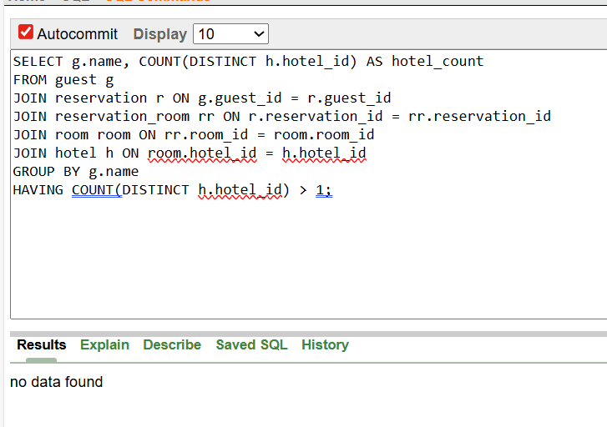

15-Guests who booked but never used services:
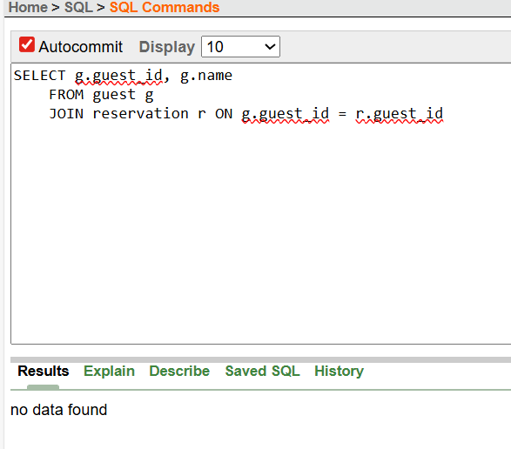

16-Find reservation with highest total service cost (analytic function):
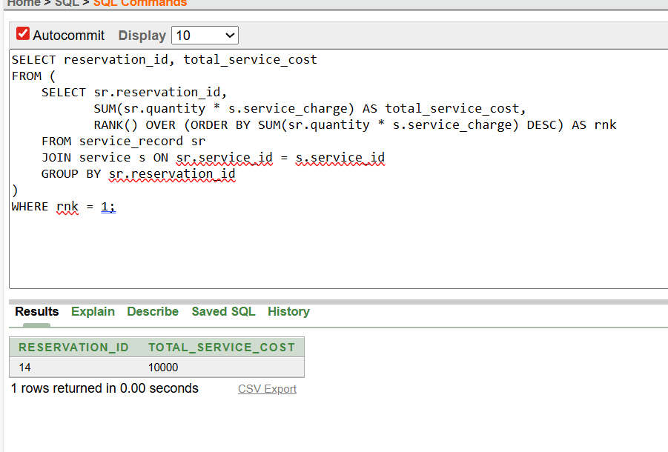

17- Who performed the most services in Correlated Subquery — Find staff with their hotel:
