DATABASE PROJECT (DELIVERABLE#3)
TOPIC: Hotel Reservation System

Procedures & Triggers

Name:JAVERIA JAVAID
Rollno:BCSF24A041

PROCEDURES
1-Add_guest
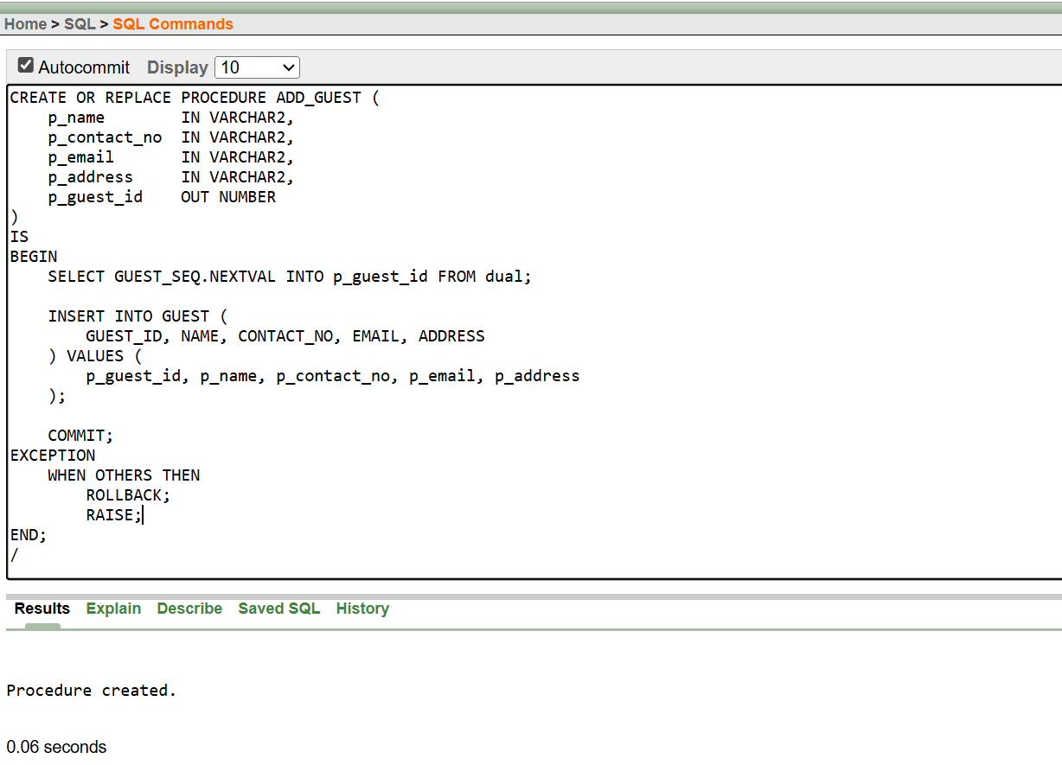

2-Create Reservation
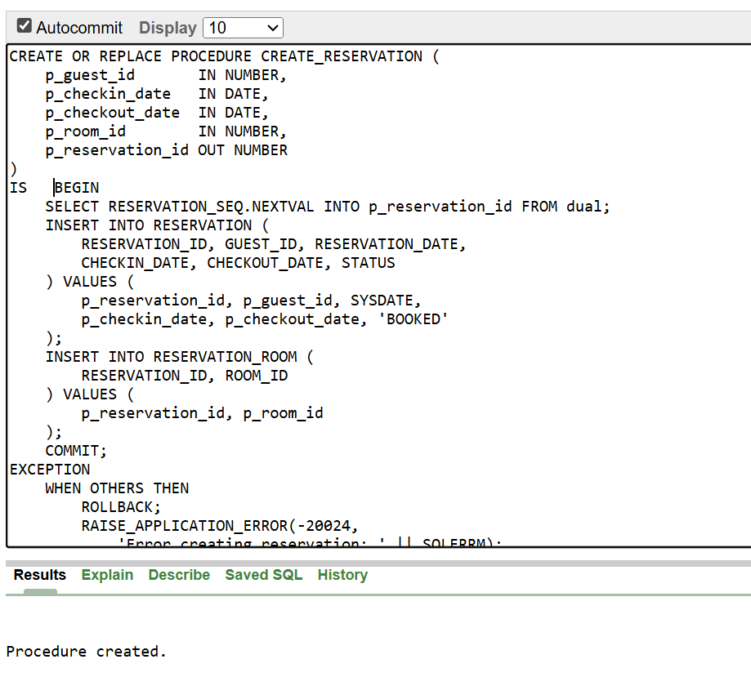

3-Assign room to a guest
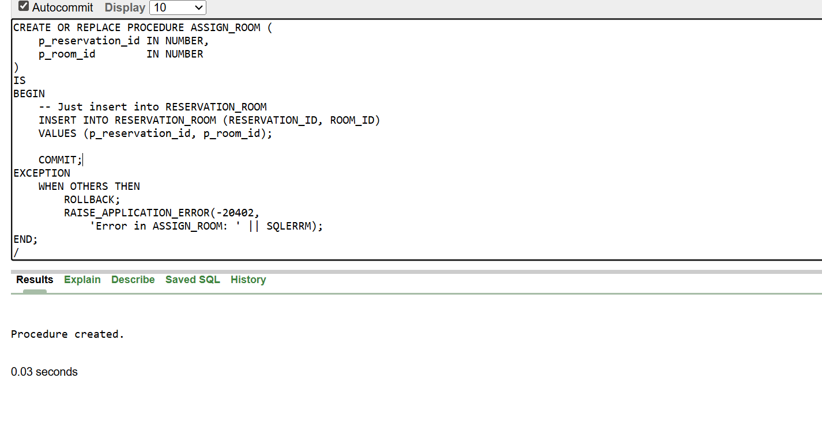

4-Calculate total service charges for a reservation
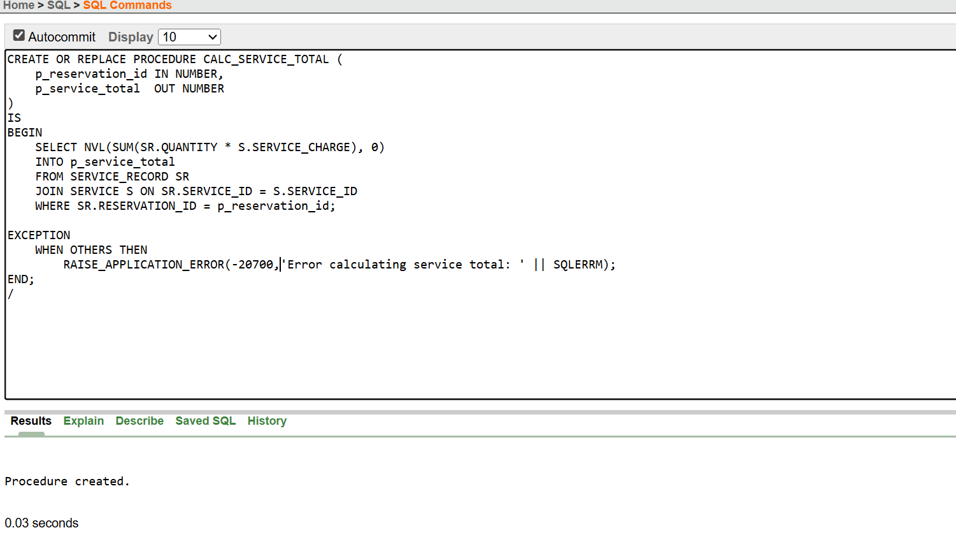

5-Calculates the total amount for a reservation (room + service)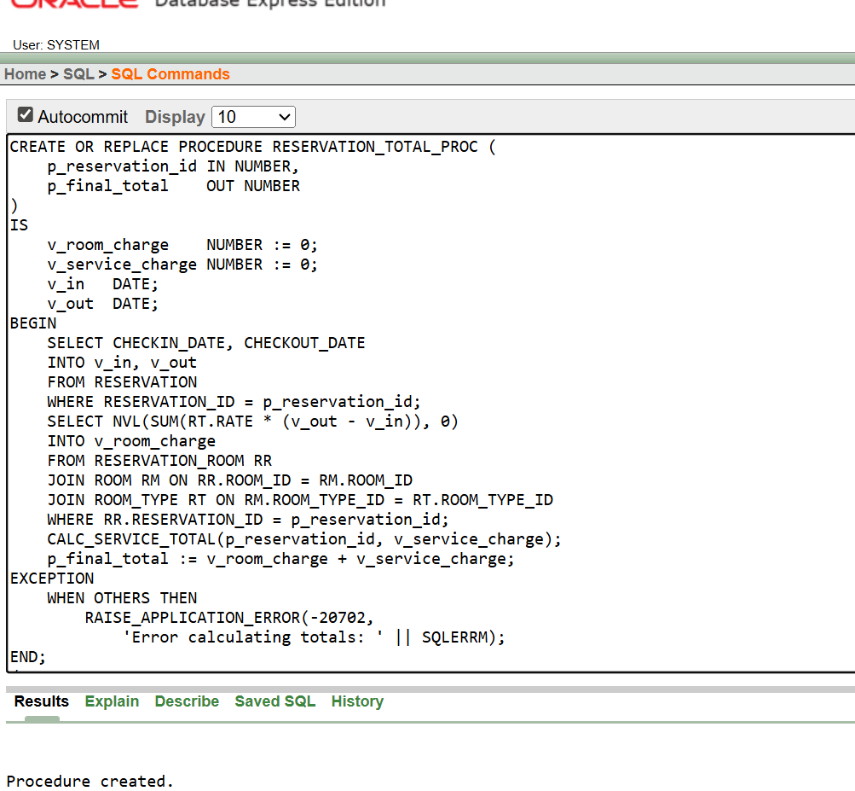

6-Adds a service record to a reservation.
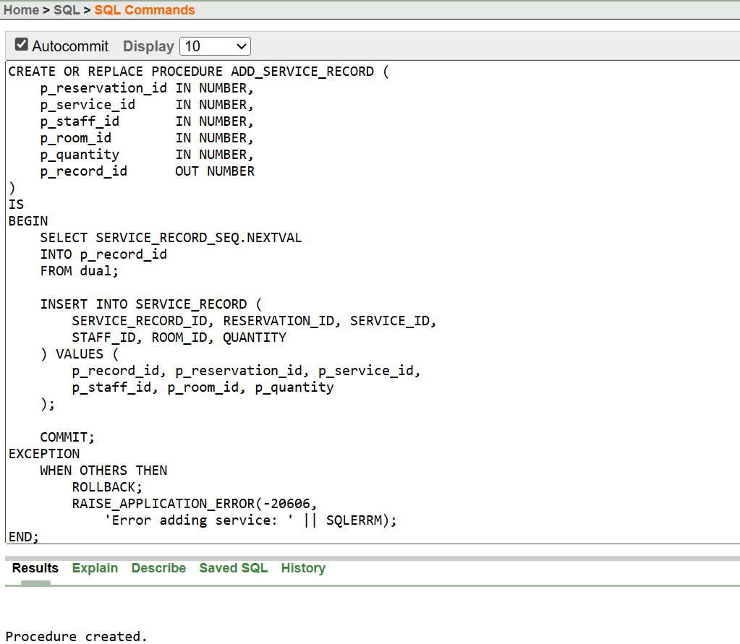
7-Adds a payment record
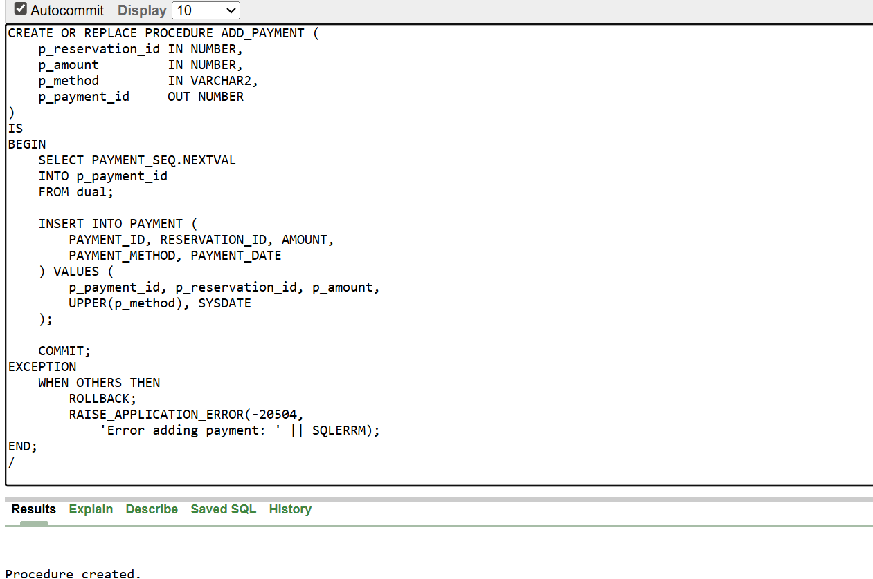

Triggers
1-Prevent assigning a room that is already reserved for the same date range.
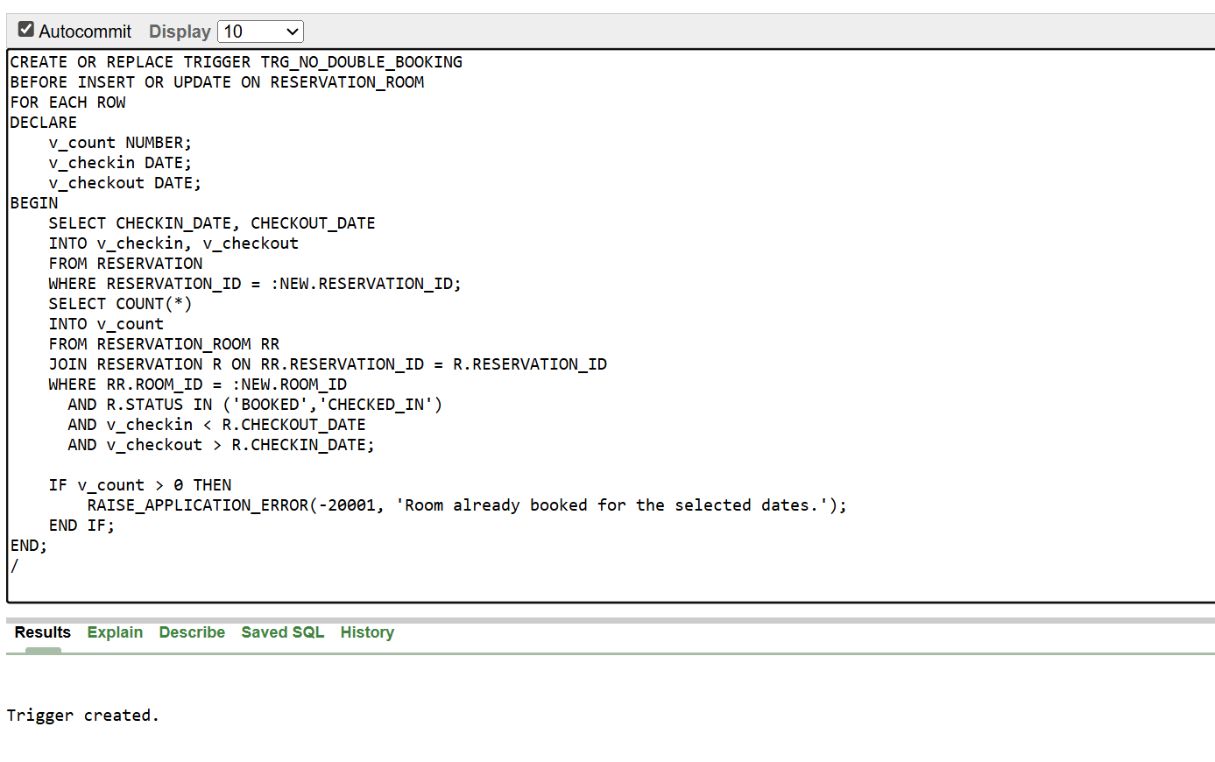

2-Automatically update room status when reserved
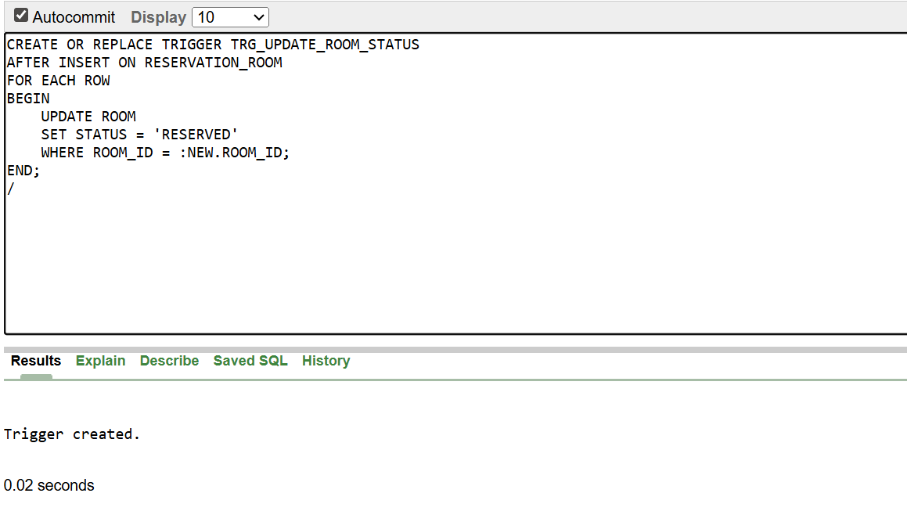
3- Update room status when checkedout
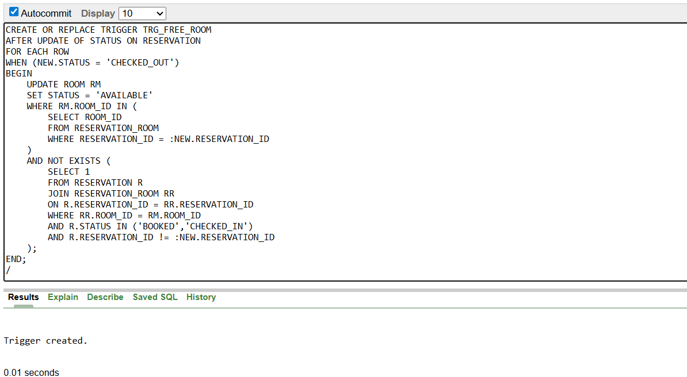

4-Ensure that the service added belongs to the same room as the reservation.
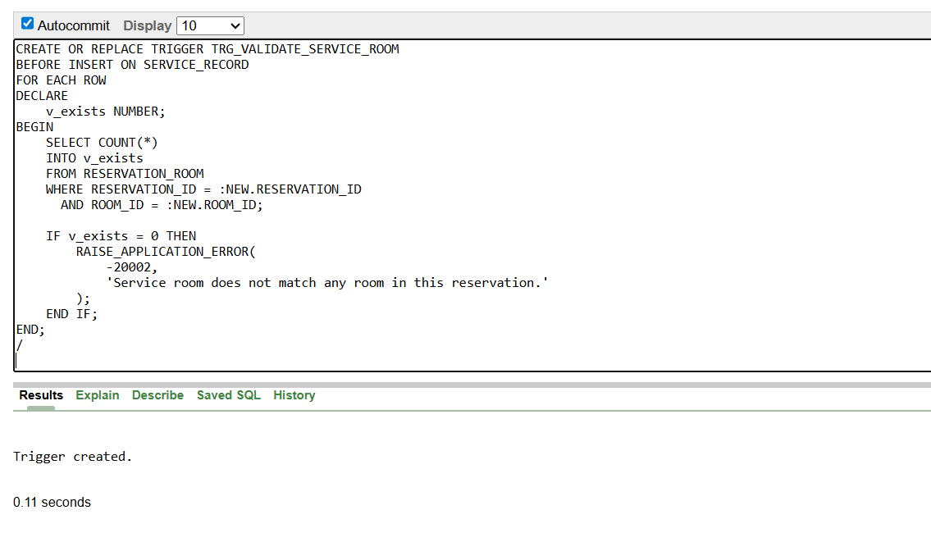

5-Cannot delete a guest if they have active reservations.
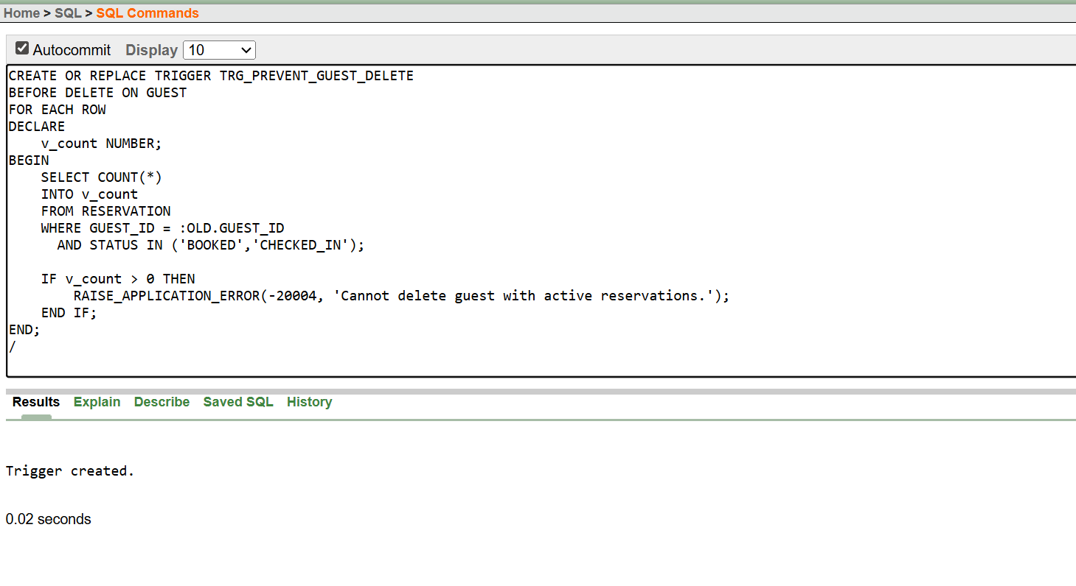

6- reservation status cancelled then no payment
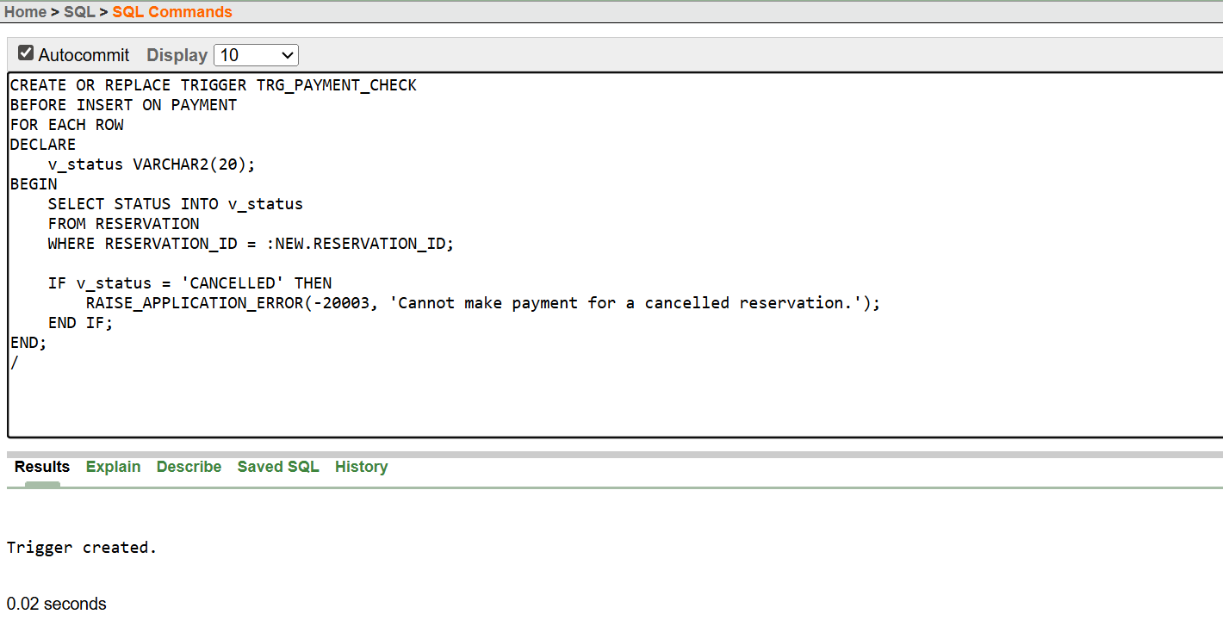
7. automatic room release when the checkout date is changed to an EARLIER date
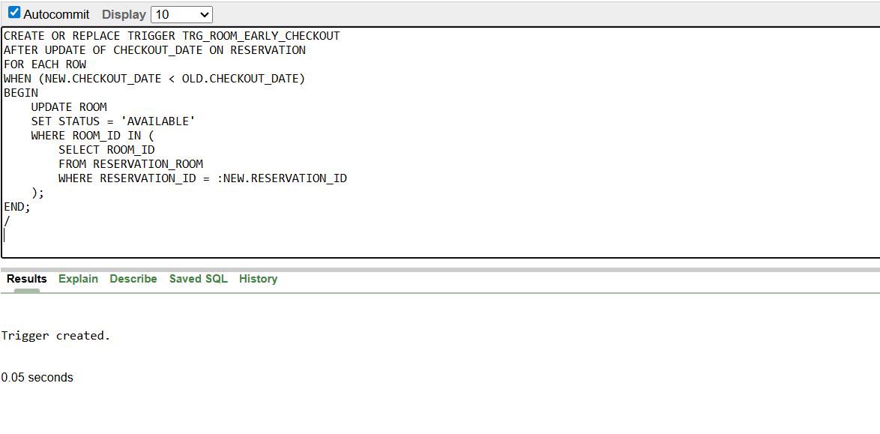

TESTING:
1.TEST: ADD_GUEST Procedure
1.1 Successful Guest Creation
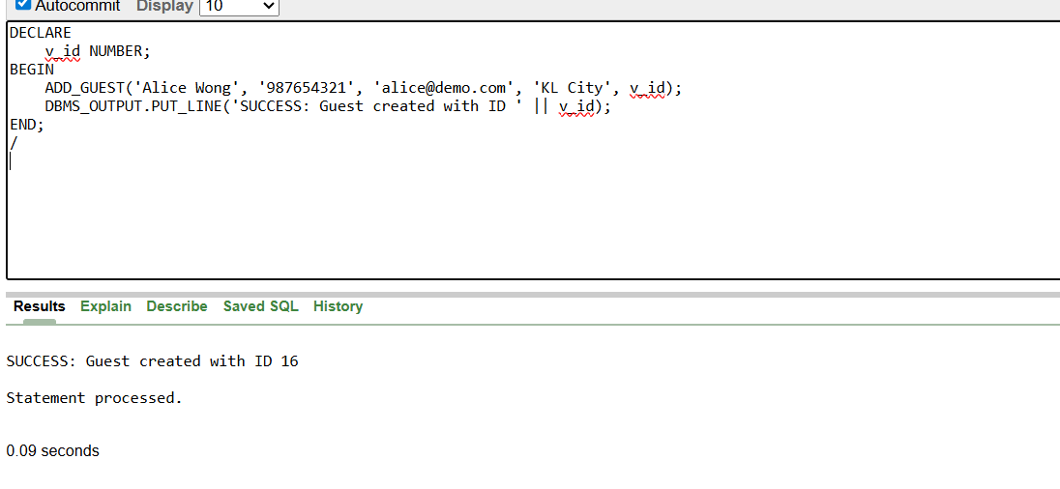
  - Error Case (Handling via procedure rollback)
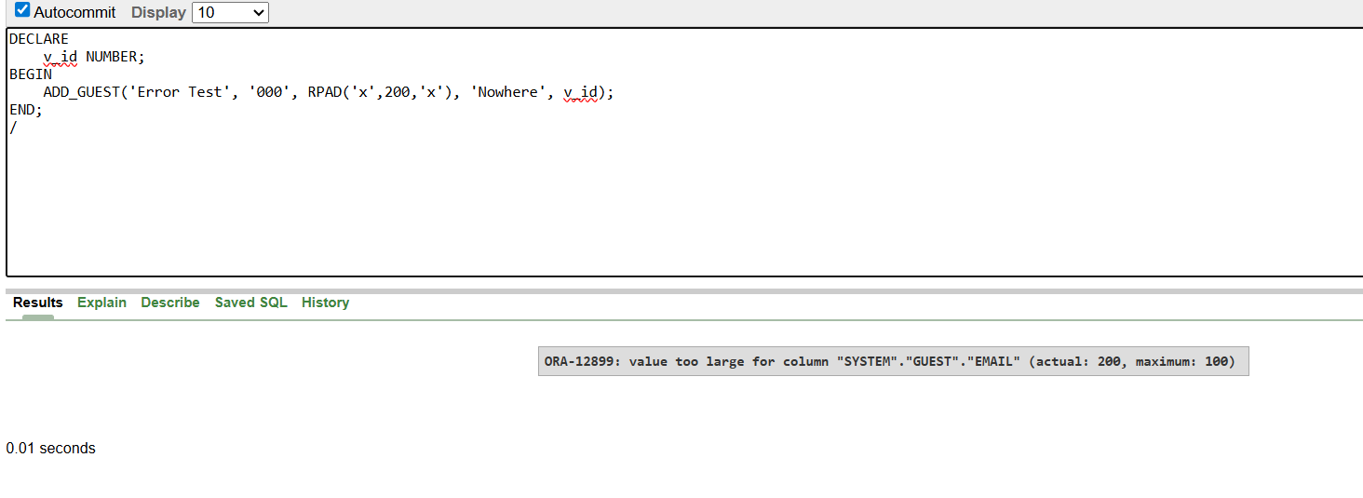
DESCRIPTION:
- This procedure adds a new guest to the database.
- The first test checks successful guest creation with valid input data.
- The second test intentionally provides invalid input (e.g., overly long email) to verify that errors are raised when business rules are violated.

2. TEST: CREATE_RESERVATION + TRG_NO_DOUBLE_BOOKING
2.1 Successful Reservation
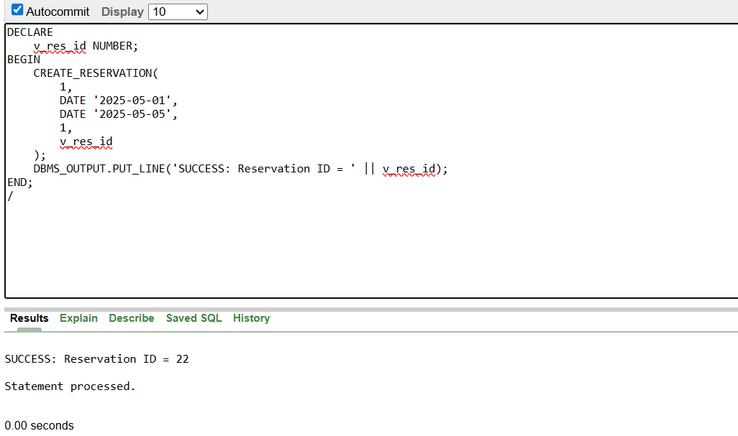
2.2 Trigger Error: DOUBLE BOOKING
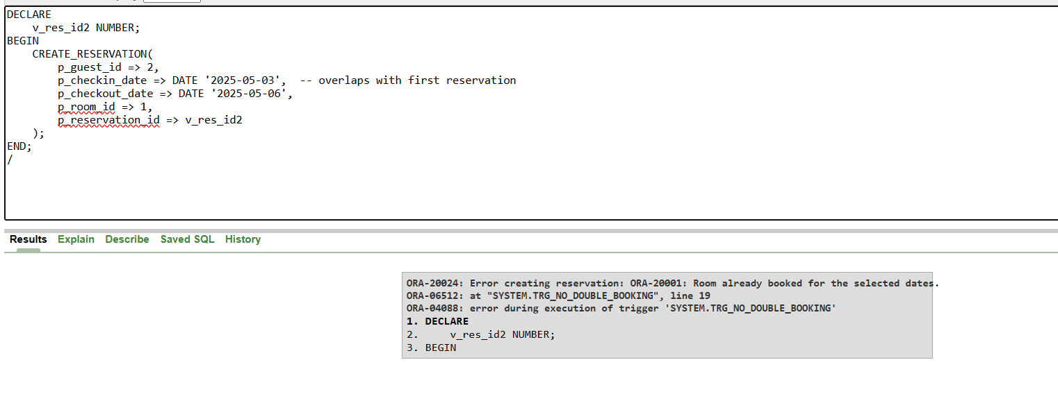
DESCRIPTION:
- This procedure creates a new reservation, and the trigger prevents double booking of the same room.
- The first test confirms a reservation can be created successfully.
- The second test attempts to book a room already reserved during overlapping dates, checking that the trigger raises an error.

3. TEST TRIGGER: TRG_UPDATE_ROOM_STATUS
3.1 Room Should Become RESERVED After RESERVATION_ROOM Insert
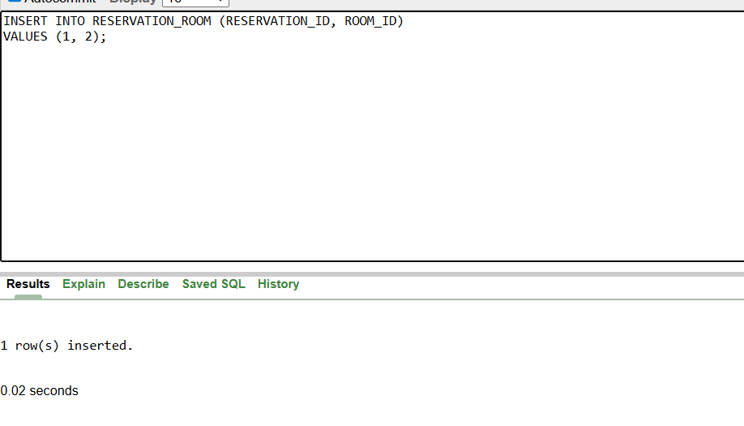
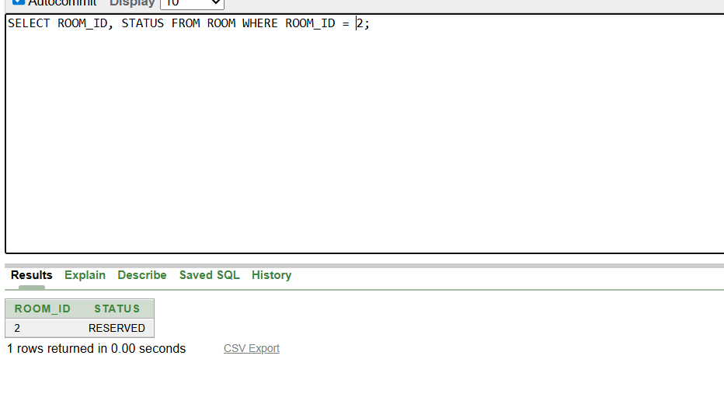
DESCRIPTION:
- This trigger automatically updates a room’s status to “RESERVED” when it is assigned to a reservation.
- The test inserts a reservation-room record and checks that the room status is updated correctly.

4. TEST PROCEDURE: ADD_SERVICE_RECORD + TRIGGER TRG_VALIDATE_SERVICE_ROOM
4.1 Successful Service Record
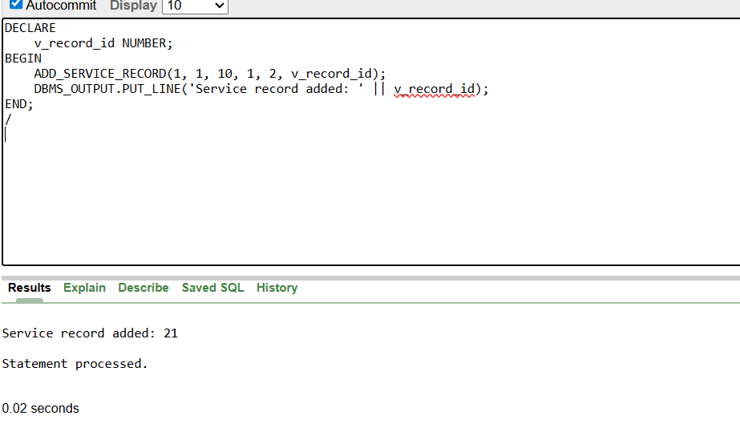
4.2 FAILURE: Wrong ROOM_ID for the Reservation
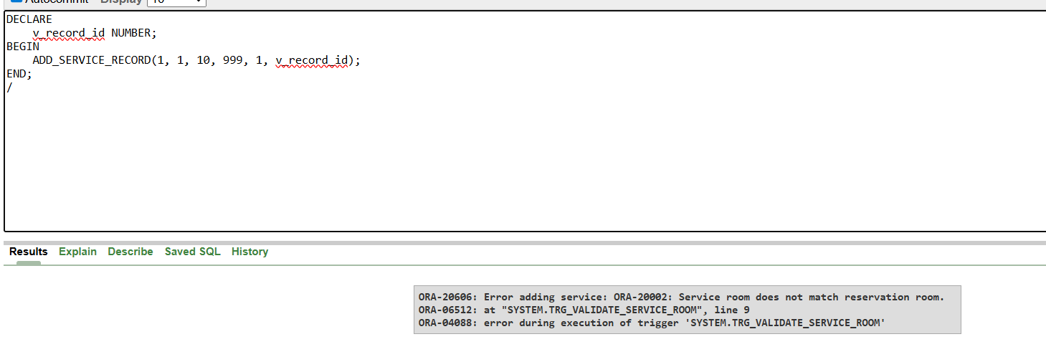
DESCRIPTION:
- This procedure adds a service record linked to a reservation, while the trigger ensures the service is assigned only to rooms included in the reservation.
- The first test adds a service successfully for a valid room.
- The second test attempts to assign a service to a room not in the reservation, verifying that the trigger raises an error.

5. TEST TRIGGER: TRG_FREE_ROOM
5.1 Checkout Reservation → Room Becomes AVAILABLE
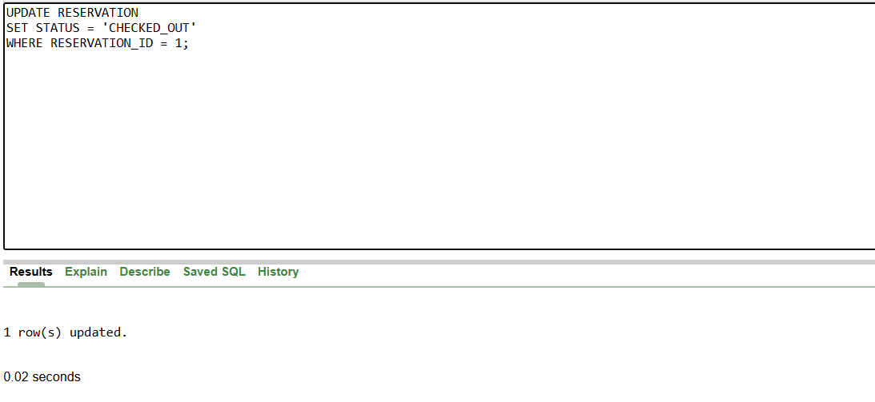
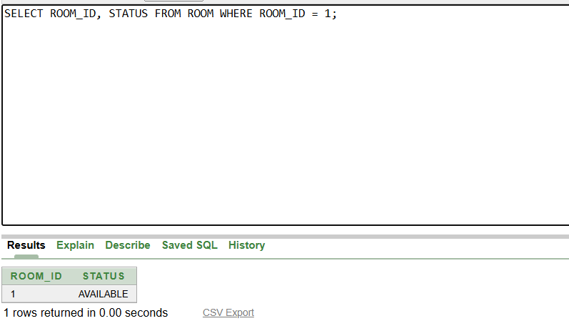
DESCRIPTION:
- This trigger updates the status of rooms to “AVAILABLE” when the associated reservation is checked out.
- The test updates the reservation status to “CHECKED_OUT” and confirms the room status changes as expected.

6. TEST TRIGGER: TRG_PREVENT_GUEST_DELETE
6.1 FAILURE: Attempt to Delete Guest With Active Reservation
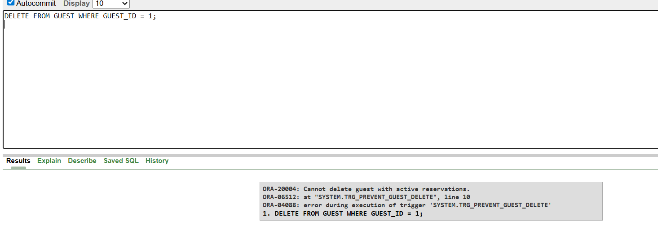
6.2 Successful Deletion After All Reservations Completed

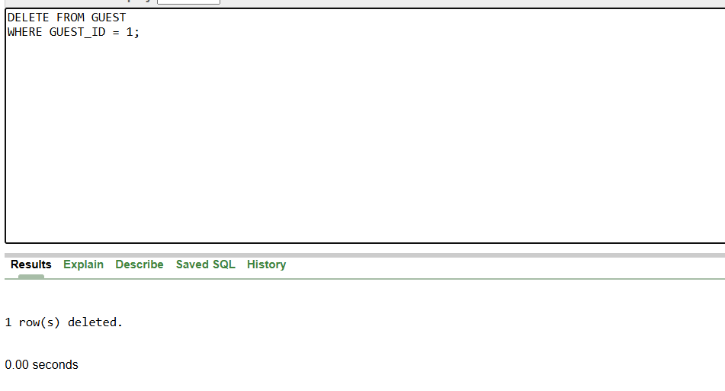
DESCRIPTION:
- This trigger prevents deletion of guests who have active reservations.
- The first test attempts to delete a guest with an active reservation to confirm an error is raised.
- The second test deletes the guest after all reservations are completed to show normal deletion works.

7. TEST PROCEDURE: ADD_PAYMENT + Trigger TRG_PAYMENT_CHECK
7.1 Successful Payment
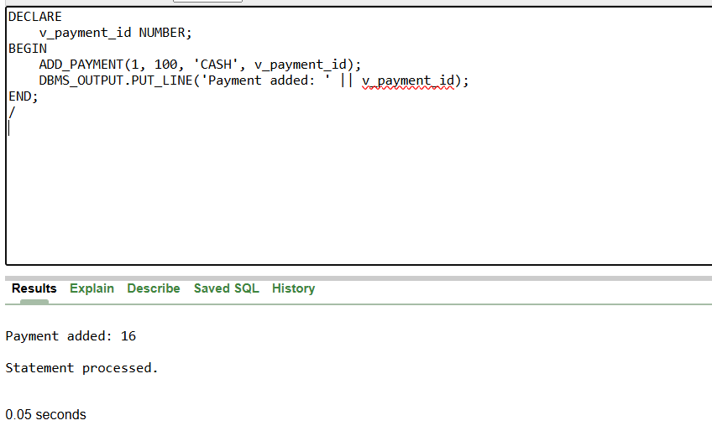
7.2 FAILURE: Add Payment to CANCELLED Reservation
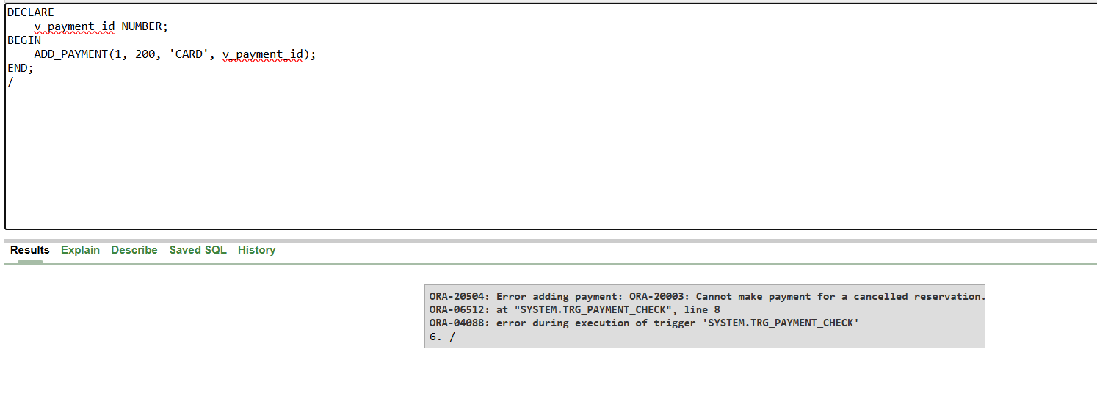
DESCRIPTION:
- This procedure records payments for reservations, and the trigger prevents payments for cancelled reservations.
- The first test successfully adds a payment for an active reservation.
- The second test attempts to add a payment for a cancelled reservation, confirming the trigger raises an error.

8. TEST PROCEDURE: CALC_SERVICE_TOTAL & RESERVATION_TOTAL_PROC
8.1 Successful Calculation of Service Total
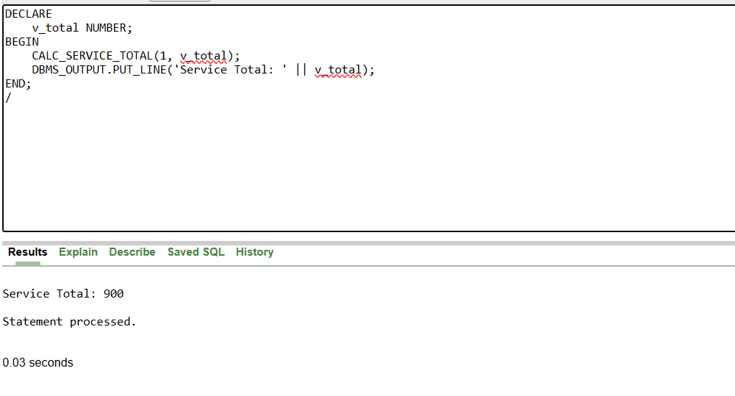
8.2 Successful Final Reservation Total
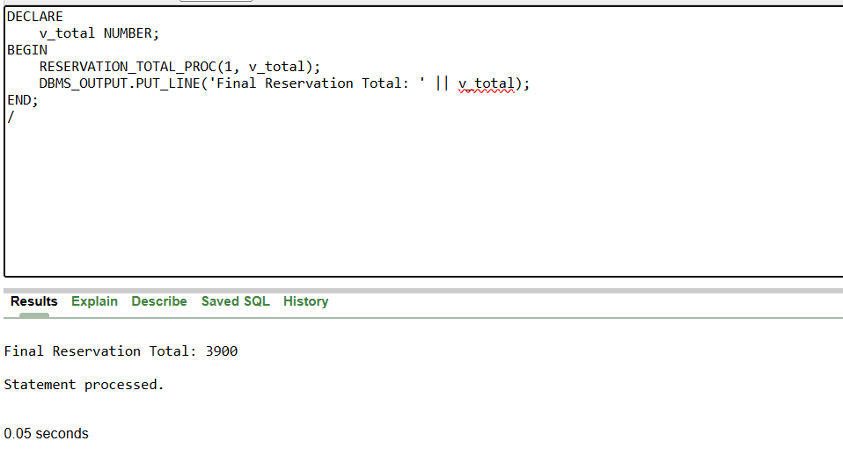
DESCRIPTION:
- These procedures calculate totals for services and overall reservation charges.
- The first test calculates the total cost of services for a reservation.
- The second test calculates the final reservation total, including services, to verify correct computation.

9.TEST TRIGGER: TRG_ROOM_EARLY_CHECKOUT
9.1: CHECKOUT_DATE changed → associated room status updated to AVAILABLE
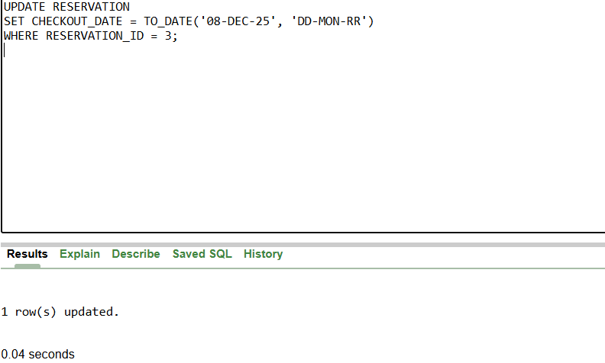
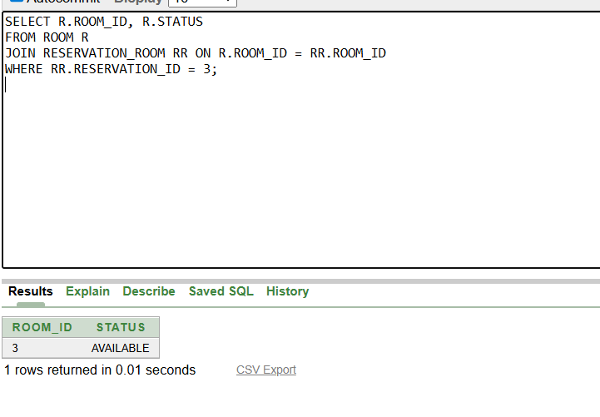
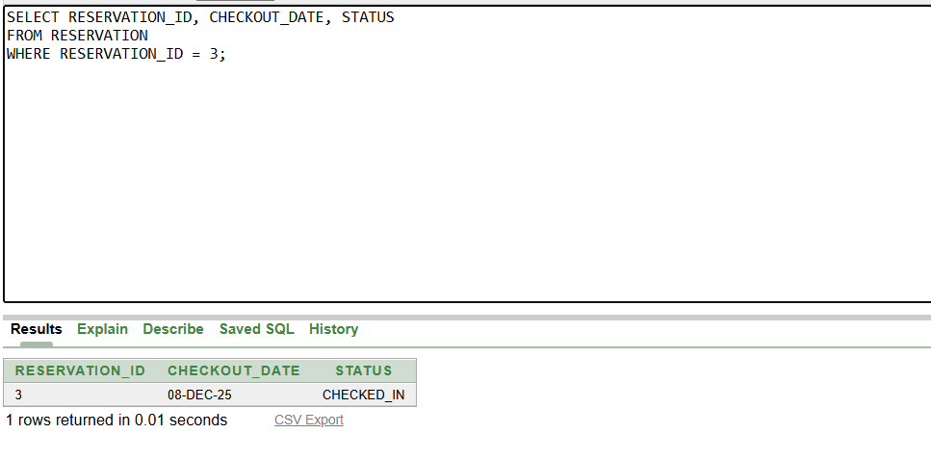
DESCRIPTION:
- This trigger updates the status of rooms to “AVAILABLE” if a reservation’s checkout date is moved earlier.
- The test updates the checkout date and verifies that the room status changes accordingly, ensuring early checkouts are handled correctly.

