ABASYN UNIVERSITY ISLAMABAD CAMPUS


CS375-MOBILE APPLICATION DEVELOPMENT

Assignment 04

NAME: Javeria Hussain

REG NO: 8593

SEMESTER: 5th

SECTION: SE (B)

DEPARTMENT OF COMPUTING

Product Successfully Added on Gumroad Dashboard
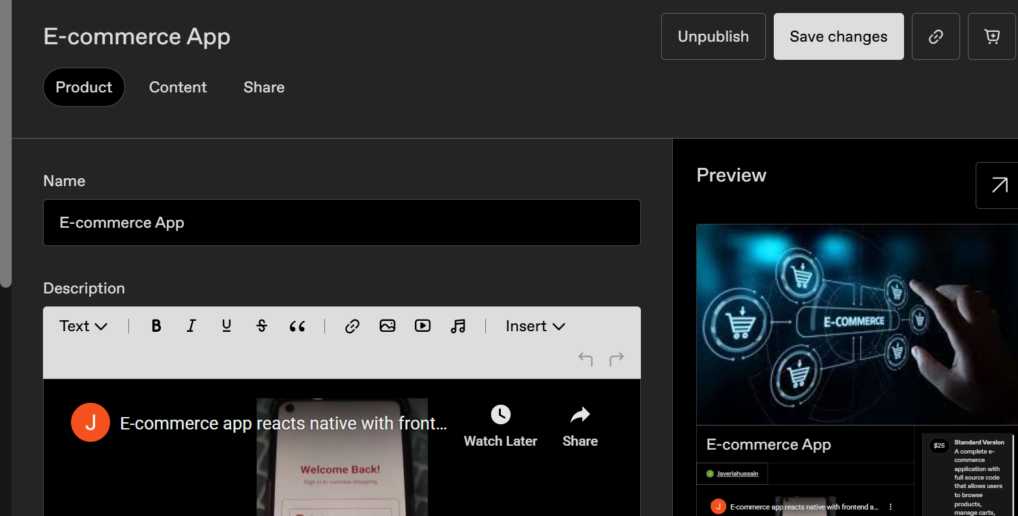
Description:
This screenshot shows the Gumroad seller dashboard after successfully adding an e-commerce product. The product is now published and available for sharing through multiple options such as a direct link, social media platforms, and Gumroad’s built-in sharing tools. The dashboard confirms that the product has been saved successfully and is ready for promotion and future sales.

Payment Method Successfully Added on Gumroad
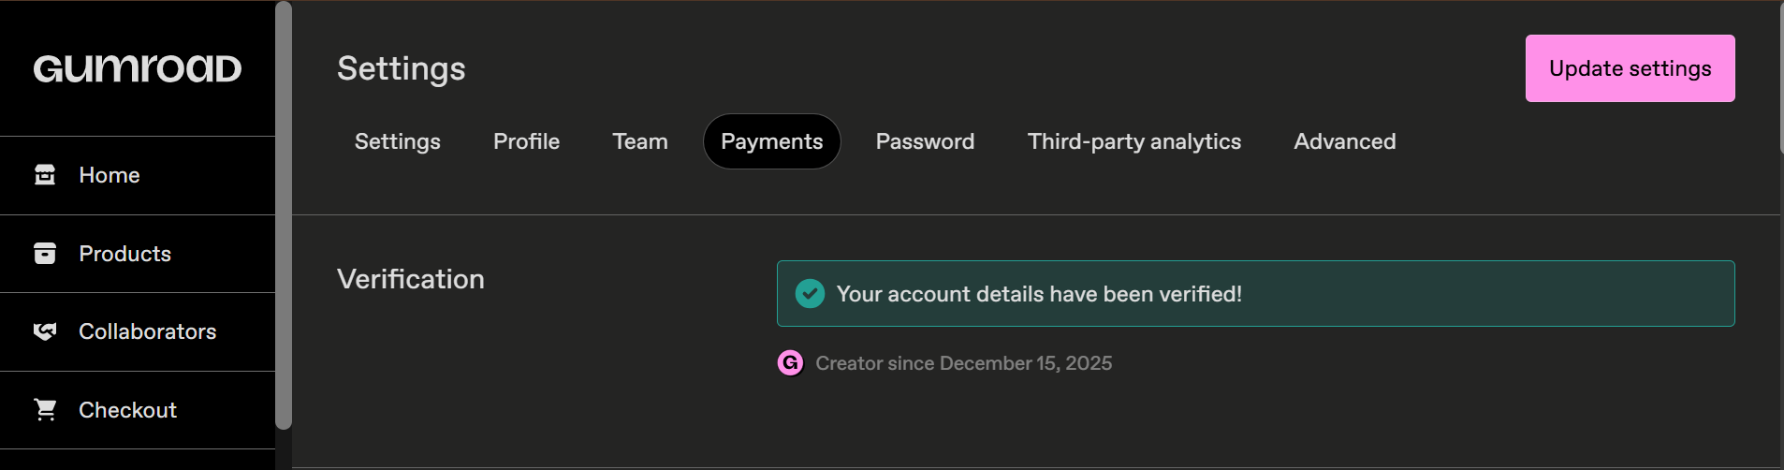
Description:
This screenshot confirms that the payment method has been successfully added to the Gumroad account. With the payment details configured, the seller can now receive payments smoothly from customers and proceed with publishing and selling products without any transaction issues.

App Successfully Published and Available for Sale
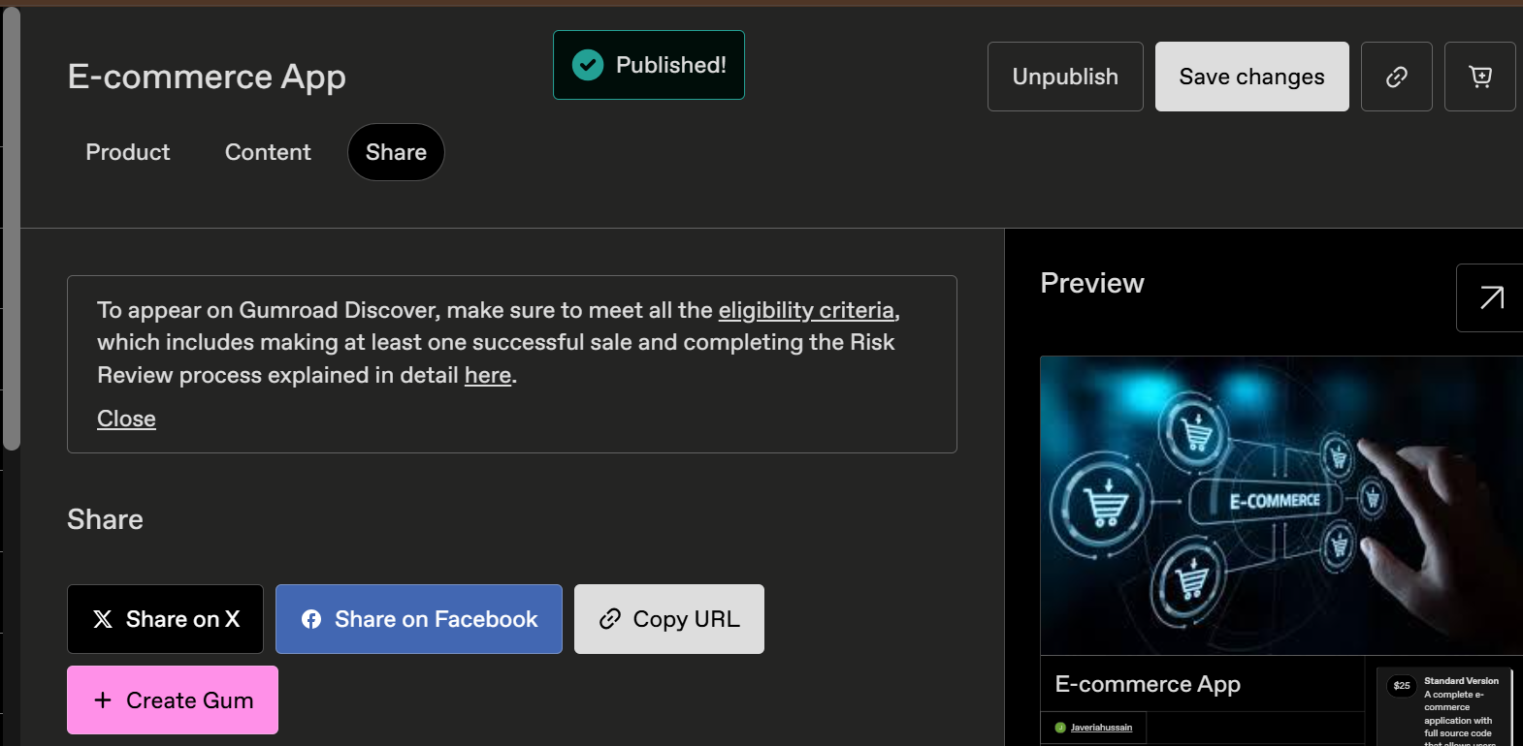

Description:
This screenshot confirms that the application has been successfully published on Gumroad and is now live for sale. Customers can view the app, access its details, and purchase it directly through the platform. The product is fully set up and ready for promotion and sales.

