Adnan Jelani BUIC

CSL 114 Introduction to Information & Communication Technology Lab
Lab 10 Journal
HTML + CSS

Table of Contents
Lab Deliverables (submission guideline) 1
Lab Task 2
Task 1: First JavaScript Output 2
Task 2: Using Variables 2
Task 3: Button Click Event 2
Task 4: Change Background Color 2
Task 5: Simple Calculator 2
Task 6: Show/Hide Content 2
Task 7: Basic Form Interaction 2
Task 8: Dropdown Interaction 2
Task 9: Send User Profile to Another Page 2
Assessment Questions 3

Lab Deliverables (submission guideline)

Create a folder named after your enrollment number and add the following files:
  - The YourRollNumber_Lab11_JS folder containing:
    - task1.html
    - task2.html
    - task3.html
    - task4.html
    - task5.html
    - task6.html
    - task7.html
    - task8.html
    - task9_profile.html
    - task9_show.html
  - This Word document (Rename it to your enrollment number)
Add Full-Screen screenshot of the code and browser output after every task and answer the questions in the end.
Zip the Folder and upload to LMS.

Lab Task

Task 1: First JavaScript Output
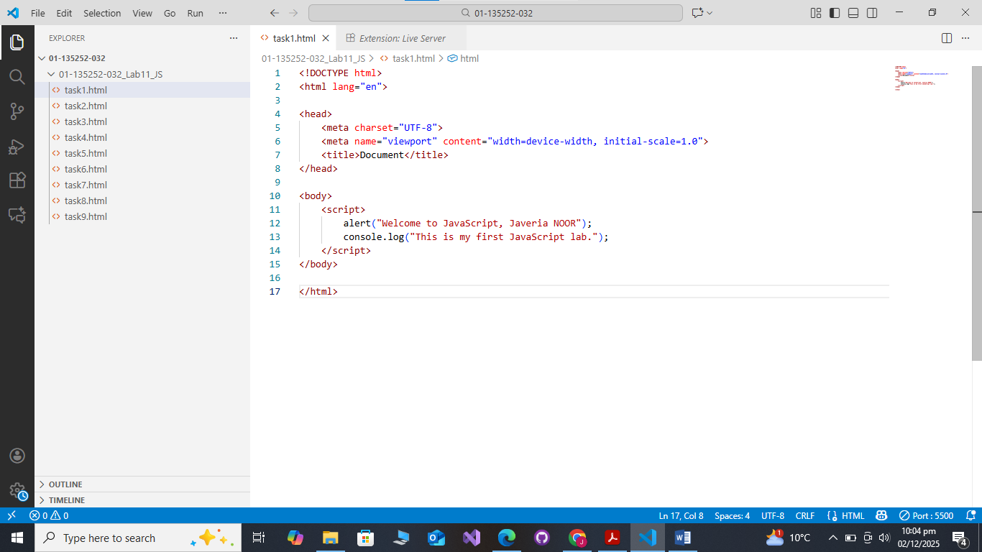

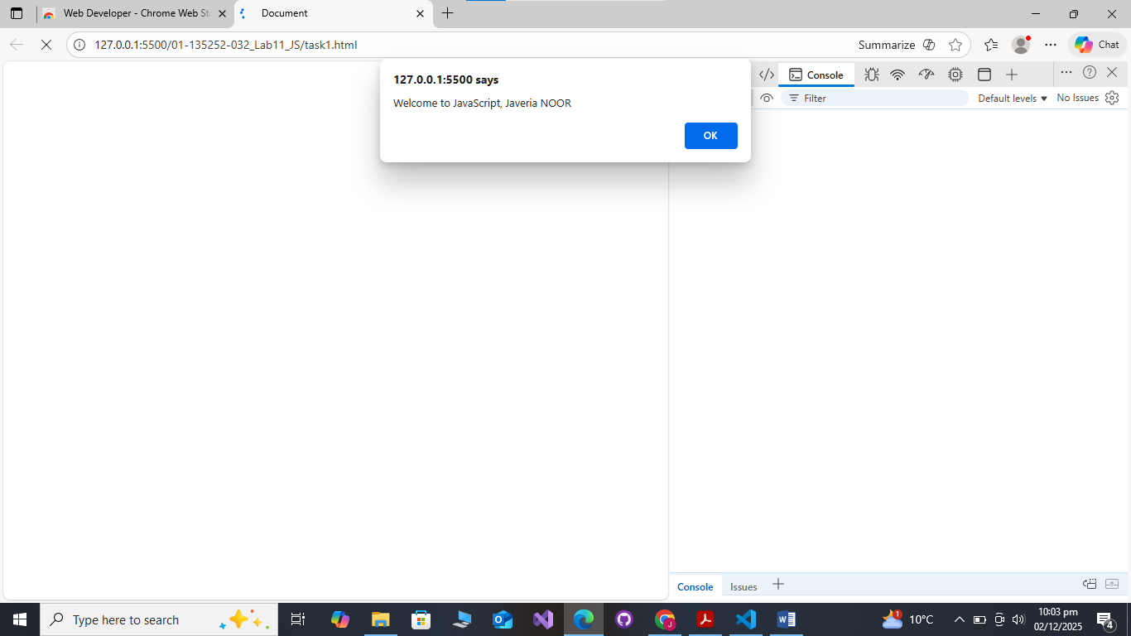
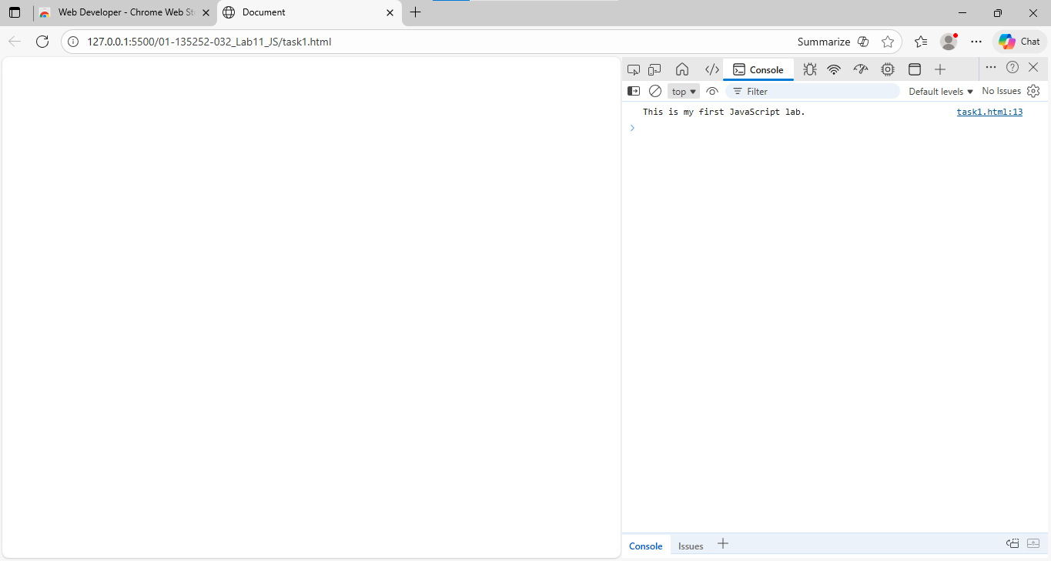

Task 2: Using Variables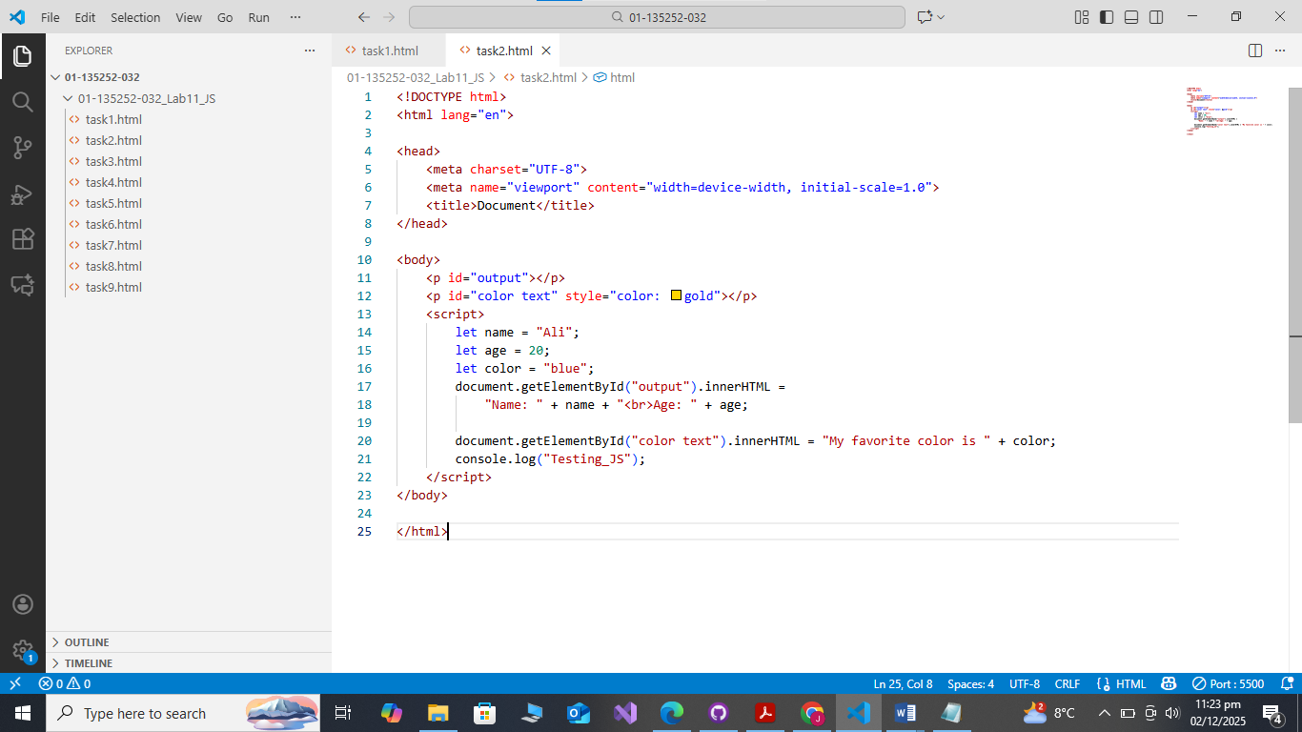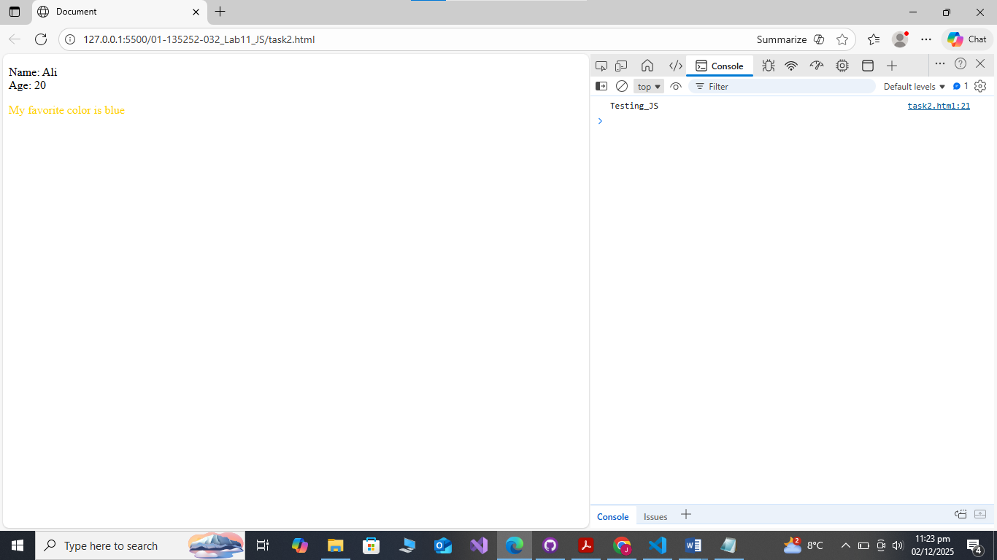

Task 3: Button Click Event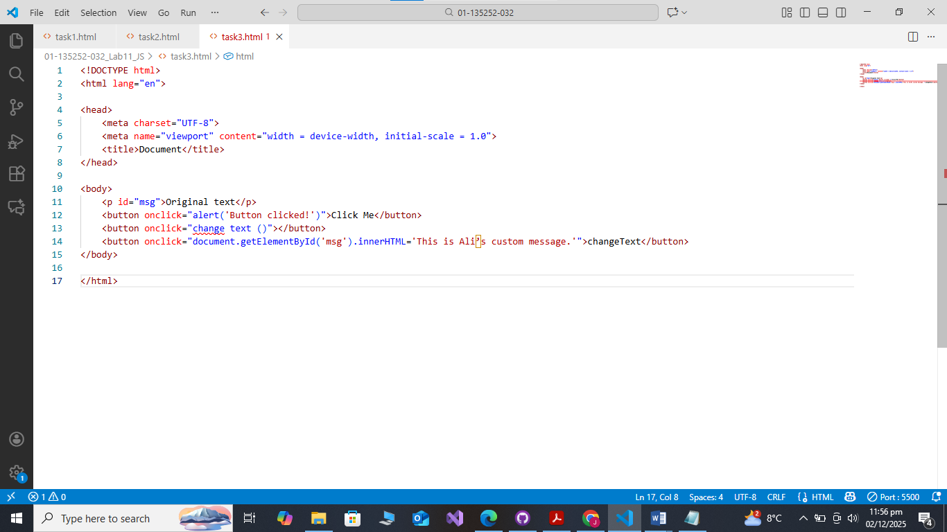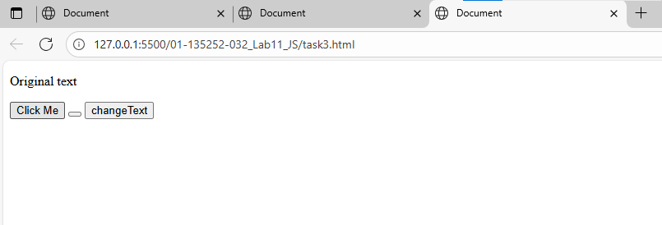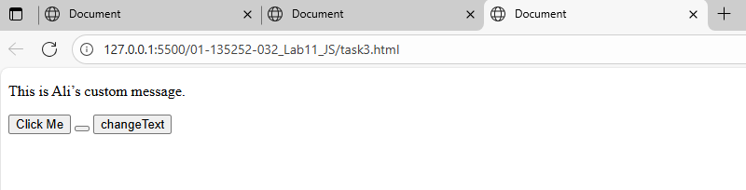

Task 4: Change Background Color
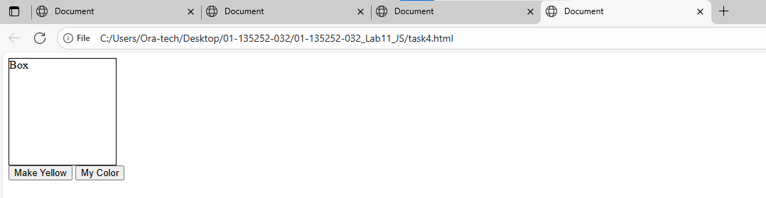
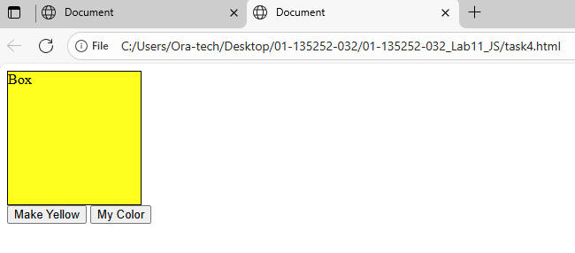
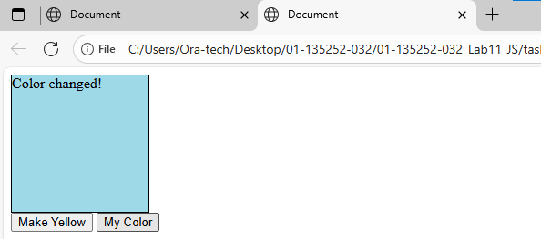

Task 5: Simple Calculator
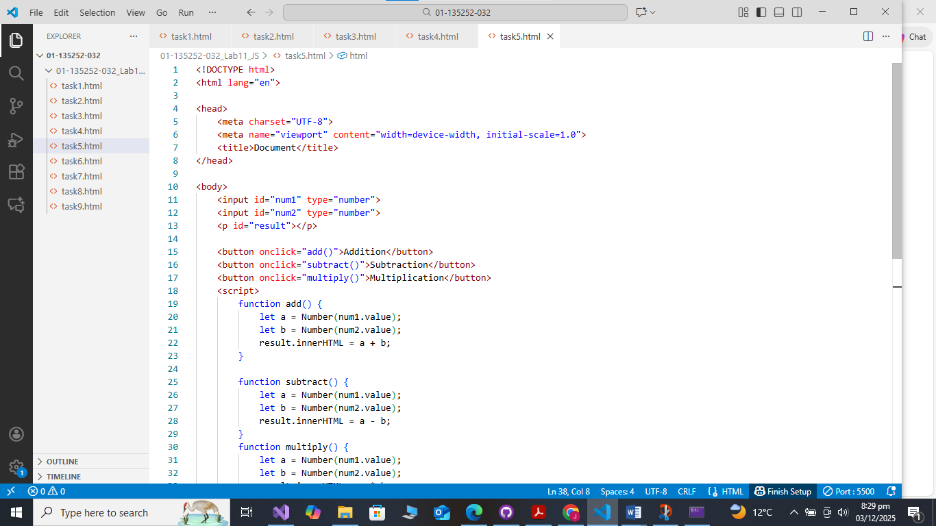
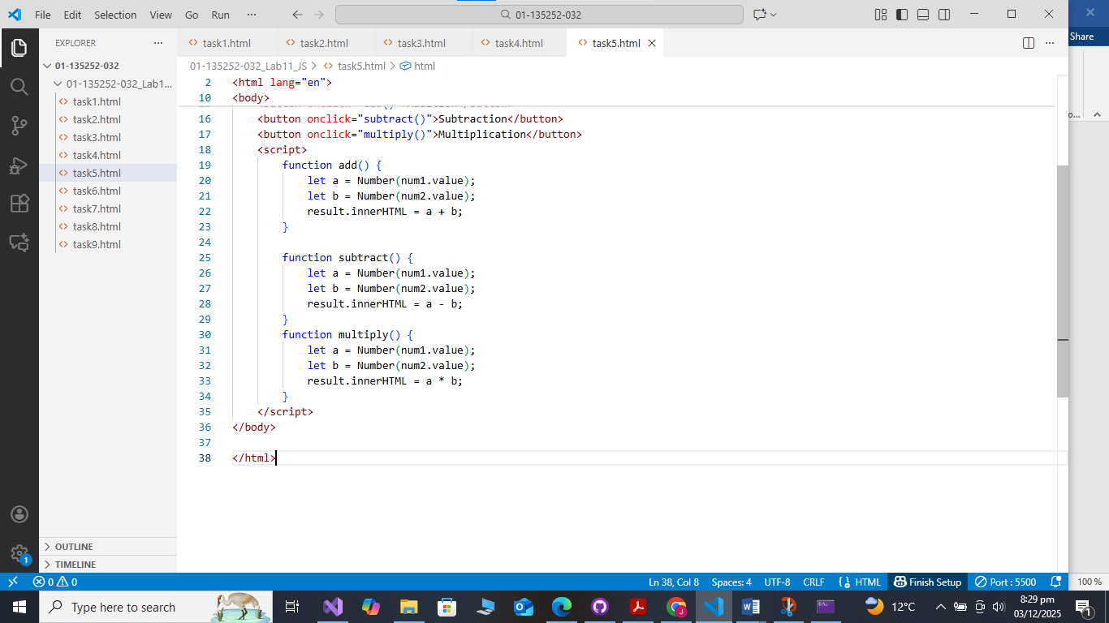
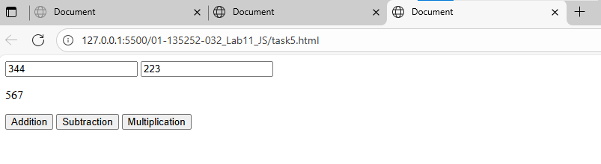
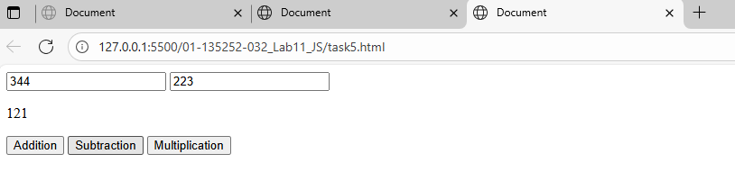

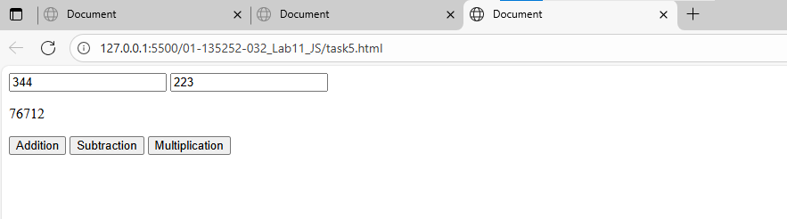

Task 6: Show/Hide Content

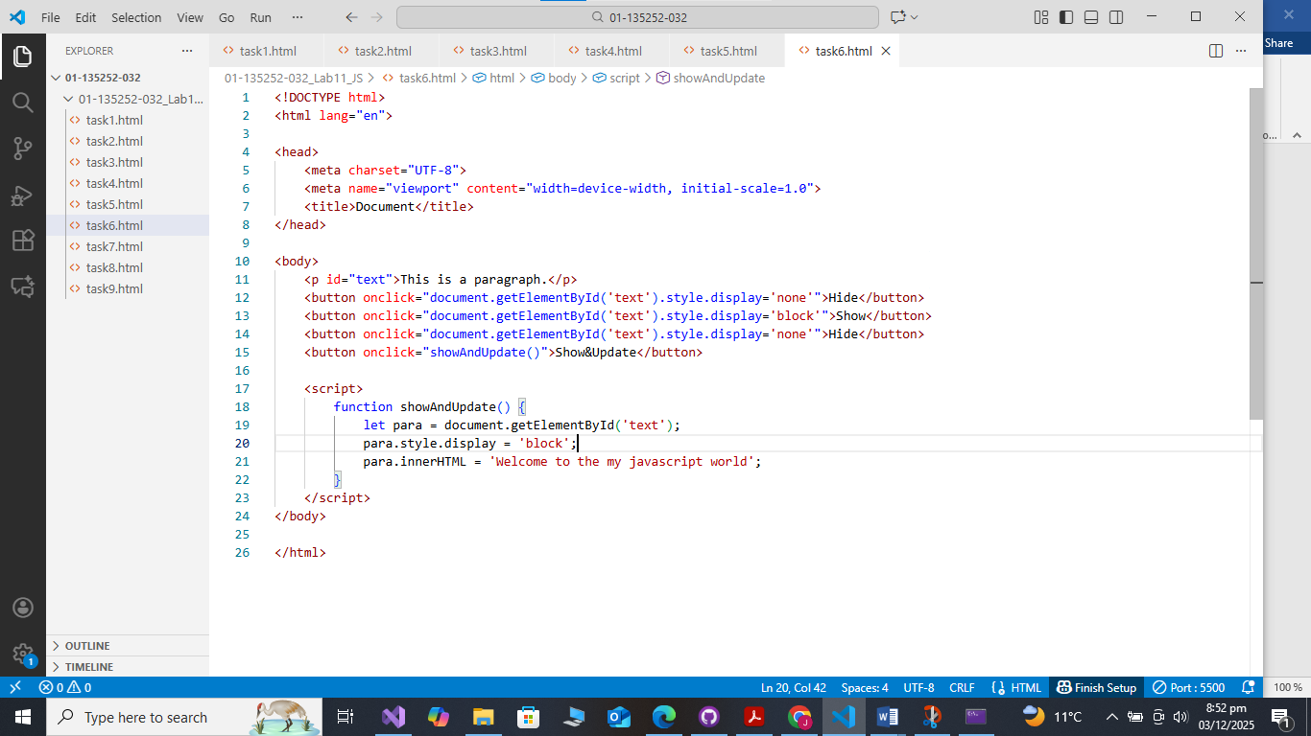
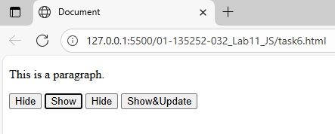
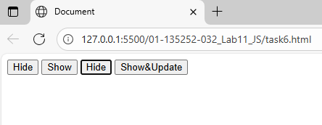
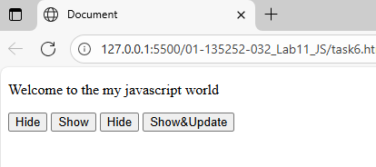

Task 7: Basic Form Interaction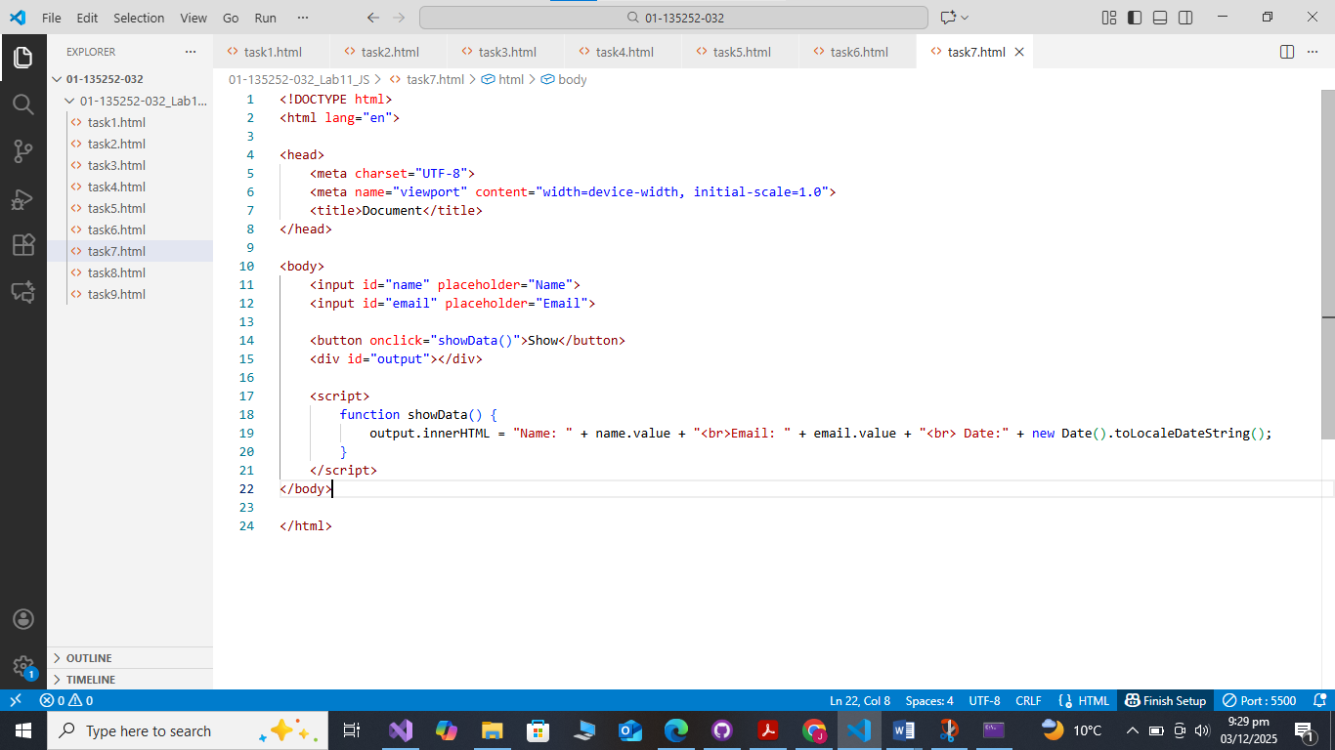 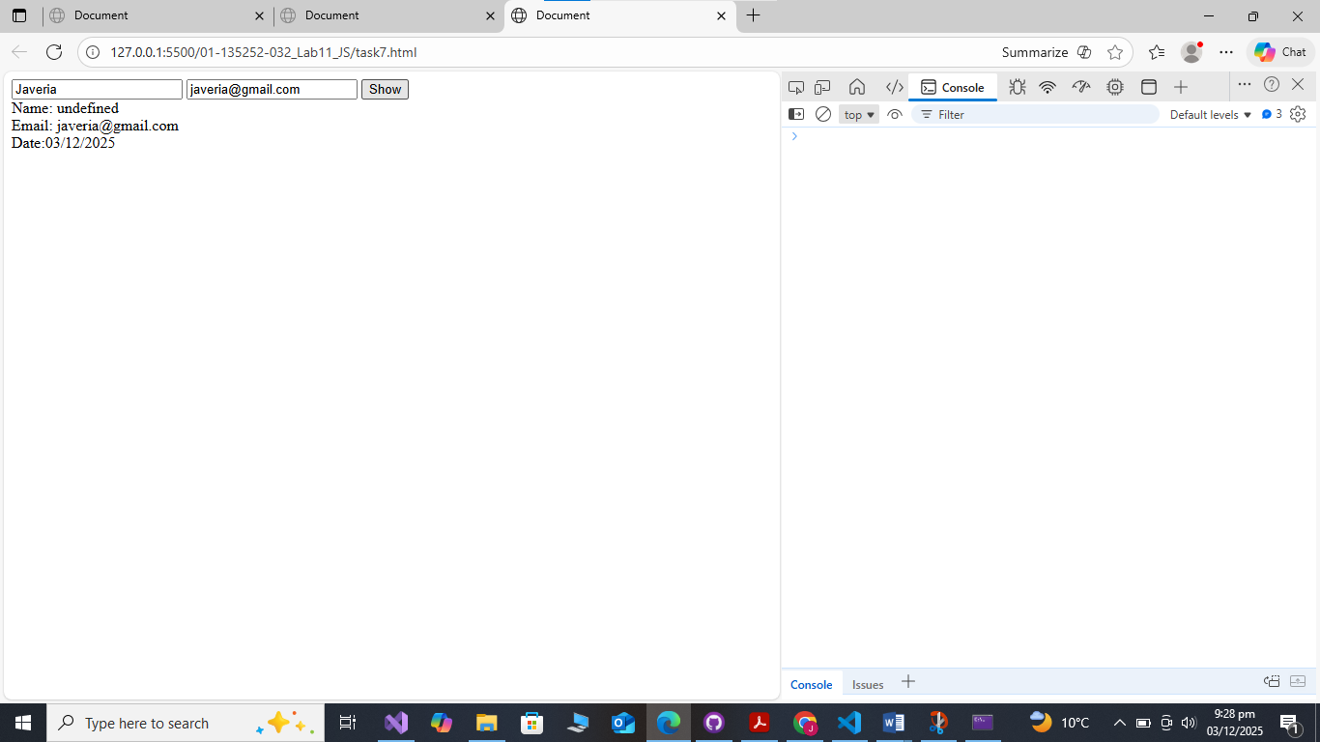

Task 8: Dropdown Interaction 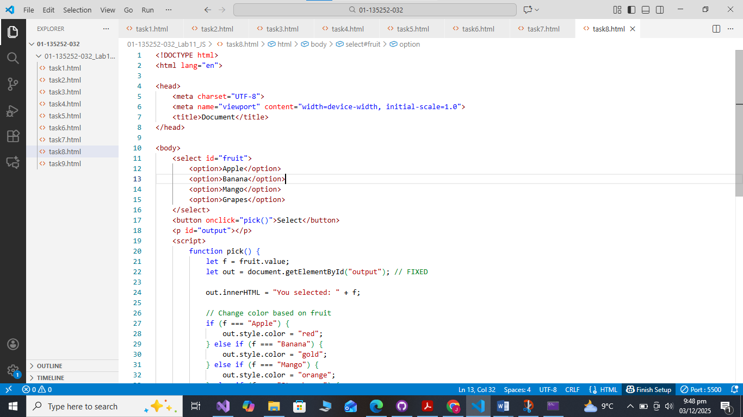
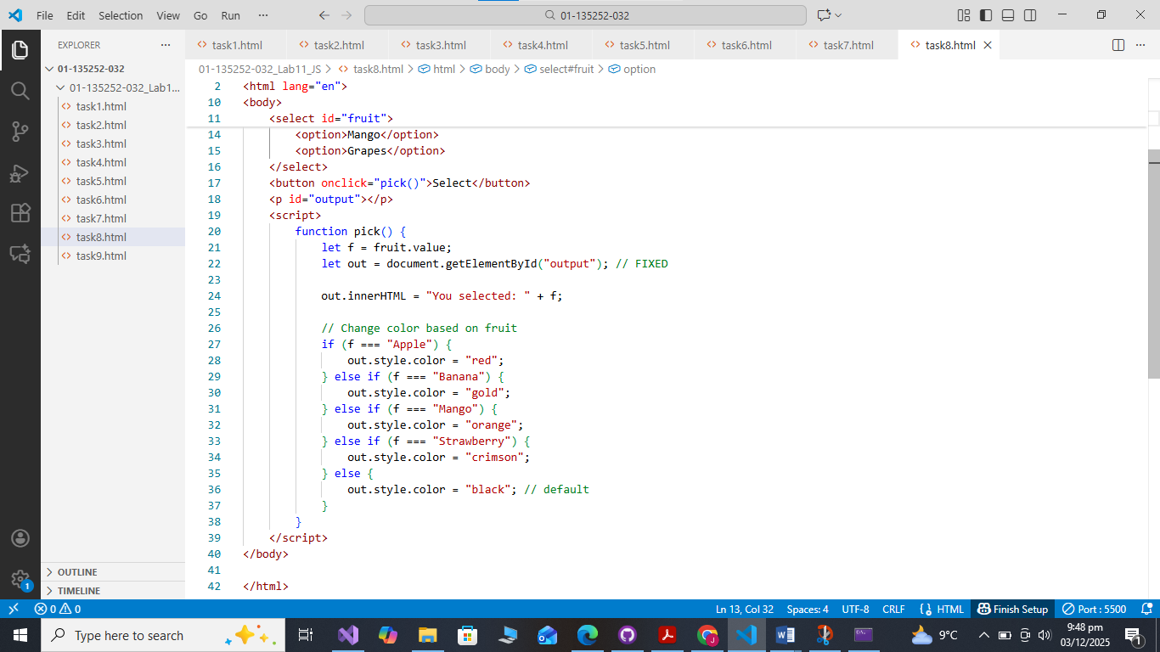
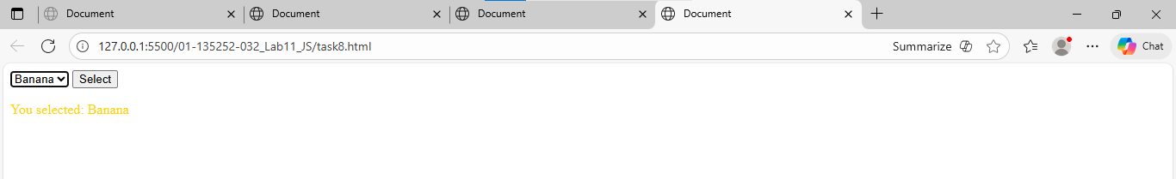

Task 9: Send User Profile to Another Page

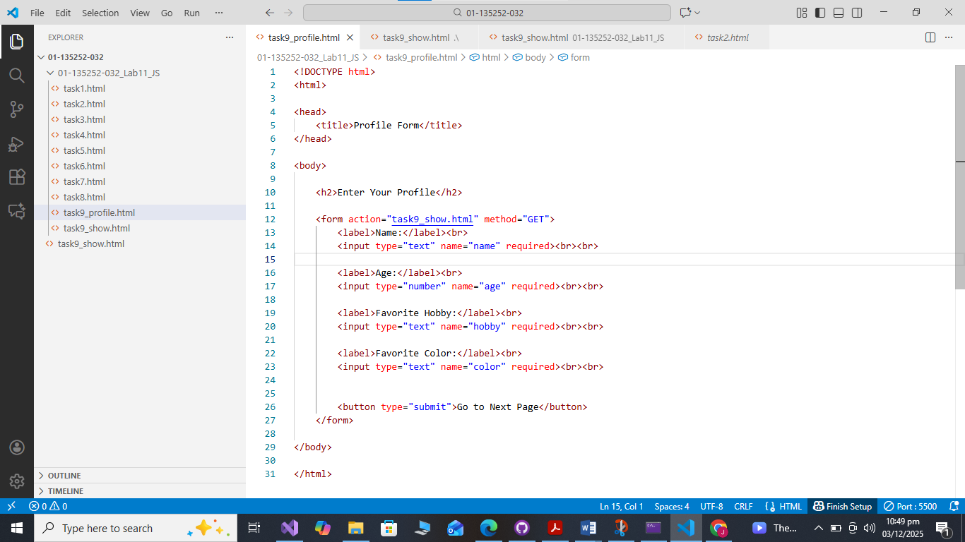
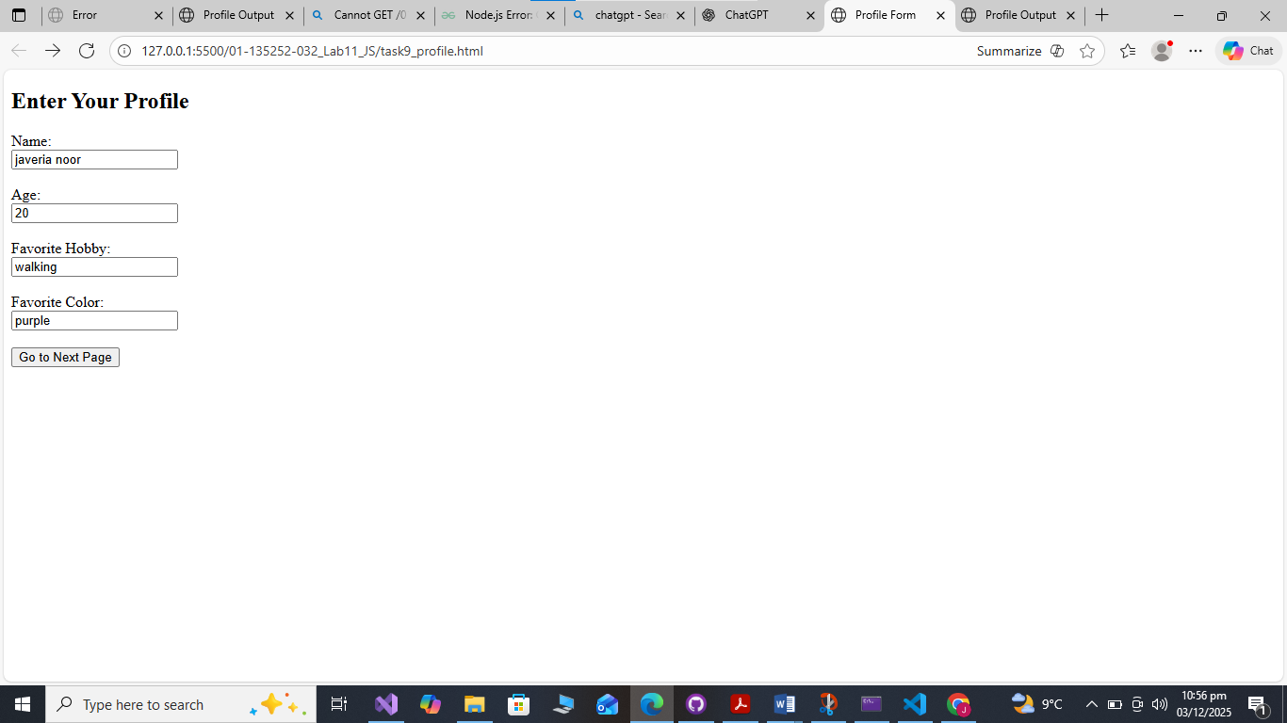

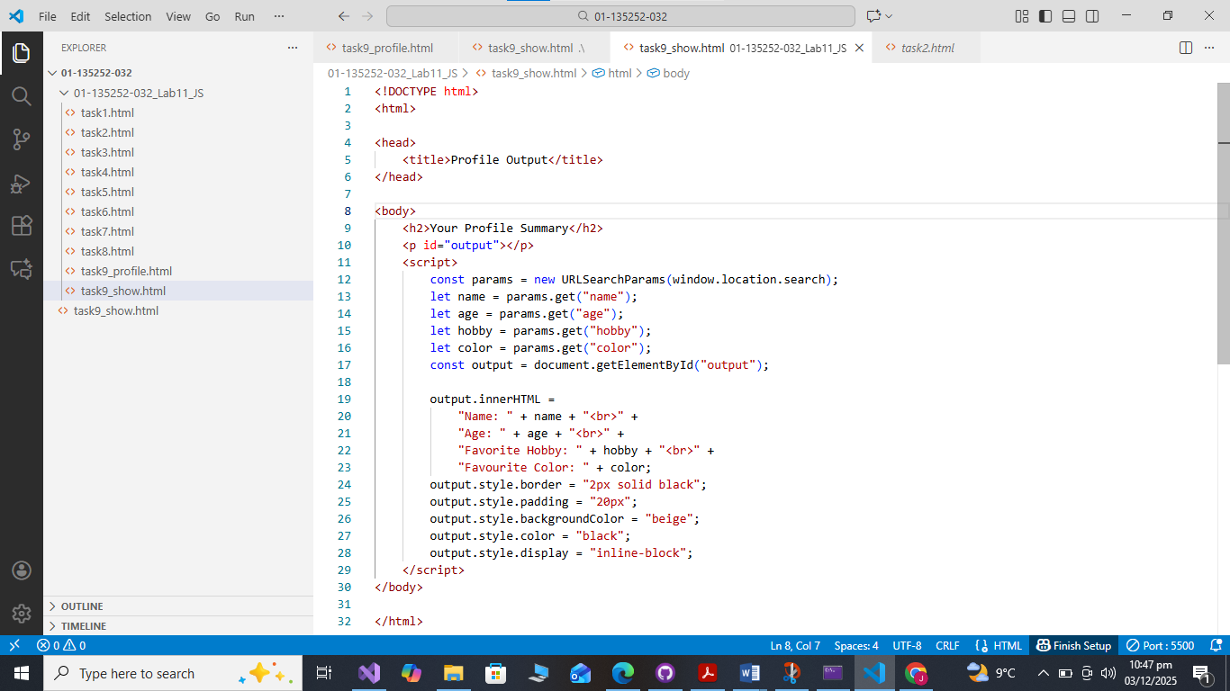

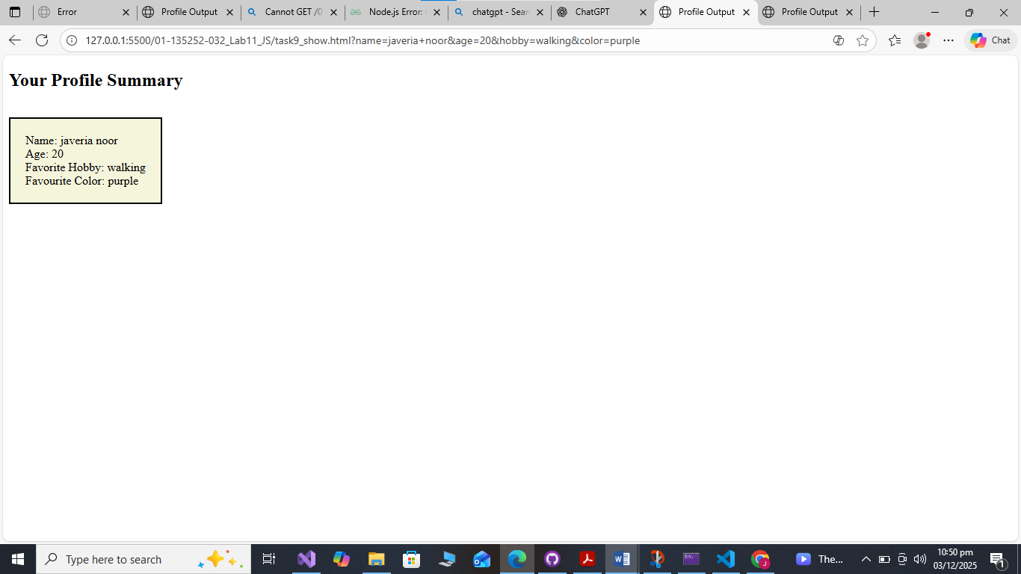

Assessment Questions
- What is the difference between alert(), console.log(), and innerHTML in JavaScript? Give an example of when you would use each.
- alert()
Shows a popup message on the screen.
Use when: we want the user to see a warning or message.
Example: alert("Form submitted!")
- console.log()
Prints a message in the browser console (for developers).
Use when: we want to check values or debug.
Example: console.log(name);
- innerHTML
Changes or displays content inside an HTML tag.
Use when: we want to update text on the webpage.
Example: document.getElementById("p1").innerHTML = "New text";

- Explain how data entered in profile.html can be displayed on show.html using GET method. Why can’t POST method work without a server?
- In profile.html, the form uses:
<form action="show.html" method="GET">
When the user submits, the values appear in the URL like:
show.html?name=Ali&age=20
- In show.html, JavaScript reads the URL and shows the data using URLSearchParams.
- Why POST cannot work without a server?
POST sends data inside the request body, not in the URL.
Browsers only process POST properly when a server receives it.
Without a server, there is nowhere for the POST data to go, so the next page cannot read it.

- In Task 3, a button changes the text of a paragraph.
- Which event is used to detect the click?
- How does document.getElementById("id").innerHTML change the paragraph text?
• Which event is used?
The onclick event.
• How does innerHTML change the text?
It finds the element by its ID and replaces the text inside that tag.
- Example idea:
document.getElementById("para").innerHTML = "New message";

