1. What variables are included? What information are we getting? (1 mark)
Variables
City | Major
State | SAT
Gender | Average.score..grade.
Student.Status | Height..in.
Country | Newspaper.readership..times.wk.
Age

2. What is the format of the variables: string, numeric, etc.? (1 mark)
 | Format |  | Format
City | String | Age | Numeric
State | String | SAT | Numeric
Gender | String | Average.score..grade. | Numeric
Student.Status | String | Height..in. | Numeric
Major | String | Newspaper.readership..times.wk. | Numeric
Country | String

3. What type of variables: categorical, continuous, and discrete? (1 mark)
 | type of variables |  | type of variables
City | Categorical | SAT | Continuous
State | Categorical | Average.score..grade. | Continuous
Gender | Categorical | Height..in. | Continuous
Student.Status | Categorical | Newspaper.readership..times.wk. | Continuous
Major | Categorical
Country | Categorical
Age | Continuous

4. Is this sample or population data? (1 mark)
Sample

5. How many males/females? (1 mark)

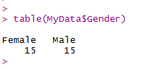

6. What is the average age? (1 mark)

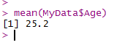

7. How many undergraduate/graduate students? (1 mark)
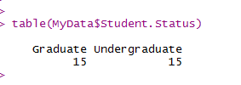

8. What is the average SAT score? It is the same for graduates and undergraduates? (1 mark)
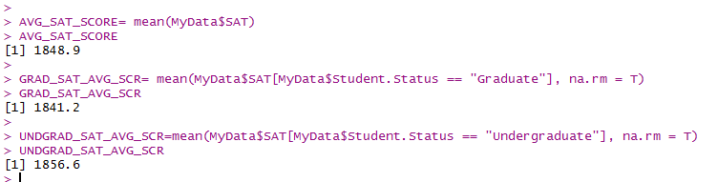

AVG SAT score is 1848.9. It is not same for graduate and undergraduate as mentioned above.

9. Who reads the newspaper more frequently: men or women? (2 marks)

Women read newspaper more frequently

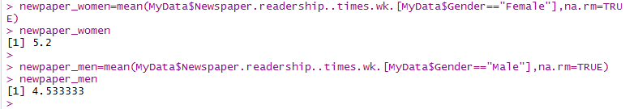

10. Calculate measure of location and dispersion for all quantitative variables using R. (10 marks)
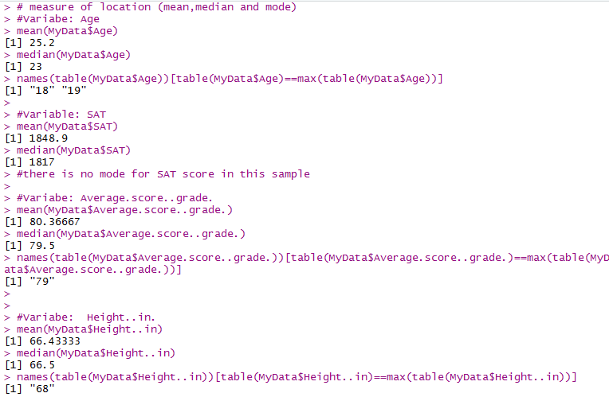
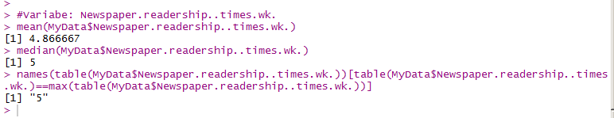
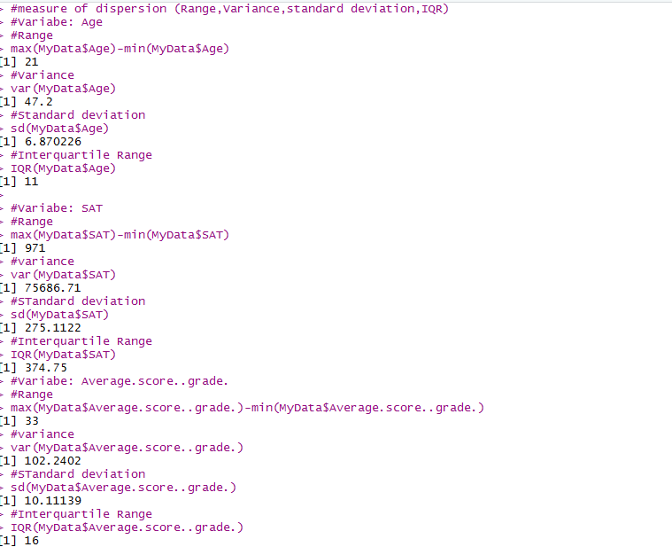

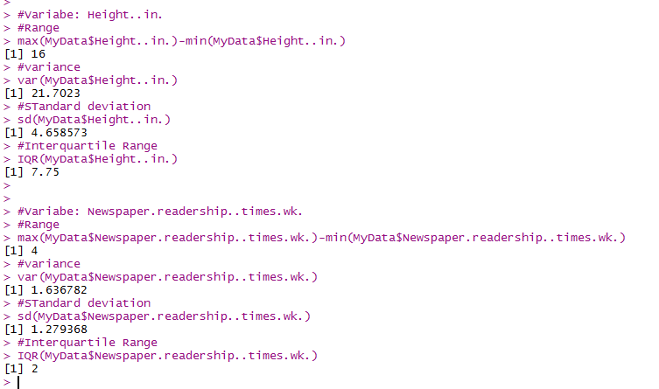

Part 2:
1. If:

Age <- c(22, 25, 18, 20)
Name <- c("James", "Mathew", "Olivia", "Stella")
Gender <- c("M", "M", "F", "F")
Then: what is the R-code for getting the following output:
## Age Name Gender
## 1 22 James M
## 2 25 Mathew M
