Machine Learning Model Development and Evaluation
Week 4 Task - Predicting Top-Quartile Views Before a Video Trends
Prepared by Javhara

1. Introduction and Problem Framing
This report is the Week 4 deliverable, closing the four-week arc on the “Trending YouTube Video Statistics” (US) dataset with a supervised machine learning model. Weeks 1-3 established the data (cleaning), the shape of it (visualization), and which relationships are statistically real (hypothesis testing) - including the Week 3 finding that category predicts audience approval more reliably than it predicts raw views. This week asks a sharper, more decision-relevant question: using only information available before or at upload time, can a model flag which videos are likely to become top performers?
This framing is intentional and matches the PreviDict problem (pre-upload performance prediction) rather than reusing Week 3's engagement-tier target, which was built from likes - a signal that does not exist until after a video is published and would leak the answer into the features.
Task: binary classification. A video is labeled a high performer (1) if its view count falls in the top quartile (≥75th percentile, ≥~1.06M views) of the trending set, and 0 otherwise. This gives a realistic, moderately imbalanced 25%/75% split - closer to a real content-triage problem than an artificially balanced 50/50 target would be.

2. Data Preparation

2.1 Starting point
The input is the same 2,400-row cleaned CSV from Week 1 (no further cleaning was required — that work was already done). This week's preparation work is feature engineering: turning the raw columns into signals a model can use without looking at the outcome.

2.2 Feature engineering - pre-upload signals only
The most important design decision in this pipeline is what NOT to include: likes, dislikes, comment_total, and every ratio derived from them (Week 3's engagement features) are excluded entirely. All of those are measured after a video is public and already trending, so including them would let the model “cheat” by looking at outcomes correlated with the label rather than genuine predictors - a classic data leakage mistake. The features actually used:
df['title_length'] = df['title'].str.len()
df['title_word_count'] = df['title'].str.split().str.len()
df['title_has_exclaim'] = df['title'].str.contains('!').astype(int)
df['title_has_question'] = df['title'].str.contains(r'\?').astype(int)
df['title_upper_ratio'] = df['title'].apply(
lambda s: sum(1 for c in s if c.isupper()) / max(len(s.replace(' ', '')), 1))
df['tag_count'] = df['tags'].fillna('').apply(
lambda s: 0 if s == '' else len(s.split('|')))
df['day_of_week'] = df['trend_date'].dt.day_name()

# Channel track record IS known before any new upload -> not leakage
channel_video_counts = df.groupby('channel_title')['video_id'].nunique()
df['channel_trend_count'] = df['channel_title'].map(channel_video_counts)
Numeric features (7) | title_length, title_word_count, title_has_exclaim, title_has_question, title_upper_ratio, tag_count, channel_trend_count
Categorical features (2) | category, day_of_week (one-hot encoded)
Target | high_performer (1 = top quartile of views, 0 = otherwise)
Rows used | 2,400 (no missing values in the feature set after engineering)
Class balance | 25.0% positive / 75.0% negative

2.3 Train/test split and preprocessing
An 80/20 stratified split preserves the 25% positive rate in both sets (train: 25.0%, test: 25.0%), so performance differences between models reflect genuine skill rather than an accidental easier or harder split. Numeric features are standardized (zero mean, unit variance) and categorical features are one-hot encoded, both fit only on the training data and applied to test data through a single scikit-learn Pipeline to prevent test-set information from leaking into preprocessing.
X_train, X_test, y_train, y_test = train_test_split(
X, y, test_size=0.2, random_state=42, stratify=y)

preprocess = ColumnTransformer([
('num', StandardScaler(), NUMERIC_FEATURES),
('cat', OneHotEncoder(handle_unknown='ignore', drop='first'), CATEGORICAL_FEATURES),
])

3. Model Selection and Training
Logistic Regression was chosen as the primary model: it is interpretable (coefficients show direction and rough magnitude of each feature's effect, useful for a content strategist who wants to know why, not just what), computationally cheap, and a sensible baseline for a binary problem with a modest number of features. A Decision Tree (max depth 5, min 20 samples per leaf) was trained alongside it as a comparison model - trees can capture non-linear interactions logistic regression cannot (e.g. “long titles only hurt performance in the News & Politics category”) and offer a useful cross-check on which features matter. A stratified-random Dummy Classifier is included as a floor: any model that cannot beat it is not adding value.
log_reg = Pipeline([('prep', preprocess),
('clf', LogisticRegression(max_iter=1000, class_weight='balanced', random_state=42))])

tree = Pipeline([('prep', preprocess),
('clf', DecisionTreeClassifier(max_depth=5, min_samples_leaf=20,
class_weight='balanced', random_state=42))])

baseline = Pipeline([('prep', preprocess),
('clf', DummyClassifier(strategy='stratified', random_state=42))])
class_weight='balanced' was used for both real models because the target is imbalanced (25% positive) - without it, both models tend to default toward always predicting the majority class, which would look like decent accuracy while being useless for the actual business goal of finding high performers.

4. Evaluation

4.1 Headline metrics
Model | Test Acc. | Precision | Recall | F1 | ROC-AUC | 5-fold CV AUC
Logistic Regression | 0.633 | 0.375 | 0.700 | 0.488 | 0.695 | 0.680 ± 0.015
Decision Tree | 0.656 | 0.368 | 0.525 | 0.433 | 0.666 | 0.683 ± 0.011
Baseline (stratified random) | 0.613 | 0.238 | 0.250 | 0.244 | 0.492 | —

Both real models clearly beat the baseline on ROC-AUC (≈0.68–0.70 vs. 0.49), and the 5-fold cross-validated AUC is close to the single-split test AUC for both — a good sign that the result is stable rather than a lucky split. Logistic Regression has notably higher recall (0.70) than the tree (0.53): it catches more of the true top-quartile videos, at the cost of more false positives (lower precision, 0.375 vs. 0.368 — roughly comparable). Which model is “better” depends on the business use: if the goal is not missing potential hits (worth a review even if some flagged videos don't pan out), Logistic Regression's higher recall is preferable; if the goal is a shorter, higher-confidence shortlist, the tree's precision-recall curve (Figure 3) shows it holding higher precision at low recall.

4.2 Confusion matrices
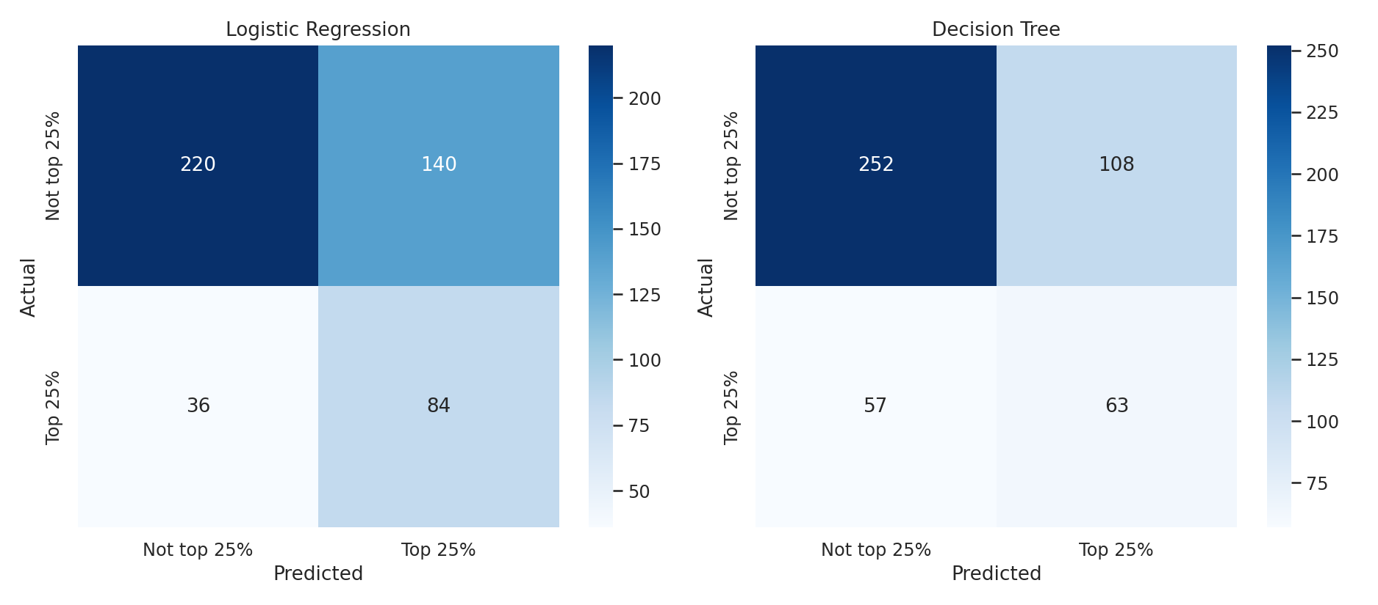
Figure 1. Confusion matrices on the held-out test set (n=480).
Reading the Logistic Regression matrix: of 120 true top-quartile videos in the test set, 84 were correctly flagged (recall 70%) and 36 were missed. Of the 224 videos flagged as top-quartile, 140 were false alarms — the direct cost of prioritizing recall under class imbalance, and worth stating plainly rather than only reporting the flattering numbers.

4.3 ROC and Precision-Recall curves
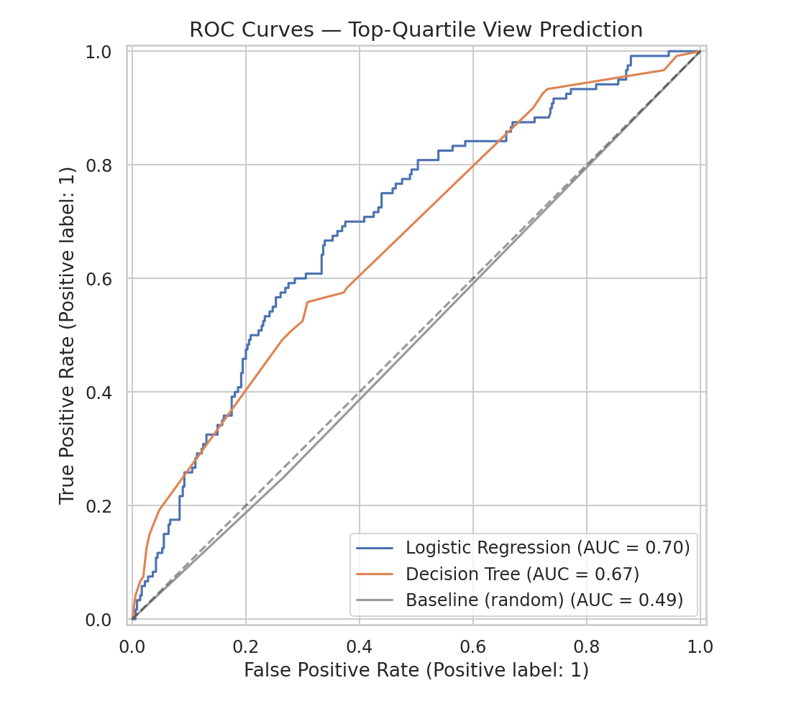
Figure 2. ROC curves for both models against the random baseline.
Why both a ROC curve and a precision-recall curve: ROC-AUC is the standard summary metric, but it can look optimistic under class imbalance because the true-negative rate is easy to keep high when 75% of the data is negative. The precision-recall curve is the more honest picture for this problem specifically, since it's calibrated to the 25% positive rate rather than treating both classes as equally common.
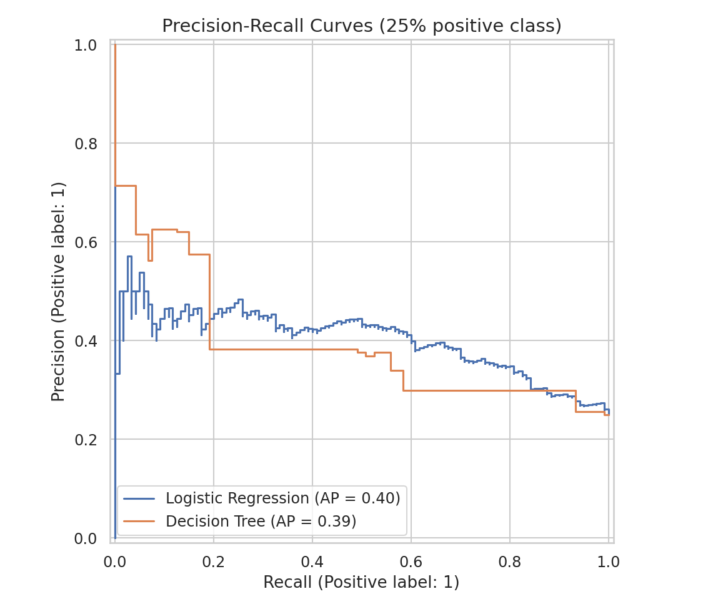
Figure 3. Precision-recall curves - the more informative view given the 25% positive class.
Both curves sit well above the 0.25 precision a random classifier would achieve at any recall level (average precision 0.40 and 0.39), confirming the models are extracting real signal, not just exploiting the class imbalance.

4.4 What the models actually learned
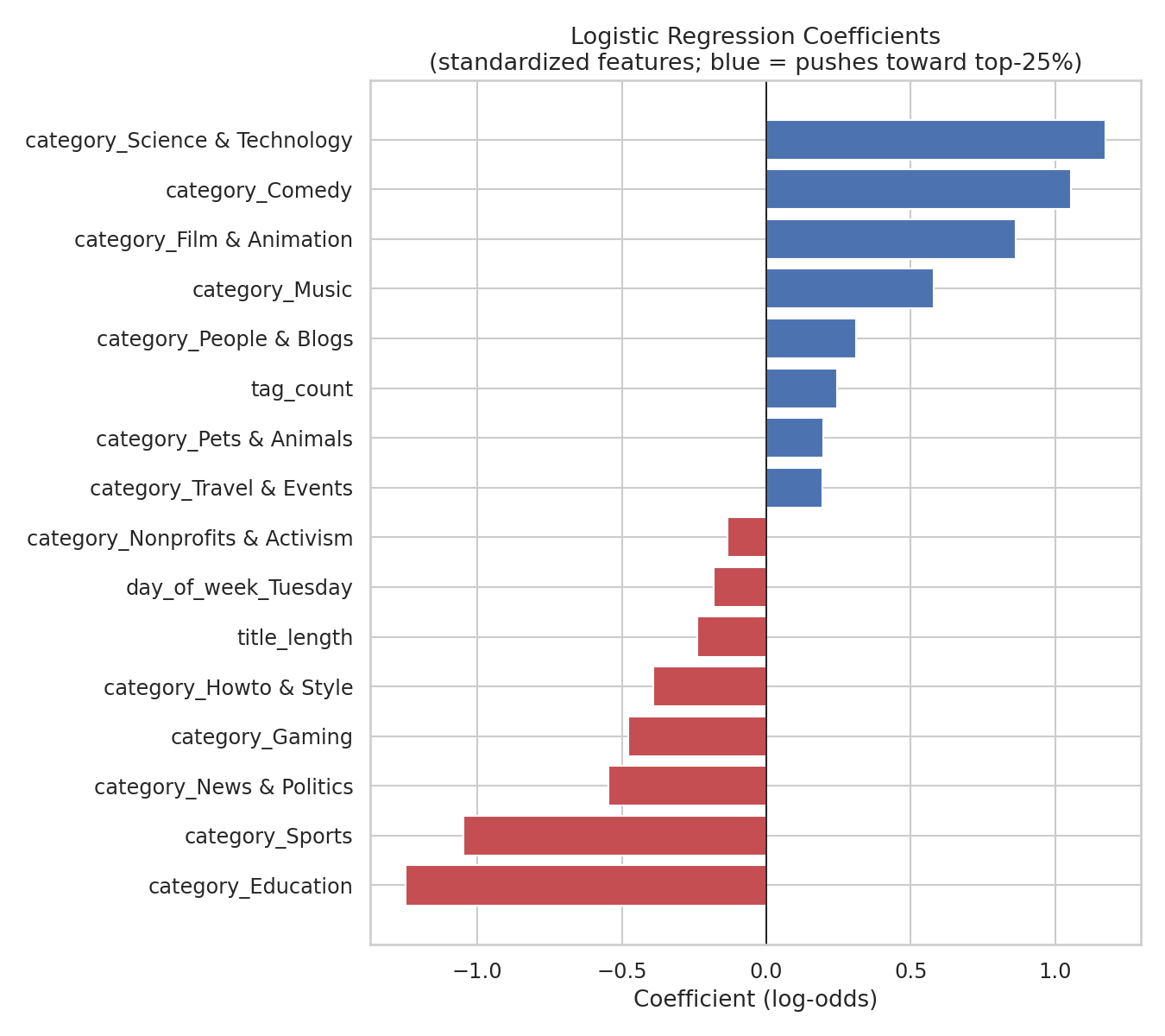
Figure 4. Logistic regression coefficients (standardized). Positive = pushes toward top-quartile.
Category dominates the coefficient list - Science & Technology, Comedy, and Film & Animation push hardest toward high performance, while Education and Sports push hardest against it. This lines up with, but is not identical to, Week 3's ANOVA result (category explains a modest but real share of view variance) - here it's the strongest signal available simply because the other features (title length, tag count) carry much weaker individual effects.
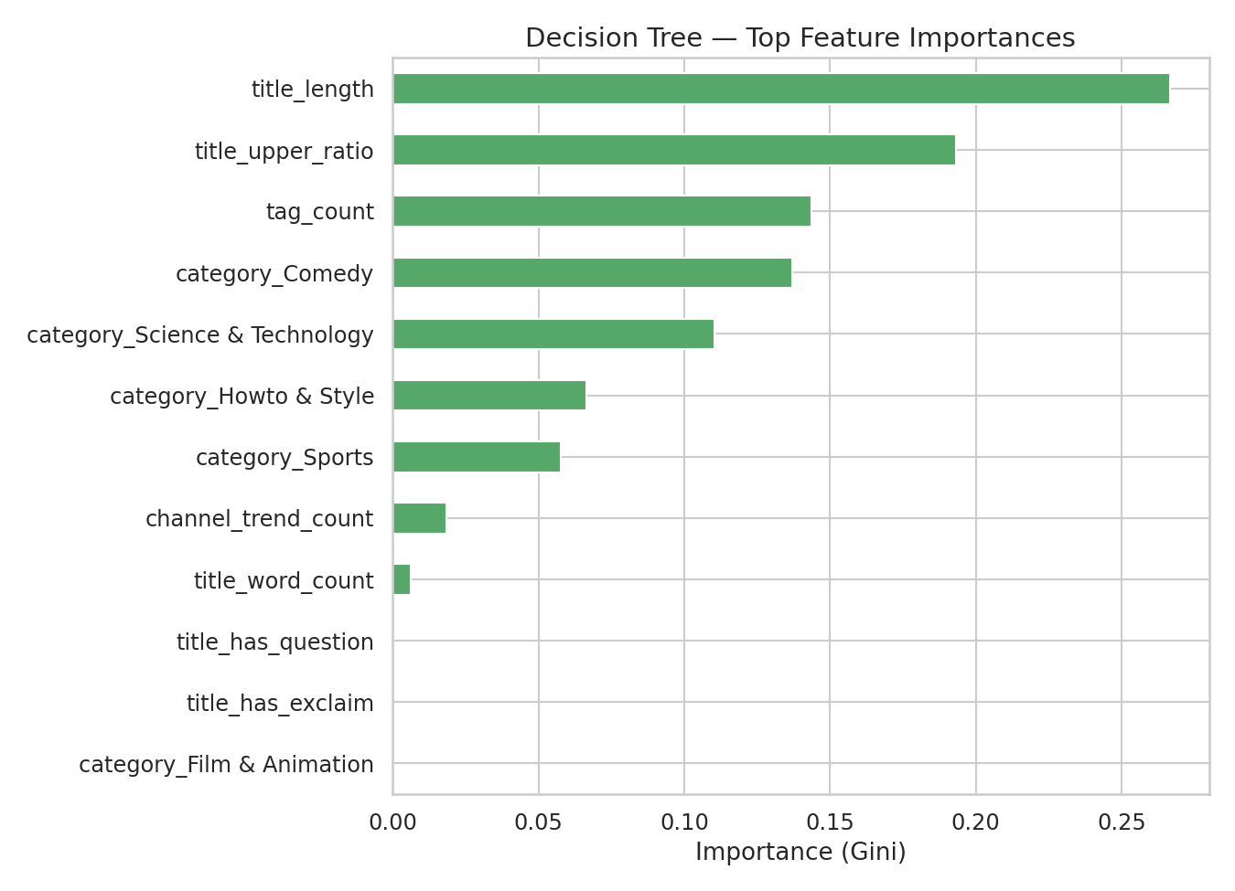
Figure 5. Decision tree feature importances (Gini).
The tree agrees that category dominates but assigns real weight to channel_trend_count (a channel's track record) and title_length — a pattern logistic regression's linear form doesn't surface as clearly, illustrating why comparing two model types is useful even when their headline scores are close.

4.5 Overfitting and underfitting check
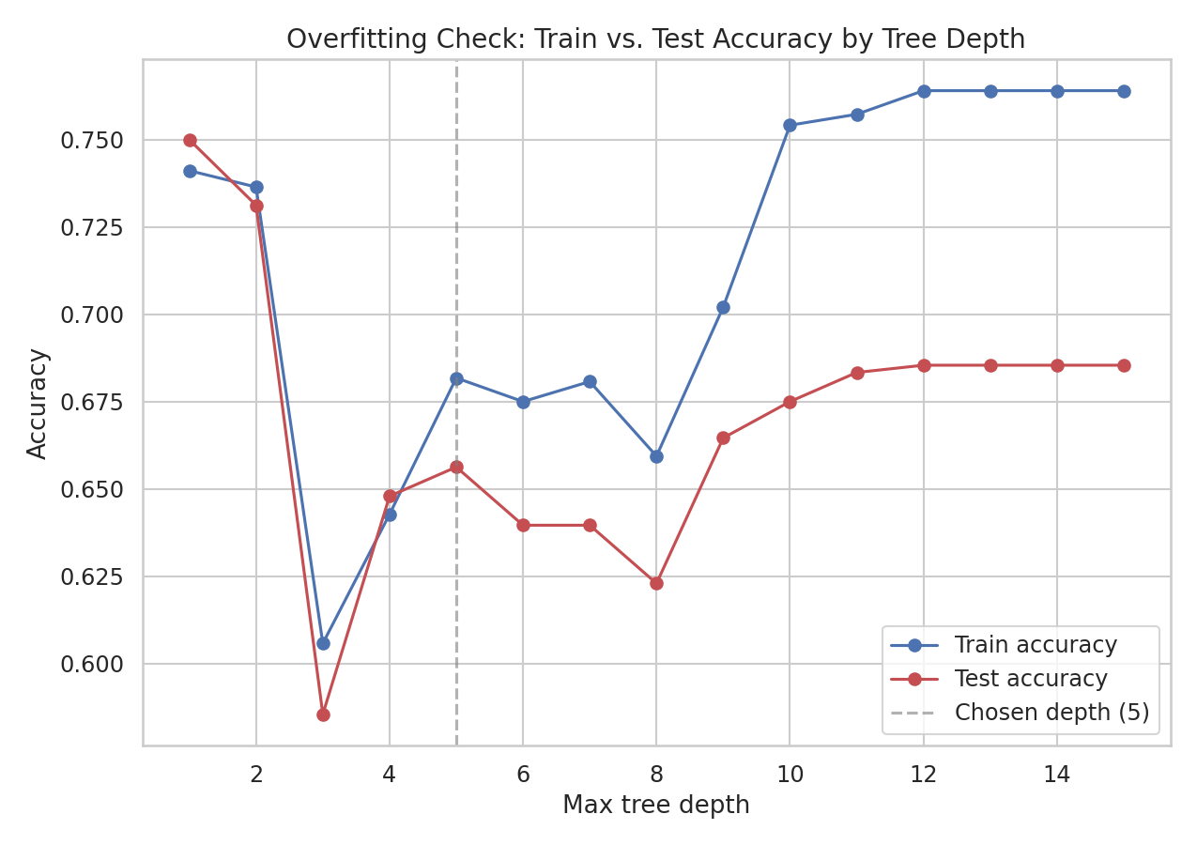
Figure 6. Train vs. test accuracy across decision tree depth.
At depth 1–2 the tree is underfit - train and test accuracy are close but both low, since a stump can't capture much. Past depth ~9 the gap widens (train keeps climbing toward ~0.76 while test accuracy plateaus around 0.685) - classic overfitting, the tree is memorizing noise in the training split rather than learning generalizable structure. Depth 5 was chosen because it sits before that gap opens meaningfully while still outperforming very shallow trees. The visible jaggedness in both curves between depths 2–8 is itself informative: with only 1,920 training rows spread across 15 categories and 7 days of the week, small changes in tree structure shift a handful of predictions each time - a reminder that this dataset's size limits how much any single split can be trusted.

5. Critical Discussion: Sources of Error and Improvements
- Feature ceiling: the available pre-upload signals (category, title text stats, tag count, channel history) explain only part of what makes a video a top performer. Thumbnail quality, actual video content, promotion/cross-posting, and pure timing luck are invisible to this feature set - the ~0.68–0.70 AUC likely reflects a real ceiling for this feature space, not a modeling failure.
- Small sample for a 15-category, 7-day feature space: 2,400 rows split across many one-hot categories means some category/day combinations are thin, which is very likely the cause of the jaggedness in Figure 6 and adds variance to any single train/test split - the 5-fold CV numbers (Table 4.1) are the more trustworthy estimate for this reason.
- Class imbalance trade-off: class_weight='balanced' improves recall on the minority (top-quartile) class but increases false positives, visible directly in Figure 1. A different weighting, or optimizing the classification threshold instead of using the default 0.5 cutoff, would shift this trade-off without retraining.
- Single region, single window: the same limitation flagged in Weeks 1–3 applies here - a model trained on 12 days of US trending data may not generalize to other regions, seasons, or non-trending upload populations (this dataset only contains videos that already trended, which is itself a selection filter).
- Next steps: richer text features (title sentiment, keyword extraction, or embeddings rather than simple length/punctuation counts), a gradient-boosted model (e.g. XGBoost/LightGBM) to better capture feature interactions than a single shallow tree, probability calibration if the output is used for ranking/prioritization rather than a hard yes/no, and testing threshold tuning against the precision-recall curve in Figure 3 rather than defaulting to 0.5.

6. Conclusion
A Logistic Regression model using only pre-upload-available features predicts top-quartile YouTube view performance meaningfully better than chance (ROC-AUC ≈ 0.70 vs. 0.49 baseline, stable across 5-fold cross-validation), with category as by far the strongest single signal - consistent with, and adding a predictive dimension to, Week 3's finding that category shapes both audience approval and (more modestly) raw view outcomes. The model is far from a solved prediction problem: recall/precision trade-offs, a limited feature set, and a small single-window sample all cap how far this specific pipeline can be pushed without new data or richer features. That said, the exercise demonstrates the full development loop end-to-end - leakage-aware feature design, a fair train/test protocol, multiple evaluation lenses (ROC, precision-recall, confusion matrix), an explicit overfitting check, and an honest accounting of where the model's ceiling comes from - which is the actual point of the task.

