Advanced Data Visualization and Storytelling
Week 2 Task — The Anatomy of a Trending YouTube Video
Prepared by Javhara Sherin

1. Introduction
This report is the Week 2 deliverable, building on the cleaned “Trending YouTube Video Statistics” (US) dataset from Week 1. The brief this week is different from Week 1's: instead of documenting a cleaning process, the goal is to turn the same data into a narrative that a non-technical reader — a content strategist, a marketing lead, a channel owner — could act on without needing to know what a correlation coefficient is.
The guiding question: once a video is trending, what actually separates the ones that explode into tens of millions of views from the ones that plateau in the thousands? Six visualizations build toward an answer, moving from “where is the attention going” (category share) down to “what signal actually predicts virality” (raw counts vs. engagement rate).

2. Methods
Dataset: 2,400 video-day records across 12 trending days (Sep 13–24, 2017) and 15 categories, cleaned in Week 1 (hidden missing values recovered, category codes labeled, dates parsed, impossible rows filtered). This week adds no new acquisition step — the same cleaned CSV is the input to every chart below.
Tooling: Matplotlib and Seaborn for statistical charts (violin, heatmap, stacked area, grouped bar) and a Squarify-based treemap for the category-share view. A Plotly-based interactive bubble chart was prototyped first for the views/likes/comments relationship; since this document is a static DOCX rather than a live notebook, the final version was rebuilt in Matplotlib so it renders identically for every reader without a browser or Chrome dependency — the underlying encoding (position, size, color) is the same either way.
To keep six charts readable rather than overwhelming, most restrict the categorical axis to the eight categories with the most trending appearances (Entertainment, Music, People & Blogs, Howto & Style, Comedy, Science & Technology, News & Politics, Film & Animation) — together these account for roughly 87% of all trending slots in the window.

3. Visual Analysis — The Data Story

3.1 Where the attention goes
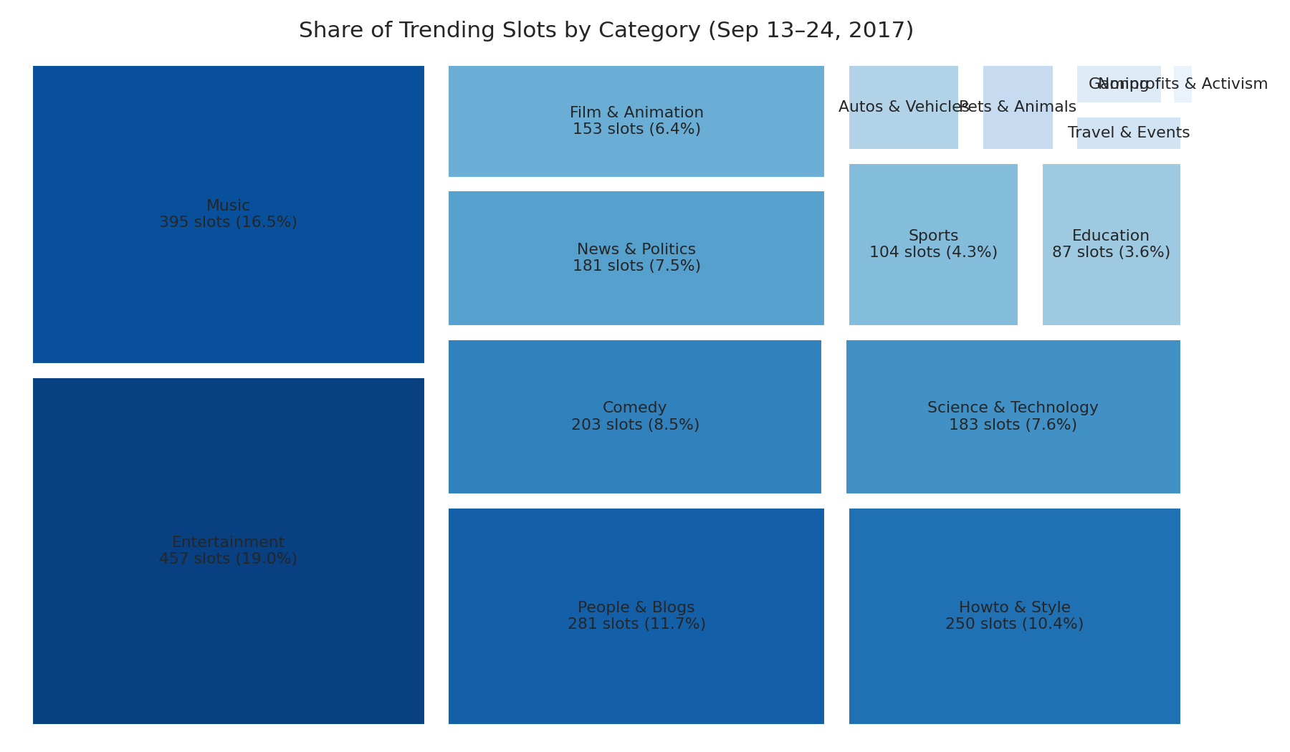
Figure 1. Share of trending slots by category, Sep 13–24, 2017.
Why a treemap: for a single categorical breakdown with 15 unevenly-sized groups, a treemap reads faster than a pie chart or a legend-heavy bar chart — area does the work, and a reader can see at a glance that Entertainment and Music alone take up over a third of all trending slots, while categories like Nonprofits & Activism barely register.

3.2 Not every category has the same ceiling
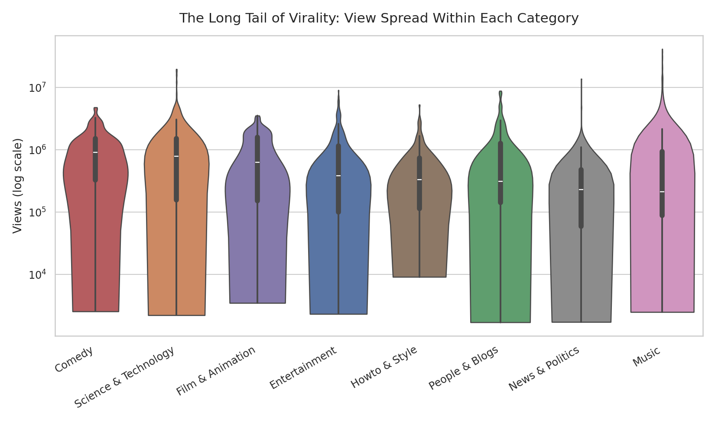
Figure 2. Distribution of views within each category (log scale).
Why a violin plot: a bar chart of average views would hide the spread — two categories can have the same average while one is consistently mid-sized and the other is mostly small with a few massive outliers. The violin shape shows both the typical case (the white line marks the median) and how far the tail stretches above it.
Narrative role: Comedy and Science & Technology have the highest typical (median) views, but Music's violin stretches furthest into the tens of millions — it has the widest gap between a typical trending video and a viral outlier. That's a different kind of opportunity (and risk) than a category like Comedy, which trends more predictably but rarely explodes as far.
3.3 What a viral hit actually looks like
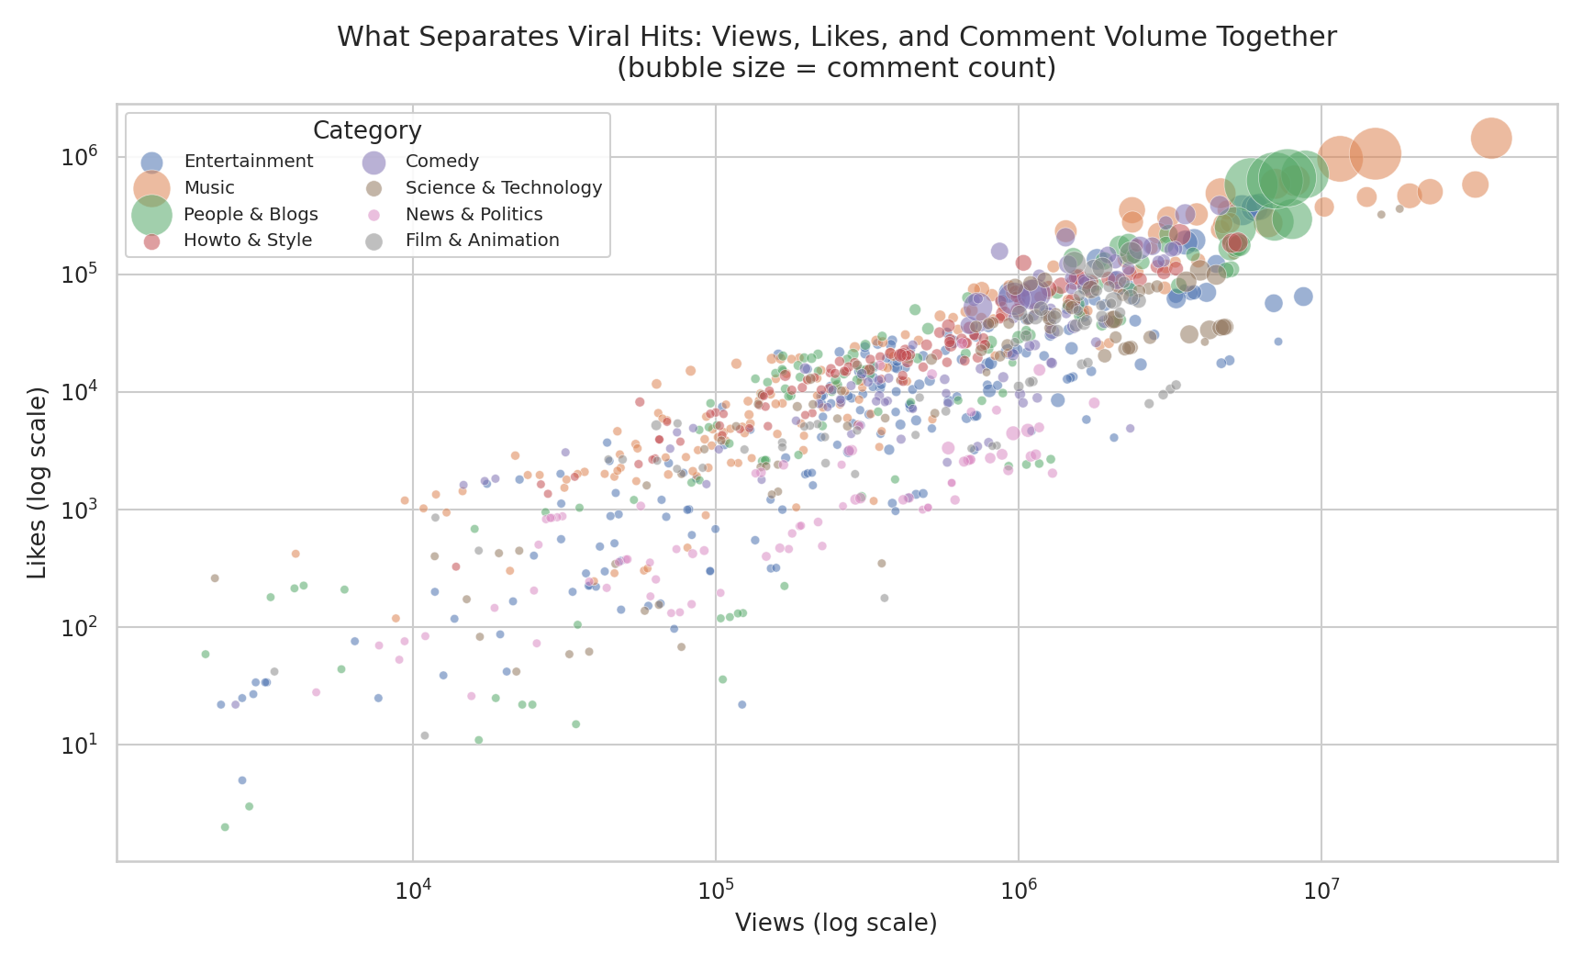
Figure 3. Views, likes, and comment volume together — bubble size encodes comment count, color encodes category.
Why a bubble chart: this is the most information-dense chart in the report on purpose — it packs four variables (views, likes, comments, category) into one view so the reader can see all of them moving together instead of comparing four separate charts in their head.
Narrative role: this is the emotional center of the story. The cloud of points climbs in a fairly tight, predictable line — views and likes move together — but the biggest bubbles (highest comment counts) cluster at the top right, disproportionately from Music and People & Blogs. That tells a content strategist something a views-only report wouldn't: comment volume isn't evenly distributed even among equally-viewed videos, and it clusters by category.

3.4 Popular is not the same as well-liked

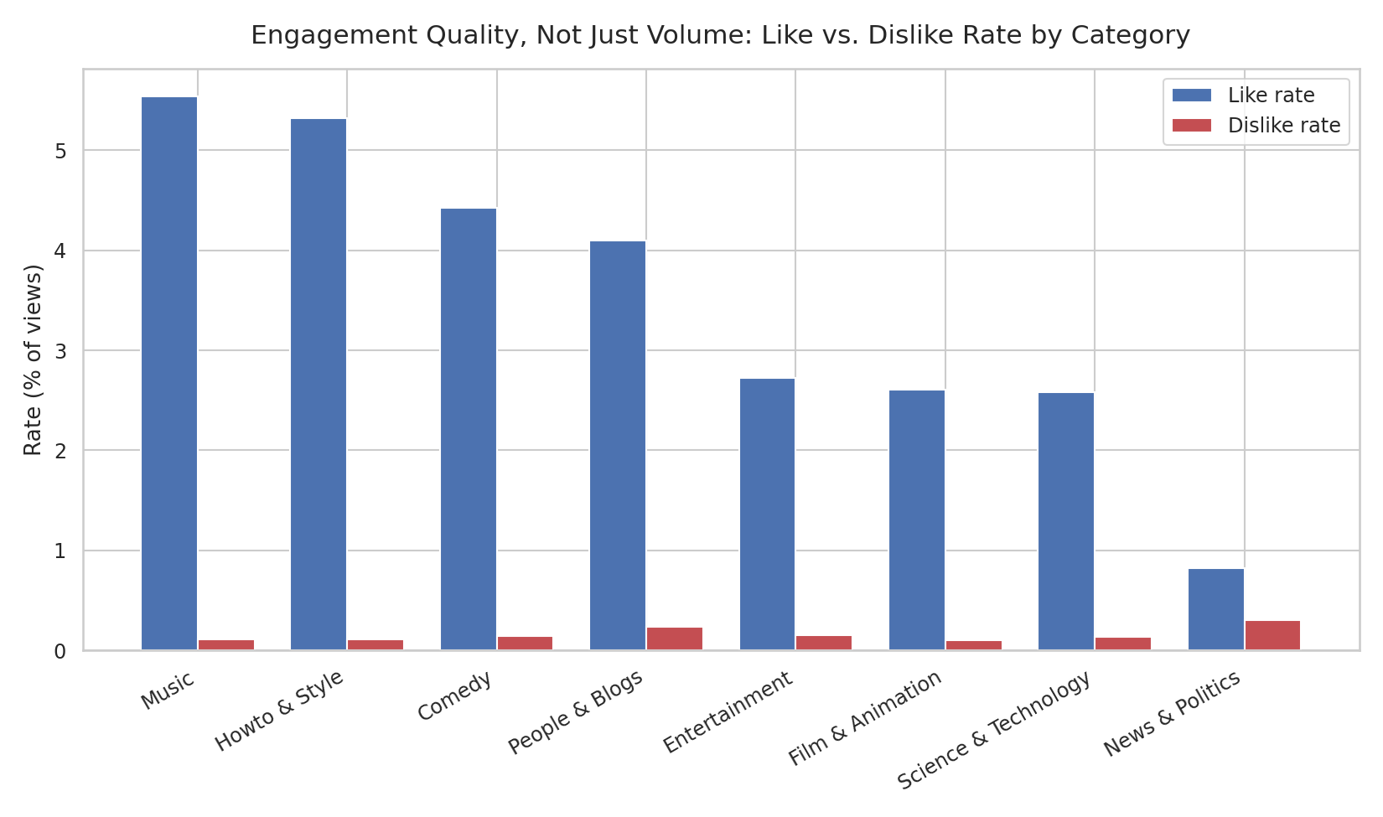
Figure 4. Average like rate vs. dislike rate by category, as a percentage of views.
Why a grouped bar chart: rates (not raw counts) are the right unit here, and a grouped bar makes the like/dislike comparison direct and category-to-category comparable — a category with huge view counts but a mediocre like rate would be invisible in the earlier charts, which this one surfaces.
Narrative role: this is the twist. Music and Howto & Style have the highest like rates (over 5% of viewers liking the video), while News & Politics has both the lowest like rate and the highest dislike rate of the group — a category that trends reliably (Figure 1) but divides its audience far more than any other. Raw view count alone would never have shown that.

3.5 The trending window has a rhythm
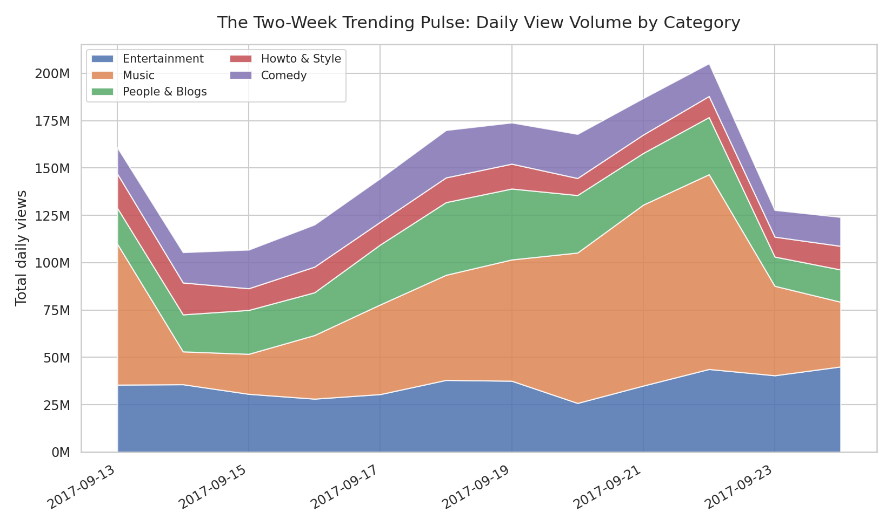
Figure 5. Total daily views by category across the 12-day trending window.
Why a stacked area chart: this is the only chart in the report with time on the x-axis, and stacking by category shows both the overall daily volume and each category's contribution to it in one view, rather than needing five separate line charts.
Narrative role: total trending views roughly double from the first days of the window to a peak around September 22, driven almost entirely by growth in Music, before falling back sharply. That kind of week-over-week rhythm is exactly the sort of pattern a content calendar would want to plan around — timing matters as much as content.

3.6 The metric that actually matters depends on the question

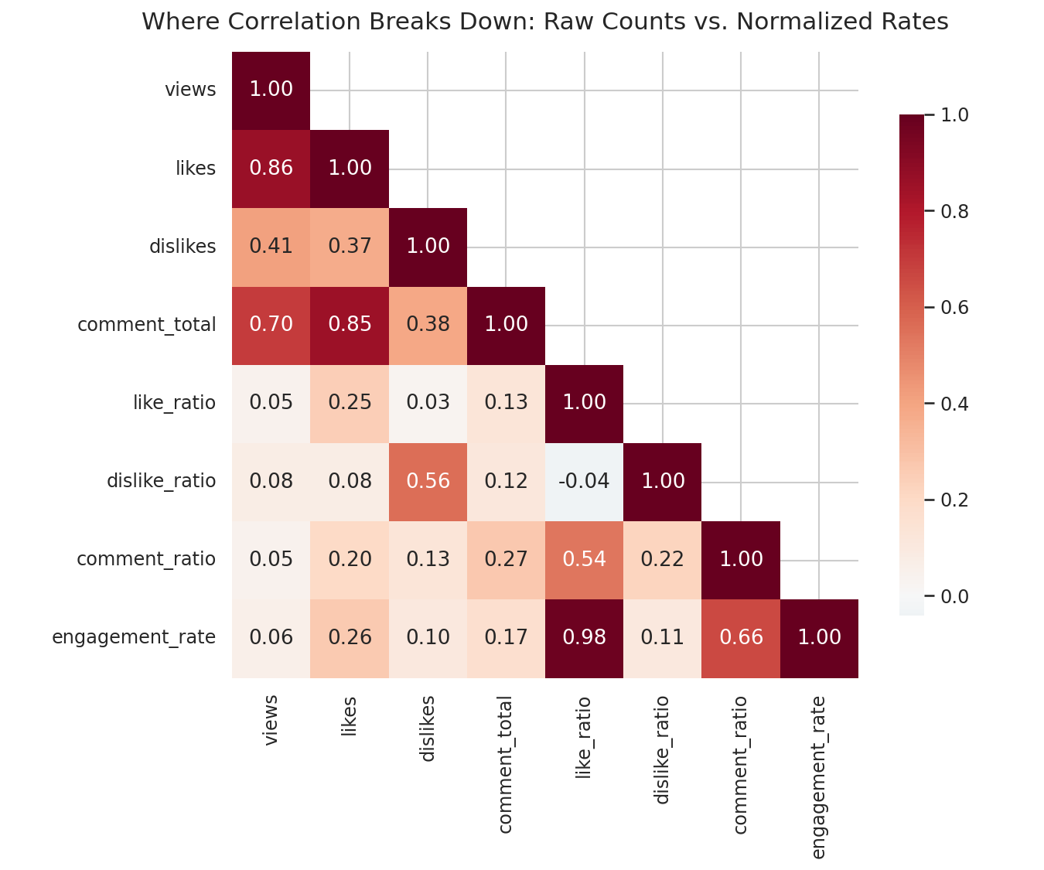
Figure 6. Correlation matrix — raw engagement counts vs. normalized engagement rates.
Why a correlation heatmap: this closes the loop opened in Figure 4. Numbers alone (a correlation table) are hard to scan; color makes the strong and weak relationships jump out immediately, and the lower-triangle layout avoids showing every pair twice.
Narrative role: this is the payoff insight of the report. Raw likes correlate strongly with views (r ≈ 0.86) — more views simply means more likes in absolute terms. But like rate (likes as a share of views) barely correlates with views at all (r ≈ 0.05). In plain terms: view count tells you almost nothing about whether an audience actually loved the video, and audience approval tells you almost nothing about whether it will go viral. They are two different stories, not one — which is exactly why Figure 4 was able to surprise us with News & Politics.

4. Business and Practical Implications

These six charts point to a few concrete takeaways for anyone making decisions about video content — a creator choosing what to publish, a platform tuning a recommendation system, or a brand deciding where to place a campaign:
- Reach and approval are separate goals. Since view count and like rate are nearly uncorrelated (Figure 6), a strategy optimized purely for views (clickbait titles, algorithm-chasing) will not reliably also produce a well-liked video — and vice versa. Teams should track both metrics, not use one as a proxy for the other.
- Category choice trades off ceiling against consistency. Music offers the highest upside (Figure 2's longest tail) but Comedy and Science & Technology offer a higher typical outcome — the right choice depends on whether the goal is a reliable content pipeline or a shot at a breakout hit.
- Audience sentiment is a category-level signal worth watching, not just a video-level one. News & Politics' unusually high dislike rate (Figure 4) despite strong trending presence (Figure 1) suggests structural audience division in that category — relevant for advertisers weighing brand safety, not just view volume.
- Timing compounds category effects. The trending pulse in Figure 5 shows engagement is not evenly spread across the window — a category's share of attention shifts day to day, so publishing timing is a lever independent of content quality.
- For any downstream prediction system (including a pre-upload view-prediction model), raw engagement counts and normalized engagement rates are functionally two different feature families, not redundant versions of each other — both are worth including, since each is blind to what the other captures.

5. Conclusion
The same dataset examined in Week 1 for cleaning quality turns out to hold a genuinely useful narrative once visualized end-to-end: attention concentrates unevenly across categories, view count and audience approval are separate signals that a single “views” number hides, and both category and timing shape outcomes in ways a summary table alone would not surface. The clearest single finding — that raw engagement and rate-based engagement diverge — is also the most actionable one, and it only became visible by building up to it visually rather than starting from a correlation table.

