Data Acquisition, Cleaning, and Exploratory Analysis
Week 1 Task — Trending YouTube Video Statistics (US)
Prepared by Javhara Sherin

1. Introduction and Objective
This document covers the Week 1 deliverable for the data science task: acquiring a public dataset, cleaning it, and running an exploratory data analysis (EDA) pass. I chose a YouTube video-performance dataset on purpose rather than a generic sample dataset (Titanic, Iris, etc.) — it's the same problem space as PreviDict, the pre-upload view-prediction project I built for ICASET 2026, so the cleaning decisions and engagement-metric patterns found here are directly reusable.
Domain: Content/video analytics. Question framing: what separates a trending video that gets a few thousand views from one that gets tens of millions, and which of the available signals (category, likes, dislikes, comments) actually track with that difference?

2. Data Acquisition
Dataset: “Trending YouTube Video Statistics” (US region), originally collected via the YouTube Data API and distributed as a public CSV. Each row represents one video on one day it appeared on YouTube's Trending list.
Rows × Columns | 2,400 × 11 (raw)
Grain | One row = one video on one trending day
Fields | video_id, title, channel_title, category_id, tags, views, likes, dislikes, comment_total, thumbnail_link, date
Format | CSV, loaded with pandas.read_csv()

Load
import pandas as pd

df_raw = pd.read_csv('USvideos.csv')
print(df_raw.shape)
print(df_raw.dtypes)

3. Data Cleaning
Nothing in this dataset failed a plain df.isnull().sum() check — it comes back all zeros. That's exactly why it's a useful cleaning exercise: the real issues are encoding problems, not blank cells, and they only show up once you actually look at what each column contains.

3.1 Fixing the date field's data type
The 'date' column was stored as a float like 13.09, meant to read as day.month rather than a real calendar date. Left as-is it's unusable for any time-based analysis (sorting, grouping by week, plotting a trend line) and pandas has no way to know it's a date. I parsed the integer part as the day and the fractional part as the month, then rebuilt a proper datetime64 column.
def parse_dd_mm(x):
day = int(x)
month = round((x - day) * 100)
return day, month

parsed = df['date'].apply(parse_dd_mm)
df['trend_date'] = pd.to_datetime(dict(
year=2017,
month=parsed.apply(lambda t: t[1]),
day=parsed.apply(lambda t: t[0]),
))
Note : the raw file has no year field. I assigned 2017 based on the known collection window of the original “Trending Youtube Video Statistics” collection this file is drawn from.

3.2 Recovering a hidden missing-value encoding
The 'tags' column uses the literal string "[none]" for videos with no tags instead of a real null. That's invisible to .isnull() — a naive cleaning pass would report 0% missing data and miss it entirely. I replaced it with an actual NaN so downstream text/NLP work (tag counts, tag-based features) treats it correctly instead of counting "[none]" as a real tag.
df['tags'] = df['tags'].replace('[none]', np.nan)

151 of 2,400 rows (6.3%) had no tags

3.3 Category IDs → human-readable labels
category_id is a numeric code from YouTube's taxonomy with no lookup table shipped in the file. Left as a number it's not analysis-ready — '24' means nothing on a chart. I mapped the 15 codes present in this dataset to YouTube's public category names (Music, Comedy, Gaming, etc.) so groupby/plot output is actually readable.
CATEGORY_MAP = {1: 'Film & Animation', 2: 'Autos & Vehicles', 10: 'Music',
17: 'Sports', 20: 'Gaming', 22: 'People & Blogs',
23: 'Comedy', 24: 'Entertainment', 25: 'News & Politics',
26: 'Howto & Style', 27: 'Education',
28: 'Science & Technology', ...}
df['category'] = df['category_id'].astype('Int64').map(CATEGORY_MAP)

3.4 Duplicates — checked, but mostly kept on purpose
df.duplicated() returns 0 exact duplicate rows. However, 2,260 of the 2,400 rows share a video_id with at least one other row — that's because a video that trends for several days gets one row per day, with updated view/like counts each time. That's the correct grain of the data, not an error, so I kept those rows for the day-level analysis. For any video-level question (“what's this video's final view count”) I built a second table, df_latest, keeping only each video's most recent trending-day snapshot.
df_latest = (df.sort_values('trend_date')
.drop_duplicates(subset='video_id', keep='last')
.reset_index(drop=True))

3.5 Sanity filtering
I added a logical-consistency check — dropping any row where likes or dislikes exceed views, which would be physically impossible and indicate a scraping error. None were found in this file (0 rows), but I kept the check in the pipeline since it's cheap insurance for any future re-pull of the data.
df = df[~((df['likes'] > df['views']) | (df['dislikes'] > df['views']))]

3.6 Derived features
For the EDA and for reuse in PreviDict-style modeling later, I added ratio features so videos of very different sizes are comparable: like_ratio, dislike_ratio, comment_ratio and engagement_rate (all three combined, divided by views).
df['like_ratio'] = df['likes'] / df['views']
df['dislike_ratio'] = df['dislikes'] / df['views']
df['comment_ratio'] = df['comment_total'] / df['views']
df['engagement_rate'] = (df['likes'] + df['dislikes'] + df['comment_total']) / df['views']

3.7 Cleaning summary
Raw shape | 2,400 rows × 11 columns
Cleaned shape | 2,400 rows × 16 columns (11 original − date + 6 engineered)
Exact duplicate rows removed | 0
Hidden missing values recovered (tags) | 151 (6.3%)
Rows dropped (impossible likes/dislikes > views) | 0
Unique videos | 2,340 video-day rows across the trending window

4. Exploratory Data Analysis
With a clean frame, I looked at (a) how much cleaning actually mattered, (b) the shape of the core views metric, (c) how the engagement metrics relate to each other, (d) which content categories over-index on views, and (e) the views-to-likes relationship at the video level.

4.1 Data quality overview
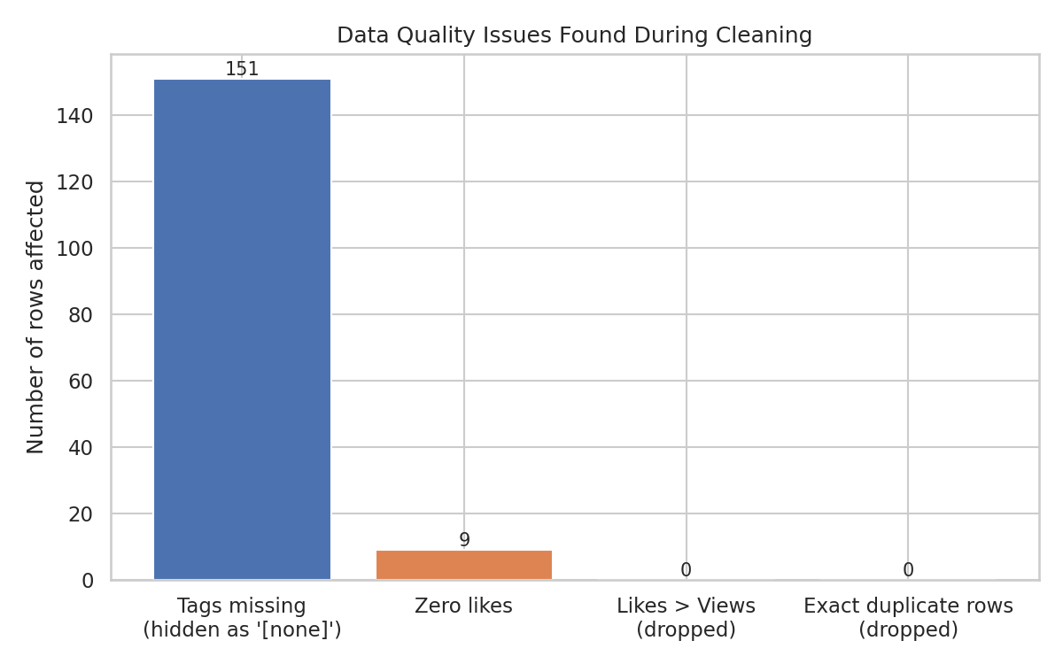
Figure 1. Data quality issues surfaced during cleaning.
Nothing here shows up in a default .isnull() scan — all four issues had to be found by actually inspecting the columns, which is the main takeaway of this section: a 0%-missing report does not mean a dataset is clean.

4.2 Distribution of views

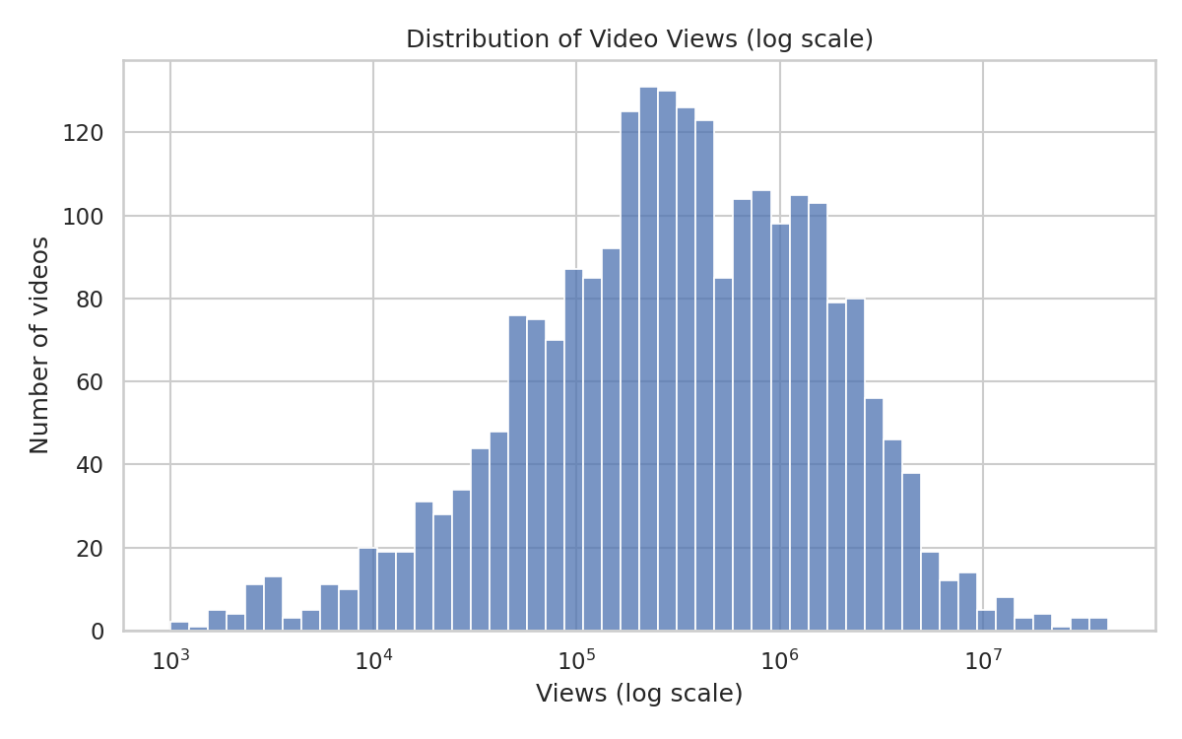
Figure 2. Distribution of video views (log scale).
Views are heavily right-skewed — median views (~324K) sit far below the mean (~1.03M), pulled up by a small number of viral outliers (max ~41.5M). On a log scale the distribution looks close to log-normal, which is the usual shape for view-count data and the reason a model like PreviDict would want to predict log(views) rather than raw views.

4.3 Correlation between engagement metrics

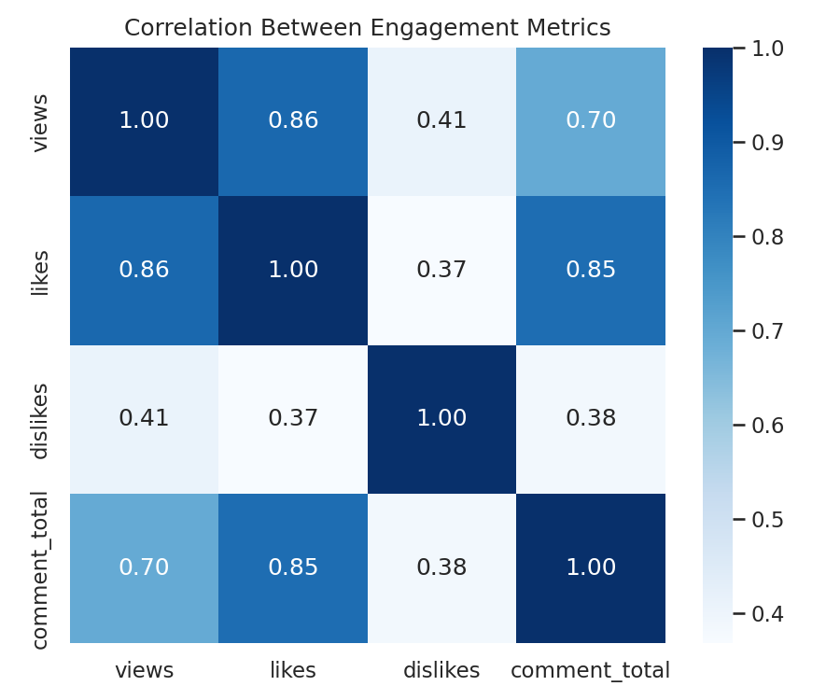
Figure 3. Correlation matrix — views, likes, dislikes, comments.
Likes correlate most strongly with views (r ≈ 0.86), comments next (r ≈ 0.70), and dislikes the weakest (r ≈ 0.41). Likes and comments are also strongly correlated with each other (r ≈ 0.85) — videos that get liked also get commented on, which suggests they're capturing overlapping engagement signal rather than fully independent information.

4.4 Views by category

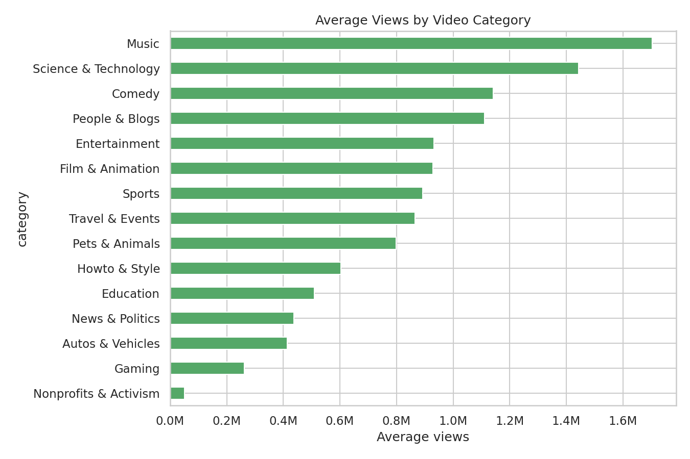
Figure 4. Average views by video category.
Music (~1.70M avg views) and Science & Technology (~1.44M) lead by a wide margin; Nonprofits & Activism and Gaming sit at the bottom. Category alone looks like a meaningful, low-cost feature — worth including even before any text-based signal from the title or tags.

4.5 Views vs. likes

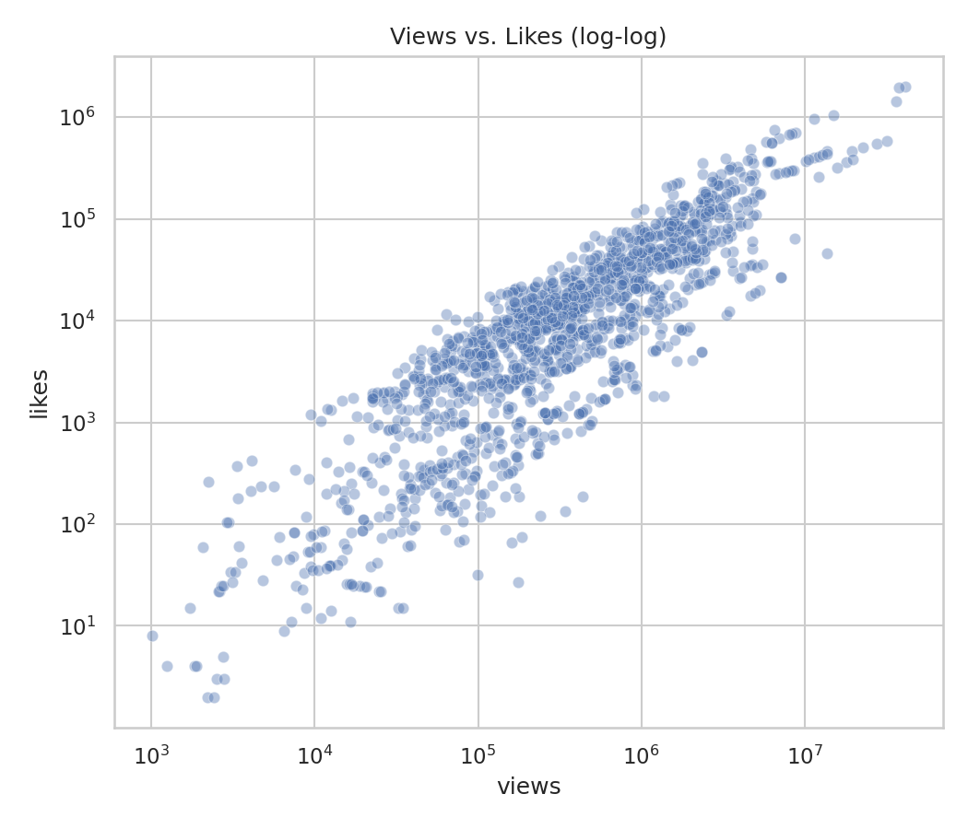
Figure 5. Views vs. likes, log-log scale (1,500-row sample).
The log-log relationship is close to linear, consistent with the strong correlation in Figure 3 and with a roughly constant like-per-view rate across most of the range — useful as a sanity baseline for later engagement-prediction work.

5. Summary of Insights
- The dataset's biggest data-quality risks were invisible to a standard null check: an encoded '[none]' string for missing tags, a numeric-but-not-date date field, and raw category codes with no label table.
- 2,260 of 2,400 rows share a video_id with another row — that's the data's actual grain (per trending-day snapshots), not duplication, and treating it as duplication would have silently dropped most of the file.
- Views are strongly right-skewed; a small number of outlier videos pull the mean well above the median, which argues for a log transform in any downstream regression or prediction task.
- Likes are the strongest single engagement predictor of views (r ≈ 0.86); dislikes carry the least signal (r ≈ 0.41).
- Category is a meaningful, cheap-to-compute feature — average views vary by more than 30x between the top (Music) and bottom (Nonprofits & Activism) categories.
- Next steps: pull a larger multi-region sample, bring in title/tag text features (word count, sentiment, capitalization), and test whether category + engagement ratios improve a view-prediction baseline — directly relevant to extending PreviDict beyond Shorts.

6. Limitations and Assumptions
- Year for the 'date' field was assumed (2017) since the raw file only encodes day.month — flagged rather than silently trusted.
- Single region (US) and a 12-day trending window — findings may not generalize to other regions or a full annual cycle.
- 'Views' reflect a snapshot at scrape time, not final lifetime views, so later-trending videos are undercounted relative to how long they've been public.

