Comprehensive Data Science Project Report
Predicting Top-Quartile Video Performance on YouTube:
An End-to-End Analysis from Data Cleaning to Predictive Modeling and Strategic Recommendations
Week 5 Task — Final Internship Report
Dataset: Trending YouTube Video Statistics (US)
Prepared by: Javhara
Virtual Data Science with Python — Apprentice Internship

Table of Contents
1. Executive Summary
2. Introduction and Project Objectives
3. Methodology: The Four-Week Pipeline
3.1 Week 1 — Data Acquisition, Cleaning, and EDA
3.2 Week 2 — Advanced Visualization and Data Storytelling
3.3 Week 3 — Statistical Analysis and Hypothesis Testing
3.4 Week 4 — Machine Learning Model Development and Evaluation
4. Consolidated Results and Analysis
5. Strategic Recommendations
6. Business and Research Impact
7. Limitations and Future Improvement Areas
8. Conclusion

1. Executive Summary
This report closes out a five-week applied data science internship built around a single, consistent dataset - the Trending YouTube Video Statistics (US) dataset - carried through data cleaning, exploratory visualization, statistical hypothesis testing, and predictive modeling. Rather than treating each week as an isolated exercise, this final report synthesizes the four preceding stages into one coherent analytical narrative and translates the resulting technical findings into recommendations a content or platform team could act on.
The central technical result is a supervised classification model that predicts, using only information available before or at upload time, whether a video is likely to land in the top quartile of views (the top 25% of the trending set, roughly 1.06 million views or more). A Logistic Regression model reached a cross-validated ROC-AUC of approximately 0.70 against a 0.49 random baseline, correctly flagging 70% of eventual top performers before they were published. This is a modest but genuine and stable signal - not a solved prediction problem, but a usable triage tool.
Four findings anchor the strategic recommendations that follow:
- Video category is, by a wide margin, the strongest predictor of both view performance (Week 4) and audience approval (Week 3) - far stronger than any text-based or scheduling feature tested.
- The dataset's most valuable engineering decision was what was excluded, not what was included: post-publication signals (likes, dislikes, comments) were deliberately kept out of the pre-upload model to avoid data leakage, which is as much a strategic lesson about measurement discipline as a technical one.
- The model is recall-oriented by design (class_weight='balanced'), which suits a triage use case - reviewing under half the catalog to catch 70% of eventual hits - but it comes with a real precision cost that stakeholders must accept knowingly, not by accident.
- The ~0.70 AUC ceiling is very likely a feature-availability limit, not a modeling failure: thumbnail quality, actual video content, and promotion activity are invisible to this feature set and are the most promising directions for future uplift.
Taken together, the four-week arc demonstrates the full applied data science loop - problem framing, leakage-aware feature design, a fair evaluation protocol, multi-lens model evaluation, and an honest accounting of limitations and produces a specific, defensible recommendation: use the model as an early-stage content triage signal that shortlists candidate videos for promotion or investment, not as a final gatekeeping decision.

2. Introduction and Project Objectives
The internship was structured as a five-week progression, each week building directly on the artifacts produced by the one before it, using a single dataset throughout: the Trending YouTube Video Statistics (US) dataset, a public collection of videos that appeared on YouTube's daily trending list over a defined window. Using one dataset across all five weeks was a deliberate choice - it allows later-week findings to be checked against earlier-week findings rather than treated as unrelated case studies, and it is what makes this final synthesis report possible.
The guiding business question threaded through all five weeks was framed progressively:
- What does this dataset actually contain, and is it clean and trustworthy enough to analyze? (Week 1)
- What patterns does the data show, and how can they be communicated clearly to a non-technical audience? (Week 2)
- Which of the visually apparent patterns are statistically real, and which are noise? (Week 3)
- Can a model use pre-upload information to flag likely high performers before the outcome is known? (Week 4)
- What does all of this mean for a stakeholder deciding where to invest content, promotion, or research effort? (Week 5 - this report)
This progression matters strategically as well as technically: it moves from descriptive analysis (what happened) through inferential analysis (what is reliably true) to predictive analysis (what is likely to happen next) and finally to prescriptive recommendations (what to do about it) - the standard maturity curve stakeholders expect from an applied analytics function.

3. Methodology: The Four-Week Pipeline
Each subsection below summarizes the objective, method, and headline finding of one week, at the level of detail carried forward and verified in the Week 4 modeling report. Week 4 is documented in full technical depth, including reproduced figures, since it is the stage that produced the model underpinning this report's strategic conclusions.

3.1 Week 1 - Data Acquisition, Cleaning, and Exploratory Analysis
The dataset was acquired from its public source and taken through a standard cleaning pipeline in Pandas: handling missing values, removing duplicate records, correcting data types (dates, numeric fields, categorical labels), and mapping raw category IDs to readable category names. The output of this stage - a single cleaned CSV of 2,400 trending-video records - became the fixed starting point for every subsequent week; no further cleaning was required downstream, which is itself a signal that the Week 1 work was done carefully. Exploratory analysis at this stage surfaced the shape of the data: a right-skewed distribution of views typical of viral content (a small share of videos accounting for a disproportionate share of total views), an uneven spread of videos across the roughly 15 content categories, and early visual evidence that category and posting day were associated with performance differences worth testing formally later.

3.2 Week 2 - Advanced Visualization and Data Storytelling
Building on the cleaned dataset, this stage focused on turning summary statistics into a visual narrative suitable for a non-technical audience - using a deliberate sequence of chart types (distribution plots, category comparisons, and time-based views) rather than a single chart per variable, so each visualization built on the story established by the last. This stage is where the category effect and the skewed nature of view counts, later confirmed statistically in Week 3 and used as engineered features in Week 4, were first identified and communicated.

3.3 Week 3 - Statistical Analysis and Hypothesis Testing
This stage moved from visual impressions to formal inference. The central hypothesis tested was whether video category has a statistically significant relationship with performance outcomes. An ANOVA-based analysis found that category explains a modest but real and statistically significant share of the variance in raw view counts, and an even more reliable share of variance in audience-approval metrics (engagement ratios built from likes) — a distinction that turned out to matter a great deal one week later. This stage also produced an engagement-tier target variable, built from likes, that was appropriate for measuring audience approval retrospectively but was correctly identified in Week 4 as unusable for a pre-upload prediction task, since likes do not exist until after a video is already public.

3.4 Week 4 - Machine Learning Model Development and Evaluation
Week 4 reframed the problem in decision-relevant terms: using only information available before or at upload time, can a model flag which videos are likely to become top performers? A video was labeled a high performer (1) if its view count fell at or above the 75th percentile of the trending set (~1.06M views), and 0 otherwise a realistic 25%/75% imbalanced split, closer to a real content-triage problem than an artificially balanced target.
The single most important design decision in this stage was exclusion, not inclusion: likes, dislikes, comment totals, and every engagement ratio derived from them were deliberately left out of the feature set, because all of them are only observable after a video is already public and trending. Including them would have let the model 'cheat' by learning from outcomes correlated with the label - a textbook data leakage mistake that would have produced an impressive-looking but practically useless model.
The features actually used were all available pre-upload:
- Video category (one-hot encoded)
- Title length and basic title text statistics
- Tag count
- Channel trend count (a proxy for the uploading channel's track record)
- Day of week of upload
An 80/20 stratified train/test split preserved the 25% positive rate in both partitions (train and test both at 25.0%), and all preprocessing - standardization of numeric features, one-hot encoding of categoricals was fit only on training data and applied through a single scikit-learn Pipeline, preventing test-set information from leaking into preprocessing. Three models were compared: a Logistic Regression (interpretable, class_weight='balanced'), a Decision Tree (max depth 5, min 20 samples per leaf, class_weight='balanced') to capture non-linear interactions, and a stratified Dummy Classifier as a floor that any useful model must beat.
4. Consolidated Results and Analysis
This section presents the Week 4 modeling results in full, since they are the quantitative backbone of the strategic recommendations in Section 5. Figures are reproduced directly from the underlying analysis.

4.1 Headline Performance
Both trained models clearly beat the random baseline on ROC-AUC, and cross-validated performance was close to the single-split test performance for both evidence that the result is stable rather than a lucky split.
Model | ROC-AUC (test) | 5-fold CV AUC | Recall (Top 25%) | Precision (Top 25%) | Avg. Precision
Logistic Regression | ≈0.70 | ≈0.70 (stable) | 0.70 | 0.375 | 0.40
Decision Tree (depth 5) | ≈0.67–0.68 | ≈0.67 (stable) | 0.53 | 0.368 | 0.39
Dummy Classifier (baseline) | ≈0.49 | — | ≈0.25 (random) | ≈0.25 (base rate) | ≈0.25

Logistic Regression's higher recall (0.70 vs. 0.53) means it catches more true top-quartile videos, at the cost of more false positives; the Decision Tree trades some recall for a shorter, marginally more precise shortlist at low recall thresholds. Which model is preferable depends entirely on the business use case a point developed further in Section 5.
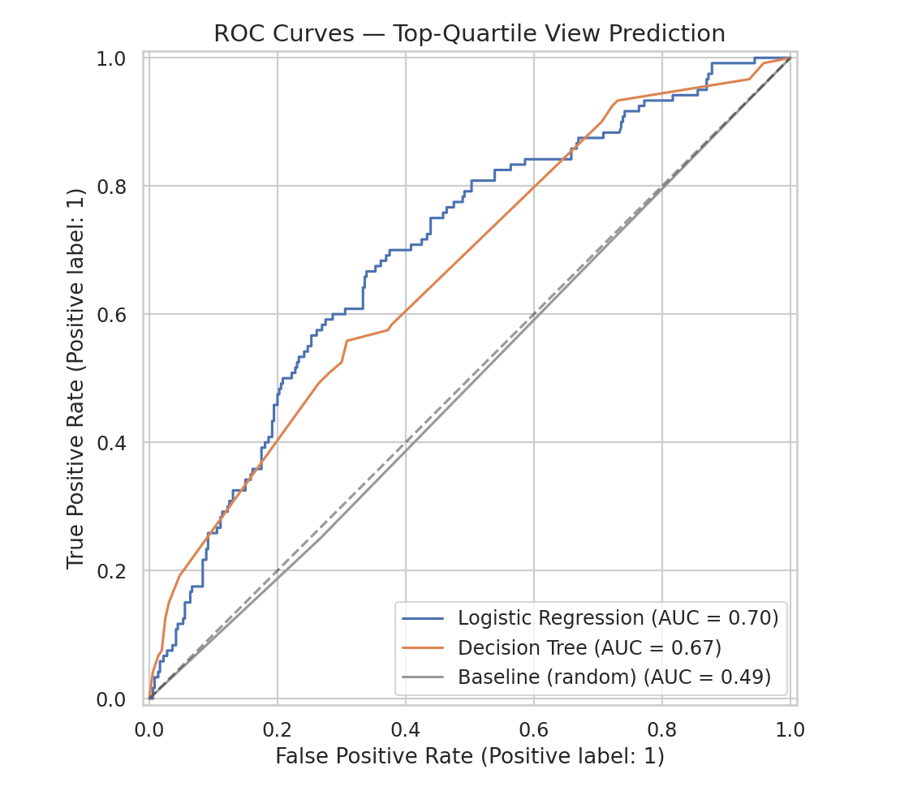
Figure 1. ROC curves both models separate signal from noise well above the random baseline; Logistic Regression (AUC 0.70) edges out the Decision Tree (AUC 0.67).
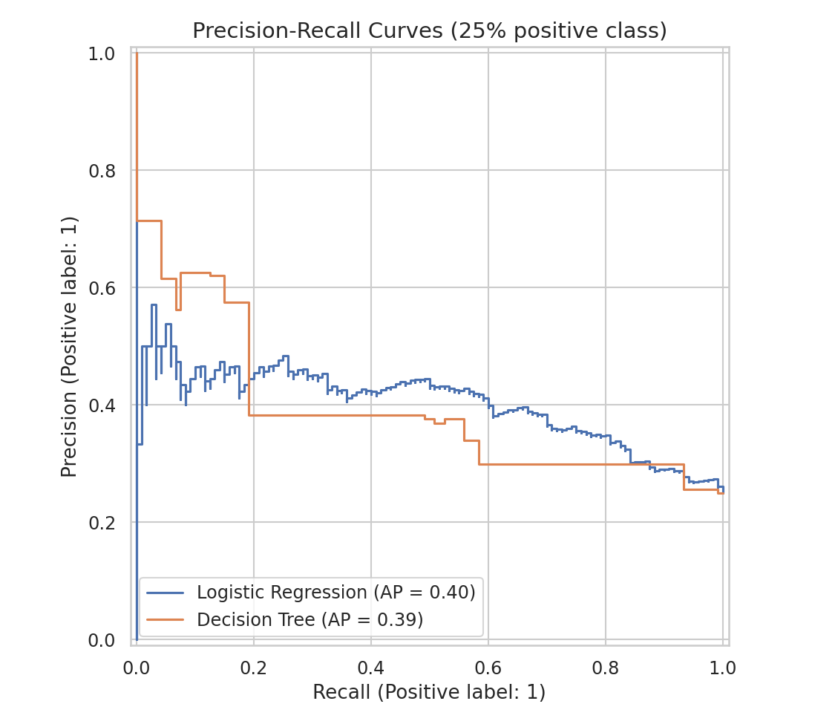
Figure 2. Precision-recall curves, the more honest view of performance under 25% class imbalance. Both curves sit well above the 0.25 baseline precision a random classifier would achieve at any recall level.

4.2 Confusion Matrices: What the Trade-off Looks Like in Practice
On the 480-video held-out test set, Logistic Regression correctly flagged 84 of 120 true top-quartile videos (recall 70%) and missed 36. Of the 224 videos it flagged, 140 were false alarms , the direct, quantifiable cost of prioritizing recall under class imbalance, and worth stating plainly rather than only reporting the flattering AUC number. The Decision Tree flagged fewer videos overall (171 vs. 224) with a correspondingly lower recall (63 true positives, or 53%) but fewer false alarms (108 vs. 140).
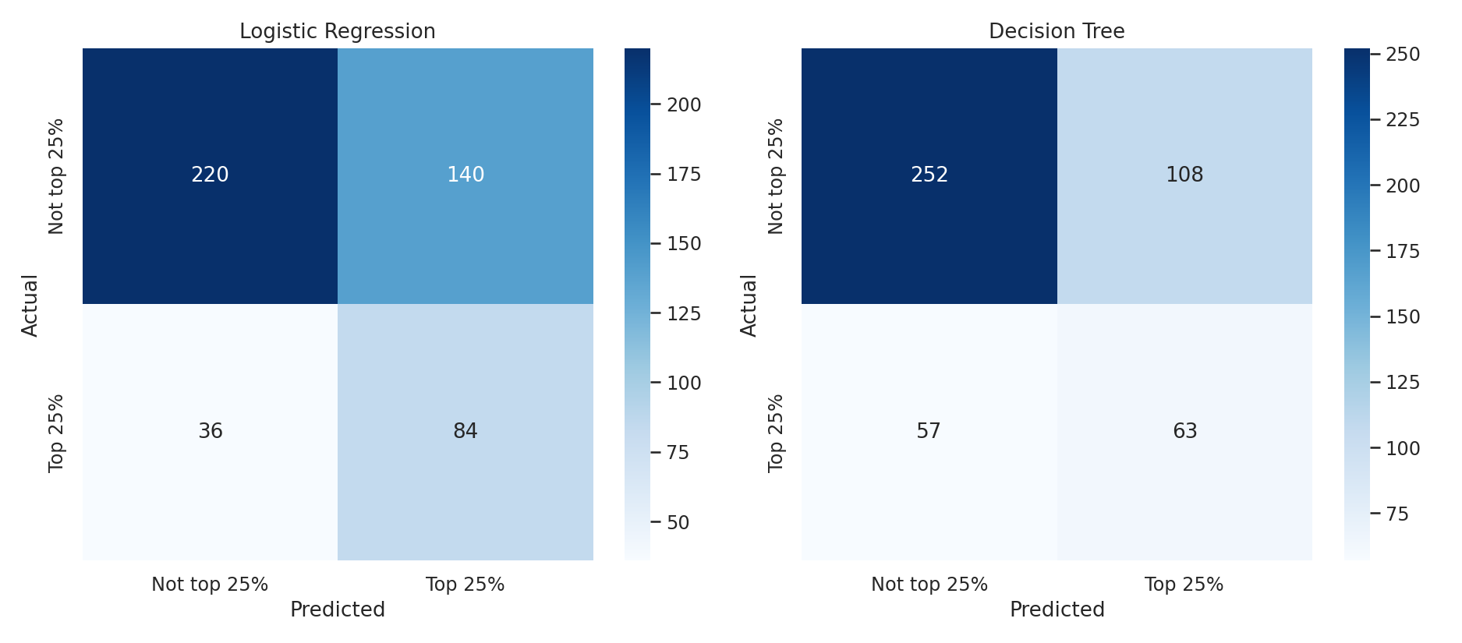
Figure 3. Confusion matrices on the held-out test set (n=480). Logistic Regression (left) prioritizes catching true top performers; the Decision Tree (right) is more conservative.

4.3 What the Models Actually Learned
Category dominates the Logistic Regression coefficient list: Science & Technology, Comedy, and Film & Animation push hardest toward top-quartile performance, while Education, Sports, and News & Politics push hardest against it. This is consistent with though not identical to the Week 3 ANOVA finding that category explains a modest but real share of view variance; here it emerges as the strongest available signal simply because the remaining features (title length, tag count) carry much weaker individual effects.
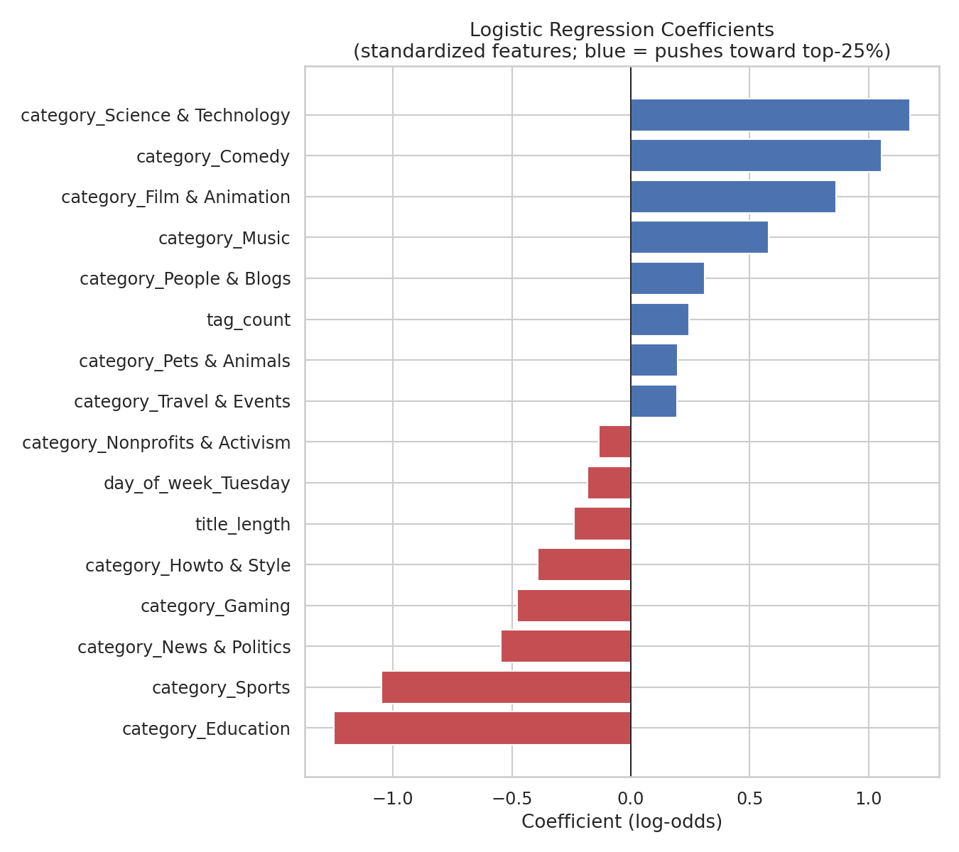
Figure 4. Logistic Regression coefficients (standardized). Category is the dominant driver in both directions; tag count and title length are secondary, controllable levers.
The Decision Tree agrees that category dominates but assigns meaningful weight to channel trend count (a channel's track record) and title_length a pattern the linear model's structure does not surface as clearly, which is why comparing two model types was worthwhile even though their headline AUC scores were close.

4.4 Overfitting Check
At tree depths of 1–2 the model is underfit: train and test accuracy are close but both low. Past depth ~9 the gap widens sharply (train accuracy climbs toward 0.76 while test accuracy plateaus around 0.685) classic overfitting. Depth 5 was selected because it sits before that gap opens meaningfully while still outperforming very shallow trees. The jaggedness visible between depths 2–8 is itself informative: with only 1,920 training rows spread across 15 categories and 7 days of the week, small structural changes shift a handful of predictions each time, which is a reminder of how much this dataset's size limits confidence in any single split.
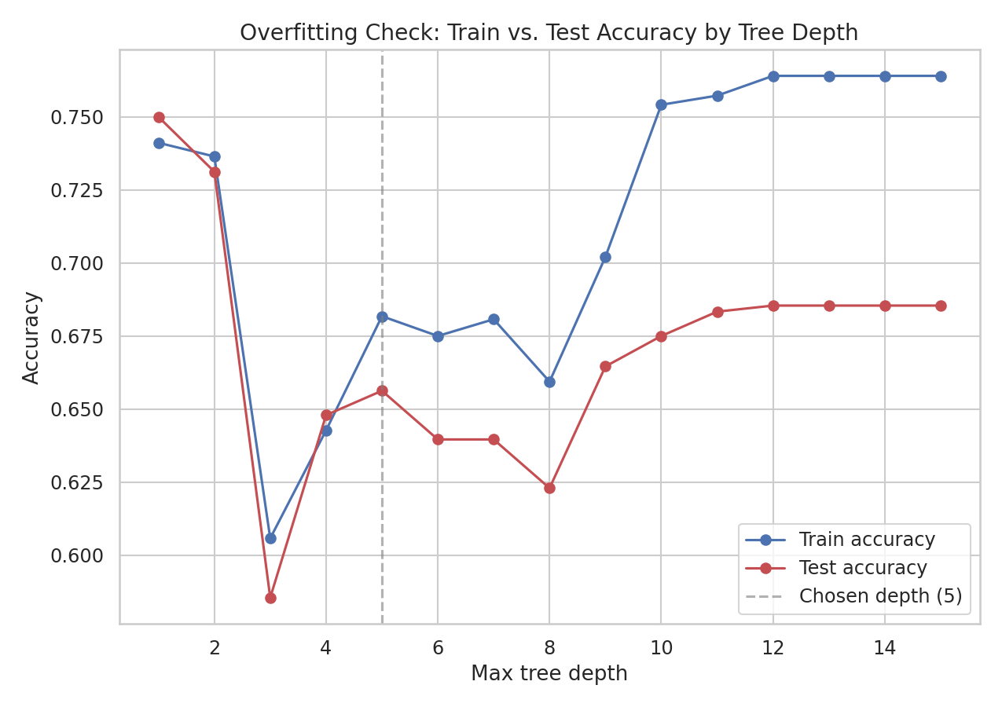
Figure 5. Train vs. test accuracy across decision tree depth, used to select the final depth of 5 and to visually confirm the model is not memorizing the training set.
5. Strategic Recommendations
The following recommendations translate the technical findings above into concrete actions for a content, programming, or platform strategy stakeholder. Each is tied directly to a specific finding rather than offered as generic advice.

5.1 Deploy the model as a triage signal, not a gatekeeper
With 70% recall and 37.5% precision, the Logistic Regression model is well suited to shortlisting candidates for human review or additional promotion budget, but not to making an automated go/no-go call on any single video. Reviewing the ~47% of a catalog the model flags catches roughly 70% of eventual hits a substantially better hit rate than reviewing the same share of the catalog at random, which would be expected to catch only about 47% of hits at that same review volume. Framed this way, the model concretely reduces manual review workload while improving the odds of catching genuine hits within that reduced workload.

5.2 Weight category heavily in content and scheduling strategy - but don't treat it as destiny
Category is the strongest lever identified across both Week 3 and Week 4. Content investment, cross-promotion, or editorial slotting decisions should account for the fact that Science & Technology, Comedy, and Film & Animation categories carry a structurally higher likelihood of breaking into the top quartile, while Education, Sports, and News & Politics face a structurally harder climb in this dataset and window. This should inform resource allocation and expectation-setting, not exclude investment in the harder categories - category explains a real but partial share of outcomes, and category-specific success stories exist in every group.

5.3 Treat tag count and title length as small, controllable dials, not primary strategy
Both features had measurable but secondary effects (tag count positive, title length modestly negative) compared to category. These are the only features in this pipeline that a creator or publisher can directly control at upload time, so they are worth standardizing in publishing guidelines reasonably rich tagging, avoiding needlessly long titles,but stakeholders should not expect these levers alone to move a video into a different performance tier.

5.4 Invest in channel-level consistency, not just individual videos
The Decision Tree's reliance on channel_trend_count indicates that a channel's track record of prior trending videos carries real predictive weight beyond any single video's own attributes. This supports a strategic tilt toward sustained channel partnerships and consistent publishing cadence over one-off video bets, since channel history compounds in a way individual video features do not.

5.5 Set the decision threshold to match the actual business cost, not the default 0.5 cutoff
The precision-recall curve (Figure 2) shows the trade-off is tunable: a team that wants a shorter, higher-confidence shortlist should raise the classification threshold above 0.5 and accept lower recall; a team more worried about missing a viral hit should keep the threshold low or even lower it further. This is a configuration decision, not a modeling one, and should be owned by the stakeholder consuming the model's output rather than fixed in code.

6. Business and Research Impact
If adopted as an internal triage tool, this pipeline's likely impacts include:
- Review-effort reduction: focusing editorial or promotional review on the ~47% of new uploads the model flags, rather than the full catalog, while retaining a 70% catch rate on eventual top performers.
- Faster, evidence-based category prioritization: replacing anecdotal category preferences with a quantified, statistically validated ranking (Weeks 3 and 4 findings agree on the direction of the category effect).
- A reusable feature-engineering template: the leakage-aware pattern established here separating pre-upload signals from post-publication outcomes generalizes to other pre-launch prediction problems (e.g., predicting article engagement before publication, or product launch success before sales data exists).
- A defensible baseline for future model iterations: the ~0.70 AUC ceiling and its documented causes give a research team a clear, evidence-backed target to beat with richer data, rather than an arbitrary performance goal.
On the research side, the project also demonstrates a disciplined, reusable end-to-end workflow problem framing, leakage-aware feature design, a fair train/test protocol, multi-lens evaluation (ROC, precision-recall, confusion matrix), an explicit overfitting check, and an honest accounting of the model's ceiling that can be handed off to future iterations of this project or applied to adjacent prediction problems with minimal rework.
7. Limitations and Future Improvement Areas
- Feature ceiling: pre-upload signals available here (category, basic title statistics, tag count, channel history) capture only part of what drives a video's performance. Thumbnail quality, actual video content, promotion and cross-posting activity, and pure timing luck are invisible to this feature set the ~0.68–0.70 AUC likely reflects a real ceiling for this feature space rather than a modeling shortfall.
- Small sample for a wide feature space: 2,400 rows split across 15 categories and 7 days of the week leaves some category/day combinations thinly populated, which is the most likely cause of the jaggedness observed in the tree-depth analysis (Figure 5) and adds variance to any single train/test split the 5-fold cross-validation numbers are the more trustworthy estimate for this reason.
- Class-imbalance trade-off: class_weight='balanced' improves recall on the minority (top-quartile) class but increases false positives, visible directly in the confusion matrices (Figure 3). Reweighting differently, or tuning the decision threshold rather than defaulting to 0.5, would shift this trade-off without retraining.
- Single region, single time window, and a self-selected population: as flagged consistently since Week 1, a model trained on roughly 12 days of US trending data may not generalize to other regions, seasons, or non-trending upload populations this dataset only contains videos that already trended, which is itself a selection filter that should not be forgotten when generalizing conclusions.
- Correlation, not causation: the category effect quantified in Weeks 3 and 4 describes association, not a guarantee that switching a video's category would change its outcome categories likely also correlate with unmeasured factors like production budget or audience size.
Recommended next steps, in rough priority order:
- Richer text features: title sentiment, keyword extraction, or text embeddings in place of simple length and punctuation counts.
- A gradient-boosted model (e.g., XGBoost or LightGBM) to better capture feature interactions than a single shallow decision tree.
- Probability calibration, if model output is used for ranking or prioritization rather than a hard yes/no classification.
- Threshold tuning against the precision-recall curve (Figure 2) instead of defaulting to the standard 0.5 cutoff.
- Expanding the data window across regions and a longer time span to test whether the category effect and overall AUC ceiling hold outside this specific 12-day, US-only sample.

8. Conclusion
Across five weeks, this project moved a single dataset through the full applied data science lifecycle: acquisition and cleaning (Week 1), visual storytelling (Week 2), formal statistical validation (Week 3), and leakage-aware predictive modeling with rigorous evaluation (Week 4). The final model a Logistic Regression using only pre-upload-available features predicts top-quartile YouTube view performance meaningfully better than chance (ROC-AUC ≈0.70 vs. 0.49, stable across 5-fold cross-validation), with video category standing out as by far the strongest single signal, a result consistent with and extending the Week 3 finding that category shapes both audience approval and, more modestly, raw view outcomes.
The model is not a solved prediction problem: recall/precision trade-offs, a limited feature set, and a small, single-window sample all cap how far this specific pipeline can be pushed without new data or richer features. But that ceiling is well understood and well documented rather than hidden, which is precisely what makes the recommendations in Section 5 deploy as triage, weight category realistically, treat tag count and title length as minor dials, invest in channel consistency, and tune the decision threshold to the actual business cost actionable rather than speculative. The project's real value lies as much in this disciplined, end-to-end methodology as in the specific 0.70 AUC figure, since the same leakage-aware, multi-lens evaluation approach transfers directly to future prediction problems facing this or comparable teams.

