Statistical Analysis and Hypothesis Testing
Week 3 Task — Does Content Category Really Drive YouTube View Counts?
Prepared by Javhara

1. Introduction and Hypothesis
This report is the Week 3 deliverable, applying formal statistical hypothesis testing to the same cleaned “Trending YouTube Video Statistics” (US) dataset used in Weeks 1-2. Week 2's exploratory work raised a specific claim worth testing rigorously rather than eyeballing from a bar chart: the raw-average chart in Week 2 showed Music videos with the highest average view count of any category, and Music also showed the widest spread of outcomes in the violin plot. That's exactly the kind of pattern a content strategist would want to bet on - or would want disproven before betting on.
Primary hypothesis (H1): Trending videos in the Music category achieve significantly higher view counts than trending videos outside Music.
Null hypothesis (H0): There is no difference in mean view counts between Music and non-Music trending videos.
Three supporting analyses extend this into a fuller statistical picture: whether category in general (not just Music) explains meaningful variation in views (ANOVA), whether category is associated with audience approval rather than just reach (chi-square test), and whether the relationship between views and likes established descriptively in Week 2 holds up as a formally significant correlation (correlation significance test).

2. Methodology
Dataset: the same 2,400-row cleaned CSV from Week 1 (12 trending days, 15 categories). Views are log10-transformed for every parametric test in this report, since Week 1 and Week 2 both established that raw views are heavily right-skewed - running a t-test or ANOVA directly on raw views would violate the normality assumption those tests rely on and let a handful of viral outliers dominate the result.
Four hypothesis tests were run, each chosen for the shape of the comparison it needed to make:
- Test 1 - Welch's two-sample t-test (one-sided): Music vs. non-Music mean log-views, confirmed with a non-parametric Mann-Whitney U test.
- Test 2 - One-way ANOVA across the top 8 categories on log-views, confirmed with a Kruskal-Wallis test, with Tukey HSD post-hoc comparisons to identify which specific category pairs differ.
- Test 3 - Chi-square test of independence between category and a binary “high vs. low like-rate” engagement tier, to test whether approval (not just reach) varies by category.
- Test 4 - Pearson and Spearman correlation significance tests between views and likes, with a 95% confidence interval on the Pearson coefficient via Fisher's z-transform.
For every test, assumptions were checked before choosing the test rather than after: normality via the Shapiro-Wilk test, and homogeneity of variance via Levene's test. Where an assumption was violated, the corresponding non-parametric test is reported as the primary evidence and the parametric test as a secondary cross-check (or vice versa, when they agree). Significance level α = 0.05 throughout.

3. Test 1 - Music vs. Non-Music Views

3.1 Assumption checks
Shapiro-Wilk tests reject normality for both groups (Music: p < 0.001; Non-Music: p < 0.001) even after the log transform - not unexpected with n in the hundreds, since Shapiro-Wilk grows very sensitive to small deviations at large sample sizes. Levene's test does not reject equal variances (p = 0.120), so a standard t-test would be defensible on that front, but Welch's t-test (which does not assume equal variance) was used regardless as the more conservative choice, backed by the distribution-free Mann-Whitney U test as a robustness check.
from scipy import stats
shapiro_music = stats.shapiro(music_log_views) # p < 0.001
shapiro_nonmusic = stats.shapiro(nonmusic_log_views) # p < 0.001
levene_p = stats.levene(music_log_views, nonmusic_log_views).pvalue # 0.120

t_stat, p_two_sided = stats.ttest_ind(music_log_views, nonmusic_log_views, equal_var=False)
u_stat, p_one_sided = stats.mannwhitneyu(music_log_views, nonmusic_log_views, alternative='greater')

3.2 Results
Music n / Non-Music n | 395 / 2,005
Mean log10(views): Music | 5.467
Mean log10(views): Non-Music | 5.486
Welch t-statistic | −0.461
One-sided p-value | 0.678
Mean difference (95% CI) | −0.020 [−0.103, 0.064]
Cohen's d (effect size) | −0.026 (negligible)
Mann-Whitney U, one-sided p | 0.988

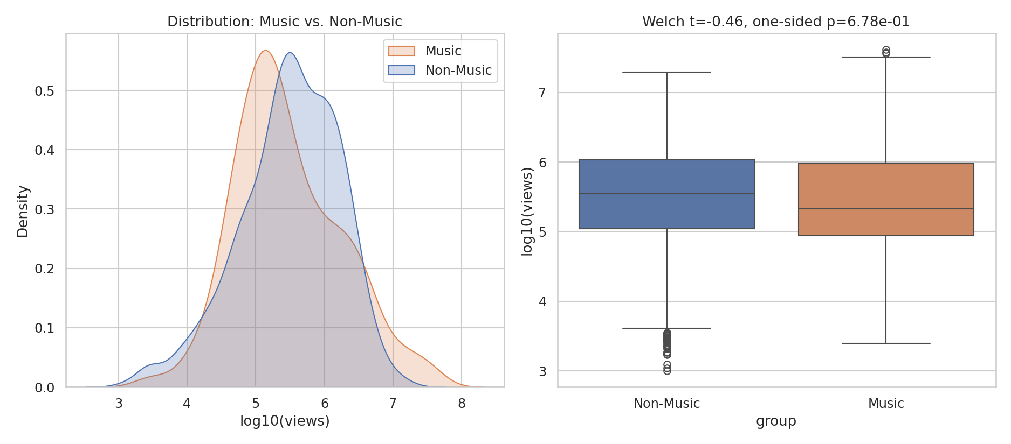
Figure 1. Left: overlapping density of log-views for Music vs. Non-Music. Right: boxplot comparison with test statistics.

3.3 Interpretation
The hypothesis is not supported. Both the Welch t-test (p = 0.678) and the Mann-Whitney U test (p = 0.988) fail to reject the null — Music's mean log-views is statistically indistinguishable from every other category combined, and the effect size (Cohen's d ≈ −0.03) is negligible in either direction. This directly contradicts what Week 2's raw-average bar chart appeared to show.
The reconciliation is the outlier sensitivity of a raw mean: Week 2's Figure 4 used untransformed average views, which is exactly the statistic a small number of extreme viral Music videos (Figure 2 in Week 2 showed Music's violin plot stretching furthest into the tens of millions) can pull upward without changing the typical outcome at all. Once the comparison is made on a scale where a handful of outliers can't dominate the result — log-transformed means, or the distribution-free rank test — the apparent Music advantage disappears. This is the central lesson of this test: a descriptive chart and a hypothesis test can legitimately disagree, and the hypothesis test is the one that should be trusted for a claim like “Music performs better.”

4. Test 2 — Does Category Explain Variation in Views? (ANOVA)

Even though Music specifically isn't special, category as a whole might still matter — the null result in Test 1 only rules out Music being different from the average of everything else lumped together. A one-way ANOVA tests the broader question: across the eight most common categories, is there any real difference in typical views at all?

4.1 Assumption checks and test selection
Levene's test rejects equal variances across the eight category groups (p < 0.001), so the standard ANOVA's equal-variance assumption is violated. The ANOVA result is reported below for completeness and comparability with standard practice, but the Kruskal-Wallis test — which does not require equal variances and compares ranks rather than means — is treated as the primary result.
groups = [df[df.category == c].log_views for c in top_8_categories]
levene_p = stats.levene(*groups).pvalue # < 0.001 -> variances unequal
f_stat, anova_p = stats.f_oneway(*groups) # F=12.61, p=6.3e-16
h_stat, kw_p = stats.kruskal(*groups) # H=108.32, p=2.0e-20

4.2 Results
Levene's test (variance equality) | p < 0.001 (rejected)
One-way ANOVA | F(7, 1568) = 12.61, p < 0.001
Effect size (η²) | 0.040 (small-to-medium)
Kruskal-Wallis (primary result) | H(7) = 108.32, p < 0.001
Significant Tukey HSD pairs | 14 of 28 pairwise comparisons

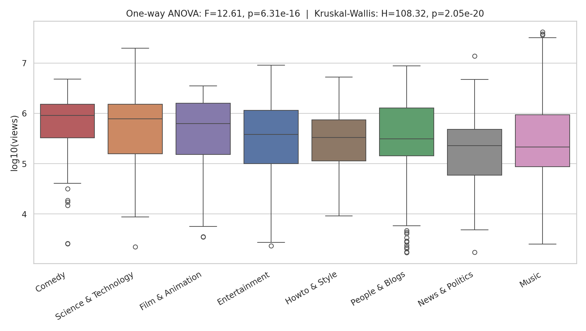
Figure 2. log-views by category, ordered by median, with ANOVA and Kruskal-Wallis statistics.
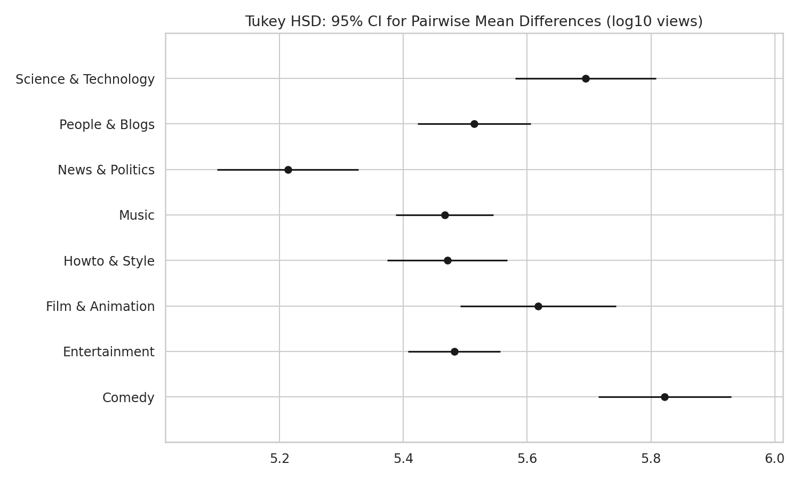
Figure 3. Tukey HSD 95% confidence intervals for each category's mean log-views — non-overlapping intervals indicate a significant pairwise difference.

4.3 Interpretation
Both tests agree: category does explain a real, statistically significant share of the variation in views (p < 0.001 either way), though the effect size is modest (η² = 0.04 means category explains about 4% of the variance in log-views — real, but far from the dominant factor). Figure 3 shows specifically where the differences lie: Comedy and Science & Technology sit at the high end with non-overlapping confidence intervals against News & Politics and Music at the lower end, while many of the middle categories overlap each other and are not statistically distinguishable. Consistent with Test 1, Music's confidence interval sits in the lower half of the range — reinforcing that its high raw average in Week 2 was an artifact of outliers, not typical performance.

5. Test 3 - Is Category Associated with Audience Approval?
Views measure reach, not sentiment. Week 2 (Figure 4) suggested categories differ in like/dislike rate; this test asks the same question in a hypothesis-testing framework: is a video's likelihood of landing in the “high like-rate” half of the data independent of its category, or does category predict audience approval?
median_like_ratio = df['like_ratio'].median()
df['engagement_tier'] = np.where(df.like_ratio >= median_like_ratio,
'High like rate', 'Low like rate')
contingency = pd.crosstab(df.category, df.engagement_tier)
chi2, p, dof, expected = stats.chi2_contingency(contingency)
# chi2 = 233.52, dof = 4, p = 2.3e-49

5.1 Results
Categories compared | Top 5 by trending frequency
Contingency table size | 5 × 2 (n = 1,586)
Chi-square statistic | χ²(4) = 233.52
p-value | p < 0.001
Effect size (Cramér's V) | 0.384 (moderate-to-strong association)

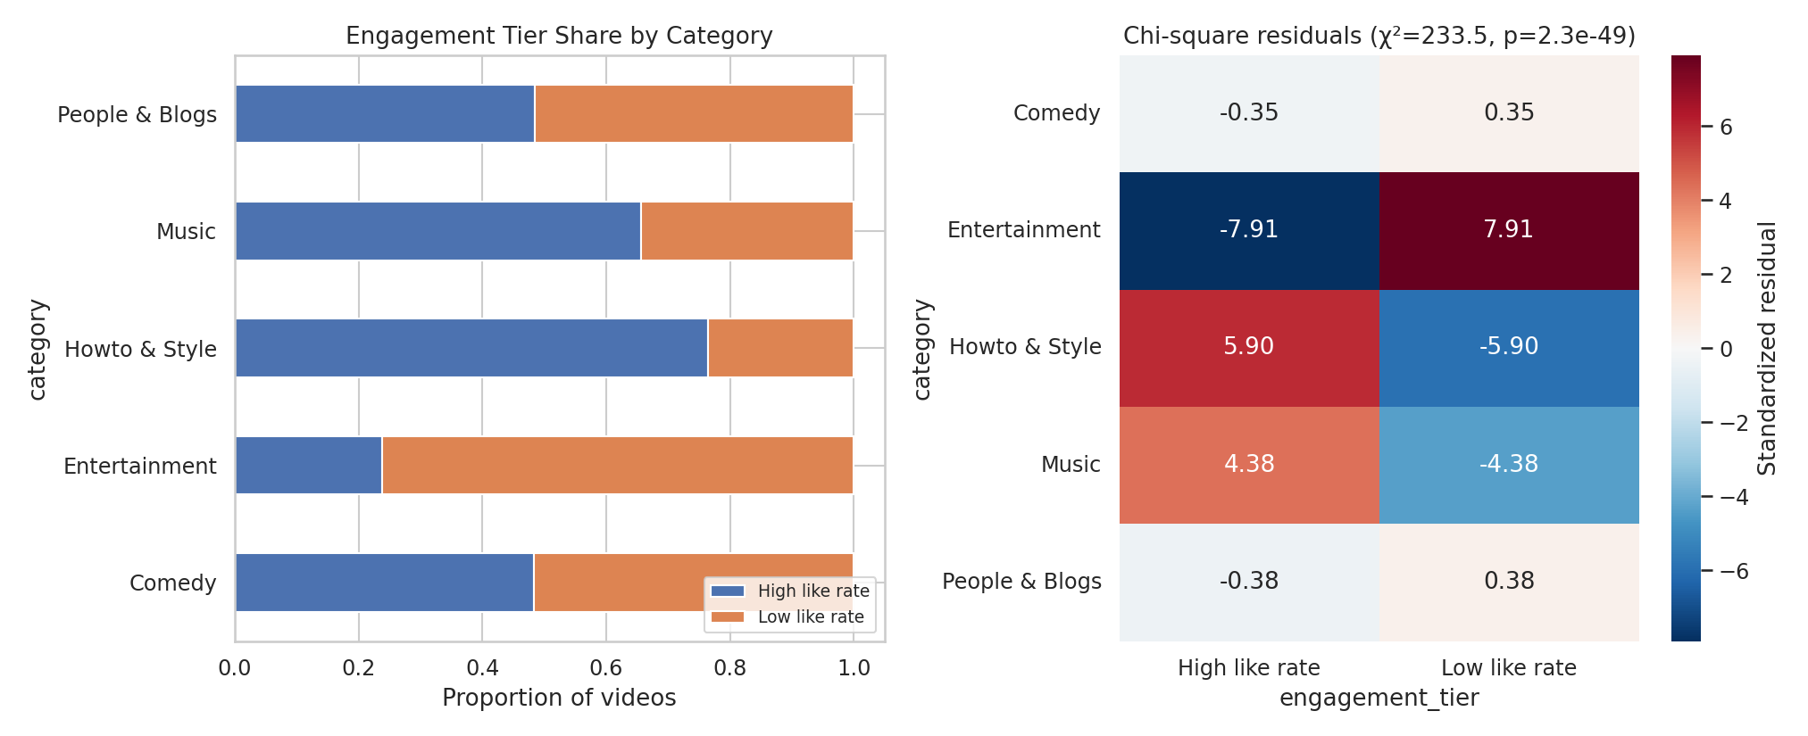
Figure 4. Left: engagement-tier proportions by category. Right: standardized residuals — larger magnitude means that cell deviates more from what independence would predict.

5.2 Interpretation
The null hypothesis of independence is firmly rejected (p < 0.001), and Cramér's V (0.384) indicates this isn't a statistically-significant-but-trivial effect — category and audience approval are meaningfully linked. The residuals in Figure 4 identify exactly where: Entertainment is strongly over-represented in the low like-rate tier (residual +7.91) and correspondingly under-represented in the high tier, while Howto & Style (+5.90) and Music (+4.38) skew the opposite way, over-represented among high-approval videos. Reach (Test 2) and approval (this test) are therefore genuinely separate axes that categories occupy differently — Entertainment trends often (Week 2, Figure 1) but comparatively few of those videos land in the high-approval half, while Howto & Style trends less often but converts a larger share of its views into approval.
6. Test 4 — Does the Views–Likes Relationship Hold Up Statistically?

Week 2's correlation heatmap reported r ≈ 0.86 between views and likes descriptively. This test asks whether that relationship is statistically significant and estimates a confidence interval for it, rather than treating the point estimate as the full story.
pearson_r, pearson_p = stats.pearsonr(log_views, log_likes)
# r = 0.851, p < 0.001
z = np.arctanh(pearson_r); se_z = 1/np.sqrt(n-3)
ci = np.tanh(z - 1.96*se_z), np.tanh(z + 1.96*se_z) # [0.840, 0.862]
spearman_r, spearman_p = stats.spearmanr(views, likes) # rho = 0.858, p < 0.001

6.1 Results
Pearson r (log-log) | 0.851
95% CI for r (Fisher z) | [0.840, 0.862]
Pearson p-value | p < 0.001
Spearman ρ (rank, untransformed) | 0.858, p < 0.001
n | 2,400

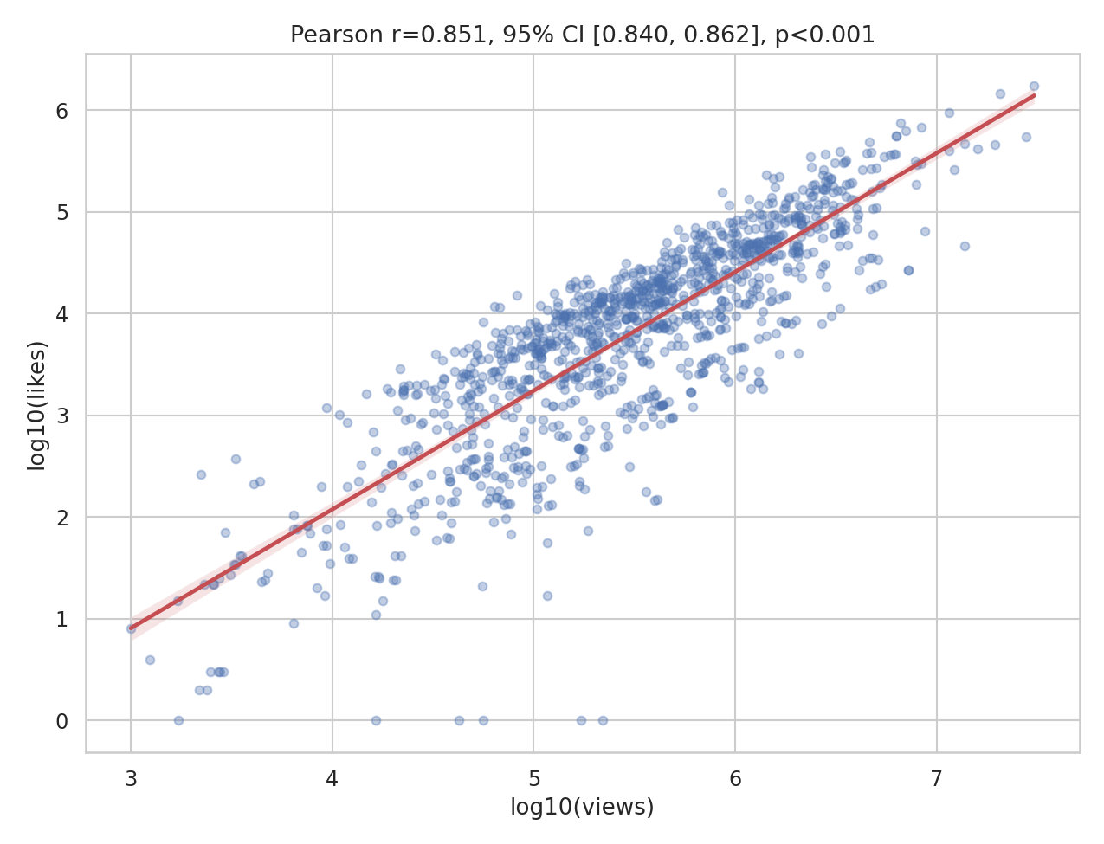
Figure 5. log-views vs. log-likes with fitted regression line and 95% confidence band.

6.2 Interpretation
The relationship is both strong and statistically robust — the 95% confidence interval [0.840, 0.862] is narrow, reflecting the large sample size, and both the parametric (Pearson) and rank-based (Spearman) coefficients agree closely, so the result isn't an artifact of the log transform or of a few extreme points. Practically, this confirms that raw like counts are a strong proxy for views at the population level, which is a very different statement from Test 3's finding that like *rate* (likes as a share of views) is comparatively unrelated to raw view count — the two metrics genuinely capture different things, as first suggested descriptively in Week 2.

7. Synthesis: What the Four Tests Say Together

- Music is not a statistically superior category for views (Test 1) — its strong showing in Week 2's raw-average chart was driven by outliers, not a real shift in typical performance.
- Category does matter overall (Test 2), just modestly (η² = 0.04) and unevenly — Comedy and Science & Technology outperform News & Politics and Music on typical views, but many categories are statistically indistinguishable from each other.
- Category matters more for audience approval than for reach (Test 3's Cramér's V of 0.384 is a moderate-to-strong effect, versus Test 2's small η² of 0.04) — which category a video sits in says more about how well-liked it will be than about how many views it will get.
- Views and likes are strongly and reliably correlated in raw terms (Test 4), but that says nothing about the rate-based engagement question Test 3 answers — the two are complementary, not redundant, findings.

8. Conclusion and Limitations
The original hypothesis — that Music trending videos significantly outperform others in views — is rejected by the data once tested formally. This is a useful result precisely because it corrects a conclusion the raw descriptive chart in Week 2 would have supported: the difference between “eyeballing an average” and “testing a hypothesis” is not academic here, it changes the actual business conclusion a content strategist would draw. The supporting tests round this out: category does drive real (if modest) differences in views, drives a stronger difference in audience approval, and the views-likes relationship itself holds up as statistically robust with a tight confidence interval.
- Sample: single region (US), single 12-day window — results may not generalize to other regions, seasons, or platforms (e.g., Shorts vs. long-form).
- Multiple comparisons: Test 2's Tukey HSD already corrects for the 28 pairwise comparisons; no correction beyond that was applied across the four independent tests in this report, since each addresses a distinct hypothesis rather than testing the same one repeatedly.
- Engagement tier in Test 3 was defined via a median split, a simplification chosen for interpretability — a continuous model (e.g., linear regression on like_ratio) would use more information and is a natural next step.
- Association (Tests 2 and 3) is not causation — category likely proxies for content style, audience expectations, and typical video length, any of which could be the more direct driver.

