Preguntas Objetivo 6
Pregunta 1
Which two statements are correct about modules in Java? (Choose two.)

A. java.base exports all of the Java platforms core packages.
B. module-info.java can be placed in any folder inside module-path.
C. A module must be declared in module-info.java file.
D. module-info.java cannot be empty.
E. By default, modules can access each other as long as they run in the same folder.

Pregunta 2
Given this requirement:
Module vehicle depends on module part and makes its com.vehicle package available for all other modules.
Which module-info.java declaration meets the requirement?
A.
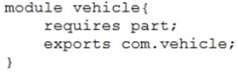
B.
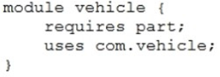
C.
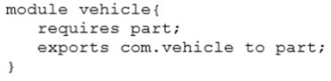
D.
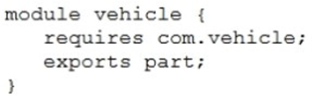
a)
Pregunta 3
Which command line runs the main class com.acme.Main from the module com.example?

A. java --module-path mods com.example/com.acme.Main
B. java -classpath com.example.jar com.acme.Main
C. java --module-path mods -m com.example/com.acme.Main
D. java -classpath com.example.jar -m com.example/com.acme.Main

Pregunta 4
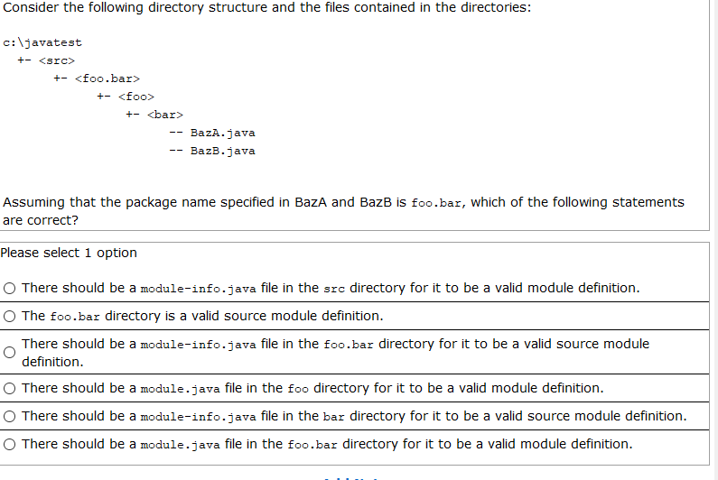

Pregunta 5
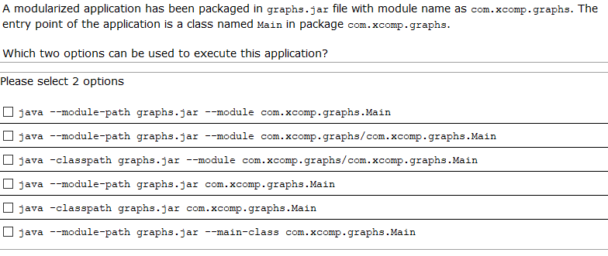
b,e
Pregunta 6
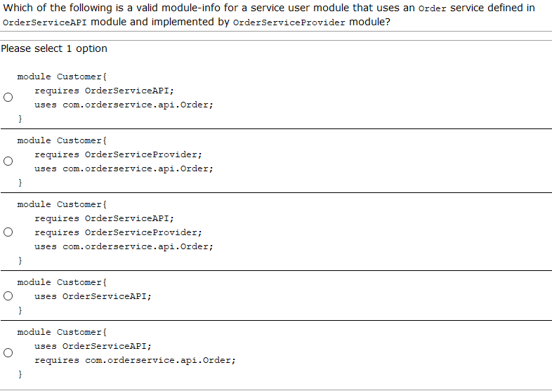
a) Porque el consumidor requiere el módulo del servicio.
Y usa la Interfaz.
Pregunta 7
Which two statements are true about Java modules? (Choose two.)

A. Modular jars loaded from --module-path are automatic modules.
B. Any named module can directly access all classes in an automatic module.
C. Classes found in -classpath are part of an unnamed module.
D. Modular jars loaded from -classpath are automatic modules.
E. If a package is defined in both the name module and the unnamed module, then the package in the unnamed module is ignored.

Pregunta 8
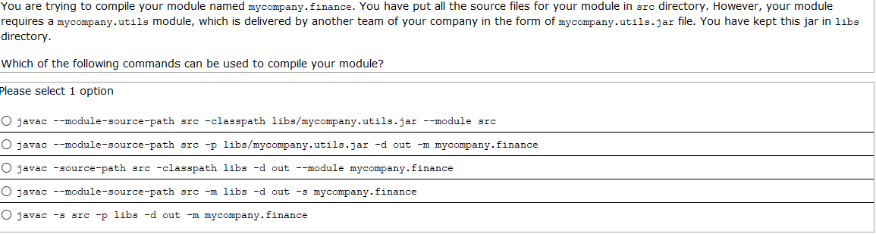
b)
Pregunta 9
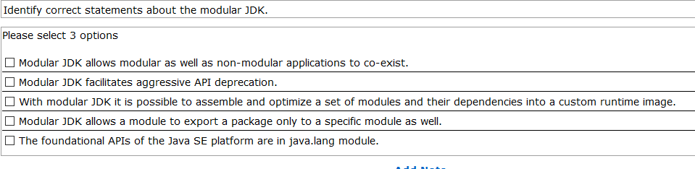

Pregunta 10
You are creating a com.sales module that makes its two classes - com.sales.service.Clients and com.sales.service.Sales - available to all other modules for use. Also, you need to use all the class packages exported from module testing.clients
Which of the following files correctly defines this com.sales module?
- module com.sales{
exports com.sales.*;
requires testing.clients;
}
- module com.sales{
exports com.sales.service;
requires testing.clients;
}

- module com.sales{
exports com.sales.service.*;
requires testing.clients;
}

- module com.sales{
exports com.sales.*;
imports testing.clients;
}
- module com.sales{
exports com.sales to testing.clients;
imports from testing.clients;
}

Pregunta 11
Which statements are true? (choose 2)
- An automatic module exports all packages to named modules
- An unnamed module exports no packages to named modules
- An automatic module exports no packages to named modules
- An unnamed module exports all packages to named modules
- An automatic module exports only the specified packages to named modules

Pregunta 12
Your group has an existing application (reports.jar) that uses a library (analytics.jar) from another group in your company. Both - the application and the library - use a JDBC driver packaged in ojdbc8.jar.
Which of the following options describes the steps that will be required to modularize your application?
- 1. Convert analytics.jar and ojdbc8.jar into automatic modules 2. Convert reports.jar into a named module. 3. Add requires clauses for analytics and ojdbc8 in reports.jar in its module-info.java.
- 1. Modularize analytics.jar and ojdbc8.jar into modules by adding module-info.java to these jars. 2. Convert reports.jar into a named module. 3. Add requires clauses for all packages contained in analytics.jar and ojdbc8.jar that are directly referred to by classes in reports.jar in its module-info.java
- 1. Convert reports.jar into a named module. 2. Add requires clauses for analytics and ojdbc8 modules in reports.jar in its module-info.java. 3. Use analytics.jar and ojdbc8.jar as unnamed modules.
- 1. Convert ojdbc8.jar into automatic module. 2. Convert analytics.jar into a named module by adding module-info.java to it. In this module-info, export all packages that are used by reports.jar and add requires clauses for all packages of ojdbc8.jar that are used by analytics.jar. 3. Convert reports.jar into a named module. Add requires clause for analytics module in reports's module-info.java.

