# Preguntas Objetivo 1

## Pregunta 1

Given the code fragment:

3. public static void main(String [] args){

4. int ivar=100;

5. float fvar=23.4f;

6. double dvar=20;

7. ivar=fvar;

8. fvar=ivar;

9. dvar=fvar;

10. fvar=dvar;

11. dvar=ivar;

12. ivar=dvar;

13. }

Which three lines fails to compile?

A. Line 7

B. Line 8

C. Line 9

D. Line 10

E. Line 11

F. Line 12

## Pregunta 2

Which of the following compiles with no errors? (choose 4)

A. int a = 2.7;

B. byte n=(byte) 4546.9;

C. int c=0b110_100;

E. double t =_6.4;

F. float g = 23;

G. short k =(short)45L;

H. boolean n =(boolean)1;

I. char vv=300000;

## Pregunta 3

Given:

System.out.println("6+3="+2+7);

System.out.println("6+3="+(2+7));

**What is the result?**

A. 6+3=27

6+3=27

B. 6+3=2+7

6+3=9

C. 9=9

9=9

D. 6+3=27

6+3=9

## Pregunta 4

Given the following:

1. public class Test {

2. static int i;

3. public static void main (String []args) {

4. int a = 2, b = i+1;

5. if ((a++>++b) && (++a>5)) {

6. a +=b;

7. }

8. }

9. }

**What is the final value of a?**

A. 1

B. 2

C. 3

D. 4

E. 5

## Pregunta 5

What will the following lines of code print?

System.out.print(1 + 5 < 3 + 7);

System.out.print( (2 + 2) >= 2 + 3);

1. They will not compile.
2. 1false10 false
3. truefalse
4. falsefalse

## Pregunta 6



## Pregunta 7

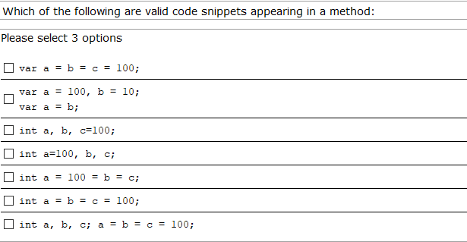

## Pregunta 8

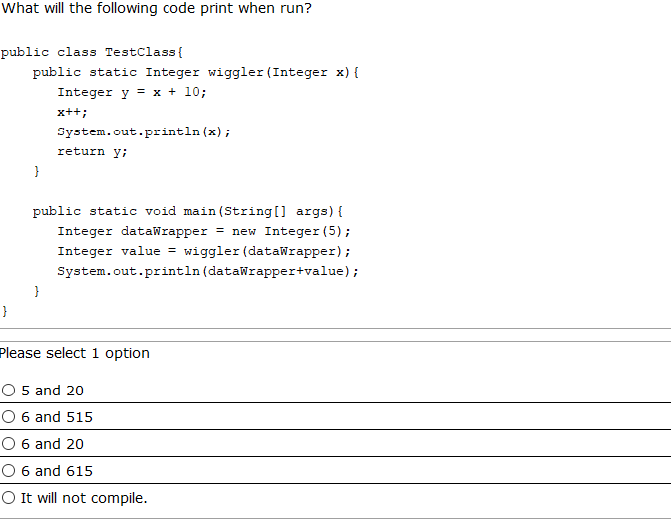

## Pregunta 9

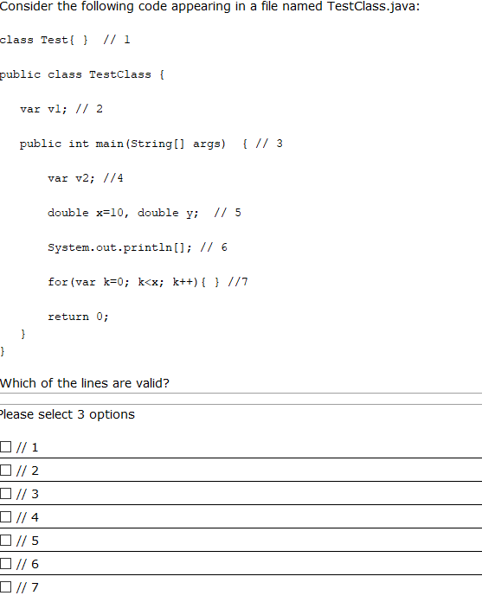

## Pregunta 10

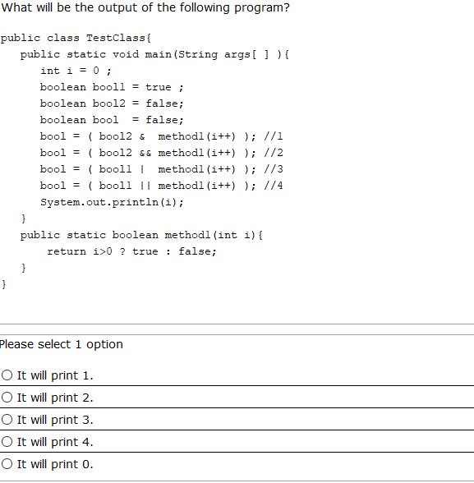

## Pregunta 11

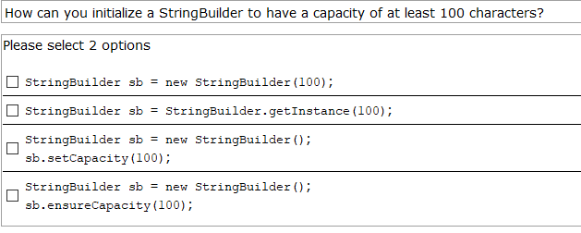

## Pregunta 12

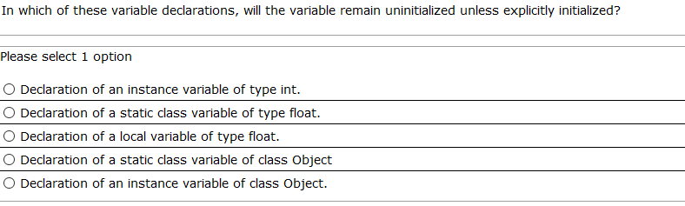

## Pregunta 13

Indica cual de las siguientes declaraciones de parámetros en expresiones lambda son incorrectas (elige 2):

1. var c->...
2. (var a, b)->
3. (@NotNull var b)->
4. (var x, var y)->

## Pregunta 14

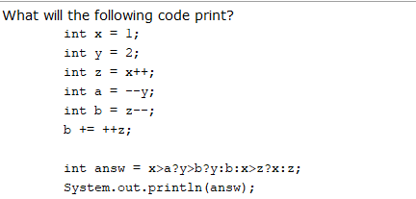

1. 0
2. 1
3. 2
4. -1
5. -2
6. -3

## Pregunta 15

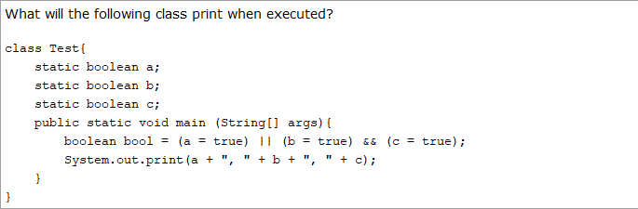

1. true, false, true
2. true, true, false
3. true, false, false
4. true, true, true

## Pregunta 16

Given the code fragment:

StringBuilder sb1=new StringBuilder("hello");

String str1=sb1.toString();

//insert code here

System.out.println(str1==str2);

Which code fragment, when inserted at "insert code here", enables the code to print true?

A.String str2 = str1;

B.String str2 = new String (str1);

C.String str2 = sb1. toString ();

D.String str2 = "hello";

## Pregunta 17

Given:

String cad1="This is text";

String cad2="""

This is text""";

String cad3="""

This is text

""";

System.out.print(cad1.equals(cad2)+"-");

System.out.print(cad1.equals(cad3)+"-");

System.out.print(cad2.equals(cad3)+"-");

System.out.print(cad1.length()==cad2.length());

What is the result?

A.false-false-false-false

B.true-false-false-false

C.true-true-false-false

D.true-false-false-true

E.false-true-true-true