# Preguntas Objetivo 8

Pregunta 1

Consider the following code:

import java.io.*;

public class Test {

public static void main(String[] args) throws Exception {

var fw = new FileWriter("text.txt");

// fw.write("hello"); //1

fw.close();

}

}

Which of the following statements are correct?

a.it will throw an exception if text.txt does not exist.

b. It will create text.txt file in the filesystem if it does not exist.

c. It will not throw an exception if text.txt does not exist and it will not create a file either because nothing is being written to the file.

d. It will throw an exception if //1 is uncommented and if text.txt does not exist.

e. It will throw an exception if text.txt already exists

Respuesta:

Pregunta 2

What will the following code print?

Path p1 = Paths.get("\\photos\\vacation");

Path p2 = Paths.get("\\yellowstone");

System.out.println(p1.resolve(p2)+" "+p1.relativize(p2));

1. yellowstone  ..\..\yellowstone
2. \yellowstone  ..\..\yellowstone
3. \yellowstone  \yellowstone
4. \yellowstone  yellowstone

Respuesta:

Pregunta 3

Given the code fragment:

Path file = Paths.get (“courses.txt”);

// line n1

Assume the courses.txt is accessible.

Which code fragment can be inserted at line n1 to enable the code to print the content of

the courses.txt file?

**A.** List<String> fc = Files.list(file);

fc.stream().forEach (s - > System.out.println(s));

**B.** Stream<String> fc = Files.readAllLines (file);

fc.forEach (s - > System.out.println(s));

**C.** List<String> fc = readAllLines(file);

fc.stream().forEach (s - > System.out.println(s));

**D.** Stream<String> fc = Files.lines (file);

fc.forEach (s - > System.out.println(s));

Respuesta:

Pregunta 4

Given the code fragment:

public static void main (String [ ] args) throws IOException {

BufferedReader br = new BufferedReader (new InputStremReader (System.in));

System.out.print (“Enter GDP: “);

//line 1

}

Which code fragment, when inserted at line 1, enables the code to read the GDP from the

user?

**A.** int GDP = Integer.parseInt (br.readline());

**B.** int GDP = br.read();

**C.** int GDP = br.nextInt();

**D.** int GDP = Integer.parseInt (br.next());

Pregunta 5

Given the code fragment:

Path path1 = Paths.get(“/app/./sys/”);

Path res1 = path1.resolve(“log”);

Path path2 = Paths.get(“/server/exe/”);

Path res1 = path1.resolve(“/readme/”);

System.out.println(res1);

System.out.println(res2);

What is the result?

**A.** /app/sys/log

/readme/server/exe

**B.** /app/log/sys

/server/exe/readme

**C.** /app/./sys/log

/readme

**D.** /app/./sys/log

/server/exe/readme

Pregunta 6

Given that /green.txt and /colors/yellow.txt are accessible, and the code fragment:

Path source = Paths.get(“/green.txt);

Path target = Paths.get(“/colors/yellow.txt);

Files.move(source, target, StandardCopyOption.ATOMIC_MOVE);

Files.delete(source);

Which statement is true?

**A.** The green.txt file content is replaced by the yellow.txt file content and the yellow.txt file

is deleted.

**B.** The yellow.txt file content is replaced by the green.txt file content and an exception is

thrown.

**C.** The file green.txt is moved to the /colors directory.

**D.** A FileAlreadyExistsException is thrown at runtime.

Pregunta 7

Given:

String INPUT_FILE = "c:\\temp\\src\\foo.bar\\module-info.java";

Assuming the file exists, which of the following options will print the contents of the file?(2)

A.- Files.lines(INPUT_FILE).forEach(System.out::println);

B.-Stream<String> lines = Files.lines(Paths.get(INPUT_FILE));

lines.forEach(System.out::println);

C.- Stream<String> lines = Files.readAllLines(Paths.get(INPUT_FILE));

lines.forEach(System.out::println);

D.- List<String> lines = Files.readAllLines(Paths.get(INPUT_FILE));

lines.forEach(System.out::println);

|  |  |  |
| --- | --- | --- |
| |  | | --- | | E.- List<String> lines = Files.lines(Paths.get(INPUT_FILE));  lines.forEach(System.out::println); | |  | |

F.- String[] stra = Files.readLines(Paths.get(INPUT_FILE));

for(String s: stra) System.out.println(s);

Respuesta: B y D

Pregunta 8

How many methods have to be provided by a class that is not abstract and that says it implements Serializable interface?

1. 0
2. 1
3. 2
4. 3

Respuesta: A

Pregunta 9

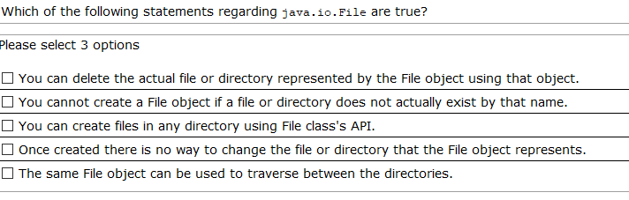

Pregunta 10

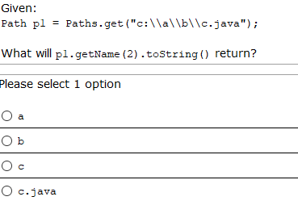

Pregunta 11

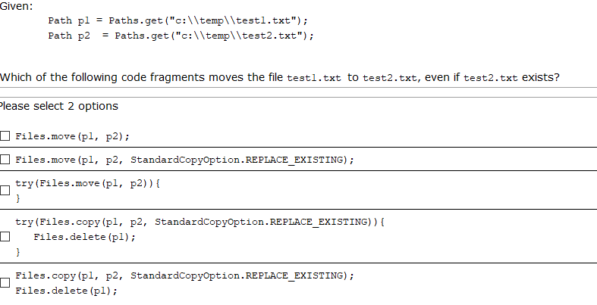

Pregunta 12

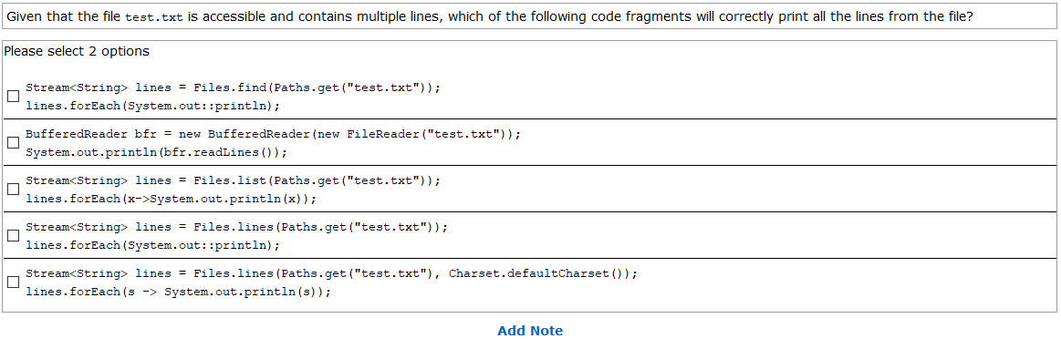

Pregunta 13

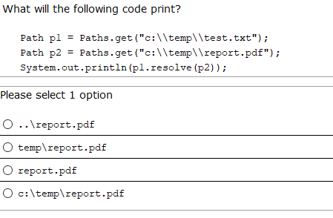

Pregunta 14

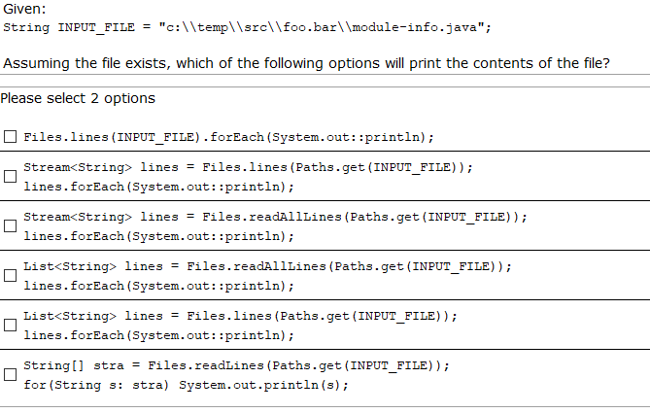

Pregunta 15

Connection connection = dataSource.getConnection();

PreparedStatement stmt = connection.prepareStatement("select * from CUSTOMER where EMAILID=?");

stmt.setObject(1, "bob@gmail.com"); //LINE 10

ResultSet rs = stmt.executeQuery();

while(rs.next()){

System.out.println(rs.getString("EMAILID")); //LINE 12

}

connection.close();

Assuming that the query returns exactly 1 row, what will be printed when this code is run? (Assume that items not specified such as import statements, DB url, and try/catch block are all valid.)

1. It will throw an exception at //LINE 12.
2. Compilation will fail due to //Line 12
3. It will print bob@gmail.com
4. It will print bob@gmail.com and then throw an exception.

Respuesta: C

Pregunta 16

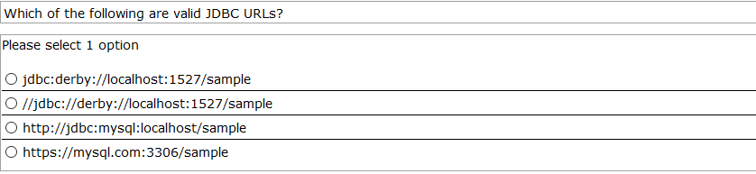

Respuesta: A

Pregunta 17

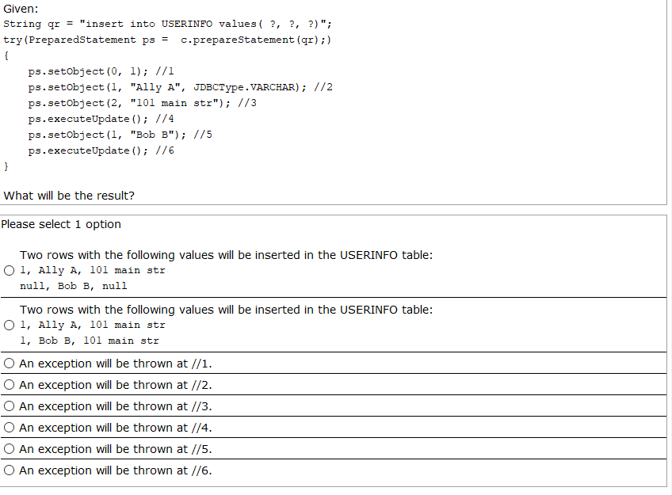

Pregunta 18

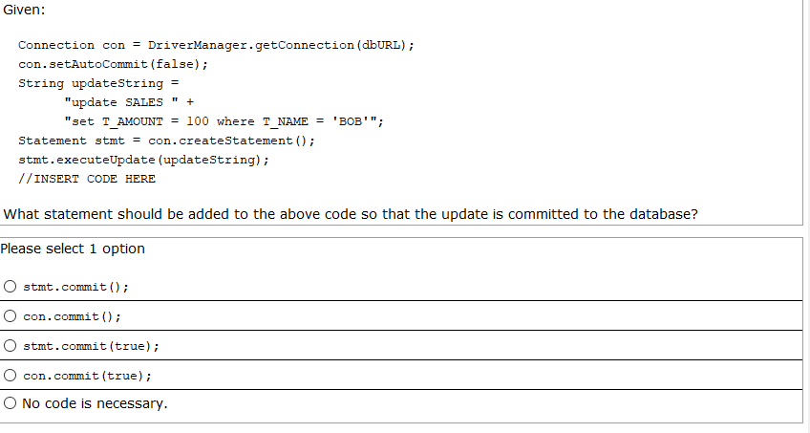

Respuesta: B

Pregunta 19

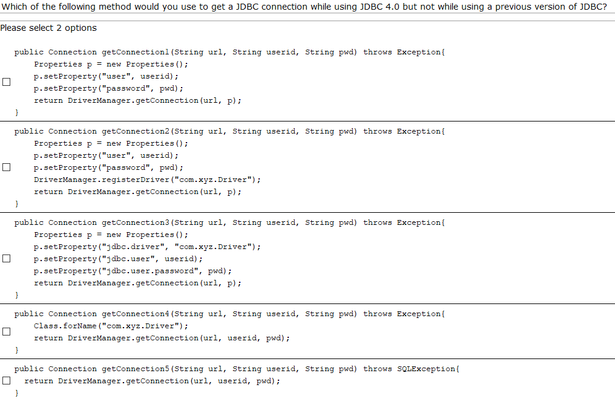

Pregunta 20

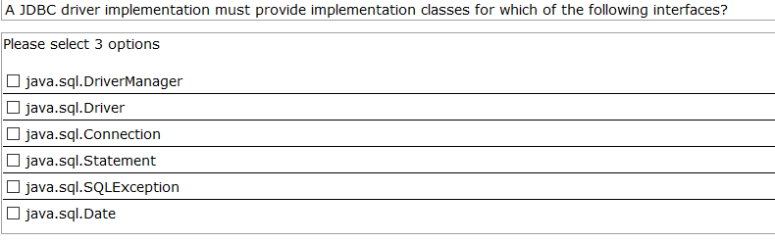

Pregunta 21

