# Preguntas Objetivo 9

Pregunta 1

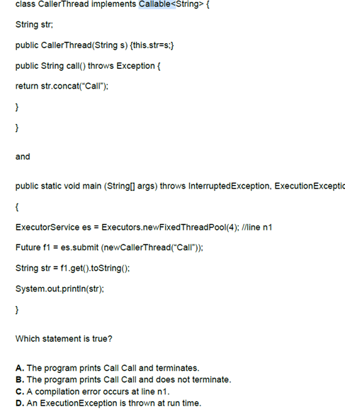

Pregunta 2

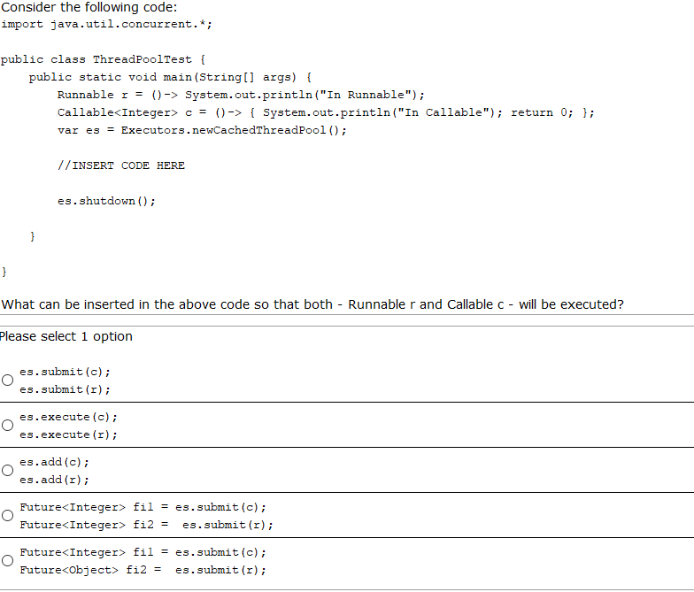

Pregunta 3

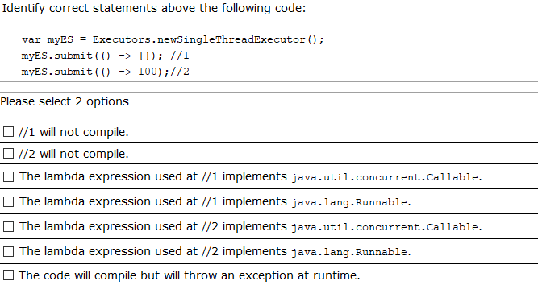

Pregunta 4

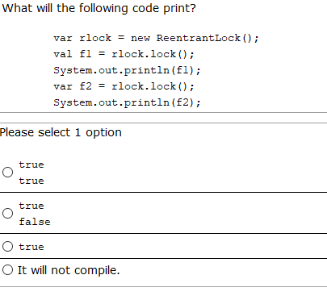

Pregunta 5

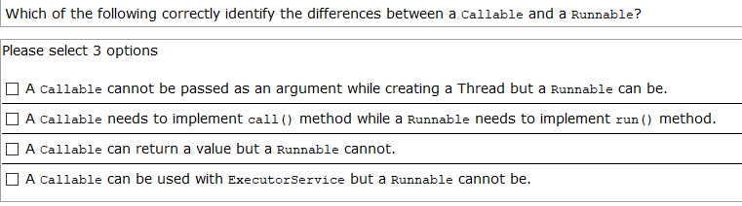

Pregunta 6

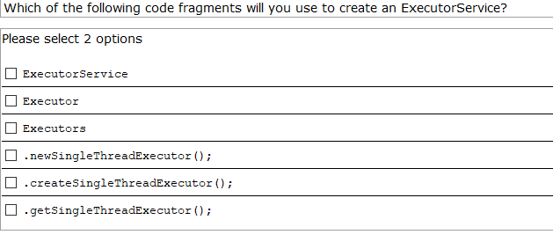

Pregunta 7

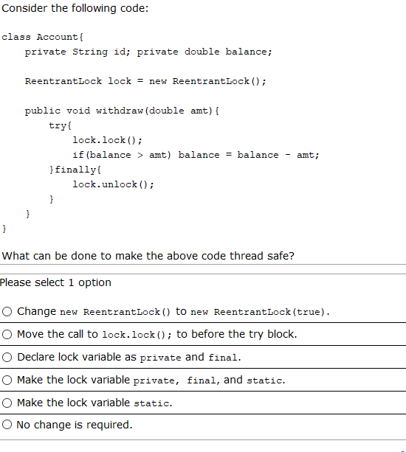

Pregunta 8

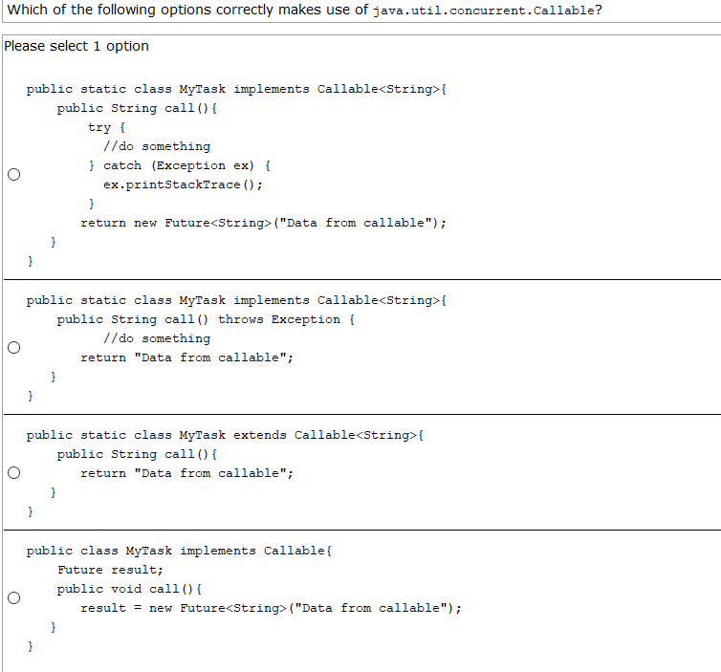

Pregunta 9

Given:

**public** **class** TestThreading {

**public** **static** **void** main(String[] args) **throws** InterruptedException, ExecutionException {

Integer[] numbers= {4,1,7,11,2};

ExecutorService executor=Executors.*newCachedThreadPool*();

**var** f1=executor.submit(()->Arrays.*stream*(numbers)

.filter(n->n%2==0).mapToInt(n->n).sum());

**var** f2=executor.submit(()->Arrays.*stream*(numbers)

.filter(n->n%2!=0).mapToInt(n->n).sum());

System.***out***.println(f1.get());

System.***out***.println(f2.get());

executor.shutdown();

}

}

What will be printed?

1. 6 and 19 in that order
2. 6 and 19 in any order
3. It prints nothing and the program will end
4. It prints nothing and the program will not end
5. It will throw an exception

Pregunta 10

Given:

Runnable r1=()->System.***out***.print("hello,");

Runnable r2=()->System.***out***.print("by,");

Thread t1=**new** Thread(r1);

t1.start();

t1=**new** Thread(r2);

t1.start();

System.***out***.println("tomorrow,");

t1.start();

What will be printed?

1. hello, by,tomorrow,by, in any order
2. hello,by in any order, and then by,tommorrow, in that order
3. hello,by,tomorrow in any order
4. There is a compilation error
5. An exception will be thrown